Ants, Grasshoppers, and Student Debt

Ordinarily this column stays away from politics with a capital ‘P’. While economics necessarily borders on politics, defined as the basic interaction between people, this column tries hard not to call individual Politicians nor to take a partisan position. That said, the recent interaction between Elizabeth Warren and an unnamed Iowa father is worth discussing in that it brings into sharp focus the old point of Frederick Bastiat about what is seen and unseen in the economy.

The interaction is shown in the following YouTube clip (first minute is sufficient).
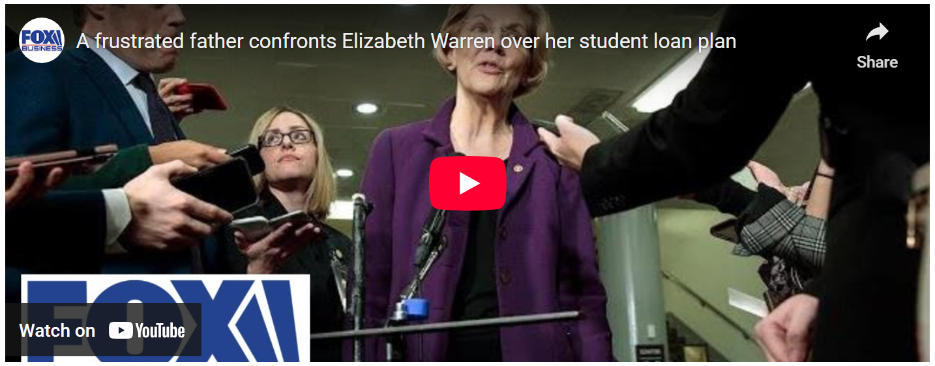

<iframe width="560" height="315" src="https://www.youtube.com/embed/62i2feu9fxk" frameborder="0" allow="accelerometer; autoplay; encrypted-media; gyroscope; picture-in-picture" allowfullscreen></iframe>

The dialog is short and worth repeating in print here.

Iowa Father: I just wanted to ask one question. My daughter is getting out of school. I’ve saved all my money. She doesn’t have any student loan. Am I going to get my money back?

Warren: Of course not.

Iowa Father: So, you’re going to pay for people who didn’t save any money and those of us who did the right thing get screwed.

Warren: No, you’re not getting screwed.

Iowa Father: Of course we did. My buddy had fun, bought a car, went on vacations. I saved my money. He made more than I did. But I worked a double shift, worked extra - my daughter worked since she was 10.

The interaction got hotter after that but the main point of the Iowa Father made is correct. This observation certainly flies in the face of those who look only at the seen cost of student debt.

There are clear problems with young people holding student debt. In many cases students have been sold a bill of goods that a college education is simply the only way to get ahead and make good money. Plumbers, mechanics, and HVAC technicians all over the country would no doubt laugh at the idea that you need a college education to make money. In addition, graduates across the land are probably lamenting the fact that $50,000 of student debt and a degree have not led to the promised land.

This problem pairing of a bad degree with burdensome student debt is only exacerbated by the fact that students can even get out from under by declaring bankruptcy, which would be a fine remedy since the students would simply bear a different cost.

But the sympathy that we all may have for the plight of the bad-degree/burdened-by-debt individuals (a seen cost) should not blind us to the unseen cost that that Iowa Father pointed out.

The Iowa Father acted like the proverbial ant in Aesop’s parable of the ant and the grasshopper. In the original parable, the ant saved food during the summer against the lean days of winter. In contrast, the grasshopper frolicked and danced, putting nothing aside for any dark days. When winter descends, one finds the grasshopper begging the ant for food and the ant refusing the grasshopper to share in the fruit of his labor.

The Iowa Father did the right thing. He scrimped and saved. He forewent fun, new cars, and vacations. He delayed his gratification in order to secure his daughter a college education unencumbered by student debt. His buddy was like the grasshopper. He spent and he idled and his kids now have to live with student debt.

But just like some people want to rework the original parable to point out the lack of compassion of the ant (as if the ant were a villain and not a sober individual who recognized the need for thrift), some people only want to focus on how bad it is to have student debt. Suppose we, as a society, chose to forgive that debt. Any compassion one might be showing to the student and his family is far outweighed by the callousness and lack of compassion we are showing to the Iowa Father.

He is bearing two unseen costs and we are effectively telling him that his work, efforts, and his virtues are all reasons he should be enslaved by the state.

The first unseen cost is opportunity cost he bore while saving for his daughter’s college education. Think of all the merry times he not only missed but will never be able to experience again. There must have been a trip, perhaps to Disney World, with his teenage daughter that he passed over in order to put money aside. Probably, he can afford the trip it now but his daughter is much older and the moment is lost. He also was denied the fond memories of many family outings or the enjoyment of a new car, all of which he sacrificed so that she graduated without debt.

The second unseen cost is now the increase in taxes and cost of living that this fellow must endure so that the creditors can have their loan returns met while the profligate takers of those loans skate free. This step adds insult to injury making him not only pay for his own sacrifices but also making him sacrifice for the gains the other family enjoyed.

By ignoring the costs born by the Iowa Father, what we are effectively saying is that there is a certain class of people in society who deserves to be oppressed and exploited and that this class is exactly the group that should be rewarded and held up as an example. We’ve turned the world upside down because forgiving student debt not only victimizes the “ants” amongst us it incentivizes the “grasshoppers” to be even more prodigal.

In short, the Iowa Father was correct - he is getting screwed.

