A February to Remember

Their trading company of choice is called Robinhood, the subreddit where they discuss and plan is called r/wallstreetbets, and their now trademark move is called the GameStop short squeeze but no name has yet to attach to the group of retail investors who’ve jumped into the spotlight for their role in one the landmark incidents in world of high finance. Whatever name history eventually dubs these ‘average joes’, there is no doubt that their actions – which are one part David versus Goliath and one part Revenge of the Nerds – have bloodied the nose of high finance and will change the way Wall Street, Congress, and society at large looks at investing and stock trading going forward.
Despite the excitement and drama surrounding the movement of GameStop stock during the past month, the mechanics of the story are rather simple although, perhaps, couched in unfamiliar terms. A group of institutional traders (e.g., brokerages, hedge funds, etc.) decided that GameStop was an over-valued company and shorted the stock. These actions were followed by the retail reddit investors driving the stock price up in a squeeze that caused big financial losses for many of those institutions.

In a short, the trader, called the short seller, borrows the stock from a lender and sells it to the broader market at the price Pb (‘b’ for borrow). The short seller, in addition to paying a lending fee, has an obligation to buy the same amount of the stock back and return it to the lender at some future time. During the time between the loan and the repayment, the short seller must collateralize the loan with a cash holding called margin and may have to post additional margin if as the stock price moves.
As long as the future price Pf (‘f’ for future) is lower than the Pb the short seller stands to make a profit equal to (Pb – Pf)*n (with n = number of shares), which is his reward for correctly betting against the stock. But if the future price is greater than the borrow price the short seller loses money, and since there is theoretically no limit to how high a stock price may go, the corresponding losses are unlimited.
By rule, whenever a trader takes a short position (i.e., short sells a particular stock) it is publicly disclosed; this disclosure has both a downside and an upside. On the downside, the fact that someone has bet against the stock puts a downward pressure on the price of that stock, which strengthens the short seller’s chances of realizing a profit. On the upside, the public position of that bet makes the trader vulnerable to others pushing the stock price higher, forcing the short seller to increase his margin (held collateral) or to exit his short position at a loss. This later event is an example of what is called a short squeeze and is precisely what the group in wallstreetbets/r did.
As Jill Schlesinger points out in the following video, what makes this story ‘delicious’ is that in crowdsourcing this short squeeze, the retail investors of this world (so-called dumb money) showed that they could also manipulate the market to their advantage in the same way that only the institutional investors (so-called smart money) could do until now.
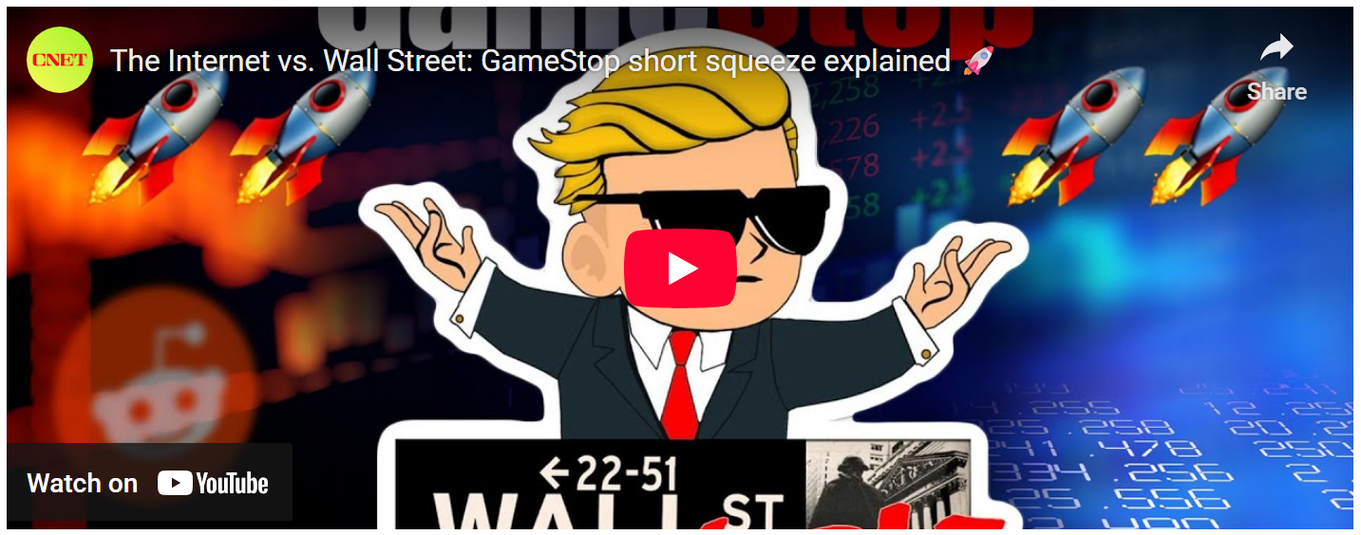
<iframe src="https://www.cnet.com/videos/share/what-does-gamestops-skyrocketing-stock-have-to-do-with-a-subreddit/" width="480" height="270" frameBorder="0" seamless="seamless" allowFullScreen></iframe>

To better understand this ‘snobs’ versus ‘slobs’ situation, consider that, for decades, the gap between the ‘big boys’ in the professional trading houses (institutional traders) and the average stock market trader (retail trader) has widened on several fronts.
On the snob side is a dazzling array of high-tech innovations. The increasingly sophisticated mathematical models of quantitative finance with its use of stochastic calculus and advance statistical algorithms has marginalized many who either hadn’t earned a PhD in mathematics, physics, or engineering or possess the money to buy the services of someone who had. Also, with great money comes great access to great technology – the kind of technology that can move mountains, literally. As Christopher Steiner narrates in his article, Wall Street's Speed War, the obsession for speed advantages in institutional trading led to the covert construction of a specialized ‘straight’ line of fiber connecting Chicago to New York in order to realize a 3 millisecond advantage over those institutions that used a more meandering path around obstacles like mountains and cities. As Steiner puts it this “… one-inch cable is the latest weapon in the technology arms race among Wall Street houses that use algorithms to make lightning-fast trades.”
On the slob side is… well not much in the way of sophistication. Sure, the number of day-trading sites has increased along with a host of ‘tutorials’ designed to help onboard the retail investor. But it wasn’t until dumb money used crowdsourcing to become a virtual institution that they could stand toe-to-toe with the professional trading houses and win. And win they did when it came to GameStop.
To get a sense what the folk from reddit set into motion, consider first the average daily share price (defined as the simple average between the listed high and low cost of a share on a given day) for the 1 year period from March 2020 to March 2021.
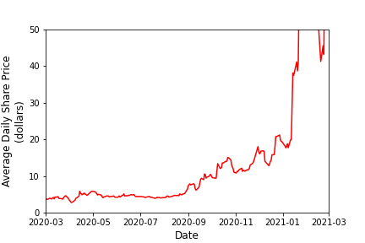

Share price was flat at somewhere around $5 until the fall of 2020 where there was a marked upward trend that then exploded in February of 2021. The explosion is more evident in the following plot that lifts the restrictions on the y-axis range and extends back 5 years.
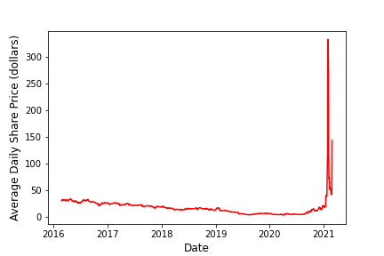
Clearly the stock had been steadily falling from 2016 to mid-2020 but once the reddit gang started pushing the stock price up, the increase took off from there and acquired a life on of its own. Before discussing how the short squeeze mechanism provides this life it is worth taking a look at the amount of money involved. The following plot shows the movement of money associated with the stock trades in billions of dollars.
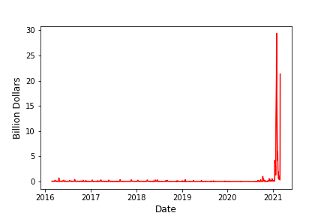
The amount of money stayed relatively low until the critical time frame. The next plot shows the same data with a log scale on the y-axis to show more detail.
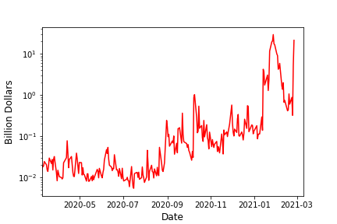
Note that in addition to the overall rise in the amount of money changing hands the size of the fluctuations (usually called volatility) also got large (much larger).
It’s the amount of the money involved that is key to understanding how the short squeeze becomes self-perpetuating. Once the reddit gang traded up the price to a critical level, the margin positions of the short sellers started becoming tight requiring each seller to either add more collateral to his margin account or to vacate his position. Each seller who vacates causes the price to go up even further causing an even greater problem for those left behind. The process is inherently unstable leaving behind a runaway process which sees sellers scrambling to liquidate their positions are the stock price inflates by huge factors (approximately a factor of 80 for GameStop).
These situations have happened in the past, but it usually took place between institutional investors trying to muscle each other along with the market as a whole. This is the first time that it was caused by a group of retail investors.
So, there you have it, a historic short squeeze brought on by a team effort amongst some folk on reddit. Look out baseball, there may be a new definition of suicide squeeze in the making.

