The Lemelson Debate
An old adage says there are always two sides to every story and this is certainly true about the life and controversial career of inventor Jerome Lemelson. What makes his tale so different from other public, polarizing figures is that the arguments traded between his admirers and his detractors concerning his use of the US patent system reflect, in a microcosm, two dramatically different points-of-view about how inventions and intellectual property should be governed in society.
When one thinks of the great inventors of American history, one might conjure up Thomas Edison or George Eastman or Samuel Westinghouse. Each of these men is famous for bringing to market, some device or machine that changed the way we live. For example, George Eastman, dissatisfied by his experiences getting a photographic portrait, invented photographic film and the first portable camera and revolutionized how we record history, be it the small, private kind we each enjoy or the collective, public kind that shapes the doings of the world. However, it is rare to find a person for whom the name Jerome Lemelson is even known let alone a household name, on par with those listed above, despite the fact that Lemelson holds approximately 600 US patents, making him one of the most prolific patent holders in the world.
That portion of the world that does know him divides into two very diverse camps. His admirers think him a visionary who made our modern life possible. His detractors think him a hoarder who gamed the US patent system and, perhaps, was a forerunner of the modern patent troll.
The pro-Lemelson side is succinctly presented in the Smithsonian book Little Explorer - Jerome Lemelson: the Man Behind Industrial Robots, by Lucia Raatma. (Note similar stories are told in the book Inventors You Should Know: Profiles for Kids, by Sam Simon– both are available on scribd.com)

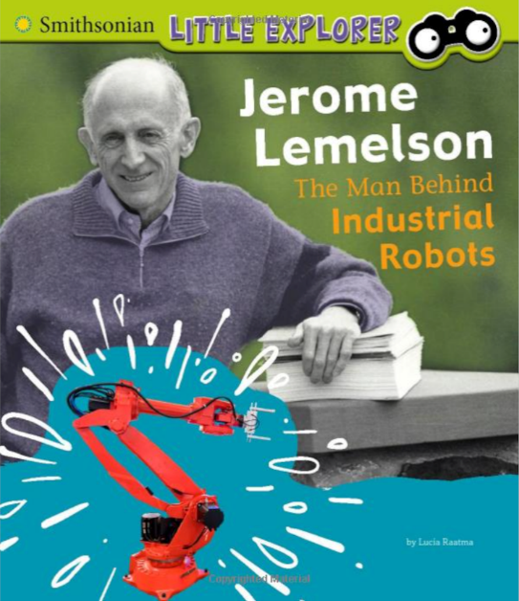
The book provides a brief biographical sketch noting that Lemelson, born July 18, 1923 in Staten island New York, earned an engineering degree from New York University despite having his studies interrupted by service in World War II. After graduating, Lemelson started in a typical salaried engineering job before striking out on his own as an inventor. The book claims Lemelson’s most successful invention as the universal robot that would use one of his earlier patents on machine vision, which Lemelson imagined as a computer analyzing images from a video camera, to study a task and then “figure out the best way to complete it”.
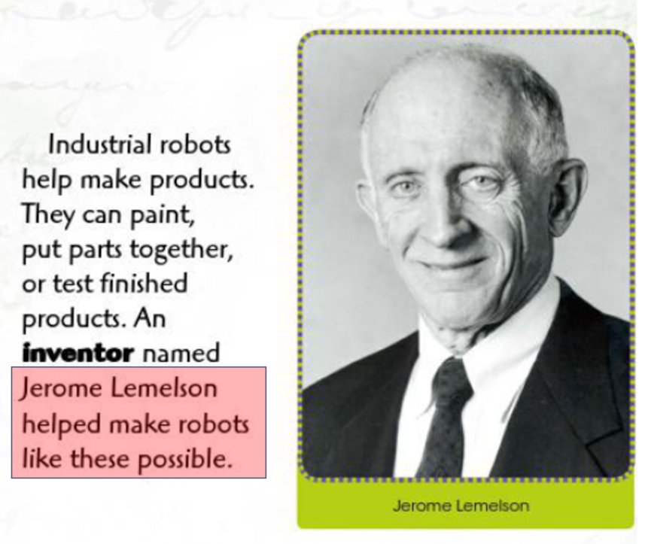
Raatma also spends some time talking about Lemelson’s approach to business. She says of his licensing and patent prosecution efforts that “an important part of being an inventor is licensing one’s ideas. People can’t buy new items if they don’t know they exist.” To that end he founded the Licensing Management Corporation to “sell his ideas” and to file lawsuits to protect his intellectual capital. The money he derived was then returned to the community in the form of philanthropy designed to help budding inventors.
A more critical looks at Lemelson’s career is found in A History of Inventing in New Jersey: From Edison to the Ice Cream Cone, by Linda J. Barth. She concedes that, despite his philanthropy, his career mostly consisted of filing patents and suing companies and customers who, allegedly infringed them, an approach she was clearly uncomfortable with. Barth characterizes him as “not conduct[ing] much laboratory or manufacturing work” and she relates the following anecdote to drive home the point that much of his activity centered on litigation.
“An example is a suit against Kellogg cereals. Lemelson submitted to the cereal company an idea for printing a children’s mask on the box that could be cut out and worn. Kellogg dismissed the idea, as it had used cut-out masks in the past. Lemelson then obtained a patent for his particular mask and later sued Kellogg when he saw a printed mask on a box of Corn Flakes.”
In her closing paragraphs, Barth writes
“Today, the Lemelson debate goes on. …On the August 20, 2005 broadcast of ABC News, Adam Goldman said “to his many detractors, Lemelson’s patents were, in fact, worthless. Lemelson, they say, was one of the great frauds of the 20th century.”
In the article Down but Not Out, R. P. Siegel points out that Lemelson’s inventions were “often so far ahead of their time that, in many cases, the technology required to build them did not yet exist.” Siegel also goes on to say that “a big part of Lemelson’s success was that he filed patent applications that remained pending for decades, and delayed work to his advantage.” Since patent applications remain hidden until the patent is granted, decades of delay on Lemelson’s part meant that other companies would unintentionally ‘re-invent the wheel’ by bringing a similar idea to market only to find later that they were subject to an accusation of patent infringement.
These so-called submarine patents enabled Lemelson’s Licensing Management Corporation to extract hundreds of millions of dollars from companies around the world. Siegel cites that Las Vegas Judge Phillip M. Pro, who ruled 14 of Lemelson’s patents as “invalid and unenforceable” partially due to the submarine aspect but partially for lack of enablement, which means that no person skilled in the art could produce the device based on the teaching of the specification. According to Jesse Jenner, the lead attorney representing Cognex, a company that disputed Lemelson’s claims of patent infringement, “these … rulings assert that no one, including Lemelson’s himself, ever built the machine vision system or bar-code scanner he licensed to thousands of companies.”
The idea that Lemelson’s patents are fraudulent is vocalized most forcefully by Mike Masnick, in a post entitled Lemelson’s Legacy: Great Inventor or Patent Hoarder, in which he characterizes Lemelson as a “complete fraud” who hoarded ideas and patents that effectively held companies, who actually did innovate and perform the hard work needed to bring a product to market, for ransom. Masnick concludes by describing Lemelson as being “more a science fiction writer than an inventor” and that “crediting Lemelson with machine vision is like saying Jules Verne invented space travel.”
So, what to make of Lemelson? In the process of wrestling with the facts surrounding his career, one must inevitably ask what the role of idea versus industry is in the economy. Certainly, having a good idea is a commodity that should reap an economic reward and one’s immediate sympathy most likely goes to the ‘idea holder’ and, by all accounts, Lemelson had ideas. But a bit of reflection should walk one away from the perspective that the ‘idea holder’ is pre-eminent. If it is simply a matter of having an idea a without having the will power and means to bring it to fruition, then Lemelson should not be credited with the invention of the industrial robot anymore than anyone else who came after GK Chesterton.
Chesterton, who cared little for machines and industry and modern economies, introduced the concept of the robot in his short story The Invisible Man, in 1911, roughly two decades before Lemelson was ever born. In this story, Chesterton foresees a future layered littered with mechanical helpers:
<The man called Angus emptied his coffee-cup and regarded her with mild and patient eyes. Her own mouth took a slight twist of laughter as she resumed, “I suppose you’ve seen on the hoardings all about this ‘Smythe’s Silent Service’? Or you must be the only person that hasn’t. Oh, I don’t know much about it, it’s some clockwork invention for doing all the housework by machinery. You know the sort of thing: ‘Press a Button — A Butler who Never Drinks.’ ‘Turn a Handle — Ten Housemaids who Never Flirt.’ You must have seen the advertisements. Well, whatever these machines are, they are making pots of money; and they are making it all for that little imp whom I knew down in Ludbury.
…
As Smythe took the handles and they turned the great corner of the street, Angus was amused to see a gigantesque poster of “Smythe’s Silent Service,” with a picture of a huge headless iron doll, carrying a saucepan with the legend, “A Cook Who is Never Cross.”
“I use them in my own flat,” said the little black-bearded man, laughing, “partly for advertisements, and partly for real convenience. Honestly, and all above board, those big clockwork dolls of mine do bring your coals or claret or a timetable quicker than any live servants I’ve ever known, if you know which knob to press. But I’ll never deny, between ourselves, that such servants have their disadvantages, too.
“Indeed?” said Angus; “is there something they can’t do?”
“Yes,” replied Smythe coolly; “they can’t tell me who left those threatening letters at my flat.”>
A critic might be inclined to point out that Lemelson did more that have an idea, since one can’t just patent an idea, but that point is fairly well retired by both the Corn Flakes anecdote above and the fact that, as Judge Pro ruled, many of Lemelson’s patents could not actually be used to build a device that achieved the idea.
Sad to say, it seems that Lemelson’s usual bag of tricks was to dream up an idea any futuristic might have and then to slap just enough ‘hard science’ onto it to serve as a fig leaf covering the basic fact that his ideas were naked. He then seems to use the strategy in dragging his applications out until real inventors, independently having similar ideas, caught technology up to the point where an actual device were possible. At that point, Lemelson surfaces and sues real innovators who had never heard of either him or his shadow idea. This is clearly not an actual desirable good in society and any economic rewards along these lines merely incentivizes more of the same and more waste on the part of individuals and companies that really invent. Thankfully, Congress put an end to the submarine patent with the Uruguay Round Agreement Act in June 8, 1995. Hopefully we won’t see another Lemelson as long as we live.

