The Joshua Bell Experiment

In 2007, classical violinist Joshua Bell went incognito to play an impromptu concert in L’Enfant Plaza just outside a Washington Metro station.
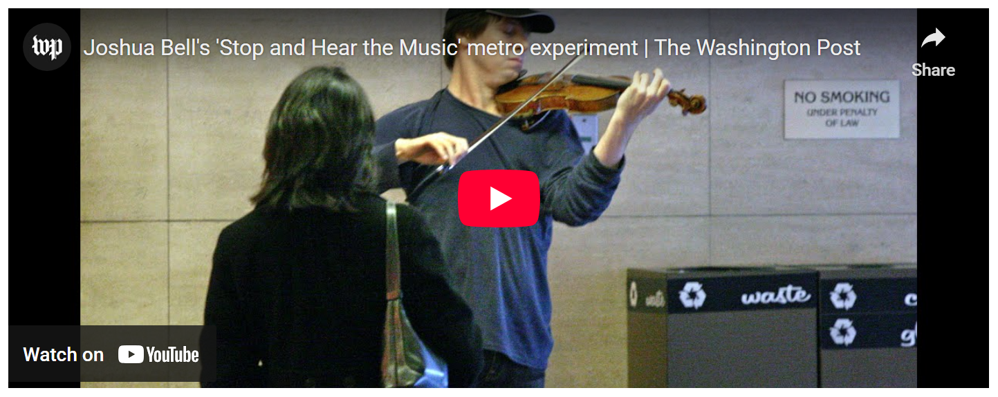
<iframe width="560" height="315" src="https://www.youtube.com/embed/hnOPu0_YWhw" title="YouTube video player" frameborder="0" allow="accelerometer; autoplay; clipboard-write; encrypted-media; gyroscope; picture-in-picture" allowfullscreen></iframe>
Much has been made of the fact that ‘no one stopped to listen to him play’ and ‘only a handful’ even so much as paused to regard his renditions of pieces by Bach, Massenet, Schubert and others. Wasn’t this the same world-renowned classical music composed by the greatest of classical composers? Wasn’t this violin one of the most expensive musical instruments ever made? Wasn’t the performer one of the world’s greatest musicians who people line up to hear, often paying hundreds of dollars for the privilege? How could the public response be so cold and indifferent?
Before digging into those questions, let’s take a moment to clear up a few misconceptions identified by Gene Weingarten, the Washington Post reporter who setup this ‘experiment’ and who garnered a Pulitzer Prize for his efforts. First, the ‘popular’ account that many people have heard is likely apocryphal as Gene makes clear in his article Gene Weingarten: Setting the record straight on the Joshua Bell experiment. Several people did stop and listen. Second, and more important, the ‘stunt’, as Gene has called it, has exacted a toll on Joshua Bell in a way that neither of them anticipated. Being ignored was disconcerting (no pun intended) for the classical violinist, so much so that Weingarten describes Bell as being nervous prior to a repeat engagement. Happily, Bell’s second go in 2014, which was properly billed and announced, went far better.
Nonetheless, the essential aspect of the story was correct – a thing (musical performance by Bell) is highly sought after in one context and highly ignored in another. This post is not intended to heap any additional discomfort on Bell nor is it to meant to criticize society as a whole and lament as to what is wrong. It is merely meant to look at ways of explaining that contextual difference.
YouTuber Conor Neill offered an Aristotelian explanation for the contextual difference.

<iframe width="560" height="315" src="https://www.youtube.com/embed/O2dEuMFR8kw" title="YouTube video player" frameborder="0" allow="accelerometer; autoplay; clipboard-write; encrypted-media; gyroscope; picture-in-picture" allowfullscreen></iframe>
While I am a big fan of Aristotle and I don’t discount the psychology (the failure to connect with the pathos and ethos of the ‘audience’) that Neill explores, I think that he misses the point. And, while I am religious, I think all the sermons delivered by priests, preachers, and pundits on this experiment also miss the point. As do any other analyses that try to understand why and draw conclusions. It isn’t important to determine whether one person passed by because he was late for work, while another failed to linger because, as a Metro passenger, he connects more with Rock music, and that a third only would have listened had he known that the musician was famous. These particulars are just that – particular reasons that each person had.
Rather, the real lesson here is one of economics. Regardless of why these 1097 people basically ignored Bell’s performance in L’Enfant plaza they did ignore it. Clearly the performance did not have value to them. Much like those famous cautionary tales about gold being useless to a man dying of thirst in the desert the only lesson here is that value is in the eye of the beholder – that there is no true and objective worth that any of us can put on anything. It is this subjectivity that makes it possible for us to deal with each other in the economic sphere and come away after this interaction better off than when we started.

