Cumbersome Cumberbatch
Ask anyone who views motion pictures as high art what they think about movies. Very often, you will receive an exposition on the ‘special’ nature of the medium that allows it to rise above ‘mere entertainment’ to become a vehicle of social change. Such films present a microcosm of society; a lens by which we can collectively self-examine and learn.
If it is true the stories featured in films can be microcosms for life, then it shouldn’t be a stretch to see that the business of Hollywood can also be a microcosm for the economy; or maybe more accurately, a petri dish where various strains of economic policies incubate, infect, and metastasize. Case in point: the recent declaration by Benedict Cumberbatch that he won’t takes roles in productions in which women are not paid equally.
<div class = “myQuoteDiv”>Look at your quotas. Ask what women are being paid, and say: 'If she's not paid the same as the men, I'm not doing it.’</div>
These sorts of announcements are common but what exactly is meant by ‘not paid the same as men’? Before crafting a policy to address an economic wrong we need to define what the wrong is, how to recognize and measure before turning to a remediation and the question as to how economically viable it may be.
To start, recognize that work in Hollywood is done almost exclusively by contract, typically negotiated between a legal representative of the production and the actor’s agent. Long gone are the days when actors were salaried to a studio and they got roles based on talent, availability, and the desire by the company to expand the expertise of its staff. Each actor exercises his autonomy in deciding to accept a role. Each actor tests the market demand with respect to his talent, exposure, popularity, and so on. Each actor modifies his market supply based on interest, availability, strategic positioning, and the like. A multitude of factors go into making the decision to sign on to a production or to let it pass by.
As result, it is incredibly complicated, if not down-right impossible, for all of these factors to be analyzed and controlled so that each actor is given exactly what he ‘deserves’. Exactly how does one normalize actor salaries to make an equal-pay outcome?
To illustrate some of these complexities while keeping the scope manageable, let’s imagine a two-person movie with a male and a female lead. There are several two-person films that have been made over the years (e.g. Sleuth) and one, in particular, nicely fits the bill: the very disturbing movie Closet Land (click here for the full movie). Closet Land features the chilling interrogation and torture of a children’s author (Victim played by Madeline Stowe) by a member of a totalitarian regime (Interrogator played by Alan Rickman) unhappy with her subversive stories.

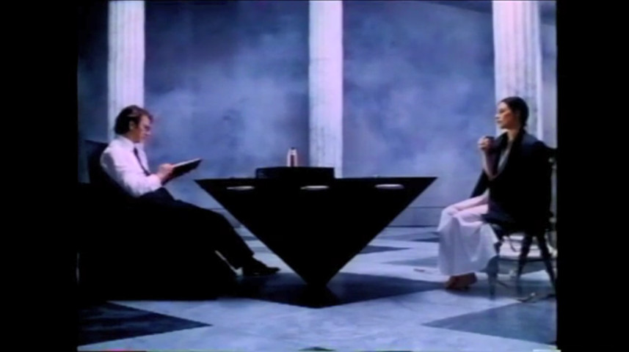
How do we determine what metric to use to set the pay for the actors involved? Should pay be based on how many lines are uttered, or by the total number of minutes the actor appears on-screen? Maybe count the Twitter or Facebook subscribers for each actor, as a measure of fan-appeal, and figure that into the computation. Don’t forget about the number of Oscar or Golden Globe nominations or awards. If Closet Land is going to be a vehicle for social change then we want people to watch it – we want stars who will draw an audience into theaters.
The situation becomes even more muddled when we turn to even more subjective measures based on talent and emotional delivery. Things like the character’s importance to the story or how evocative the actor portrayed a character’s death at a pivotal point in the plot somehow have to figure into the pay that the actor receives. Who is more important to Closet Land; Victim, who, as a cruelly treated innocent, allows to identify with the terrible plight of the victims of totalitarianism, or Interrogator, whose brutish behavior drives home the horrors of life under such regimes?
Put all these messy considerations aside, for the sake of argument, and simply assume that there is an unambiguous way to determine the merited pay for a given actor based on some amalgam of all of the above. Call this measure the actor’s worth. Also call the pay that the actor is being offered by the production the actor’s pull.
What Mr. Cumberbatch wants to correct are those situations where the female lead’s worth is more than her pull when her male counterpart’s pull equals his worth.
Even with all these assumptions in place to strip much of the complexity and messiness away from this situation there are still a lot of nuances in an ‘inequitable’ situation that can’t be dismissed with the simple-minded “it’s because she’s a woman” response.
First, the actress may be starting out in the business so that her pull is less than her worth because nobody has had the chance to see what she can do. Perhaps she’s been an amazing actor in stage productions on Broadway but is essentially unknown to the movie industry. Regardless of the circumstances, information about her worth is unavailable to the market and the information cost to find out more is prohibitive. In this case, her smaller pull reflects the market’s uncertainty.
Another scenario: suppose that the actress is a recognized star, able to pull in more than her male counterpart, but is between contracts and willing to take a smaller deal to be in a movie that she believes can actually affect social change.
Yet another scenario: suppose the actress is a proven commodity but doesn’t quite fit what the production wants; maybe she is older than the role calls for. She might want to negotiate her pull downwards below her worth to secure the role.
In all of these scenarios, and countless more, the economic freedom of the actress to negotiate her situation to her benefit, as judged by her and her alone, should be unfettered. Note that in all of these scenarios there are factors under her control and others over which she can exercise little or no influence. A naïve equal-pay-for-equal-work policy would produce barriers to entry that inflect harm on the actress.
Of course, a skeptical reader may be objecting vociferously at this point. What Cumberbatch really meant wasn’t any of this. Sure, it’s hard to quantify what an actor deserves, and sure an actor may want to make a deal for a variety of reasons, but what Benedict meant to address is when the male and female lead are identical in worth but the production company is full of misogynists.
Leaving aside the obvious critique against the simplistic mind that thinks that any two actors (or people) can have identical worth, suppose that the production house is misogynistic. Is an equal-pay-for-equal work policy the best way to address the injustice?
The most intelligent approach centers on letting the free market do its job. As is discussed in the following clip by Milton Friedman, companies that discriminate against a segment of the workforce ultimately bear a cost in the free-market and they don’t bear under equal-pay-for-equal-work policies.
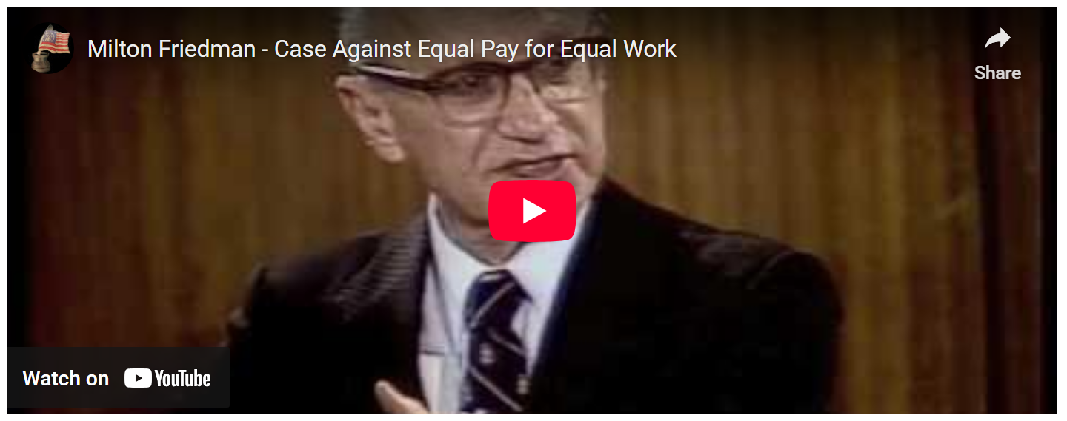
<iframe width="560" height="315" src="https://www.youtube.com/embed/hsIpQ7YguGE?start=15" frameborder="0" allow="autoplay; encrypted-media" allowfullscreen></iframe>
So, what does one make of the statement by Benedict Cumberbatch. Perhaps he has a clear picture that Hollywood isn’t a free market and that collusion abounds and that he hopes to right a wrong now that his star is on the rise. Unfortunately, my own interpretation is a rather cynical one and is based on the paragraph that followed the quoted one above. It’s a simple sentence that reads:
< Cumberbatch hopes to enact this policy at his new production company, SunnyMarch, as well - Abigail Hess>
Yep! It doesn’t take a Sherlock to suspect that all this virtue signaling is nothing more than an attempt to secure free advertising to a fledgling business.

