Getting a New Gig
Once again California demonstrates to the rest of the country that it believes that the laws of economics don’t apply to the wonderful world of that Golden State out west. At issue this time is the status of those individuals working within their gig economy and the protections that must be afforded to them at all costs. Never mind the consequences that bring a little more misery and a new set of unwanted side-effects that redound to the detriment of its citizens so long as the state can ‘do the right thing’. That unintended results and all of the collateral damage that follows could have been predicted and avoided by some sound economic reasoning never seems to enter the heads of the state’s judicial branch.
Now if you have been living under a rock, apparently like I have, then you may not actually know what the gig economy is and, as a consequence, why California’s latest juridical ruling has caused far more harm than good. In short, the gig economy is the term used to describe those people who work as independent contractors or, as David Shadpour puts it in his article The Gig Economy: Pioneering The Future, “are workers who are not employees of the company that signs their paychecks”.
Of course, the notion that people can work as independent contractors is not a new one and the only justification for coming up with a new term (besides the celebrity and funding always desired by researchers) is the strong growth of on-demand services like Lyft and Airbnb that some economists and commentators believe represents a fundamental change in the way the economy works.
Despite the pithy labeling, no consensus exists as to how many workers actually populate the gig economy. Larry Alton, writing for Forbes (Why The Gig Economy Is The Best And Worst Development For Workers Under 30), presents estimates that gig workers make up 34 percent of the workforce. In contrast, Robert J. Samuelson reports much smaller numbers in his article Is the gig economy a myth? Samuelson cites a survey by Katz and Krueger that indicates that the percentage of people engaged in the gig economy rose from 10.7 percent in 2005 to 15.8 percent in 2015. He then presents more current numbers from the Bureau of Labor Statistics that show that the percentage of the population in the gig economy had remained essentially flat over the last twenty years (9.9 percent in 1995, 10.7 percent in 2005, and 10.1 percent in 2017).
A likely explanation to this vast discrepancy is that, as Ben Casselman points out in Maybe the Gig Economy Isn’t Reshaping Work After All, the government’s statistics do not include people who do gig work as a supplement to their traditional 9-to-5 job. He goes on to explain that while the growth in the gig economy may be flat in aggregate, certain industries have seen a marked growth (e.g. transportation) while others have fallen (e.g. construction). In addition, he cites that the Federal Reserve recently released numbers showing that by including supplemental gig workers in with full-time ones, that nearly a third of adults engage in some form of independent contractual work. The fact that these estimates suggest that 2/3 of the gig economy is comprised by workers engaged in supplemental employment (a ratio independently arrived at by the McKinsey Global Institute as reported in Independent work: Choice, necessity, and the gig economy). This is an important point that will be discussed further below.
With some understanding of the statistics behind the gig economy in hand, let’s now turn to the reasons why people might engage in the gig economy. Alton suggests that millennials, craving new experiences and shouldering student debt, turn to the gig economy to test the waters while alleviating their financial burden before deciding on a permanent employment choice. Abha Bhattarai, in Now hiring, for a one-day job: the gig economy hits retail, puts her finger on another reason why certain sectors may be wanting independent contractors rather than permanent staff: employers are wary of hiring full-time employees because of overtime and health-care costs. These are only a few amongst the host of economic reasons for workers engaging in the gig economy or businesses only hiring contract workers.
Despite the clear data that indicate that a large fraction of those engaged in the gig economy do so as a ‘side hustle’, there are many commentators worried about the lack of protections afforded gig workers and who use, knowingly or unknowingly, faulty statistics and logic to bolster their case. For example, Bhattarai rightly points out that contract workers are not covered under the National Labor Relations Act and, thus, don’t have rights to a variety of employee protections. Unfortunately, she then goes on to criticize that most gig workers (she cites 85 percent) make less that $500 a month without acknowledging the fact that at least 2/3 of them are engaged in supplemental income or without analyzing the number of hours worked. Likewise, Alana Semuels laments in her article The Online Gig Economy’s ‘Race to the Bottom’, that third world workers engaged in freelance activities are forced to enter a global marketplace with ‘endless competition, low wages, and little stability’ without discussing the possibilities that their lives were filled with ‘endless poverty, low prospects, and little stability’ without the freelance work, which she begrudgingly admits may have raised wages and broadened opportunities.
This kind of fuzzy thinking (which Frederic Bastiat would be inclined to describe as ignoring the unseen costs) has clearly colored the California Supreme Court. Or perhaps the court was reacting to statistics that ‘indicate’ that the California’s rise in poverty lies squarely at the feet of the gig economy. Jeff Daniels seems to argue just that point in his article Nearly half of California's gig economy workers struggling with poverty, new survey says. But as Daniels own statistics show, only one in every 20 Californians struggles with poverty while being in the gig economy in contrast to the nearly 1/3 of all Californians and 47 percent of California workers that he cites as being in the same sorry state. Thus, 42 percent of California workers struggle with poverty for reasons that have nothing to do with the gig economy. These workers may even be able to benefit from the gig economy – or more precisely they may have benefitted. That was before the court ruled that many gig workers should have the pay and benefits of employees (as reported by Moore and Nuzzo in Gig economy will do wonders for Florida, if we let it).
Now the situation is much darker. Rather than providing for more economic growth and better wages this latest ruling, which adds more compliance burdens, seems to be having an adverse effect on businesses and workers alike as discussed in this very insightful video from Sacramento.
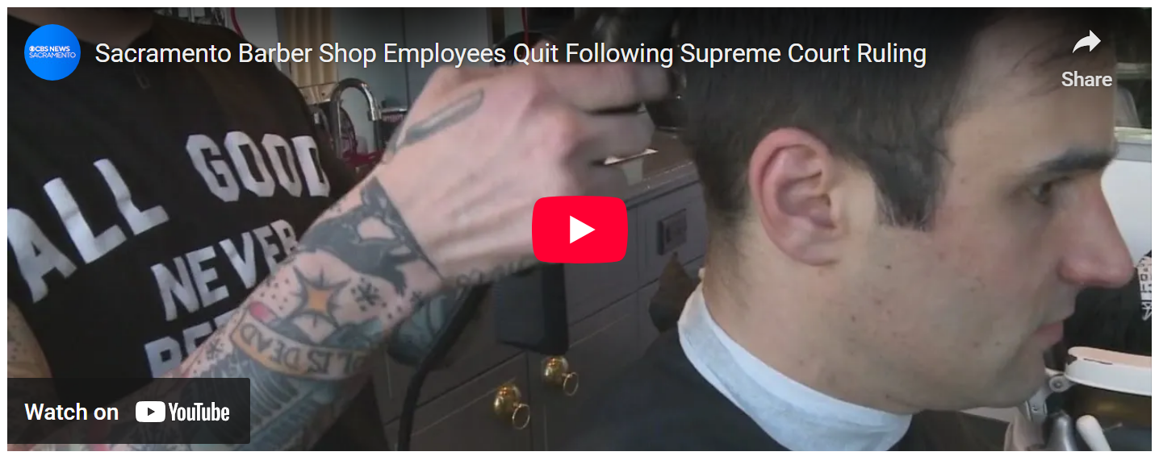
<iframe width="560" height="315" src="https://www.youtube.com/embed/3VZnucGhjtg" frameborder="0" allow="autoplay; encrypted-media" allowfullscreen></iframe>
Sigh…Maybe the California Supreme Court should get a new gig.

