Finding the Socratic Method
There is a standard debate in mathematics about the application of the terms ‘invention’ versus ‘discovery’. It resurfaced the other day when a colleague and I were talking about some mathematical graffiti that adorned a door jamb in the conference room in which we were meeting. This graffiti took the form of some mathematical symbols printed on a magnet held in place at the top part of the door. None of us in the room were able to determine what, if any, message was being sent but in the process of discussing the possible meaning, my colleague said, in passing, that Pythagoras had invented the theorem that bears his name. I questioned whether the verb should have been ‘discovered’ rather than ‘invented’. We spent a few minutes discussing that point then we gave up altogether and went our separate ways. On the drive home that evening I began to think about the proper use of those two words and I finished up wondering if Socrates invented or discovered his famous method.
To understand this distinction between ‘invent’ and ‘discover’, let’s return to the Pythagorean Theorem for a moment. Most everyone knows the theorem, namely that the sum of the squares of the lengths of sides of a right triangle is equal to the square of the length of the hypotenuse. The most common proof and, in my opinion, the most elegant, draws a right triangle with squares of the appropriate area on a side. I’ve provided such a diagram for a 3-4-5 Pythagorean triangle below.
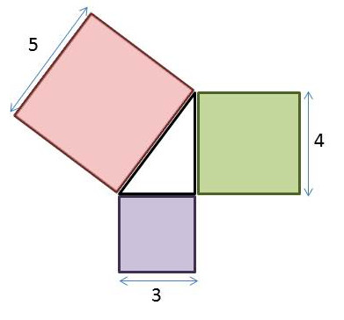
The proof proceeds by laying the bigger of the two side squares onto the hypotenuse square
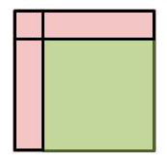
and then adding up the remaining area and showing that it is equal to the area of the smaller square
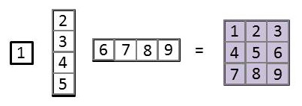
Of course, the steps shown above were quickly done in PowerPoint graphics and there is no reason for a skeptic to actually accept them as proof. But the doubters can go at this ‘proof’ with whatever vigor they desire. The answer will always be the same: a^2 + b^2 = c^2.
And that brings us to the point about invention versus discovery. I would argue that the Pythagorean Theorem is an exercise in discovery. That finding that all right triangles satisfy it is exactly the point – we find or discover that all right triangles obey this relationship.
Contrast this Edison’s invention of the light bulb. I say invention because of a number of factors. First there is the particular form of the object in question. The base, with its two contacts, one at the bottom center and one on the periphery, is choice of form that could have been done many other ways. The shape of the bulb itself is only a suggestion of what could be done given the state of art of glass blowing at the time of its introduction to society. Second there is the particular design and implementation. The placement, current and voltage running through the filament were all carefully chosen to meet specific goals or requirements. The materials that comprise all the parts were chosen to provide the maximum economy based on availability and convenience in pre-existing manufacturing processes. So I would argue that while it is proper to say that laws and properties of electricity were discovered that the light bulb is a true invention.
So far so good, but what about the Socrates? Did he discover or invent the Socratic Method? As quick review, a few brief words are in order about what I mean when I say the Socratic Method (ironically, if you follow the link to the Wikipedia article you’ll find that both ‘invention’ and ‘discover’ are used in describing Socrates’s contribution).
The Socratic Method is best explained by the Platonic dialog called Euthyphro. In this dialog, we find Socrates and Euthyphro both showing up at the Athenian court but for very different reasons. Socrates is answering a call by the court to make account of his ‘criminal ways’ whereas Euthyphro intends on petitioning the court to bring a charge of murder against his father for the death of a slave in his possession. The two meet on the steps leading inside and exchange with each other their reasons for being there. Socrates expresses surprise that Euthyphro is accusing his father of murder since the slave in question died from being imprisoned for murdering another slave. Euthyphro says that he is compelled to this course of action due to his piety. That’s all the prompting needed by Socrates and soon the two are engaged in a discussion where Socrates asks a question like ‘what is piety’ and Euthyphro attempts to answer with a response like ‘what is pleasing to the gods’. After each answer, Socrates questions some new part of the response as a way a sharpening the reasoning behind the response.
The Socratic Method is a way of examining the logical content of a statement by carefully examining the basic notions that make up that statement. So asking what do ‘piety’, ‘pleasing’ and ‘gods’ mean is a way of finding the truth. Generally, when the method is applied, we are more apt to find out what a particular concept, like ‘piety’, isn’t rather than finding out what it is. Most of the dialogs (and for that matter modern applications) end with both parties departing before the full meaning has been established but at least with a clearer picture of what is not meant.
So with all the preliminaries out of the way, the key question to grapple with is whether Socrates invented this method or discovered it. My vote is for discovery. I say this mostly because of the universal nature of this mode of inquiry but partly because Socrates believed in Truth, in the most absolute sense. If he invented this type of intellectual exploration then the application of it would be necessarily limited to those contexts where its design matched a particular cast of mind or cultural milieu. The fact that it is a successful philosophical pursuit the world over is testament to its ability to transcend the accidentals of human culture. The fact that it was fashioned with the goal of discovering Truth through logic and reason and that Socrates believed in Truth leads me to believe that he would agree that he discovered his method.
I am willing to say that Plato invented the particular encounters presented in the dialogs and that Socrates invented the accidental trappings whereby he applied his method to the Athenian society. Recognizing these inventions is equivalent to recognizing the invention of the particular symbols for denoting an algebraic quantity as ‘a’ or multiplication by ‘x’ or equality as ‘=’. Writing c*c = a*a + b*b versus saying ‘the square of the hypotenuse is equal to the sum of the squares of the two sides’ are two different, invented ways for expressing the same truth.

