Why do We Teach the Earth is Round?
You’re no doubt asking yourself “Why the provocative title? It’s obvious why we should teach that the Earth is round!” In some sense, this was my initial reaction when this exact question was posed in a round table discussion that I participated in recently. The person who posed the question was undaunted by the initial pushback and persisted. Her point was simply a genuinely honest question driven by a certain pragmatism.
Her basic premise is this. For the vast majority of people on the Earth, a flat Earth model best fits their daily experiences. None of us plan our day-to-day trips using the geometry of Gauss. Many of us fly, but far fewer of us fly long enough distances where the pilot or navigator consciously lays in great circle path. And even if all of us were to fly, say from New York to Rome, so what if the path the plane follows is a ‘geodesic on the sphere’, very few of us are either aware or care. After all, that is someone else’s job to do. And certainly gone are the days where we sit at the seashore and watch the masts of ships disappear last over the horizon – cell phones and the internet are far more interesting.
I listened to the argument carefully and mulled it over a few days and realized that there was a lot of truth in it. The points here weren’t that we shouldn’t teach that the Earth is round but rather that we should know with a firm and articulable conviction why we should teach it and that that criteria for inclusion should be open to debate when schools draw up their curriculum.
So what criteria should be used to construct a firm and articulable conviction? It seems that at the core of this question was a dividing line between types of knowledge and why we would care to know one over the other.
The first distinction in our round-Earth epistemological exploration is one between what I will call tangible and intangible knowledge. Tangible knowledge consists of all those facts that have an immediate impact on a person’s everyday existence. For example, knowing that a particular road bogs down in the afternoon is a slice of tangible knowledge because acting on it can prevent me from arriving home late for dinner (or perhaps having no dinner at all). Knowing that the rainbow is formed by light entering a water droplet in the atmosphere in a particular way so that it is subjected to a single total internal reflection before exiting the drop with the visible light substantially dispersed is an intangible fact, since I am neither a farmer nor a meteorologist. Many are the people who have said “don’t tell me how a rainbow is formed – it ruins all the beauty and poetry!”
An immediate corollary of this distinction is that what is tangible and intangible knowledge is governed by what impacts a person’s life. It differs both from person to person and over time. A person who doesn’t drive the particular stretch of road that I do would find the knowledge that my route home bogs down at certain times and the meteorologist would find the physical mechanism for the rainbow a tangible bit of knowledge, even if it kills the poet in him.
The second distinction is between what I will call private and common knowledge. The particular PIN I use to access by phone is knowledge that is, and should, remain private to me. In the hands of others it is either useless (for the vast majority who are either honest, or don’t know, or both) or it is dangerous (for those who do know me and are up to no good). Common knowledge describes those facts that can be shared with no harm between all people. Knowing how electromagnetic waves propagate is an example of common knowledge but knowing a particular frequency to intercept enemy communications is private.
With these distinctions in hand, it is now easy to see what was meant by the original, provocative question. As it is taught in schools, knowledge that the Earth is round is, for most people, a common, intangible slice of human knowledge. In this context, it is reasonable to ask why we even teach it to the students.
A far better course of action is to try to transform this discovery into a common but tangible slice of knowledge that effects each student on core level. The particular ways that this can be done are numerous but let me suggest one that I regard as particularly important.
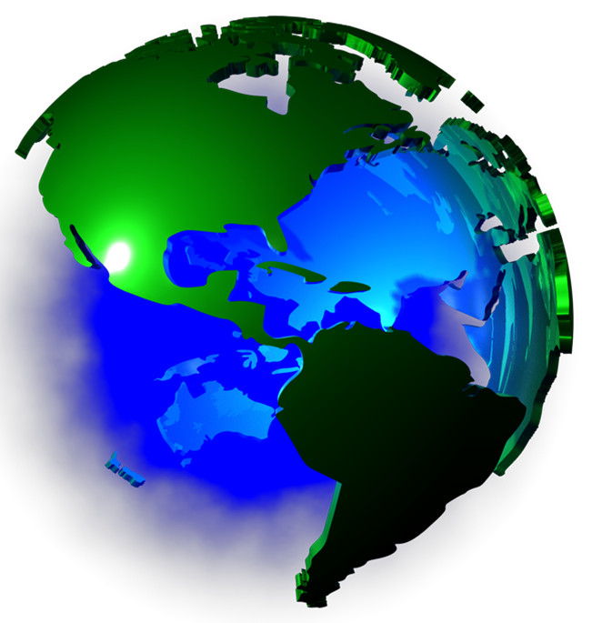
Teaching that the Earth is round should be done within a broader context of how do we know anything about the world around it, how certain are we, and where are the corners of doubt and uncertainty. A common misconception is that the knowledge that the Earth is round was lost during the Dark and early Middle Ages. The ancient Greeks knew with a great deal of certainty that the Earth was round and books from antiquity tell the story of how Eratosthenes determined the radius of the Earth to an astounding accuracy considering the technology of his day. This discovery persisted into the Dark and Middle Ages and was finally put to some practical use only when the collective technology of the world progressed to the point that the voyages of Columbus and Magellan were possible. Framing the lesson of the Earth’s roundness in this way provides a historical context that elevates it from mere geometry into a societally shaping event. Science, technology, sociology, geography, and human affairs are all intertwined and should be taught as so.
Along the way, numerous departure points are afforded to discuss other facets of what society knows and how does it know it. Modern discoveries that the Earth is not a particularly spherical (equatorial bulge) know take on a life outside of geodesy and the concepts of approximations, models, and contexts by which ‘facts’ are known and consumed now become tools for honing critical thinking about a host of policy decision each and every one of us has to make.
By articulating the philosophical underpinnings for choosing a particular curriculum, society can be sure that arbitrary decisions about what topics are taught can be held in check. Different segments can openly debate what material should be included and what can be safely omitted in an above board manner. Emotional and aesthetic points can be addressed side-by-side with practical points without confusion. And all the while we can be sure that development of critical thinking is center stage.
Failure to do this leaves two dangerous scenarios. The first is that student is filled with a lot of unconnected facts that improve neither his civic participation in practical matters nor his general appreciation for the beauty of the world. The second, and more importantly, the student is left with the impression that science delivers to us unassailable facts. This is a dangerous position since it leads to modern interpretations of science as a new type of religion whose dogma has replaced the older dogma of the spiritual simply by virtue that its magic (microwaves, TVs, cell-phones, rockets, nuclear power, and so on) is more powerful and apparent.

