Metaphors and Videogames
The genesis of this post was some time off that I finally took from work and the chance to sit down and play some videogames and relax. In the process of playing an old favorite and then discussing it with my friends I got a new appreciation for some of the subtle points of how language and thinking shape each other.
To set the stage, I must confess that many years back, I willingly allowed myself to be swept-up by the Doom craze. I recall that when the free sample came out a lot of guys at work (me included) loaded up the game as a diversion from the code-slinging the powers-that-be demanded. A few scant years later found me in possession of Doom and Doom 2 and the corresponding Battle Books (walkthroughs with a much cooler name) and having spent countless hours dodging imps, cacodemons, and the like.
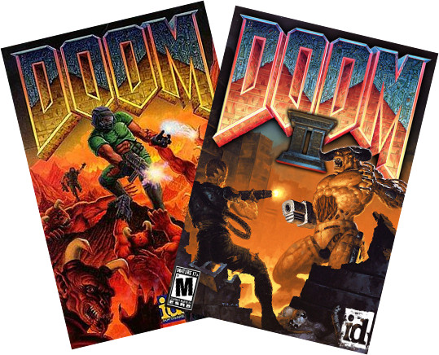
Fast forward nearly 20 years (sigh…) and similar scene is now playing out again, although in a different residence and on a quite different platform. Gone was the old DOS-based, Windows-running Pentium machine I spent over $2000 to buy. In its place is a sleek, black PS3 which cost about a tenth of that price with decidedly more graphics and computational horsepower. Gone are the old CD-ROM versions of the games, each requiring a lengthy installation. In its place is a DVD bearing the name Doom: BFG Edition (I wonder – what does BFG stand for?) containing Doom’s 1-3; each capable of starting up right out of the box with no installation. Both changes are improvements to be sure. Unfortunately, not everything was an improvement.
After playing the original Doom on the PS3 for a short while, I began to become very irritated with the awkwardness I was experiencing. Certainly a large portion of that was initially due to my rust and age. After all, two decades had passed since I regularly played arcade and first-person shooter type games, and my hand-eye coordination was not as fresh and sharp. But my expectation was that the irritation would fade as I got more practiced and that expectation was not met.
Upon some reflection (once my adrenaline had dissipated), I realized that it was a particular game mechanic that was getting in the way. In the original Doom, which was released for the PC, the developer had a vast number of input keys/devices to choose from. The keyboard alone offers over 100 different keys, including the arrow keys. Throw in a mouse and one has a potent set of device combinations to map to the game mechanics.
The situation is quite different on the PS3. While it is true that the two analog sticks each offer full 2-degrees of freedom, they are almost always reserved for in-game translation and rotation. That leaves only 14 keys for interacting with the cyber-environment with the triangle, square, circle, and ‘x’ being the primary ones.
For much of Doom’s game play, which is primarily moving, turning, and shooting, the smaller number of key’s is not an impediment. The place where the mechanic breaks down is weapon selection. At the start of the game, your character is simply armed with… well his arms. As the game progresses, additional weapons are acquired, each with its own strengths and weaknesses. During battle with a host of foes, you need to be able to switch weapons smoothly to maximize you lethality and minimize your chances of dying. On the PC, weapons-switches happened by selecting a number key in the range 1-6, inclusive. Selecting ‘1’ meant you were using bare knuckles, ‘3’ was the shotgun, and ‘6’ meant you were yielding the BFG (there’s that abbreviation again – I wonder…). In the PS3 version, random access of the weapons list is replaced by an awkward cycling through of the weapons in one direction by repeatedly pressing the circle button.
It is really hard to select the correct weapon while being attacked and, even when it is calm, it is easy to accidently go past the weapon you want and have to circle back to get it. Speed and fluidity are hallmarks of Doom and this method of switching weapons really detracts from feeling immersed in the game.
This is a case where the language betrays the message; a case where how the idea is expressed is a road-block to the idea itself. It is an example of a user-interface metaphor that simply doesn’t work.
Often we don’t notice when the metaphor expressed in a user-interface is good. That is as it should be, with the language (the particular button sequence being used) cleanly expressing the intention (the actions on the screen). But we clearly notice when the metaphor is bad. It sticks out like a sore thumb.
As a user community we’ve even come to expect compromised or even bad metaphors from software we need to use. Examples here range from mandated applications at our work, or programs we use as a means to an end (e.g. tax preparation software).
But within the context of gaming, a bad metaphor can’t be ignored. After all, the purpose of the game is to have fun. If the metaphor is bad it lessens or even destroys the fun. Since the game is the end and not the means to another end, there is no way to justify awkwardness of expression. This conclusion holds broadly for much of how we use language. We will slog or way unhappily through an obscurely written tax form or government regulation simply because we must. But we will reject an unartfully constructed joke or an awkwardly written story. In the case of the videogame, we get to see the whole phenomenon work in a highly compact and specialized language – the language of buttons, joysticks, symbols, and lights and shadows played out on a screen.

