Dumbing AI Down
The concept of the Turing Test as the basic gate that an artificially intelligent system must pass to be judged sufficiently human-like is both pervasive and intriguing. Dealt with widely in both serious academic circles and in fanciful science fiction avenues, the usual theme is one in which the AI must overcome a set of hurdles to pass the test.
Usually, these hurdles are viewed as question of evolution - of smartening the AI so that it acts like a human being. Topics along this line include enabling and sophisticated algorithms that recognize levels of evocation; an essential property that allows for understanding humor, getting double entendres, and recognizing sarcasm. Poetry and evocative imagery is also a complication that has been explored off and on.
Far less frequently is the concept of devolution explored. The idea here is to dumb down the AI so that it seems less like a computer and more like a human being. It should know how to rounds numbers grossly, use vague characterizations, uses contractions, cuts verbal corners and the like. One should imagine Commander Data from Star Trek the New Generation as the textbook example.
This post deals with an unillumined corner of this latter category. Specifically, how to make sure an AI can mimic the intuition of a human being, warts and all. What I am talking about is a designed AI with the same usual blind spots and foibles as the average human being. Nothing illustrates this so clearly as intuition-defying results that come from big numbers.
Humans are not usually good with numbers in general and are notoriously bad with big numbers. This is such a prevalent problem that there is even a term to describe just how poor the average soul’s understanding of numbers and mathematics is – innumeracy.
Even for those practiced in the art, intuition can fail when big number come in the form of probability and statistics. Two puzzles are famous for challenging the mortal mind: The Birthday and the Monte Hall Puzzles. Any AI that wants to blend in better trip over these two problems with the rest of us or run the risk of being exposed as something other than human.

The Birthday Puzzle
Often called the Birthday Paradox, this puzzle is a significant challenge to the basic intuition that each of us as to the likelihood of coincidences. As described, the Birthday Puzzle, goes something like this. Suppose that there are $n$ persons in a room, say attending a party. What is the probability that any two of them have the same birthday? Stated slightly differently, how many people do you need in a room before the probability is 50% that any two of them share the same birthday.
To be concrete and to keep things as simple as possible, let’s agree to ignore leap days and the possibility of a birthday falling on February 29th. This step is not essential but it keeps the number of special cases to consider down to a minimum.
Ask the average person and they will tell you that you need about 182 people in the room to get a 50-50 shot (assuming that the average person can actually divide 365 in half and properly round). Whether it is a result of nature or nurture, this ‘intuitive’ and ‘obvious’ answer is grossly wrong.
The easiest way to compute the probability is to compute the much easier probability that none of the $n$ persons have the same birthday and then to subtract this number from 1 to get the probability that at least one pair share a birthdate in common.
Suppose that there are 3 people in the room, then there are 365 days to assign person 1’s birthday, 364 days to assign to person 2’s birthday, and 363 days to assign to person 3’s birthday. Each of these numbers is then divided by the total number of days to get the probability. The value of this number is
\[ \tilde P = \frac{365}{365} \frac{364}{365} \frac{363}{365} \; .\]
The probability that in a group of 3 persons at least one birthday is held in common is
\[ P = 1 - \tilde P = 0.0082 \; . \]
This approach, which doesn’t come naturally to most of us, is, at least comforting, in that common sense tells us that when there are 366 or more people in a room then at least one pair share a birthday. The real assault on common sense begins when we generalize the analysis to an arbitrary number of people and graph the result.
The general formula is
\[ P_n = 1 - \frac{365}{365} \frac{364}{365} \cdots \frac{365-n+1}{365} \; .\]
When graphed the unexpected appears: only 23 people are needed to get a probability just over 50%.
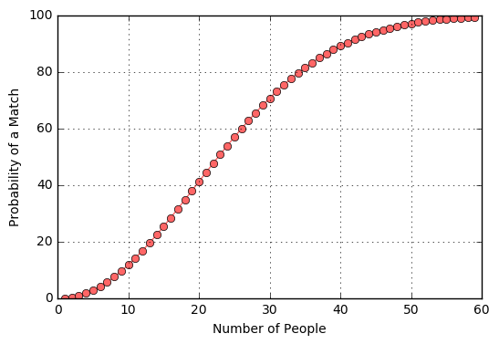

By the time the number of people reaches about 60, the probability of a match is nearly 100%. This result challenges our expectations and causes us genuine surprise. How will an AI that passes the more conventional aspects of a Turing test react?

The Monte Hall Puzzle
Even more interesting and non-intuitive is the Monte Hall or Let’s Make a Deal Puzzle. Based on the final segment of the game show Let’s Make a Deal, contestants are offered a choice between three doors. Behind two of them are so-called booby prizes, usually a farm animal or so other unwanted thing. Behind one of the doors is usually a car. Monte Hall, the host of the show, asks the contestant to pick one door. Next, he opens one of the other two doors and reveals one of the booby prizes (e.g. the goat).
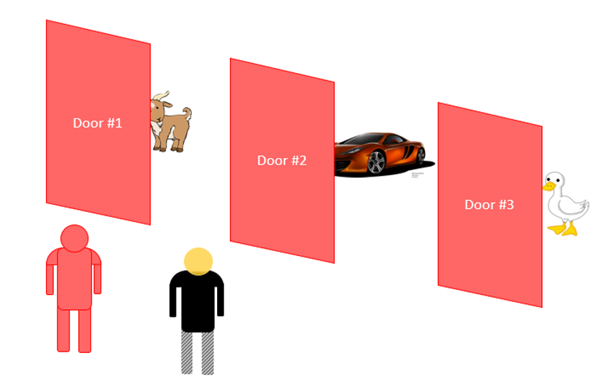
Monte’s final step is to offer the one unopened door in trade to the contestant. The question then is should the contestant accept the offer and switch doors or should he stay with his original pick? Of course, there is no way to guarantee the correct choice, but the contestant has a definite statistical advantage if he switches. The probability that the car is behind the door he chose is 1/3 while the probability it is behind the other door is 2/3. Most people see two doors and assume that the odds are 50-50. That’s human intuition – even though it is wrong. And Monte Hall, who I believe must have been a confidence man before going legit, played on the contestant’s greed and excitement, by offering cash if they stay with their first choice. Usually, he kept them from getting the car, which I suppose was his aim.
Now imagine what would happen when an AI went onto Let’s Make a Deal. Certainly, the AI should be able to understand natural language. But how should it react to the door choices, to Monte Hall’s con-man techniques. If the AI is going to fool the humans around it, it better be conned alongside the rest f us.

