Category Theory Part 4 – Determination and Choice

This month’s post on category theory picks up where the last post left off, with a look at the choice problem, the complimentary situation in map composition to the determination problem considered in the last post. However, before digging in the choice problem directly this narrative will begin by revisiting the determination problem. This go-back is one of the consequences of just following where the roots of discovery lead without having trampled down a path. After having a month to reflect on the determination problem, it became clear that a discussion of the choice problem would greatly benefit from a little more detail in former.
One of the major failures of Lewvere’s and Schanuel’s book is not sufficiently connecting the combinatorics associated with composing maps with both problems. While it is true that the text emphasizes the formal analogies between multiplication of ordinary numbers with compositions of maps, the usefulness of the analogy is never clearly stated. Their exposition goes from the very simplistic (e.g. considering how to tell when two sets have the same number of elements) to the very complicated (retractions and sections as a way of defining inverse mappings) with no intermediary steps. The purpose of this post is to provide those waypoints. Along the way, it will become clearer why the authors focus on automorphisms.
To lay the groundwork, consider the finite sets [latex display=inline]A[/latex], [latex display=inline]B[/latex], and [latex display=inline]C[/latex] as shown in the diagram below,
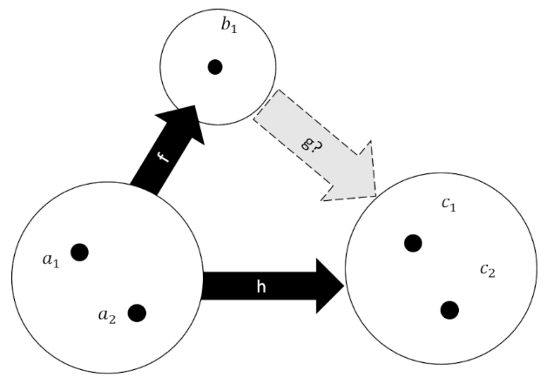
along with known mappings [latex display=inline]f:A \rightarrow B[/latex] and [latex display=inline]h:A \rightarrow C[/latex] and the yet-to-be-determined mapping [latex display=inline]g:B \rightarrow C[/latex]. Set [latex display=inline]A[/latex] has two elements as does [latex display=inline]C[/latex], while [latex display=inline]B[/latex] has only one. In the last post, the importance of the mapping [latex display=inline]f[/latex] being injective was raised but not sufficiently explained. A clear distinction wasn’t made as to whether or not a non-injective map could actually solve the determination problem. We will detail the various mappings possible between the three sets shown in the figure and will show that not injective mappings can solve the determination problem but only in special contrived cases and never when the mapping between [latex display=inline]A[/latex] and [latex display=inline]C[/latex] is an automorphism.
Before diagraming each of the individual cases, let’s count the number of diagrams needed – one for each of possible sets of mappings [latex display=inline]\{f,g,h\}[/latex] (whether or not the set solves the determination problem). The number of mappings between any two sets is equal to the number of elements in the target or codomain set raised to the power of the number of elements in in the domain set. Since [latex display=inline]B[/latex]has only one element all mappings from any other set must look the same, that is every element of the domain maps to the singleton in [latex display=inline]B[/latex]. The number of mappings from [latex display=inline]B[/latex] to [latex display=inline]C[/latex] is equal to the number of elements in [latex display=inline]C[/latex], which in this case is two. A similar computation shows that the number of distinct mappings from [latex display=inline]A[/latex] to [latex display=inline]C[/latex] is four. Already we can see that there is likely to be a problem in trying to solve the determination problem as there are only two distinct ways to go from [latex display=inline]A[/latex] to [latex display=inline]C[/latex] with a waypoint at [latex display=inline]B[/latex] whereas there are four ways in which to go from [latex display=inline]A[/latex] to [latex display=inline]C[/latex] directly. To see which of the four versions of [latex display=inline]h[/latex] are incompatible let’s look at the diagrams for the cases where [latex display=inline]h[/latex] is not injective followed by where it is.
In the case were the mapping [latex display=inline]h:A \rightarrow C[/latex] is not injective, there is always the solution to the determination problem despite the fact that the mapping from [latex display=inline]f:A \rightarrow B [/latex] also fails to be injective. The figure below shows the four possible sets of [latex display=inline]\{f,g,h\}[/latex] in this case with the left side showing the correct choice for the mapping [latex display=inline]g[/latex] and the right showing the wrong way to do it.
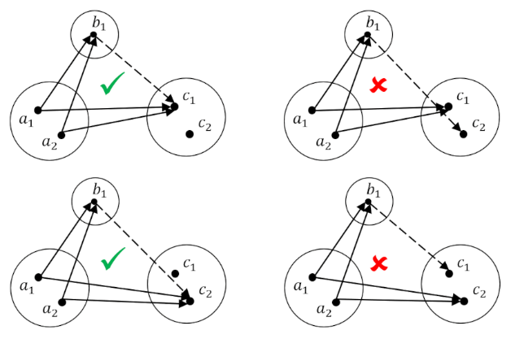
However, when the mapping [latex display=inline]h[/latex] is injective, that is to say that each element in [latex display=inline]A[/latex] maps to a unique element in [latex display=inline]C[/latex] (more generally every point in the codomain has, at most, one incoming arrow), then no solution to the determination problem can be found. This is shown in the following diagram for the two distinct possibilities for [latex display=inline]h[/latex], one of which is in an automorphism (with the identifications [latex display=inline]a_1 = c_1[/latex] and [latex display=inline]a_2 = c_2[/latex]) and the other a permutation.
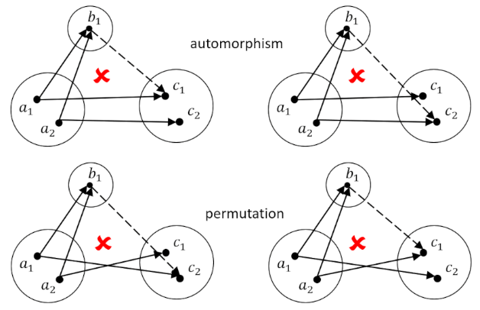
If we restrict ourselves to only the automorphism between [latex display=inline]A[/latex] and [latex display=inline]C[/latex], then we have to give up all hope of contriving a solution if [latex display=inline]f[/latex] is not injective, because, otherwise we would have to force some doubly-targeted element (i.e. [latex display=inline]b_1[/latex] in this case) into trying to do the impossible – to simultaneously point to two separate elements in its codomain.
The special case where a mapping [latex display=inline]g[/latex] solves the determination problem for the case where [latex display=inline]h=I_A[/latex] is called a retraction for [latex display=inline]r[/latex] for [latex display=inline]f[/latex] and it obeys the relation [latex display=inline]r \circ f = I_A[/latex].
We are now in a better position to understand the choice problem and the role of the automorphisms in it. The choice problem is the analog to the determination problem where the mappings [latex display=inline]h: A \rightarrow C[/latex] and [latex display=inline]g:B \rightarrow C[/latex] are known and where the map being sought is [latex display=inline]f:A \rightarrow B[/latex]. We’ve already cataloged all the possible sets of maps in the examples above and we know that the choice problem is only compatible with the case where [latex display=inline]h[/latex] is not-injective but this doesn’t give us enough information to understand the properties of [latex display=inline]g[/latex]. So, to really appreciate the choice problem we are going to have to change the composition of the sets. The simplest approach is to enlarge [latex display=inline]B[/latex] to have 3-elements (the reason for skipping a 2-element [latex display=inline]B[/latex] should become obvious afterwards).
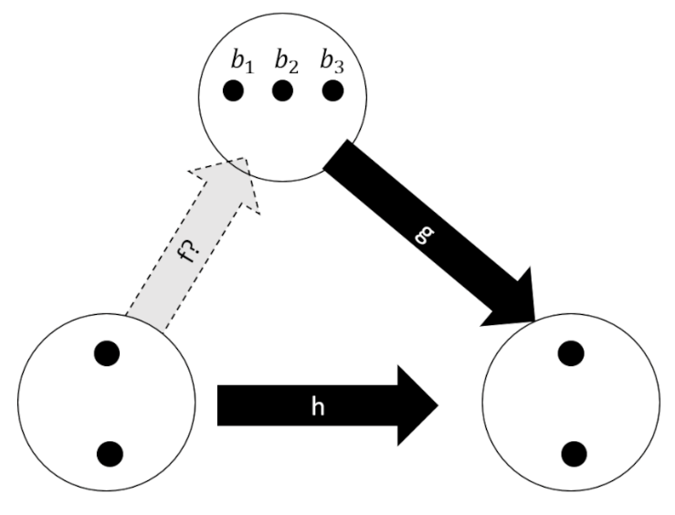
Since we are interested in automorphisms as a special case of the 4 possible mappings from [latex display=inline]A[/latex] to [latex display=inline]C[/latex] we can substantially decrease the tedium of working through all the possible combinatorics. In this special case, a solution to the choice problem is called a section and is usually denoted as [latex display=inline]s[/latex].
Despite this simplification, there are still nine possible mappings into [latex display=inline]B[/latex] and eight possible mappings from it (for a total of 72 possibilities). Fortunately, our job will get even easier after we examine the following diagram which focuses on one specific mapping from [latex display=inline]B[/latex].
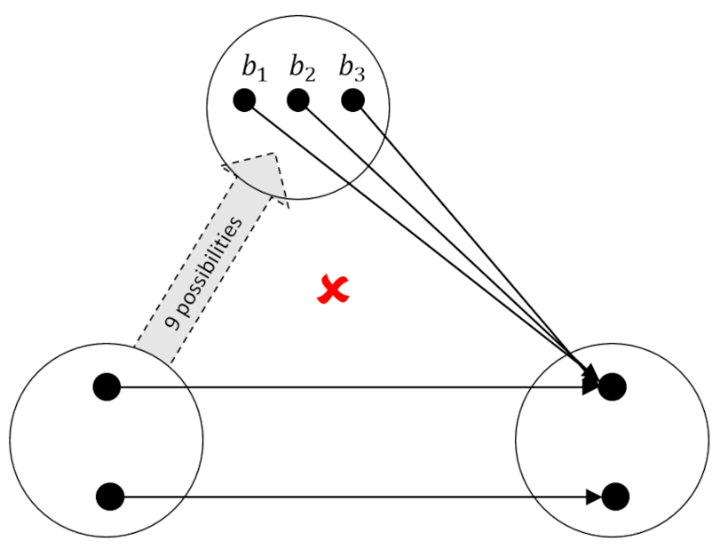
Of the nine possibilities that map the 2-element set (call it [latex display=inline]A[/latex] or [latex display=inline]C[/latex] as you wish) to [latex display=inline]B[/latex] none of them work because each element of [latex display=inline]B[/latex] aims at the same element in [latex display=inline]A[/latex]. The remedy is to make sure that mapping [latex display=inline]g[/latex] sends at least one arrow to each element in [latex display=inline]C[/latex] - that is that [latex display=inline]h[/latex] is surjective.
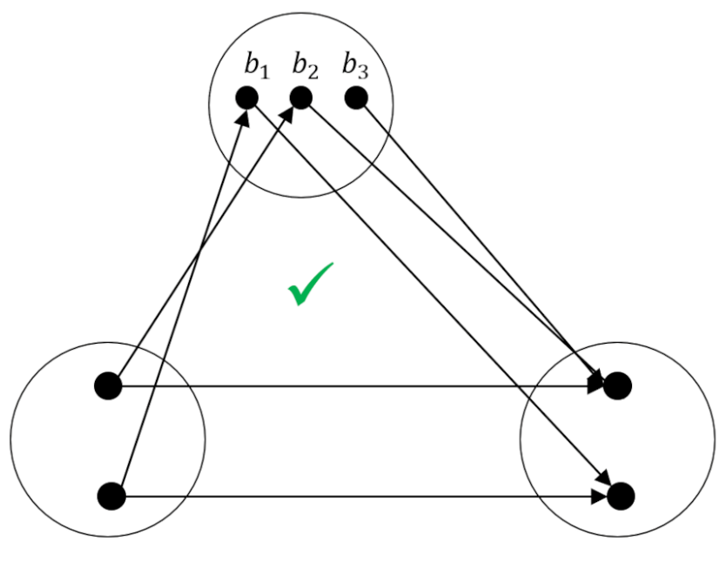
It doesn’t matter exactly how the rest of the mapping is specified (for example [latex display=inline]b_3[/latex] could point to the other element). The key feature is simply that all elements in [latex display=inline]A[/latex] are covered with at least on arrow head.
These two special cases are summarized quite nicely in the following diagram (adapted from the one on page 73 of Lawvere and Schanuel).
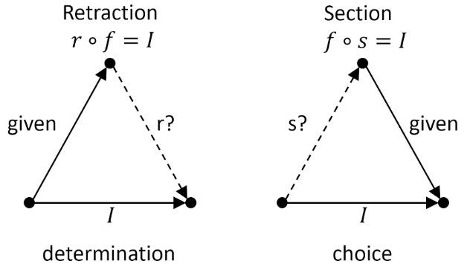
Next month, we’ll explore how to relate retractions and sections of a given map [latex display=inline]f[/latex] to a variety of ‘division problems’ in the category of finite sets and will we’ll explore a new insight into inverse mappings [latex display=inline]f^{-1}[/latex] that they provide.

