Category Theory 5 – Retractions, Sections, and a New Definition for Inverse
With a clearer picture of determination and choice established in the last post, we now turn to refining the picture of the ‘division problem’ within the category of sets. The basic mechanic in both of these problems is trying to find the missing side of the triangle where the base is the direct mapping [latex display=inline]h: A \rightarrow C[/latex] and the two sides are the mappings [latex display=inline]f:A \rightarrow B[/latex] and [latex display=inline]g:B \rightarrow C[/latex] composed together, with the set [latex display=inline]B[/latex] acting as a waypoint. The only difference is between the two problems is which of the two sides is considered given and which is being solved for. In other words, the idea is to ‘divide’ both sides by [latex display=inline]f[/latex] to solve [latex display=inline]f \circ g? = h[/latex], in the determination case, or to ‘divide’ both sides by [latex display=inline]g[/latex] to solve [latex display=inline]f? \circ g = h[/latex] in the choice case, knowing full well that in certain circumstances an answer simply does not exist.
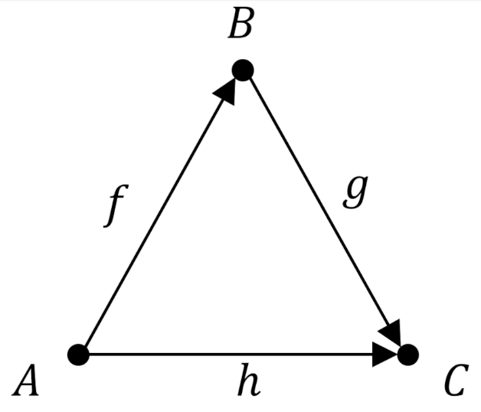
Lawvere and Schanuel, without explicitly saying clearly why in words, pay particular attention to a smaller subset of the determination and choice problems in which base of the triangle is an automorphism [latex display=inline]I_A: A \rightarrow A[/latex]. In this special case, the solutions to the determination and choice problems take the special name retractions and sections, respectively.
The two mathematical relationships that summarize these special cases are [latex display=inline] r \circ f = I[/latex] and [latex display=inline]f \circ s = I[/latex] and where [latex display=inline]f[/latex] is the given mapping in whichever of the two problems is being considered (although, to be clear, [latex display=inline]f[/latex] will sometimes be called [latex display=inline]g[/latex] when it is the second leg of the composition and the context is clearer to do so).
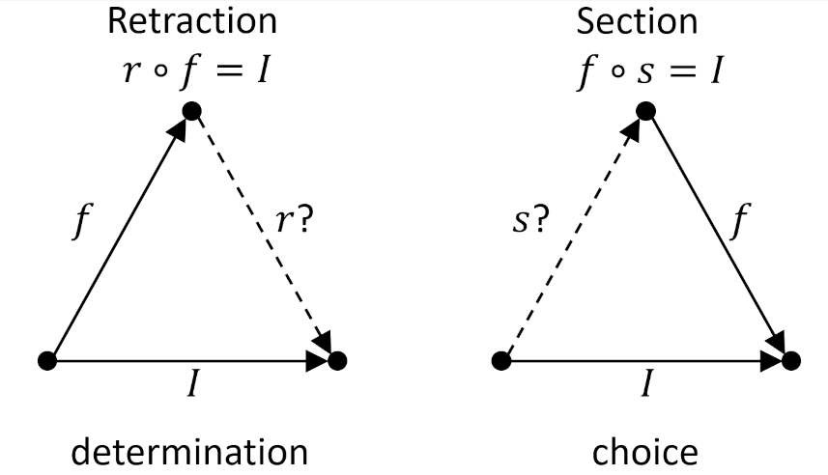
Of course, no matter which leg of the waypoint is specified as [latex display=inline]f[/latex], once a solution is found, both sides enter a dual relationship with the other and it then becomes a matter of taste as to which is the retraction and which is the section. Thus, [latex display=inline]f[/latex] can be regarded as the section to the retraction [latex display=inline]r[/latex] in the determination case and as the retraction to the section [latex display=inline]s[/latex] in the choice case. The following diagram illustrates this duality for a particular set of mappings between a two-element set (the label [latex display=inline]A[/latex] being suppressed for clarity) and the three-element set [latex display=inline]B[/latex].
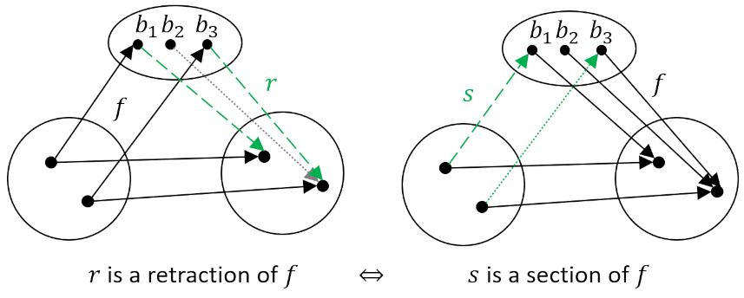
The green lines correspond to the specific components of the mapping being solved for. The dotted lines correspond to arrows that could be chosen differently (e.g. [latex display=inline]b_2[/latex] could point to either element in [latex display=inline]A[/latex]).
Once a section or a retraction have been found, other, more general ‘division’ problems can be solved. In some sense, a retraction or a section are the primitives that unlock these problems.
The first of these general cases is built upon the retraction problem, where the mapping [latex display=inline]y[/latex], which goes from [latex display=inline]A[/latex] to a new set [latex display=inline]T[/latex], is given and the question is whether there exists a mapping [latex display=inline]x[/latex] from [latex display=inline]B[/latex] to [latex display=inline]T[/latex]. The ‘division problem’ we are trying to solve is defined by
[latex]x \circ f = y \; . [/latex]
The triangle portion of problem is summarized on the left where the ‘circular arrow’ connecting [latex display=inline]A[/latex] to [latex display=inline]A[/latex] is meant to remind us of the automorphism.
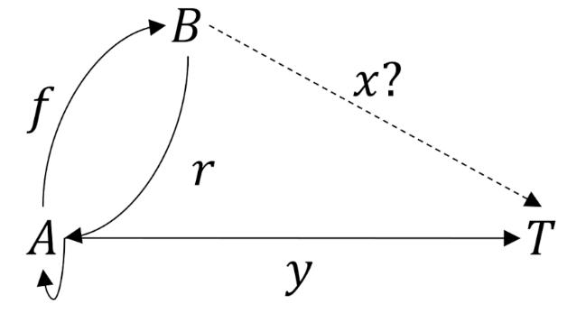
Lawvere and Schanuel point out that this problem always has a solution when [latex display=inline]x \equiv y \circ r[/latex], since
[latex] x \circ f = (y \circ r ) \circ f = y \circ ( r \circ f ) = y \circ I_A = y \; . [/latex]
A specific instance of this, for the two- and three-element sets above, is given by the following diagram,
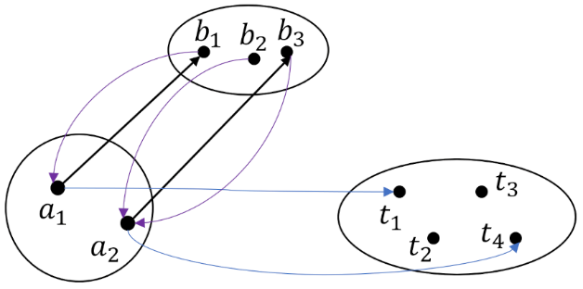

where the components of [latex display=inline]y[/latex] are the blue arrows, and the black and purple arrows are the original [latex display=inline]f[/latex] and [latex display=inline]r[/latex] dual pair of the retraction problem, respectively. The action of the retraction [latex display=inline]r[/latex] is to bring an element of [latex display=inline]B[/latex] back to [latex display=inline]A[/latex] where it can use the mapping [latex display=inline]y[/latex] to have access to the set [latex display=inline]T[/latex]. The specific pieces of [latex display=inline]x[/latex] are:
[latex]x(b_1) = (y \circ r) (b_1) = y (a_1) = t_1 \; , [/latex]
[latex]x(b_2) = (y \circ r) (b_2) = y (a_2) = t_4 \; , [/latex]
and
[latex]x(b_3) = (y \circ r) (b_3) = y (a_2) = t_4 \; . [/latex]
In analogous way, the other, general cases is built upon the section problem, where the mapping [latex display=inline]y[/latex], which goes from a new set [latex display=inline]T[/latex] to [latex display=inline]A[/latex], is given and the question is whether there exists a mapping [latex display=inline]x[/latex] from [latex display=inline]T[/latex] to [latex display=inline]B[/latex]. The ‘division problem’ we are now trying to solve is defined by
[latex] f \circ x = y \; . [/latex]
The triangle portion of problem is now summarized on the right where, again, the ‘circular arrow’ connecting [latex display=inline]A[/latex] to [latex display=inline]A[/latex] is meant to remind us of the automorphism.
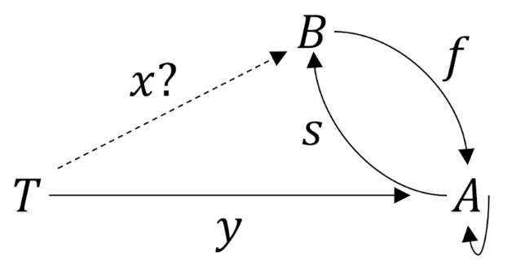
This problem always has a solution when [latex display=inline]x \equiv s \circ y[/latex], since
[latex] f \circ x = f \circ ( s \circ y ) = ( f \circ s ) \circ y = I_A \circ y = y \; . [/latex]
A specific instance of the section problem, again for the two- and three-element sets above, is given by the following diagram,
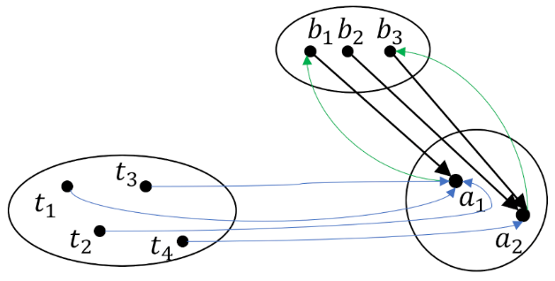

where the components of [latex display=inline]y[/latex] are still the blue arrows, and the black and green arrows are the original [latex display=inline]f[/latex] and [latex display=inline]s[/latex] dual pair of the section problem, respectively. The action of the section is to connect the action of the mapping [latex display=inline]y: T \rightarrow [/latex] to the set [latex display=inline]B[/latex] thereby putting each element of [latex display=inline]T[/latex] into the appropriate correspondence with elements in set [latex display=inline]B[/latex]. The specific pieces of [latex display=inline]x[/latex] are:
[latex]x(t_1) = (s \circ y) (t_1) = s (a_1) = b_1 \; , [/latex]
[latex]x(t_2) = (s \circ y) (t_2) = s (a_1) = b_1 \; , [/latex]
[latex]x(t_3) = (s \circ y) (t_3) = s (a_1) = b_1 \; , [/latex]
and
[latex]x(t_4) = (s \circ y) (t_4) = s (a_2) = b_3 \; . [/latex]
One final note about the retraction and section problems. By making the base mapping of the triangle problem an automorphism, we are forces to supply additional requirements not imposed in the more general case. As was seen in the last post, an essential ingredient is that the left-side mapping from [latex display=inline]A[/latex] to [latex display=inline]B[/latex] be injective and the right-side mapping from [latex display=inline]B[/latex] to [latex display=inline]A[/latex] be surjective. It is instructive to look at how the number of retractions vary with size of the waypoint set [latex display=inline]B[/latex]. The following diagram illustrates the retraction problem for the three cases with either one fewer, the same number of, or one more elements in [latex display=inline]B[/latex] than in [latex display=inline]A[/latex] (where [latex display=inline]f[/latex] and [latex display=inline]g[/latex] are used to specify the left- and right-side of the triangle).
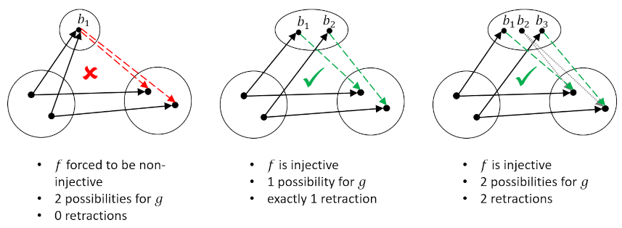
Likewise, the following diagram illustrates how the number of sections vary through the same progression in the set [latex display=inline]B[/latex].
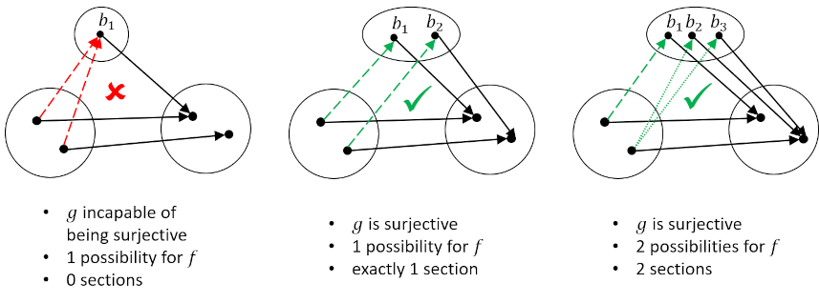
In both cases, there is a sense that the size of [latex display=inline]B[/latex] (i.e. the number of the elements) is central to whether or not the problem has a solution and, if so, how many solutions exist. This observation leads to two conclusions.
First, the definition of an inverse mapping, which was originally specified by the two conditions [latex display=inline] g \circ f = I_A[/latex] and [latex display=inline]f \circ g = I_B[/latex] (see this post for details), can now be recast as:
< A map [latex display=inline]f:A \rightarrow B[/latex] is an isomorphism if there exists a unique inverse map [latex display=inline]f^{-1}[/latex] which is both a retraction and a section for [latex display=inline]f[/latex] such that [latex display=inline] f \circ f^{-1} = I_B[/latex] and [latex display=inline]f^{-1} \circ f = I_A [/latex].>
Since the inverse must be both injective and surjective (since it is both a retraction and a section), we arrive at the familiar result that an inverse must be bijective.
Second, one may wonder why all this machinery is needed to arrive at a result already familiar to mathematics centuries earlier. According to Lawver and Schanuel, all this hard work will pay off when tackling categories where the objects are promoted from simple finite sets to richer sorts. In particular, infinite sets and dynamical systems are cited but the jury is still out in this exploration as to whether their argument will ultimately be convincing.

