A Look at Finance - Part 1: New Years Resolution
As we all know, people tend to make resolutions for the New Year. Whether they keep them or not is a different matter, but the rage is to make resolutions. For a change, I thought I would join the trend and make a resolution concerning this column but making it a resolution that is relatively easy to keep, although it marks a significant departure from years past. I’ve decided that it might be both fun and profitable to focus on a single book associated with money and related matters for the foreseeable future.
The book I’ve chosen is Finance: A Quantitative Introduction by Nico van der Wijst

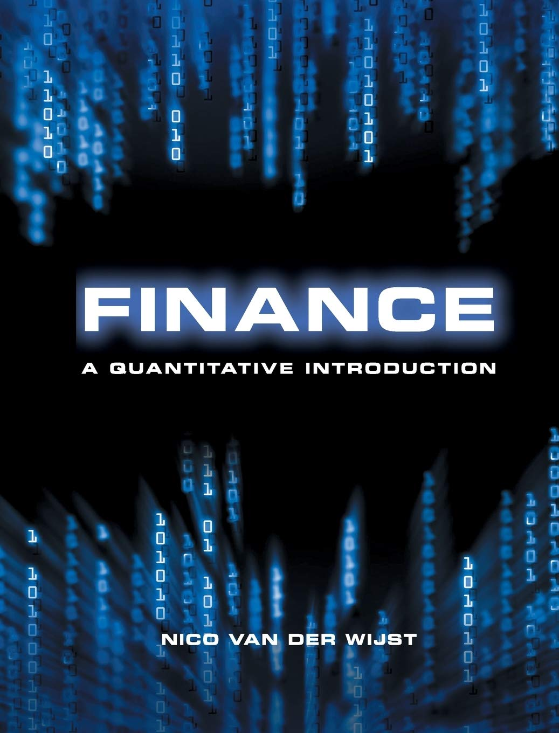
mostly because he promises a course offering a “quantitative approach that is particularly well suited to students with backgrounds in engineering and the natural sciences”, which is encouraging for someone like me with a background in physics.
My plan is to cover a chapter a month for the entirety of 2026 (perhaps this resolution will crumble as so many others do but I’ll try) starting this month with his overview in the Preface and Chapter 1. Along the way, I might also throw in a dash of ideas and concepts from other works but how much, how often, and if at all remains to be seen.
van der Wijst starts his ‘hook’ with two enticing statements. The first, aimed at anyone in the world with any sort of economic sense is the most surprising (and perhaps alarming):
“Today, the worldwide trade in derivative securities represents a much larger money amount than the global production of goods and services”
Although his book was written over a decade ago, it is a matter of a few well engineered prompts to get a rough estimate (probably good to 10-20%) of the dollar values involved in 2025. The gross world product is estimated at $117 trillion dollars, with about 25% of that total coming from the United States and another 25% coming from Europe. In contrast, the total nominal or face value of all derivative contracts is estimated at about $850 trillion dollars or about a factor of 7 larger. Of course, various sources go out of their way to point out that this value is a measure of all contracts, both positive and negative, and doesn’t represent the actual capital at risk. A more ‘modest’ value comes from the gross market value of $22 trillion, which is a value just 20% lower than the GDP production of goods and services from the US or Europe. So, even if van der Wijst is not quite right about the economic size, $22 trillion dollars is nothing to sneeze at.
Second, van der Wijst promises that the STEM professional will gain a better understanding of how project managers and business professionals arrive at funding decisions for all sorts of activities such as engineering design, manufacturing, and deployment. His stated main emphasis is on “investments in real assets and the real options attached to them.
The main ingredients for this enhanced understanding of decision making for investments are:
- Portfolio Theory
- Pricing Models (e.g. Black-Scholes)
- Market Efficiency
- Capital Structure
- Derivative Pricing
Each of these ingredients builds a coherent picture aimed at one goal: how people choose between uncertain future values. The ideas centering around how allocation of resources is made in the face of scarcity and various possible alternative uses of those scarce resources.
van der Wijst lists some typical problems:
**
- Should company X invest in project A or not?
- How should we combine stocks and risk-free borrowing or lending in out investment portfolio?
- What is the best way to finance project C?
- How can we price or eliminate (hedge) certain risks?
- What is the value of flexibility in investment projects?
**
Each of these, so the promise goes, should be amenable to rational decision making assuming a correct valuation of the choices and the probabilities for future outcomes. van der Wijst argues that these are just the ingredients that make finance a science on par with physics or chemistry as its practitioners make theoretical models and test their predictions against observed outcomes but he makes some allowances for it being different in certain details. For example, since we can’t run the world economy as a controlled experiment with hundreds or thousands of copies, each differing in only one precise way he argues that finance is different from the natural sciences that “usually show little dispersion around their theoretically predicted values.” Here I believe he is indulging in a hasty generalization drawn from some well-publicized successes in physics and chemistry but his point is still valid: finance as a science is built on looser foundations than the natural sciences but, being quantitative, it is tighter than social sciences.
Since the central theme of finance involves choices between uncertain future values the two main problems then become: 1) valuation of each choice and 2) determining the probability that a given choice may be realized.
Valuation is particularly tricky because the value of a good or service is not the amount of money exchanged at the time of the latest transaction. As has been pointed out in this column on a number of occasions, value is in the eye of the beholder. However, for the sake of argument, let’s assume that the value of the asset is amount of money used in the last transaction for it. That value is attached to a time in the past and the notion of choice implies a decision to be made in the future. So, we are faced with the problem of moving a valuation forward in time (for an asset already delivered) or backward in time (for a promised asset). The process for doing this time-movement of money is compounding (forward in time) or discounting (backward in time) and it assumes we have some idea about interest rates.
Finally, as Yogi Berra is attributed as saying “It's tough to make predictions, especially about the future”. Any idea of a choice must be informed, either qualitatively or quantitatively, with a notion about how likely it is that that choice will turn out favorably. Thus, both quantitative tools are need to price an asset in the future and to assign a probability to its realization.
As a prime example, van der Wijst points to techniques such as the Black-Scholes options pricing model that, while not perfect by any means, gives a way to value a given choice based on three ingredient: 1) ‘greedy’ investors, 2) a constant interest rate and level of stock market volatility, and 3) so-called frictionless markets. Using these assumptions, markets worldwide price options contracts (for good or bad) and, ostensibly, this powers the modern, globalized economy. There are, of course, other pricing models, such as CAPM and APT but his overall point remains that finance is a science.
In the months to come, I’ll use van der Wijst’s text as a guide to this science and we’ll see where we land.

