Medicare for None
Representative Kamela Harris recently tossed her hat into the ring as a contender for the Democratic Party’s nomination for president in the 2020 election. The one plank in her platform that has stirred the most discussion is Harris’s bid to institute a single-payer health care system for every American, called Medicare For All.
Her reasons for this, in her own words are:
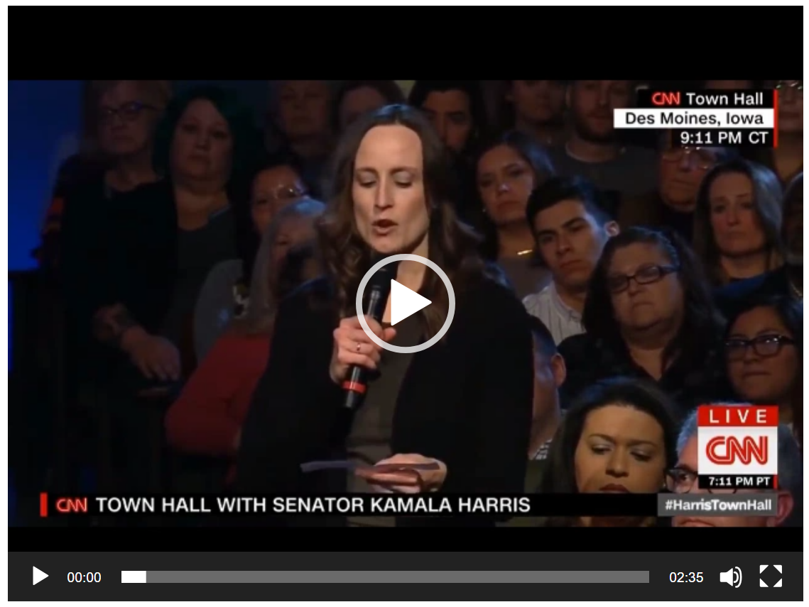
<clip from CNN>
In her conception of health care access, Medicare for All would eliminate all existing private insurance companies. As the end of the clip shows, when asked about their fate, Representative Harris simply say “Let’s eliminate all of that.”
Now there are obvious political ramifications for such a single-payer proposal. Doctors and the health systems they work with and for have powerful lobbyists. Insurance companies also have a great deal of influence in politics given their financial holdings and their presence in every state. And whether such a plan would be popular with a majority of voters has yet to be tested. But let’s leave that all behind and simply ask what economic factors exist that support Harris’s assertions and what factors refute it.

Health Care Price and Supply
One of the cornerstone ideas in economics is the law of supply and demand that dictates that the price goes down when the supply is higher than demand. The primary way to encourage an ample supply is to allow the suppliers to reap a profit when they persuade a consumer to buy their offering. Ideally, we would want more health care professionals to enter into the market than is strictly necessary by statistics alone. These individuals would compete fiercely with each other driving the price down and forcing less-competent professionals out of the market place, in the process making way for more-competent ones to enter. Less expensive health care would go a long way to addressing her complaint that “[H]aving a system that makes a difference in terms of who receives what based on your income is unconscionable.”
Currently, competition in the health care arena is blunted primarily by two factors.
First, by government regulation, insurance companies only compete amongst themselves within specific states. No buying of insurance across state lines is permitted. For example, the ugly battle between UPMC and Highmark only takes place within western Pennsylvania with neighboring states being completely ignorant. UPMC mostly furnishes health care through its networks of hospitals. Highmark is the largest insurer in Pennsylvania. While their battle is fierce, it is between payor and payee with neither having strong competition in their own sphere. As a result, the western PA consumer gets to watch two behemoths smack each other around, wasting resources that could be better put to use. How much better behaved would these institutions be if there were credible health care providers and insurers who could swoop in while UPMC and Highmark were distracted with their little war?
Second, since the primary mechanism by which most of us get our health care coverage is through our employment, competition is further limited to the number of choices provided by people (i.e. employers) who aren’t directly consuming the product.
Under Harris’s plan for a single-payer system, competition would be erased rather than enhanced. With the elimination of private insurance would also go any incentive for the provider, in this case the Federal Government, to lower costs. Without competition, the average bureaucrat will have little reason to push for a higher efficiency and almost no motivation to put patient/customer first. For the health care practitioner, the situation could go one of two ways. Either the government will attempt to fix prices in order to address cost or it subsidize the activity, thus the pervasive government regulations will likely discourage people the really good people from becoming doctors and nurses while encouraging substandard ones to become part of what, for them, would be a lucrative payday.
Having the majority of Americans secure their health coverage through their workplace, a vestigial practice left over from the wage-controlled years during World War II, also blunts our ability to engage in the marketplace and this lack of market knowledge leads to higher prices and lower quality. By having our employer provide health care coverage as a ‘benefit’ we lose sight of the cost we incur (lowered wages) and, therefore, we have less motivation to push back on the market. As a previous blog discussed, each of us is a far savvier consumer of car repair than human repair. Our knowledge of the mechanic market not only allows us to usually figure out when we are being scammed but also places a strong pressure on repair shops to be reputable. Most of us develop and groom this knowledge because we directly bear the cost. But because we often don’t perceive the cost for employer-supplied coverage, we know far less about the business side of medicine. As a result, we have no sense of quality or proper cost and so doctors and insurers have no pressure to provide higher quality.
Under Harris’s plan, we would become even further removed from the marketplace. At least when we receive health care coverage through our employers we can always quit and go somewhere else with better benefits. Once the government is the only game in town, how do we go somewhere else for benefits?
There are plenty of stories of how single payer systems drop the ball on quality. Well-documented problems in the Veterans Administration, Britain’s National Health System, and a particularly gut-wrenching piece on Canadian care (video except following – click here for Steven Crowder’s full video) abound.

<clip from Crowder>
Closely associated with quality facet is the timely receiving of health services. With a profit motive driving delivery, markets are incentivized to deliver high quality in as speedy a fashion as possible. After all, the higher the throughput the greater the profit (and for those worried about the lowering of quality in order to increase speed refer to the discussion of market knowledge you just read). Under a single-payer government system, no one is incentivized to do anything rapidly. No additional profit flows for timely action.
Having just criticized a single-payer Medicare-for-all solution, the reader may be asking if I am defending our current system. The answer, in a word is no. Our current system delivers excellent care but for too high a price. To get costs in line with benefits, I would recommend four things
- Eliminate tax incentives for businesses to offer health care coverage as a ‘benefit’. Each person should purchase their own insurance as they do for home, car, or property. By having ‘skin in the game’ each of us would become more market aware.
- Eliminate barriers that prevent insurers from competing with each other nationwide as is done for home, car, and property.
- Significantly curtail the AMA’s ability to shield a health care professional’s reputation. I don’t care if a doctor spent years in school, he needs to deliver in the here and now. Education of the public on the shortcomings of licensing would also help here.
- Significantly curtail tortious suites against health care professionals. Society doesn’t need to punish a doctor with punitive damages yet allow him to continue to practice. Damage to his reputation will rid him from the market with far less human cost than the system we engage in now.
To close, I appreciate the human cost that Harris spoke passionately about and her desire to see that everybody, regardless of station, receives timely, quality health care. I share those traits with her – and that is why I am against Medicare-for-all.

http://content.time.com/time/health/article/0,8599,1916570,00.html

