An American Pastime Past its Prime
Football (the American not metric variety for my international readers) is deeply engrained in the United States. Each weekend during the fall, millions of viewers tune into watch the televised matches between college rivals on Saturdays. And the National Football League (NFL), which organizes the most popular men’s professional sport in the US, rules most Sundays from late August to early February and inspires conversation and controversy (and commands a lighter viewership) during the intervening week.
The NFL has been so dominant for so long, that it may be hard to believe (or recall if you are old enough) that once professional baseball was the preeminent spectator sport in this country with football coming in a distant second.

Steeped in its own brand of mythology, Major League Baseball’s (MLB) storied past formed the stuff of legend. Within its history, one could find heroic and inspiring tales of triumph by figures like Babe Ruth, Lou Gehrig, Jackie Robinson, and Roberto Clemente. One could also find tragic tales of failure as in the 1919 Black Sox scandal and Pete Rose’s fall from grace.
Baseball was so pervasively woven into the fabric of American life that its players and their personal lives often spilled out of the field and into every other facet of American life. Joe DiMaggio, one of the famous New York Yankees from the WWII era, became even more famous for his much-discussed but brief marriage to Marilyn Monroe and was immortalized in the song lyrics of Mrs. Robinson. Numerous war movies showed soldiers who were behind enemy lines proving the their bona fides by answering some obscure baseball question that only a genuine ‘yank’ would know. An excellent example of just how deeply engrained baseball is the following clip from the TV show M.A.S.H., which aired in 1980.
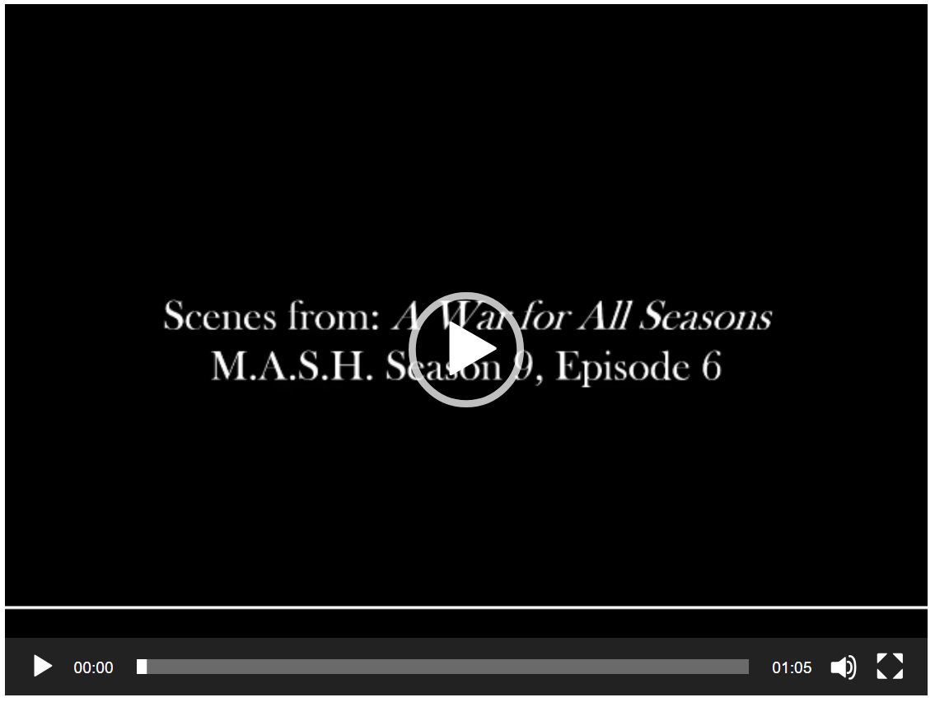
Despite its unrivalled dominance for over 100 years, by 1985 (the first year viewer preferences were polled) ESPN reports that the NFL had beaten MLB 24 to 23 percent. The same article cites that 30 years later, the gap had widened to 21 points with 35 percent of all fans citing the NFL as their favorite compared to only 14 percent who had the MLB at the top of their list.
The economics behind how “America’s Pastime” became past its prime and what MLB is trying to do to improve its standings is fascinating. It provides glimpses into how labor disputes can disrupt product delivery to the detriment of both management and labor, how complacent businesses can squander the good will of their customer base, and the role of marketing and advertising.
The place to start our analysis is with emergence of the modern era of collective bargaining between the players (labor) and the owners (management). According to Sean Lahman’s A Brief History of Baseball, this era of baseball labor relations began in 1965 when the Major League Baseball Players Association (MLBPA) hired Marvin Miller. Miller, who had been member of the United Steelworkers union for years prior, began his tenure by collecting statistics on player salaries. By the time he stepped down the modern era of free agency in sports labor had emerged.
Along the way, Miller oversaw the first collective bargaining agreement (CBA) in 1968, he . He also and He ended his t but it ended with the breaking up
Along the way Miller secured the first collective bargaining agreement (CBA) between the players and management in 1968, helped in 1974 to undermine the reserve clause that limited the ability of players to negotiate contracts with other teams, and broke up the the network of “gentleman’s agreements” that owners employed to keep a lid on player’s costs. Miller also organized a variety of labor walkouts including a 13-day one in 1972 and a 50-day strike in 1981.
While undoubtably beneficial for players salaries and freedom, the general public was sometimes hostile to what was seen as attempts by players to ruin the game for the fans. As the animosity grew between labor and management so too did the level of action each took against the other. The escalation culminated in the 1994-95 baseball strike that cancelled the 1994 World Series and did major damage to baseball’s popularity.
Baseball managed to recover some in the latter half of the 1990s and the early 2000s with the home run drama surrounding the players such as Mark McGwire, Sammy Sosa, and Barry Bonds. But revelations that much of the hitting success during this time was allegedly fueled by steroid use further damaged baseball’s reputation. The owners, hungry for a quick fix to the hangover caused by the labor-management squabbles of a generation prior, looked the other way only to have it blow up in their faces.
And so, we arrive at the current day. The modern game is filled with contract negotiations, mandatory drug tests, and long games, typically lasting over 4.5 hours. Matthew Corwin, in his article for Odyssey, believes this last problem to be the most serious. Baseball’s leisurely pace of 1930 does not mesh well with the hectic pace of the 21st century.
Baseball execs seem to agree. The new rule changes seem to center on speeding up the game by: 1) keeping pitchers in the game to face at minimum of three batters, 2) limiting who is allowed to pitch, and 3) shortening commercial breaks during innings.
This latter change is particularly interesting in that it may be showing tell-tale signs of lasting wisdom on the part of the owner and players alike. In the short run, limiting advertising time will limit ad revenue and profits on both sides. But, if shorter games led to an increase in the fan base, then both sides may actual come out ahead and that would be a real triumph of economic cooperation.
It is an encouraging sign of trust between two sides that have been all but mortal foes to decades. As to whether this new detente will last, we are still in early innings.

