Monopolies Part 1 - The Boeing Problem

By now the world is painfully aware of the shortcomings of the Boeing 737 MAX 8 aircraft. The Maneuvering Characteristics Augmentation System (MCAS) system, designed to prevent stalls on takeoff have caused numerous close calls and two catastrophic crashes with the loss of all passengers and crew onboard. The entire fleet sits idle on the ground while Boeing attempts to correct the flaws in the automation and provide a patch that will restore confidence in the plane. Several airlines have cancelled their orders and it will be years or even decades before Boeing has rebuilt and restored public trust in their products.

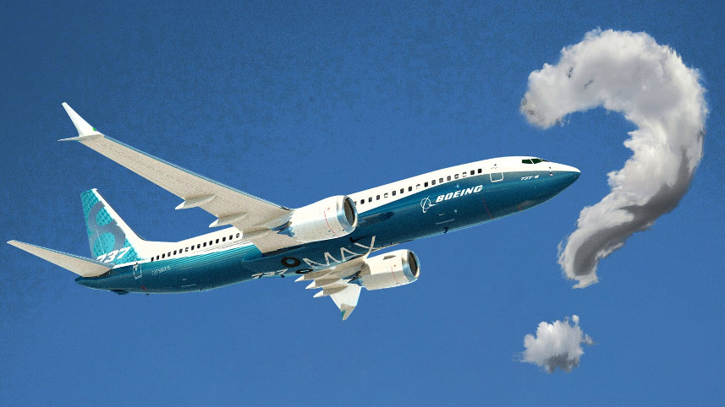

Gregory Travis covers the technical points in his highly understandable (albeit somewhat long) article entitled How the Boeing 737 Max Disaster Looks to a Software Developer (IEEE Spectrum). It is natural to want to understand how the design and manufacturing details contributed to these disasters and, indeed, stories digging into how the MCAS went wrong have riveted many people around the globe.

But as important as the technical details are to ferreting out the tangible safety aspects of the problem, they do not explain but merely point towards the managerial and business failings that caused Boeing to go so far astray. And there are more black clouds on the horizon for the corporate infrastructure of one of the US’s largest companies.

The Air Force has halted deliveries of Boeing’s KC-46 Pegasus tanker due to the presence of “foreign object debris” (FOD to those in the know) being found in close compartments throughout the aircraft. For those of us who don’t speak military jargon, FOD includes anything you should never see in a new plane ranging from an abandoned wrench left behind by a careless worker, to aluminum shavings that weren’t swept up after manufacturing, to wrappers from spent food items. As Air Force Secretary Heather Wilson characterized to the House Armed Services Committee the cause is due to “a manufacturing discipline issue, on the line ... and we saw a breakdown there.”

Boeing has misstepped in other areas (the 787 Dreamliner has had its share of problems) as well and the overall for outlook for the company was being openly questioned as it was getting ready to report its first quarter revenue. And indeed the questioning was quickly replaced by pessimism when Boeing announced its revenue had been adversely affected by the Max 8 issues, although it just as quickly rebounded. It also interesting to note that Boeing’s stock took a sharp climb during the year or two before the 737 Max 8 received FAA approval on March 8, 2017.

In any event, either through poor management or bad luck or some combination of both, the Boeing corporation is on shaky ground and numerous technical and safety questions abound for which the US government has a clear role to play (including some hard soul-searching as to whether the FAA was too chummy with Boeing). But this is not a technical blog and so the operative question here is what, if anything, should the US government do to economically support the company?

For most people, the knee-jerk reaction is that Boeing made its bed and it should lie in it. This type of question also conjures up resentment over the ‘too big to fail era’ that marked the Great Recession and the government’s intervention in the financial, housing, and automotive sectors. Ordinarily, I would agree. Living in a capitalist society, we should hope that any company (especially a company as large as Boeing) should be able to stand on its own two feet and live with the consequences of its actions. The market can vote to put its money behind another supplier and stock owners can make the appropriate response by voting directly at shareholder meetings or indirectly by selling stock.

Furthermore, for all intents and purposes, the commercial market for passenger airliners is a oligopoly consisting of only two players; a duopoly spanned by Boeing and Airbus. The two companies are protected behind one of the most formidable barriers to entry ever enjoyed by current or past industries. Modern aircraft are extremely complex mechanical, electrical, computational machines sporting a mix of modern materials. Building an airliner requires a huge knowledge base, large collections of capital, and intricate supply chains. In addition, there is an enormous compliance burden imposed by countries all around the world and only companies with deep pockets can afford to pay the host of lawyers, lobbyists, and compliance officers needed to keep various governments happy and out of the way.

To many, the fact that Boeing is essentially engaging in monopolistic practices is all the more reason to argue against government intervention on its behalf. Heartened by the observation that no monopolistic company is invulnerable to competition in the long run and that Boeing’s once seemingly unbreakable membership in the commercial aviation market is now showing substantial cracks, the same group may even think that now is the time to do some old fashioned trust busting wherein the government hastens Boeing’s fade.

But, those engaging in such an argument might do well to look past Boeing’s sins and consider what happens as it loses market share or even exits from commercial aircraft manufacturing completely. Articles such as Clive Irving’s piece in the the Daily Beast (Boeing’s Disaster Could Turn China Into Aviation Superpower) and ‘Your Loss my Gain!’ Airbus now reaping on Boeing crisis at Daily Active Kenya, gives us some clues by showing us how fast Airbus has moved to fill the order vacuum created when China cancelled its order for MAX 8s. And as Airbus’s dominance grows, the duopoly moves closer to a monopoly that, paradoxically, may mean even fewer planes in the sky than when both companies were swilling at the trough together.

Next month’s column will take a look at how monopolies work and how economists think about them and then will try to sort out whether or not it's in everybody's interest to help Boeing out.

Additional thoughts below -------------------------------------------------------------------------------------

There may be reasons afterall, reasons directed at protecting the various direct and indirect US consumers from being hurt , direct and indirect, from higher airfares and US airlines from tighter

Irving also conjectures that China may make its move into the commercial aircraft market and he goes on to say that they are likely to avoid the mistakes that have kept the Russians and Japanese out.

Okay, is it so bad if Airbus gains market share on Boeing, or if the world market transitions from a duopoly to a triopoly?

fill e.g. Clive Irvings So there may be economic reasons for the US to intervene and prop up Boeing as a means of protecting US airlines and ultimately the average flyer. Afterall, a collapse of Boeing (no matter how unlikely that may be) would impact the price and supply of airplanes. Additional considerations include

There also may be national security interests as well, given that the other member of the duopoly is French (and, as argued below, a possible new foreign member) but this concern is not really as important as the fact that any changes in the commercial airline market place may have adverse

is should Boeing’s bungling cause a shift is bad for the consumer . and Clive Irving believes he knows who can exploit these weaknesses. In his article entitled Irving argues that China might be able to push into the commercial airline market thereby succeeding where Russia and Japan have failed.
- Boeing’s missteps may allow China to push into the commercial airline market - good example of how monopolies/oligopolies can’t last forever
- In the next 20 years China is expected that will need at least 7400 new airplanes
- Laughable paragraph: Long before the grounding of the MAX-8, Airbus was clearly ahead of Boeing in China. Nearly a quarter of Airbus sales are in China, compared to 14 percent for Boeing.

