Monopolies Part 2 - The Real Harm of Monopolies

Last month’s post dealt with the disastrous rollout of the Boeing 737 MAX 8 aircraft. At the heart of the problem were a redesign of the basic jet propulsion system, flaws in the MCAS automation system, and a cutting of corners where safety was concerned, all of which resulted in numerous close calls and two crashes on takeoff that ended the lives of hundreds of people. It was argued in that post that the reason Boeing rushed the MAX 8 to market was the pressure they were experiencing from Airbus, the other member of the current commercial aircraft duopoly.

The conclusion of the preceding narrative, that Boeing’s presence in a duopoly made it vulnerable to market forces, may seem foreign and counterintuitive to anyone raised on the usual stream of fantasy stories about powerful businesses. Contrary to the laws of economics, monopolies/oligopolies are usually portrayed in movies as being nigh-omnipotent villains that require extraordinary heroism to overcome. Films, such as Rollerball, The Running Man, The Hunger Games, and Repo! The Genetic Opera reinforce the idea that a monopoly or oligopoly sit above the usuals laws of scarcity that govern the rest of our lives.

In reality, monopolistic and oligopolistic firms are subject by the same economic forces as the rest of us. The outcomes and particulars are, of course, different because of the firm’s position within the economy, but the idea that a monopolistic firm runs unchecked and roughshod over society, insinuating its tendrils into every nook and cranny of life are fantasies that serve as fodder on for the storyteller or the polemicist.

Surprisingly, the real societal ill that monopolies (for simplicity this post will only look, hereafter, at monopolies) represent is not their unmatched influence on society as much as their disengagement from society. The simple way to understand this seemingly up-ended position is to recognize that without competition to spur a firm forward, complacency takes hold and the resulting output is below what society demands.

A simple example of this is the typical department of motor vehicles (DMV). The DMV has an effective monopoly on the goods and services it provides but, as all of us who have had to endure a trip to renew a driver’s license can attest, the service is painfully slow, the processes Byzantine, and the outcomes uncertain. Its monopoly arises because it produces a unique good (official driver’s licenses) and there are high barriers to entry into the marketplace (here the barrier is law).

To see how a monopoly can underproduce compared to the socially optimal value, one must make a trip through a few graphs about supply, demand, revenue, and cost to construct a monopoly graph. The arguments here are inspired by a suite of educational YouTube videos, especially the Monopoly Graph Review and Practice-Micro 4.7 lecture by Jacob Clifford, who has a manic style that seems to have been honed by years of teaching high school students, with additional insights and examples taken from Principles of Economics: Economics and the Economy, Version 2.0 by Timothy Taylor.

The first ingredient is the typical graph of supply and demand curves showing the producer’s and consumer’s points-of-view in determining how much of a particular quantity to produce or consume as a function of price within a given market (say, for example, for televisions). Where they cross determines the equilibrium number of items produced, Q_{eq}, and the equilibrium price the market is willing to pay, P_{eq}.

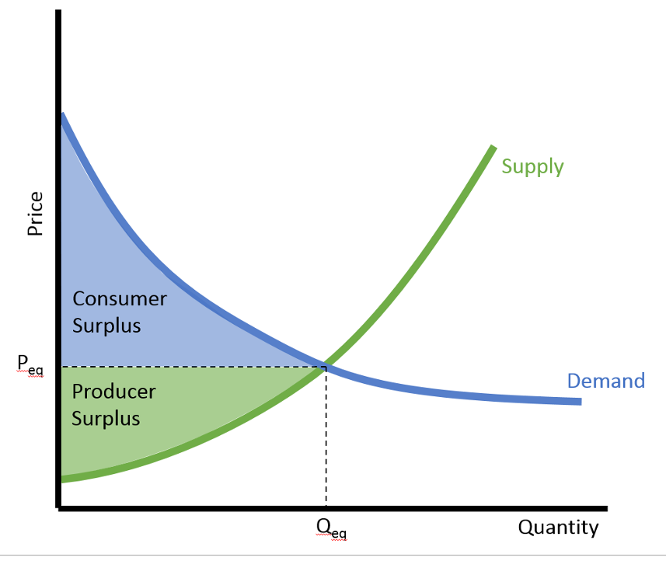

The shaded regions are perhaps less well known. The blue one represents the total consumer surplus defined as the total amount those consumers, who would have paid more, saved by having the market drive the price down to its equilibrium value. The green one represents the total producer surplus defined as the total profit those producers, who would have sold the item for less, earned by having the market drive the price up to its equilibrium value. In combination, these additional savings or earnings represent additional resources that can be put to use in other areas of the economy.

The next step involves understanding how an individual firm producing items within a given market fits into the market as a whole. Here the economist defines a spectrum of possibilities with perfect competition being on one extreme and monopoly on the other.

Within perfect competition, there are so many firms producing identical products (say oranges) that any individual firm is unable to cause the market as a whole to deviate far from P_{eq}. Such a firm is said to be a ‘price taker’ and it perceives its demand curve as being perfectly flat. This means that no matter how many products it places on the market each one will sell at the equilibrium price. In contrast, a monopolist perceives its demand curve to be identical to the demand within the market as a whole since it is the only provider. A monopoly is often called a ‘price maker’ since it can set its price but this should not imply that the monopoly is all powerful. It is bound by two constraints. First, it is unable to negotiate different prices for different customers (this is called price discrimination) since if it did, the customer receiving the lower price would then resale to the customer subjected to the higher price at an intermediate cost, thereby taking some of the profit away from the monopoly. Second, the monopoly can’t force people to buy their goods and so they must face the downward sloping demand curve of the market as a whole.

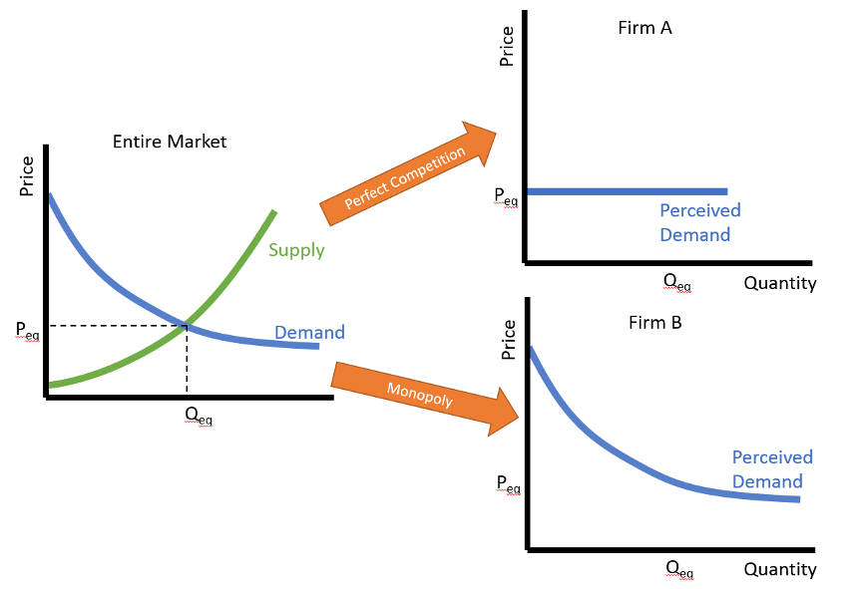

This fundamental difference in the shape of the perceived demand curve is the key to understanding why monopolies produce below the societal demand of the good. The only other ingredients are marginal cost and marginal revenue.

Both marginal cost and marginal return quantify the idiom ‘too much of a good thing’. Marginal cost/revenue measures the change in the cost/revenue for an increase in production by one unit. Functions as derivatives, the values of marginal cost and marginal revenue signal actions that a firm should take to optimize a variety of outcomes.

Based on the concepts of economies and diseconomies of scale, marginal cost will generally fall as production is scaled up from an initial size. At some point, though, the improvements that come with size taper off and additional structure becomes self-defeating. As a result, the expected shape for a marginal cost curve (MC) will be downward sloped for smaller quantities until it hit a minimum at which point it rises. Related to the marginal cost is the average total cost curve (ATC), which, as the name suggests, is the total cost divided by the quantity produced.

The marginal revenue curve (MR) is generally downward sloping with no minimum, reflecting the fact that it does no good to cut costs to attract new customers if the price changed is at or below the cost to produce the good. The zero of the MR reflects the breakeven point where the cost to produce a good equals the price it fetches.

The monopoly graph sports the perceived demand curve already discussed along with the MR, MC, and ATC curves.

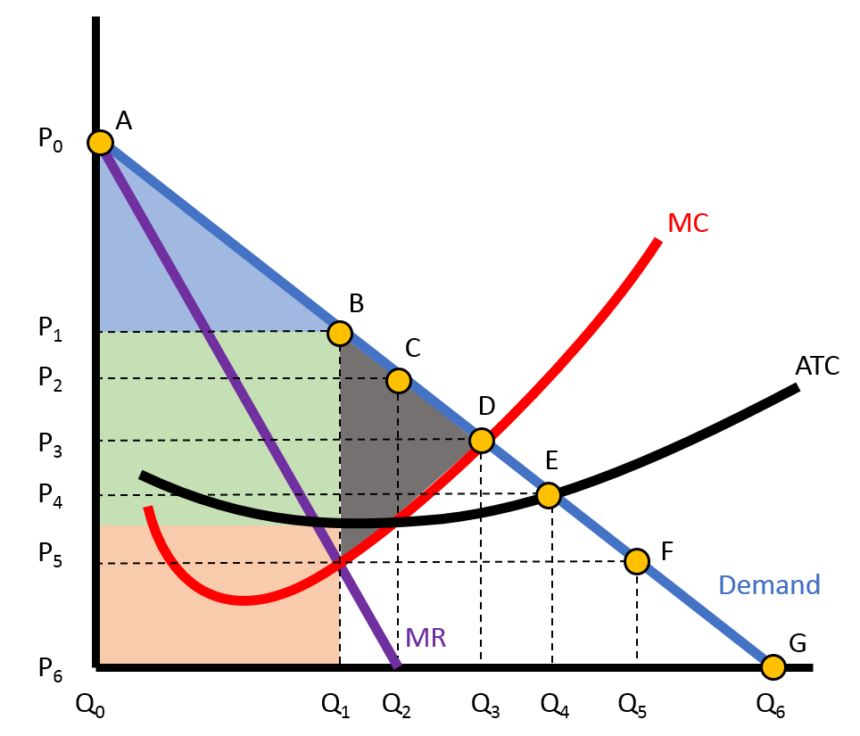

There is a lot to mine from this graph but we will content ourselves with seeing how a monopoly introduces inefficiency. The point where the MC and MR curves intersect determines the quantity (Q₁) that the monopoly should produce to maximize profit, since this means that the rate at which the revenue is decreasing exactly balance the rate at which the cost is increasing. The corresponding price (P₁) is determined where a vertical line from Q₁ intersects the demand curve (point B). Taken together, the shaded green and tan areas represent the total revenue (Q₁xP₁). The tan area has a height determined by where the vertical line from Q₁ intersects the ATC curve and it represents the total cost incurred to produce this quantity. The green area is then the profit.

Analogous to what was discussed above, the blue triangle is the consumer surplus that represents the money those willing to pay more than P1 saved. The gray triangle is a new feature of the monopoly’s presence in the market. It is called deadweight loss and it represents the lost efficiency that obtains because the monopoly produces away from the equilibrium value (Q₃). Paraphrasing Taylor, this loss of social surplus occurs because the monopolistic profit-maximizing pricing is blocking some demanders from making transactions they would be willing to make.

So there, in a nutshell, is the real reason why monopolies are to examined carefully and possibly regulated. Not because they are evil or world dominating or corrupt but because they are inefficient producers.

Next column will close out this discussion of monopolies by looking at the how monopolies form and some of the reasons why their production inefficiency might be tolerated.

