Writers' Drama

In a plot twist that clearly shows how life can imitate art, the behind-the-scenes makers of theatrical productions have now become the main characters in a real-world, economic drama. The cause of this unscripted bit of theater centers around the current strike by the Writers Guild of America (WGA) that began on May 2, 2023. One part melodrama, one part farce, this work stoppage came after the WGA failed to come to terms with the Alliance of Motion Picture and Television Producers (AMPTP), which represents over 350 studios and production companies in collective bargaining agreements with the various trade unions of the entertainment industry. And while the stakes of this particular drama are not particularly high – just a tangible threat to this fall’s TV lineup and a stagnation of new shows on the streaming service instead of the specter of world-shattering oblivion as is usually the case in a script – the tensions and competing points-of-view offer a compelling look at the laws of supply and demand, how technology changes and shapes the employment landscape, and ultimately, labor/management relations.
At the heart of the WGA’s complaint are three concessions they want from the AMPTP to address issues that have arisen from how streaming services, such as Hulu and Netflix, have negatively impacted the landscape for writers: a) steadier work, b) bigger residuals, and c) no AI-generated scripts. In order to appreciate the underlying economic impacts, we’ll have to introduce and then compare and contrast the two competing models for how television shows are produced: the network model and the streaming model. The description of these models that follows is based largely on Vox’s video How streaming caused the TV writers strike.
In the traditional network model, new shows or seasons premiere in the early fall and typically end in the late spring comprising about 22 shows distributed over 40 weeks of production, on average, a season (although there is a substantial spread around that average, especially as function of time). In the modern streaming model, services like Hulu and Netflix order a fixed number of shows typically 8 or 13 and air them (i.e., drop them) whenever they see fit for the benefit of the subscribers. Since television shows, regardless of content or venue, involve multiple, episodic stories linked within a common framework, the creative responsibilities are shared by a team who gathers, either in person or virtually, in what is called the writers’ room (although it is often called the development room in the formal legal documents).
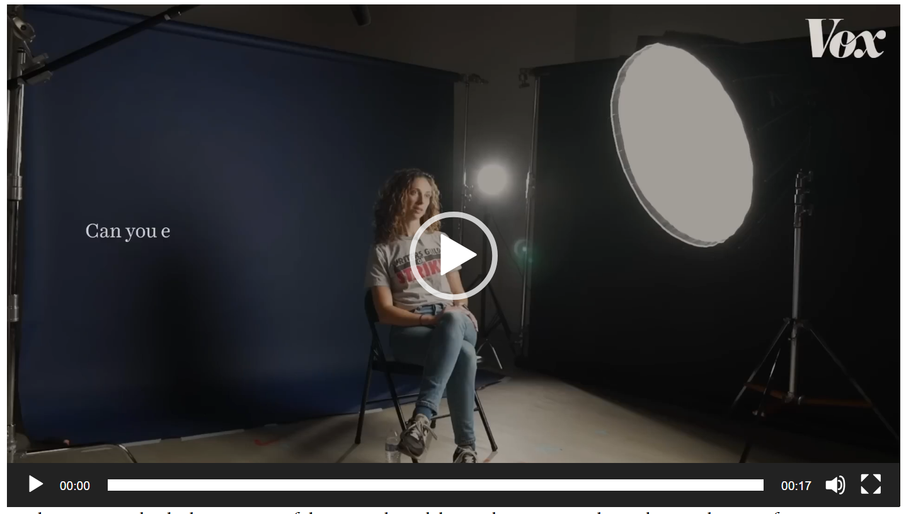
On the positive side, the larger scope of the network model provides writers with steadier employment for an entire year and, because the writing is done concurrently with filming and editing, this approach also offers ample opportunities to involve the writers in the production in addition to the conceptual stages. On the negative side, this model can only support about 80 shows given the bandwidth associated with broadcasting on one of the four major networks. In addition, writers are required to adapt their craft to the need to hold an audience during the commercial breaks (usually 5) during the course of the show.
In contrast, the positive side of the streaming model supports roughly 450 shows per year and generally allows writers far more creative control as there is no need for commercials as the audience bears the cost of the shows production through their purchase of a subscription plan. On the negative side, the size of the show order is much smaller and streamers generally want the scripts completed before production begins precluding the chance of writers to be involved in production.
The basic rate for a writer is the same regardless of under which model the writer performs his or her work. A reasonable floor value is roughly $5,000 per week as shown in the AMPTP’s formal response to the WGA’s claims.
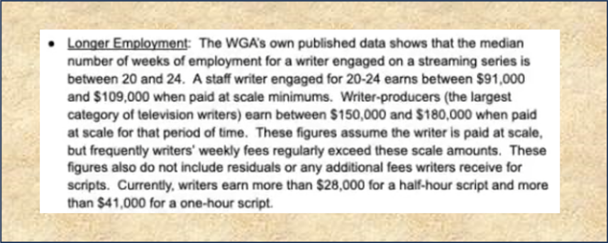The number of writers that might work on a show is tougher to gauge but 20 is a reasonable number and it is also reasonable to assume that a vast majority of writers work only one show at a time. With these facts in hand, we can do a little economic analysis.
 | Network Model | Streaming Model
Number of Shows | 80 | 420
Number of Writers per Show | 20 | 20
Number of weeks | 40 | 20
Total Number of Writers | 1,600 | 8,400
Total Cost of Capital (millions) | $320 | $840

It is important to recognize that these are estimated costs of capital which form a lower bound to what the studios actually pay to employ the 11,500 members of the WGA. The true costs are no doubt higher and will be likely higher still given the following proposed concession by the AMPTP.
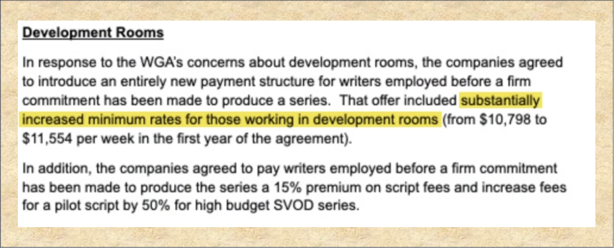
According to the Vox video, the growth in streaming has been over the last 15 years. During this same time period, the US population has grown by about 12%. Ignoring other considerations, such as inflation and the proliferation of alternative sources of entertainment (e.g., YouTube, videogames, etc.), the capital cost of writers over that same time period has increased by a factor of 3.6. This is the reason that the WGA finds itself at odds with AMPTP – there is a surplus of entertainment on the market. The situation is even more dire when one figures in the drop subscriber growth streaming services are suffering and the fact that network and cable viewership is dropping.
The WGA’s second demand only puts the squeeze on this situation even more. They are demanding higher residuals, which are basically additional income based on subsequent revenues obtained by the studio for additional viewings. Under the network model, the popularity of the show is known via the ratings system precisely because that information is used to set advertising rates. Under the streaming model, there is no incentive for a company such as Netflix to publish the number of times a show is watched and the linkage between a given show and a customer beginning or maintaining his subscription is tenuous at best. Nonetheless, the WGA has demanded concessions from the AMPTP for greater residuals to which the AMPTP issued the following response.
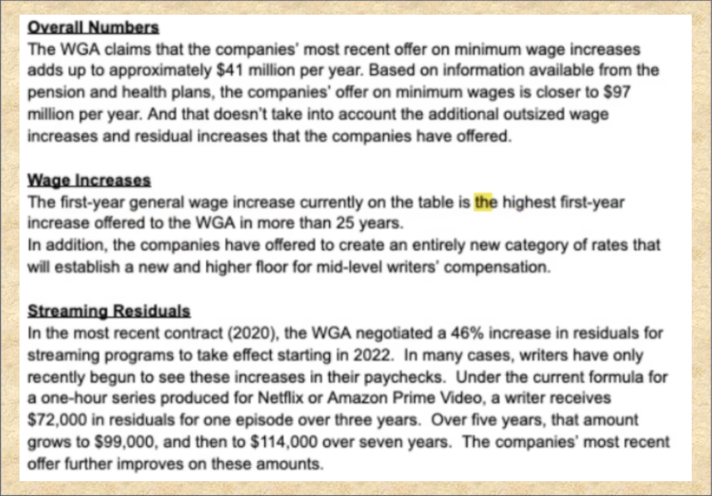
The third and final of the WGA’s point concerns the use of generative artificial intelligence to produce derivative scripts. The article 'Plagiarism machines': Hollywood writers and studios battle over the future of AI by Dawn Chmielewski and Lisa Richwine of Reuters, has a nice quote by screenwriter John August, who states the WGA position as stating the concerns as: "We don't want our material feeding them, and we also don't want to be fixing their sloppy first drafts."
The fact that the WGA made this concern a part of its bargaining is far more troublesome than it might seem at first glance since it clearly means the studios represented by the AMPTP don’t see the value in the writers that they see in themselves. Most likely the WGA thinks that the studios are greedy and that their executives want to enrich themselves at the expense of the ‘real talent’ but those very same executives recognize that they need good scripts to attract viewers; their very greed means that they value the one thing that make them money – stories that get eyes on screens. Sadly, these same executives don’t see a risky downside in replacing humans with machines and that should worry the WGA more than they are publicly letting on. Major story debacles, such as the widely panned end to the Game of Thrones series, no doubt have done little to get public opinion on their side and their own insensitivity in saying that they are impoverished when they only make $100,000/year in Los Angeles must fall on deaf ears in a county where the cost of living is one of the highest in the country and the median household income is just under $80,000/year. This strike is unlikely to end soon and the outcome is likely to be a tragedy for many of the nations writers.

