Wild, Weird West – Part 1
This post is the first installment of a three part series sampling some of the modern uses of the Wild, Weird West in comics.
Back in the nineties, when the Vertigo imprint was growing in popularity and influence, the creative team of Joe R. Lansdale, Timothy Thuman and Sam Glanzman crafted tales of the Old West laced with elements of horror and the supernatural, resulting in what I call tales of the Wild, Weird West. The protagonist of these tales was none other than that peculiar DC Comics anti-hero Jonah Hex.
The western-horror genre has long held a place in my heart since I first saw the Wild, Wild West episode “The Night of the Man-Eating House” in the mid-seventies. That episode specifically and the series as a whole impressed on me the utility of the western as a vehicle for storytelling. Later, TV episodes of the Night Gallery, namely “The Waiting Room” and “Dr. Stringfellow’s Rejuvenator”, solidified my belief that the usual morality play of the classic western could be amplified and made much more enjoyable, and deliciously creepy, by a judicious use of the supernatural.
At the time the first of these stories was slated to appear, the Vertigo imprint had already established a firm reputation for adult fantasy and/or horror with a strong bent towards the supernatural. Vertigo was tapping into the creative well from which came Swamp Thing, and Sandman, and the Watchmen (properly speaking, the Swamp Thing and Sandman titles only became Vertigo imprints well after they had started, and the Watchmen finished before Vertigo was conceived, but they all come from the same creative milieu), and the sky seemed the limit.
As a result, I was really excited about the prospects of these Jonah Hex series. Sadly, each of the mini-series, three of them in all, were a let-down.
All of the expected western tropes were used. Our leading man was paired with a small cast of supporting characters. Check! All of them are thrust into situations where their survival depends on nothing more than their courage, skill, and cunning. Check! The action takes place in some remote, isolated town emphasizing that the characters are not only on the frontiers of geography but on the frontiers of society as well, existing outside of the protection of the law and the structure of civilization, Check!
All of the expected supernatural horror tropes were also there. Evil, selfish fellows stealing bodies and re-animating them back to some semblance of life as zombies. Check! Strange monsters from under the sea or from underground come to menace the surface dwellers, steal their women, and produce twisted mockeries of human children. Check! Mysterious and unexplainable encounters with the spirit realm that leave a sense of wonder and fear. Check!
Somehow, to paraphrase The Producers, they picked the right setting, the right motifs, the right characters, and the right metaphors,…where did they go wrong? I’ve puzzled over that question off and on (mostly off) over the years since the various mini-series came out but never quite put my finger on it until fairly recently. In a few words, each of the series undercuts its own drama by being too flippant.
The first series, Jonah Hex: Two-Gun Mojo (1993), finds Hex mixed up with a freak show run by a snake-oil salesman and sideshow boss by the name of Doc “Cross” Williams. The twist here is that one of Doc’s snake-oils can actually bring the dead back to life as zombies under his control. Doc Williams, in a stroke of genius, has re-animated Wild Bill Hickok to be his enforcer. The imagery here is pretty cool with a particularly striking panel showing Hickok fighting the Apache on behalf of his twisted boss.
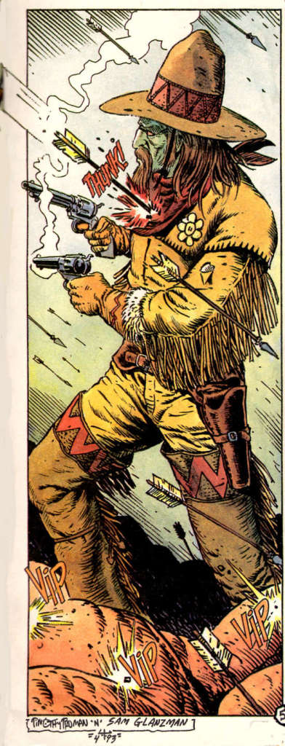

However, the success of this concept is blunted by an overly glib hand in other areas. For example, early on in the series Jonah kicks a chance companion called Slow Go Smith out of their room for snoring. Smith gets attacked by Cross’s zombies and is fatally shot. Here is the exchange as he lies dying
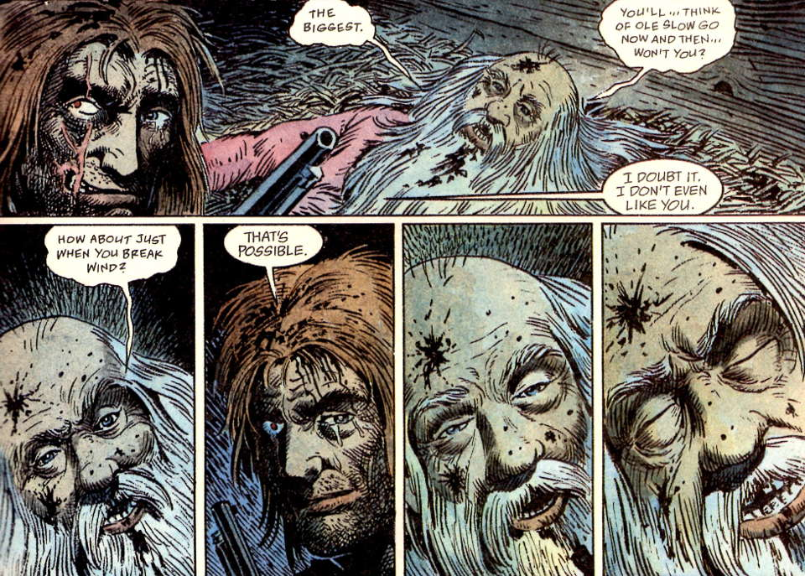
While I don’t expect hysterics and weeping from Hex, I do expect a quiet kind of outrage in keeping with his unique code of honor and justice. Instead I feel like I’m witnessing an improvised moment at a high school play. This kind of vulgar humor ebbs and flows through the five issues and each time it feels out of place.
The bar on vulgarity is raised even higher in the next series, Jonah Hex: Riders of the Worm and Such (1995). The basic premise here is that Hex falls in with a band of folks lead by an Englishman by the name of Graves. Graves runs the Wilde West Ranch and Music and Culture Emporium, an institution designed to bring beauty to the rugged, unsophisticated cowboys around him. He was inspired to this calling by witnessing a talk, and subsequent brawl, involving Oscar Wilde one night, several years earlier, in Austin, Texas. Graves’s plan to cast his pearls before swine would be going off without a hitch except for the unwelcome intrusion of worm-things from underground.
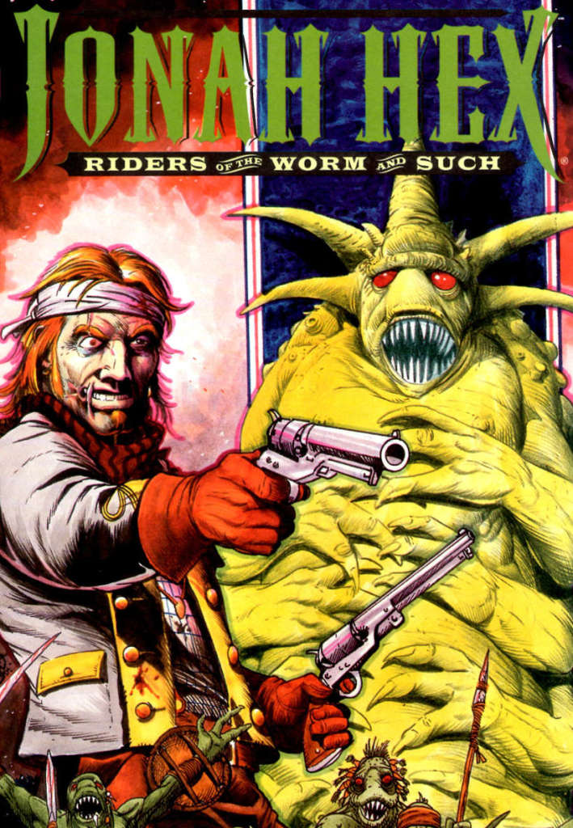
The situation is even more complicated by the fact that the worms have bred with human women and produced a set of albino half-worm, half-human gunmen that are attacking from above while the true worms come at “our heroes” from below. Obviously inspired by Lovecraft’s The Dunwich Horror, this tale lacks the potency of its inspiration. By making a humorous mockery of the albino gunmen with numerous scatological and sexual “shockers”, any chance we have a genuine horror it’s lost and all we are left with is revulsion of the kind we would have for disgusting slobs.
Even the end of the worm mother offends reason. Hex leads Graves’s men into the worm’s lair and, after a set of ridiculous occurrences worthy of Beavis and Butt Head, they come face-to-face with the large green worm mother. One member of the team is scoped up in a tentacle and has his foot bitten off. Even though it means his certain death, he nonchalantly decides to light his dynamite and the worm obligingly swallows him whole. Her death comes soon after as the inevitable explosion rips her apart.
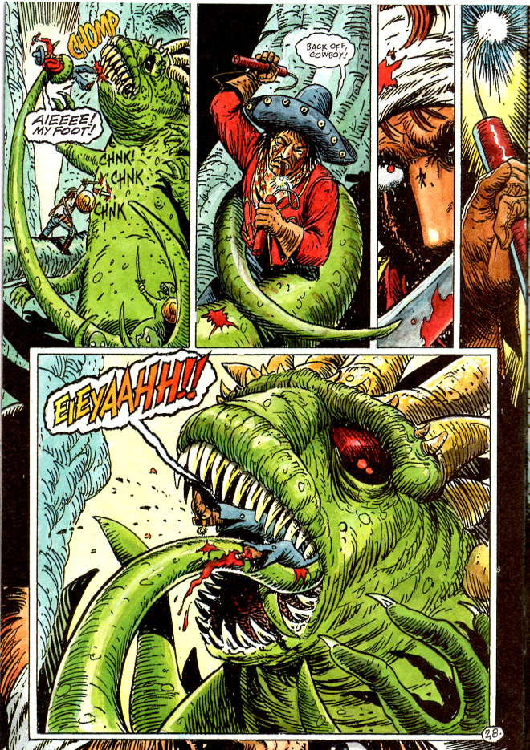
The final installment, Jonah Hex: Shadows West (1999), is arguable the best of the group, perhaps because it is also the shortest. In this go-around, Hex falls in with a carnival. Acting more true-to-form, he soundly beats one of the troupe for trying to cheat the carney’s whore of the money she earned. As Hex visits her a bit later to make up for her lost business, he inadvertently walks in on her nursing a baby with the head of a bear. Through a variety events that are not particularly compelling, the responsibility of reuniting the baby with its people falls to Jonah. In what is essentially the final scene, the spirit people are found and the baby makes it home.
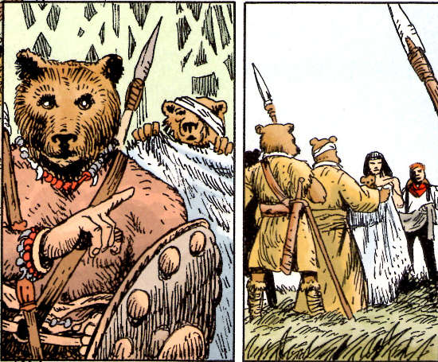
Most of the poignancy in this last scene is sabotaged by the fact that most of baby’s first words are all of the four-letter variety. Sigh…
Anyway, next week I’ll discuss the much better approach to the western-horror, one that keeps all the good parts of the Jonah Hex attempts but actually adds in compelling human motivations. Stay tuned for my discussion of the Deadlands one-shots and how they approach the Wild, Weird West.

