Wild, Weird West – Part 2
The Deadlands One Shots are single issue offerings that came out of Image in 2011-12 in conjunction with Visionary Comics, who holds the rights and have produced a few follow-on digital offerings and graphic novel called Raven, which is collected from their webcomic of the same name.
All of the stories take place in the alternate timeline called the Weird West. The history, rules, and structure are based on the Deadlands RPG created by Shane Lacey Hensley. The key features of this world are that on July 3, 1863 a group of Native Americans, led by the shaman Raven, perform a ritual design to drive the Europeans out of North America. Here the Deadlands timeline diverges from ours, with Raven unleashing a new and more dangerous hell to replace the one that they had been living under.
All sorts of supernatural and ghoulish things start taking place. Monsters of all sorts, including werewolves and plant people, roam free. A portion of California fractures and falls into the Pacific, leaving a labyrinth of canyons and cliffs called the Maze. Wizards and demons ply their trade and a mysterious substance called Ghost Rock fuels the new economy.
It is against this backdrop that the Deadlands comics set their story and what excellent stories they are. They manage to conjure a spooky atmosphere that blends wonderfully with the Old West settings.
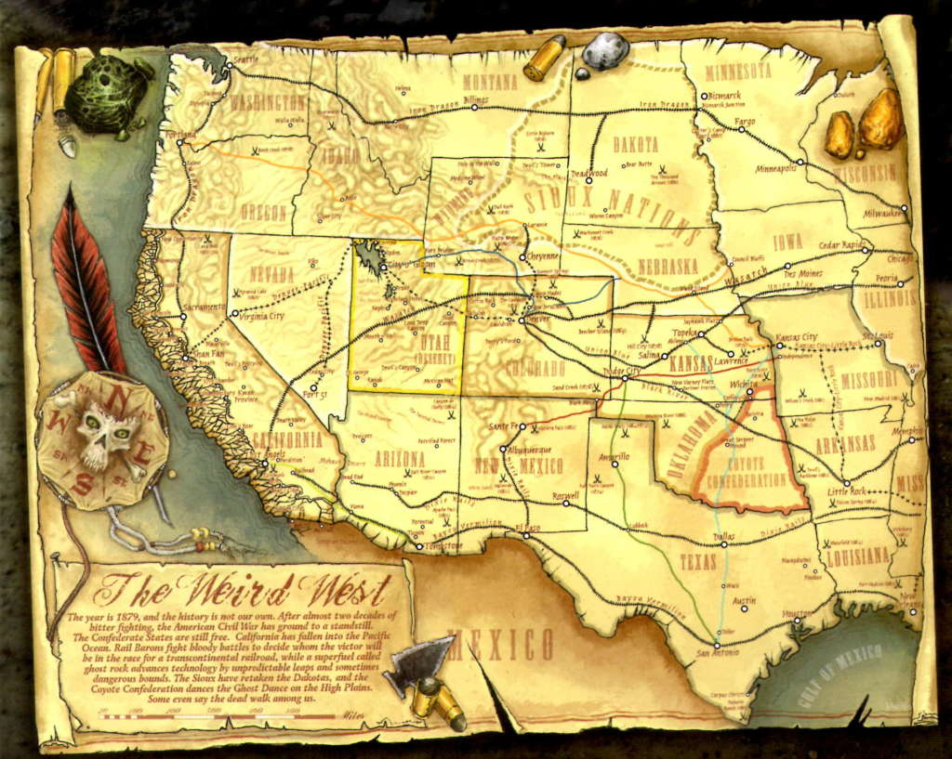
Each of the One Shots consists of a main story along with a short backup tale of about 4 pages in length. Listed in chronological order they are:
- The Devil’s Six Gun & Dime Store Back-up, Part 1 of 4, Showdown (June 2011)
- Massacre at Red Wing & Dime Store Back-up, Part 2 of 4, Hunted (July 2011)
- Death was Silent & Dime Store Back-up, Part 3 of 4, Prey (August 2011)
- Black Water & Dime Store Back-up, Part 4 of 4, Outlaw (January 2012)
Each of the issues has very nice, even beautiful art, clear exposition, tight dialog, and a seamless marrying of the horror and western themes. They are a pleasure to read and re-read, having a special place in my collection, but the best of the pack are The Devil’s Six Gun and Death was Silent.
In the Devil’s Six Gun, we encounter the lead character, Copernicus Blackburne, who is clearly based on both the appearance and personal history of Nikola Tesla. Copernicus, an accomplished weapons inventor, is enticed from his native Prague to the US by the prominent American business man Samuel Tygian, who is, perhaps, intended to be an Edison knockoff. Mr. Tygian manipulates ‘Penny’ into improving the latter’s signature invention, the Protean Pistol, by juicing it up with Ghost Rock.
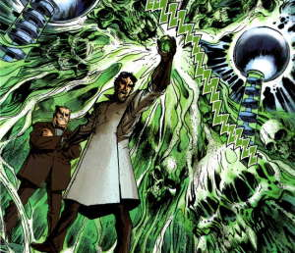
When, after years of labor in America, Copernicus grows homesick, Tygian arranges that they both take a visit back to the old country. Perhaps sensing that they are an unwanted distraction, Tygian arranges for the Blackburne family to meet with a gruesome end and then promptly disappears. Grief-stricken and vengeful, Copernicus perfects the improved pistol and comes back to the US with the Devil’s Six Gun.
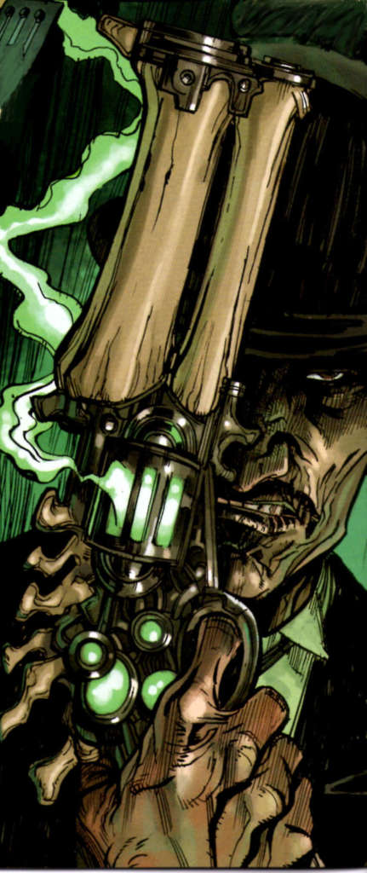
He gets his revenge by shooting S. Tygian point blank with Ghost Rock bullets that cause his mansion to blow-up in the process. Story close with an interesting surprise found amongst the rumble.
In the Massacre at Red Wing, a European girl in Native American grab tracks a group of monsters as they move down along the banks of a river, killing every human as they go.
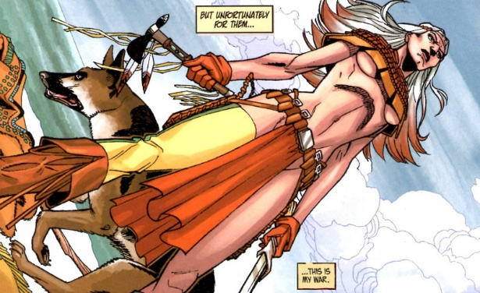
She hopes to find a lead on the whereabouts of her ‘mix-breed’ mother, Mahala Two Suns and by using some magic of her own, she forces them to give up the name of the man who owns her mother. This man, who goes by the name Wizard Morphine, is an enterprising and very sleazy pimp and is unwilling to part with Mahala. Taking a more hands on approach, the Women with No Name frees her mom from the grip of Morphine only to have her die during the escape.
Death was Silent introduces us to Hoyt and Franklin. Hoyt is a Texas Ranger with no tongue and Franklin is his dead but still shambling brother. As the story opens, Hoyt enters a dreary little town with Franklin slung over his saddle, posing as his dead bounty. Stopping in the local saloon, Hoyt orders a drink
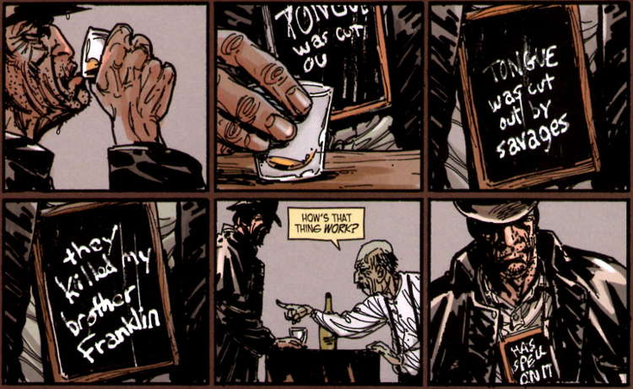
and matter-of-factly tells everyone there that he has come to kill them all.
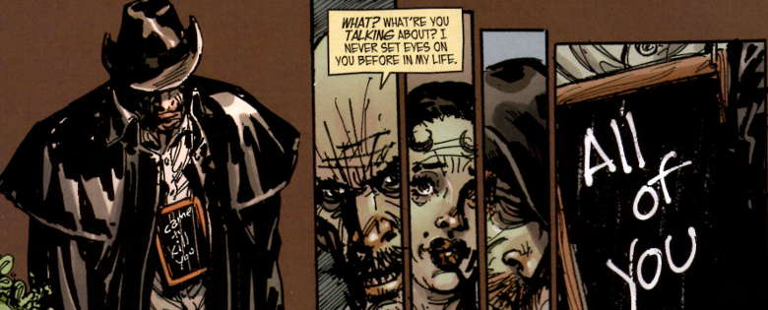
It seems that the entire town has been replaced by plant people and Hoyt and Franklin clean up the mess.
In the final One Shot, Black Water, we follow the journey of a ruthless, back-stabbing schemer, one Harmon Rappaport, as he goes from New York City to Shan Fran, California deep in the heart of the Maze. His goal is to find the woman who tended him after he was injured in the Civil War. The memory of his brief time with her has haunted him since. Arriving in California, he hires a boat and a guide to take him through the Maze. Overcoming numerous dangers, Rappaport eventually is reunited with her but not quite in the way he had hoped.
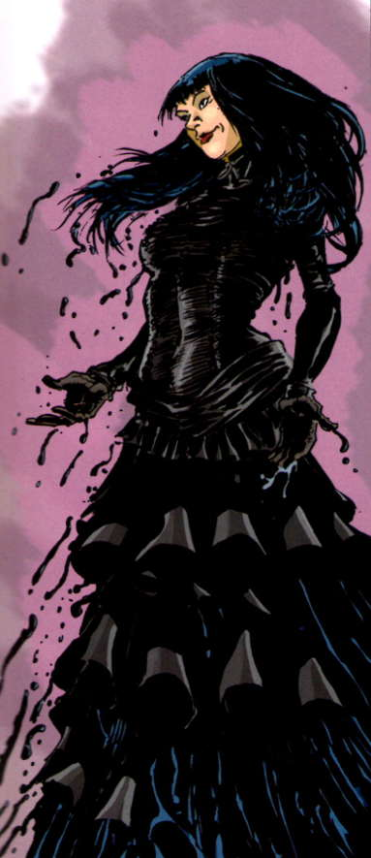
The Dime Store Back-up stories paint a tale of a young and very fast-on-the-draw Billy the Kid as he visits revenge on the Werewolves that killed his family.
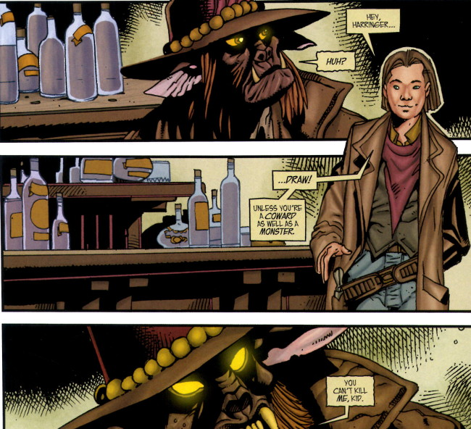
The narrative is cleverly written and, in the best traditions of the classic western, is equally about the protagonist’s cunning as it is about his skill. My only complaint is that the tale suffers from being serialized over the four books and my advice is either to read them all at one go, ignoring the main story, or purchase the collected set. To do otherwise is to blunt the force of the story.
Finally I would like to add a couple notes about the graphic novel Raven. The first is on it availability. I purchased my copy of the 5 collected issues at the Baltimore Comic-Con but it seems currently hard to come by. There doesn’t seem to be a link to purchase directly from Visionary Comics nor do third party vendors offer re-sales. The remains of the kickstarter is still up but of course if closed over a year ago. The second is on the content. By its very nature, this story is far more political and larger in scope than the others and for that reason I think it lacks the charm of the One Shots. It supplies the backstory that leads to the shaman Raven unleashing hell on Earth in the form of the Reckoners, the supernatural force behind all the weirdness.
Next week, I’ll finish with the third installment on Wild, Weird West by covering East of West, an ongoing effort from Image comics that uses the western/horror theme mixed with sci-fi and a touch of the Book of Revelation.

