Haircuts and Wine
Some time ago I devoted a column to the predicament that a group of monks had found itself in when its collection of scoff-law brothers began to sale handmade wooden coffins manufactured at their monastery (Of Monks and Coffins). These ‘shady business men’ were finally exposed by the Louisiana Board of Embalmers and Funeral Directors. This fine establishment of honest pillars of society tried to use a set of state laws that regulate and license the funerary industry to block competition by the monks on the grounds that coffin making (i.e. the making of a box) should be regulated in the same way as the handling of human remains. The tactic on display in this incident was a textbook example of how an entrenched group can use government regulation to intimidate and interfere with smaller companies as a way of stifling competition and protecting their interests.
The regulatory burden placed on small business is a serious impediment to their ability to compete with well-established firms. A business with 20 customers and 50 employees is unlikely to be able to afford the army of lawyers and compliance officers that a huge multi-national can field. In addition, small businesses can’t muster the same lobbying interests nor have the same pull with Congress. These concerns were widely voiced during the recent Senate Small Business and Entrepreneurship Committee hearing for the appointment of Linda McMahon for the Small Business Administrator.

The hearing had hardly begun when Senator Jim Risch (R-Idaho) has the following to say about the state of licensing and regulation facing the small business owner:
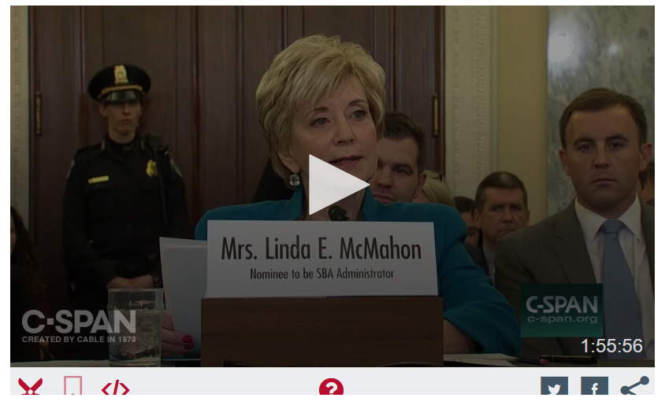

<object id='cspan-video-player' classid='clsid:d27cdb6eae6d-11cf-96b8-444553540000' codebase='http://fpdownload.macromedia.com/pub/shockwave/cabs/flash/swflash.cab#version=9,0,0,0' align='middle' height='330' width='512'><param name='allowScriptAccess' value='true'/><param name='movie' value='//www.c-span.org/assets/swf/CSPANPlayer.swf?clipid=4656453'/><param name='quality' value='high'/><param name='bgcolor' value='#ffffff'/><param name='allowFullScreen' value='true'/><param name='flashvars' value='system=//www.c-span.org/common/services/flashXml.php?clipid=4656453&style=inline&version=2014-01-23'/><embed name='cspan-video-player' src='//www.c-span.org/assets/swf/CSPANPlayer.swf?clipid=4656453' allowScriptAccess='always' bgcolor='#ffffff' quality='high' allowFullScreen='true' type='application/x-shockwave-flash' pluginspage='http://www.macromedia.com/go/getflashplayer' flashvars='system=//www.c-span.org/common/services/flashXml.php?clipid=4656453&style=inline&version=2014-01-23' align='middle' height='330' width='512'></embed></object>

His perspective was shared across the aisle with both Democratic and Republican Senators pointing to smothering government regulation as the largest hurdle to small business success (the reader is encouraged to watch or listen to the whole hearing, which runs just shy of 2 hours).

This opinion is not confined solely to legislative branch. In a recent article entitled We Shouldn’t Have to Ask Permission to Work, Robert Fellner of the Nevada Policy Research Institute, points out that a report published by the White House Council of Economic Advisers, the Department of the Treasury, and the Department of Labor offered the same conclusion. The report Occupational Licensing: A Framework for Policymakers, states that when designed and implemented carefully, occupational licensing laws “can offer important health and safety protections to consumers” but that often “the requirements are not in sync with the skills needed for the job” and that the legal framework “creates substantial costs”.

Fellner puts flesh on these drab policy bones by citing specific cases. He notes that Nevada is one of the most “onerously licensed” states in the nation requiring nearly 31 percent of its workforce to obtain governmental approval before being able to work. For example, it is a criminal offense in Nevada to practice music therapy without a license. I don’t know exactly what music therapy is (I thought that was what DJs do daily) but I find is hard to swallow that I face any health concerns and need government protection from fly-by night practitioners. Equally nefarious are the barbers of Nevada. By law, they are required to subject themselves to 890 days of education and apprenticeship, pass four exams, and pay fees of $140. Consumers must demand that all of this rigmarole must be tolerated by the budding barber-to-be so that they can avoid a bad hair day. But perhaps the most sinister of professions, lending itself to all sorts of fraud and posing a clear and present danger to consumers, is the practice of interior design. These vultures wait for our most vulnerable moments in order to convince us to get a divan rather than an ottoman and so a rigorous form of regulation (which 46 other states are too back-water to realize they need) must be imposed.

It is easy to chalk all of this nonsense up to crony capitalism wherein an established business scratches the politicians back (in the form of contributions and lobbiest-funded junkets) while the politician returns the favor by imposing regulatory burdens that favor entrenched interests and excluded new interests with hard-to-surmount barriers to interest. But this is only a fraction of the population. Why do the rest of us tolerate this nonsense?

The answer to this question is difficult to pin down. I have often argued with friends that licensing doesn’t necessarily protect us anymore than we are in an unregulated market in with free flow of information. If licensing and regulation worked perfectly, then there would never be the need for medical malpractice insurance; no one would ever get sick from food poisoning at restaurants; complaints would never be filed against home contractors or auto mechanics; and, most importantly, Yelp or Angie’s List would never have been created.

If licensing and regulation isn’t a perfect shield against malfeasance then, clearly, it is meant to minimize the number of occurrences and the impact of each. But a reasonable question, especially in this age of instant communication across social media, is whether it is better for the market to police itself, for no additional cost since all parties have ‘skin in the game’ than for a disinterested government bureaucracy to spend a great deal of tax payer dollars doing this for us.

The most common argument I’ve heard in opposition to a market solution, particularly applied to health care, is that such an approach would lead to the lowest bidder and “you don’t want to trust your health to the lowest bidder, do you?” was the inevitable response. My retort is that I always trust my health to the lowest bidder when I look for the cheapest, reputable place to replace my brakes. Nonetheless, this argument has never worked for me.

It took some years before I put two and two together. What I had forgotten was that people generally don’t value things that they don’t pay for. This tried and true maxim is really well summarized by Vox’s wonderful short on just why wine tasting is bunk.
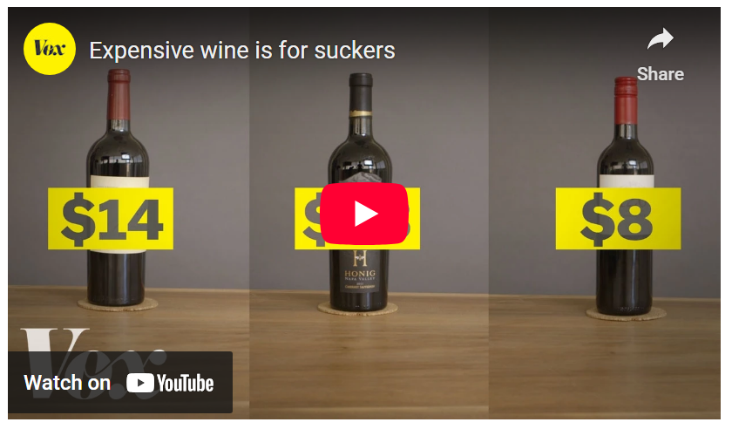

<iframe width="560" height="315" src="https://www.youtube.com/embed/mVKuCbjFfIY" frameborder="0" allowfullscreen></iframe>

What is fascinating is how the wine tasters valued the wine when they knew it was expensive. Their assessment was adapted to match their expectation that “you get what you pay for”. And while this little psychological reflex may be harmless or even amusing in the world of luxury goods, it is positively harmful in the world of licensing and regulation.

