On The Dignity of Work
There were a lot of ideas running through my head as I pondered what to write about this month. Some of the most reoccurring concepts centered around the ballooning student debt (1.31 trillion last year – the 18th year in which it rose), the sluggish participation rate, and the generally stagnation of wages and opportunities that seem to be the new normal. Competing with these grimmer ideas were the job creation news (227,000 in January and 235,000 in February), which has been better than expected of late, and the success of a stock market that is clearly enthusiastic about the future.
Unfortunately, none of these felt right. After all, March, being the month that straddles winter and spring, should be a time of hope and encouragement and not dry numbers and statistics of either the good or the bad or the ugly variety.
Fortunately, I found someone who was willing to do all the work for this column and to do it with a lot more skill than I can muster. Someone who is both down to earth and charming as the same time. I am speaking about Mike Rowe.
The former host of Dirty Jobs, Mike Rowe has become something of a spokesman for the importance and dignity of work. During the eight seasons that Rowe worked on the show, he participated in a wide-variety of jobs performed by “hard-working men and women who earn an honest living doing the kinds of jobs that make civilized life possible for the rest of us.”
Based on his experiences with these jobs and the celebrity that the show afforded him, Rowe has become something of an advocate for the dignity of work and the importance of a wide range of jobs that society has unfortunately judges as uncool. And the great thing about him is his sense of humor enables him to talk about serious subjects in a light-hearted fashion.
And the one serious topic that Rowe focuses on is the skills gap that exists in this country. What skills gap, you ask? Well the one Rowe has identified. And what has he identified is that there are over 5.5 million blue collar jobs, seventy percent don’t require a four-year degree, go unfilled because society deems those jobs as ‘uncool’ or as some ‘vocational consolation prize’.
And why should we believe him? Well….


Footage from the Bill Maher show used in fair use.

As Rowe often points out, these jobs not only pay well, generally, but they impart a sense of dignity and satisfaction to the people who hold them. The ability to start a new day and accomplish something like hanging new drywall or rewiring a room or fixing a leaky faucet is a powerful thing.
If this basic joy were simply being passed over by people more interested in higher-paying but less-satisfying jobs (I’m thinking of lawyers here) that would be one thing. But as pointed in many places, including numerous times in this column, the real unemployment rate in this country is far higher than the measure the government presents each month. Many students are graduating from four-year colleges with crushing debt and very little in the way of skills. Rowe puts it succinctly when he says


Footage from the Bill Maher show used in fair use.

So how to fix this skills gap? Rowe also has some suggestion. Primary amongst these is not to search for a job that matches our wish fulfillment but to pursue the opportunities. In a video commencement address he narrated for Prager University, Rowe argues that the best thing a person can do is to follow opportunity not passion; to be open to a variety of opportunities in excellent careers:

<iframe width="560" height="315" src="https://www.youtube.com/embed/CVEuPmVAb8o" frameborder="0" allowfullscreen></iframe>
And how did we get to this sorry state? As Row explains to Tucker Carlson, the core problem comes from the lack of an underlying appreciation for work. This lack of appreciation has its roots in the fact that we eliminated vocational training from high schools and have sold students on the idea that the only real success comes from earning a degree from an institution of higher learning.
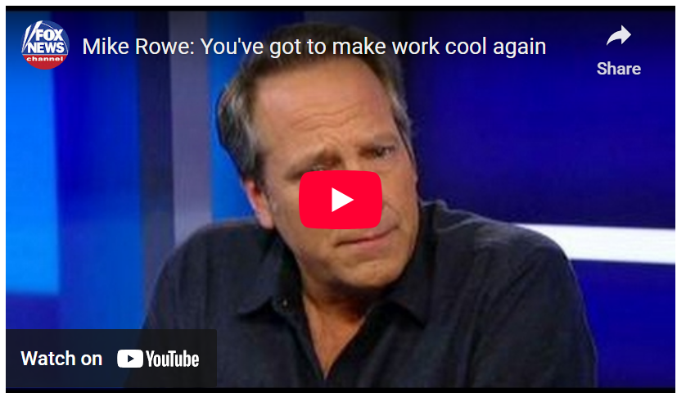
<iframe width="560" height="315" src="https://www.youtube.com/embed/yXZ7RWi98GM" frameborder="0" allowfullscreen></iframe>
As Rowe points out, guidance counselors all too often fail to talk about alternative careers. Even the term alternate careers is demeaning, making it sound like something you settle for if you can’t hack it in higher education.
But as anyone who has ever experienced it knows, there are very few feelings in the world equal to the pride one gets when one finishes a job making something and can claim ‘I made that.’ Kudos to Mike Rowe for championing the dignity of work.

