How Neutral is Net Neutrality?
Unintended consequences. That phrase could be the rallying cry for millions of people adversely affected by either poorly conceived or too-broadly applied regulations. Often these regulations, which are usually put in place to protect the economic interests of one party against the encroachments or abuses of a second party, have harmful side-effects on a third party – what economists call negative externality. Net neutrality seems to be one such type of regulation rife with all sorts of unintended consequences.
The aim of net neutrality seems noble. Keep the internet free from interference by the internet service providers (ISP) so that there is an uninterrupted conduit from content-provider to content-consumer, regardless of the nature of the content or the identities of provider or consumer. The ISP should act as a public utility maintaining the infrastructure through some equitable fee structure so that big and small alike can achieve the same throughput but, otherwise, should stay out the way.
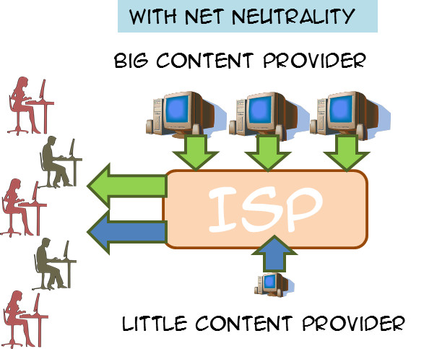
The concern that is being addressed can be best illustrated using a hypothetical situation. Suppose that two content-providers are competing for the hearts and minds of the great movie-streaming audience out there. One is a large well-established firm, like Netflix, and the other a smaller, newer company, like Hulu, that can be view as upstart competition. The situation that net neutrality is supposed to prevent is where an ISP, such as Comcast, enters into an agreement with the larger provider. The nature of the agreement is that the ISP will enhance the bandwidth of the larger streaming service, throttle the flow from the smaller competitor, or both in return for additional compensation.
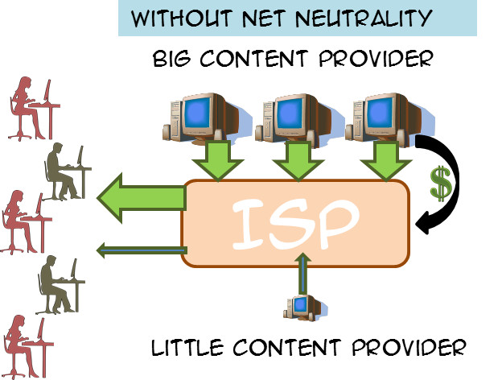
Supporters of net neutrality point to the fact that the net result of such an agreement is that the smaller provider faces an extremely large barrier to entry. They need to have capital to cover not only their operating costs but also to ‘grease the palms’ of the ISP. Small business thus starts out on a playing field that is far from being level. Furthermore, consumers are harmed when denied access to all content and that they end up paying more for two reasons. First, the larger content provider has less competition thus ensuring that it has a consistently high demand almost independently of the price it sets. Second it wants to pass on the cost it incurred in making the deal with the ISP onto its customers and can do so without fear.
Detractors point to the fact that government intervention in the free market often does more harm than good, that the government regulation stifles free speech and harms entrepreneurship. An additional critique that occurs to me (but which I haven’t seen expressed in the debate) is that compliance with government regulations is often so expensive that it constitutes a barrier to entry for small businesses. So net neutrality may enhance completion between service providers big and small but it may substantially diminish competition in the ISP market.
Obviously, the net neutrality argument is heavy and heated and extremely complex, with government being asked to balance a multitude of competing wants and needs. I’m not sure what is the best solution and I am not going to remotely try to explore all of the pros and cons. Rather I wish to comment on a small and interesting l little corner that has recently come to my attention.
In her piece Net Neutrality and Religion, Arielle Roth points out that an unintended consequence of the net neutrality is the chilling effect it would have on smaller ISPs who tailor their offering to a particular customer base that wants certain corners of the internet off limits. The usual scenario is one where a religious demographic would like to restrict access to pornography, or sacrilegious or blasphemous content. These customers want to enter into a legal contract with the ISP in which they pay to the ISP to deal with the segments of free expression for them. In other words, these customers want someone to shield them from content they would find offensive and they are willing to pay for the service.
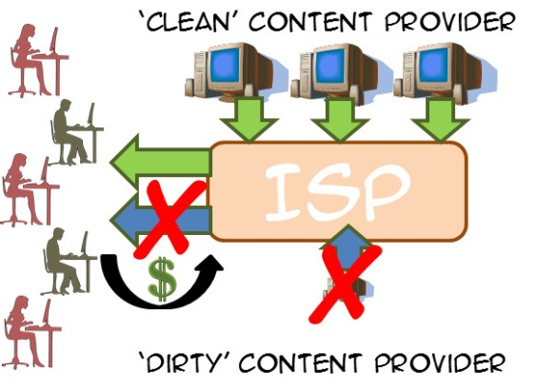
Such a service would be in violation of net neutrality since it would disadvantage a ‘dirty’ provider (say Playboy) relative to a ‘clean’ provider (say Billy Graham) even though the customer wants that disadvantage. And it isn’t clear at all how to write an exemption that respects one scenario without running afoul of another scenario. How should the government define ‘excludable content’ from ‘essential content’ without encounter the slippery slope type of arguments that manage to make all content excludable or essential.
Some free speech advocates will, no doubt, say that this is the price we pay for free speech. But that argument is not persuasive. Free speech protections guarantee an individual’s right to say just about anything (within some narrow limits) but it doesn’t guarantee that anyone must listen. And besides, there is an equally valid constitutional argument that says individuals have the right to freedom of association, which means they have the right to not associate with content they deem unacceptable.
And so this little corner of the net neutrality debate shows just how complicated and thorny it can be to try to regulate economic behaviors.

