Bad Logic on Trade & Inequality
I came across two articles recently that caught not just my attention but also my ire. They were excellent examples of what is wrong with much of the policy material that comes out of the ‘dismal science’.
Simply put, the presentation of evidence and the offered arguments built on this evidence is too scant to be respectable. The conclusions reached are too certain with no countervailing opinions considered or addressed, except in passing. The tones of the articles were too much schoolyard ‘see I told ya so’ and too little of the scholastic ‘let’s weigh all sides and pick the best path, regardless of who is right.’ Their logic is faulty and their argumentation depends on tautologies and equivocation rather than well-formed formulas required. In short, they are polemical opinion pieces better suited for a candidate running for office than they are serious pursuits of truth. And the validity of their conclusions is, shall we say, dismal.
In the first example is a recent article about economic inequality by Christine Lagarde, entitled Equality is key to global economic growth. Lagarde is currently the managing director of the International Monetary Fund (IMF). A lawyer by training, she has held a variety of economics-related roles, including as an antitrust and labor lawyer and as France’s Trade Minister and Minister of Economic Affairs. So I had hopes that her article would offer a well-thought-out support of the position so concisely summarize in her title.
Instead, I found a fluff piece with numerous examples of equivocation. For instance, the third paragraph of the article reads:
<We at the International Monetary Fund are supporting our 188 member nations in that effort. We do this through our core activities — lending, policy advice, and technical assistance — as well as by helping to deal with a set of emerging issues that are of increasing importance to them: female empowerment, energy and climate change, and reducing excessive inequality.>
Surely a definition of ‘excessive inequality’ would be coming after such a lead-in. Does she mean wealth inequality, income inequality, or some other form of inequality? After all, the inequality between Warren Buffet and the average wage earner in the US is much smaller when considering their incomes versus net wealth. Buffet makes a comparatively small income (defined as wages and salaries) every year but resides over a vast fortune.
But alas no. Lagarde does say about inequality that:
<The traditional argument has been that income inequality is a necessary by-product of growth, that redistributive policies to mitigate excessive inequality hinder growth, or that inequality will solve itself if you sustain growth at any cost.>
What kind of logic is being used in this sentence? It is almost certain that wealth inequality is a necessary by-product of economic activity. But where did income inequality creep in. And what is excessive inequality. At what value of the Gini Coefficient does income inequality become excessive? And so what if there is income inequality, it doesn’t mean anyone is poor. Both the players and owners in the National Football League are quite well-off, even though there is a distinct income inequality between the scant millions earned by the players versus the meatier hundreds of millions and billions earned by the owners.
Without any additional support, Lagarde then goes on to say that:
<[The IMF has] found that countries that have managed to reduce excessive inequality have enjoyed both faster and more sustainable growth. In addition, our research shows that when redistributive policies have been well designed and implemented, there has been little adverse effect on growth.>
How much faster and how much more sustainable is the growth – would 0.1 % be statistically significant? How little is little adverse effect on growth – would 20% be little? Sigh…
Lagarde ends with this chestnut
<What is crystal clear, however, is that excessive inequality is a burning issue in most parts of the world, and that too many poor and middle-class households increasingly feel that the current odds are stacked against them.>
There is no rationale statement in that sentence other than to say the ‘excessive inequality’ (still undefined) makes people say that they feel bad.
So much for Lagarde!
The next candidate in the bad logic hit parade is the article entitled Free Trade With China Wasn’t Such a Great Idea for the U.S. by Noah Smith. Smith’s bona fides tell us that he is an assistant professor of finance at Stony Brook University. So I had hoped for a well-reasoned discussion. But those hopes were soon dashed.
Smith is more subtle with his equivocation and, as a result, his misdirection is harder to spot. His starting position is that:
<[E]conomists often portray a public consensus while disagreeing strongly in private. In effect, economists behave like scientists behind closed doors, but as preachers when dealing with the public.
Nowhere is this evangelism clearer than on the issue of trade. Ask any economist what issue they agree on, and the first answer you’re likely to hear is “free trade is good.” The general public disagrees vehemently, but economists are almost unanimous on this point.>
These two paragraphs, examined closely, open all sorts of questions about Smith’s positions. First, by his own rules, should we be regarding Smith as a preacher rather than a scientist, since he is talking in public? Second, is being a preacher bad or, perhaps, is Smith revealing both his ignorance and his bias when it comes to faith and science? Anyway, let’s leave these questions aside and focus on the question he would like us to focus on. Is free trade with China bad?
To support the premise of his title, Smith provides us with this little gem:
<[L]ook at actual economics research, and you will find a very different picture [on free trade]. The most recent example is a paper by celebrated labor economists David Autor, David Dorn and Gordon Hanson, titled “The China Shock: Learning from Labor Market Adjustment to Large Changes in Trade.” The study shows that increased trade with China caused severe and permanent harm to many American workers.>
Increase trade equals free trade? Smith argues that Autor, Dorn, and Hanson’s findings support that:
<Autor, et al. show powerful evidence that industries and regions that have been more exposed to Chinese import competition since 2000 -- the year China joined the World Trade Organization -- have been hit hard and have not recovered.>
My response is – so what? I feel for these people who have been hit hard and have not recovered. Collectively, we as a nation should do something, and individually, me as a person should do (and am actually doing) something. But where is the evidence that free trade is the culprit?
How do I know that some economists or lawyers or professors of finance haven’t rigged the trading with China to favor themselves? After all, income inequality (or is it wealth inequality) has to come from somewhere. Or maybe government policy has left trade unfettered but has prevented these displaced persons from finding other jobs. Perhaps welfare and unemployment benefits are perversely constructed so that the displaced worker has no incentives or options to support himself while he looks or trains for new jobs. Perhaps, in an imperfect world, the benefits to society as a whole far outweigh the localized losses, as painful as they may be.
There are lots of questions and no forthcoming answers because Smith avoids examining these questions entirely. He seems to simply want to inflame the passions of a populist subject. Just the kind of behavior I would expect to see from a fly-by-night preacher.
So let me close by saying that one should stay on one’s toes when reading articles that pass for economics but are really politics. When the author argues without defining terms, without presenting quantitative evidence, and with liberal shortcuts through logic they probably aren’t worth one’s time.

Tinkering with Equilibrium
The genesis of this column is mostly based on chance; a chance visit, a chance purchase, and a chance reading. Nonetheless, the end result is a nice example of how government interventions in a market can look good on the surface but have a less-attractive side underneath.
Let’s start with the chance visit. Recently, I had an occasion to stop off at a used bookstore near a college campus. The basic function of this establishment is to buy back textbooks at a cheap price, resell the products back to others at the going rate for used textbooks, and to store the unwanted product as tastes and approaches in teaching and the professors who are teach change. The fact that the resell price is significantly higher than the buy-back price seems to irritate the bulk of the clientele (judged by my casual viewing of the interactions at the register). The reason for this cost-differential – that this particular book store needs to pay for the storage of the books, the labor of the various people who catalog and handle the product, as well the rent and upkeep of the shop – slips by the average consumer. And, although this column is not explicitly about this mismatch of expectations, the basic theme of the unseen cost is. Looking back in hind sight, these preliminary observations of mine were perhaps a foretaste of what fate had in store.
In any event, I began to wander about the store; an adventure in and of itself considering the vast number of abandoned titles piled precariously all over the floor. Training in the high hurdles would definitely be an advantage when browsing the inventory. Turning a corner, I came across the store’s collection of Schaum’s outlines. Overall, I am a fan of these do-it-yourself study guides. Not so much due to their teaching style, which is often minimalistic and confusing, but rather the vast number of worked problems that one can immediately dig into. The effect they produce is a lot like finding a bunch of how-to videos on YouTube with the convenience of the at-your-own pacing that book afford. Glancing at the shelf, my eye caught the title Microeconomic Theory, 3rd Edition, by Dominick Salvatore of Fordham University and, almost on a whim, I decided to purchase it for a mere $5 dollars (which goes to show that you can get a bargain if one is willing to settle for yesterday’s textbooks and study guides).
In odd moments, here and there, I began to dip into the outline and amuse myself with some of the questions and solved answers. Early on in the book, Salvatore goes to some effort to set the scope of the study to be strictly microeconomics. Interconnections of one market to the next are to be kept to a minimum. So I can’t blame him for what I found shortly thereafter but I thought it made for a good ‘teachable moment’ about ignored or unseen costs.
The scenario he explores is clearly contrived for pedagogical purposes, but I reason that if it is sufficiently illustrative to go into a Schaum’s outline, it is also sufficiently realistic to serve as a valuable thought experiment. In this scenario, the micro-portion of the economy that is being examined consists of 10,000 consumers and 1,000 producers of a particular product, which he calls ‘X’. For simplicity, each of the consumers possess the same demand curve given by
$$Qd_{x}=12-2P_{x}$$
where $Qd_{x}$is the quantity demanded of for a given price $P_{x}$ that they must pay. Likewise, each of the producers follows a supply curve given by
$$Qs_{x}=20P_{x}$$
where $Qs_{x}$ is the quantity they are willing to supply if they can charge price $P_{x}$. The prices that the consumer pays and that the producer demands equal each other when the market is in equilibrium. The following figure shows the demand and supply curves for this market.
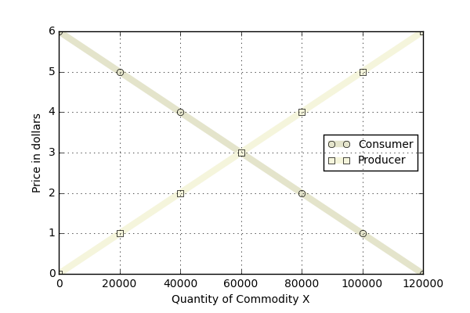

From the figure, the equilibrium point, where the two curves cross, falls at $3 and 60,000 units produced. We can confirm this result by solving the equation
$$N_{C}Qd_{x}=N_{p}Qs_{x} ,$$
where $N_{c}=1,000$ and $N_{p}=10,000$.
Salvatore then directs the reader to consider the case where the government decides to intervene in this market by providing a subsidy to the producer of $1 per unit produced. He asks:
<(a) What effect does this have on the equilibrium price and the quantity of commodity X? (b) Do consumers of commodity X reap any benefit from this?>
Part (a) is a bit tricky to solve in that one must first decide what is exactly meant by a $1-dollar subsidy. In short, it means that the producer now perceives that he can charge a dollar higher than he could without the government intervention. Ignoring for the moment that the new equilibrium will move, the producer gets $4 when a consumer pays him $3 since the government is stepping in with an additional $1. As a result, the producer’s new supply curve is
$$Qs_{x}'=20\left(P_{x}+1\right) .$$
Functionally, this looks as if the producer’s supply curve has been shifted down by $1 as seen in the figure below (the new, shifted curve is labeled ‘Government’).
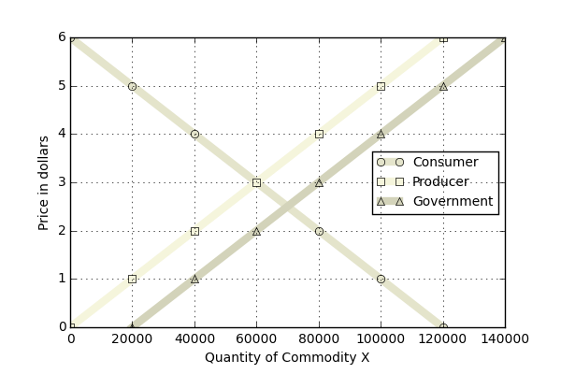

The new equilibrium is solved as before, and either direct inspection of the graph or algebraically solving
$$N_{p}Qs_{x}^{'}=N_{c}Qd_{x}$$
results in the new equilibrium of 70,000 units produced at $2.50 per unit. Salvatore then points the student to the conclusion that this government intervention has benefitted the consumer since price has fallen by 50 cents per unit. By analogy, this analysis also suggests that the producer is better off in that more units have been produced.
And this is where I got perturbed by the strict adherence to microeconomics. It is true that this market seems to have been helped but there are unseen costs that at a minimum could have be discussed even if the implications to other markets were avoided.
Specifically, before the government intervention, a total of $180,000 dollars moved from consumer to producer in this market (60,000 units at $3/unit). After the government intervention, a total of $245,000 dollars moved to the producers in this market. It is true that the 10,000 consumers only shouldered $175,000 of that cost but it is wrong to ignore that the producers actually received $70,000 in government subsidies.
Where did that additional $70k come from? It is easy and tempting to say that it comes from the government and to stop there, but that misses the point. Where did the government actually get that money? Well it could have printed it or it taxed it. If it printed it, the cost of that action eventually comes back in the form of inflation, which devalues the consumers buying power, resulting in a new set of supply and demand curves. More likely, it taxed it, which means it took money from consumers, some who weren’t that market, and injected it into this market. It made some consumers reap a benefit at the expense of others suffering a loss.
Of course, this scenario is contrived but the logic and the lesson is not. The point here is that it is easy to see the direct costs and to ignore the hidden or indirect costs. As long as a citizen doesn’t dig too deeply, he probably never knows when he is being robbed blind.

