Good, Bad, and Ugly Goods
So, once again, I decided to learn a little more about how economists see the world. The basic ingredients of their studies center on two pieces: goods and services; and the transactions and behaviors whereby they are produced, traded, and consumed. Many of my past blogs have dealt with the behavioral aspect so it seemed reasonable to ponder a bit more at just what the term ‘goods’ means (obviously expanded to include tangible items like cars and intangible items like tax preparation services).
And so off I went on a rambling intellectual walk-about through a variety of sources, both written ones, collecting dust in my home library, and virtual ones, collecting cyber-dust somewhere in the great digital repository that we all casually call the net.
I held one goal close enough to my heart that its achievement would fill me with satisfaction for a time, but far enough away that its failure would not disappoint. I greatly want to understand how the classical economist ever embraced the clearly flawed idealization of a rational consumer/actor. People rarely act rationally if, by rationally, we mean the narrow concept that they seek material gain as the primary, or perhaps even only, aim. The Ultimatum Game being one of the surest refutations of that position. Certainly I am mindful that all disciplines need approximations and idealizations to progress but at what point did the idealization cease being a model and started to become gospel was the question. Perhaps the answer lay in how economists look at the goods people produce, trade, and consume.
I wasn’t really expecting an answer but I would have liked to have even a hint. Alas, even a hint was too much to ask but I did learn some interesting things about goods that is worth at least a few more paragraphs. In short, there are three categories that, with apologies to Sergio Leone, I call good, bad, and ugly goods. Economists, of course, don’t call them that, but their categories match mine quite closely so I’ll not be shy in using my lingo interchangeably with theirs.
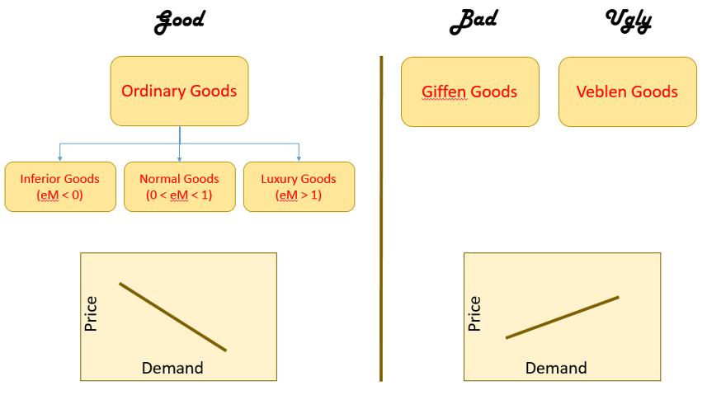
Good goods are what are generally termed ordinary goods by economists. An ordinary good possesses a negatively sloped demand curve. As the price of the good rises, there is less consumption of it as consumers seek out substitutes and alternatives. A substitute is a good that serves the same function but costs less. Switching out Bombay Sapphire for Beefeater is the kind of switch that economists mean by the term ‘substitution’ although they, no doubt, would never stoop so low as to buy a lesser gin. In contrast, giving up gin and tonics permanently in favor of tea-totaling falls under the heading of ‘alternative’. In either case, the consumer generally responds to an increase in price by changing their behavior so that they consume less when the vendor asks more.
Good goods further sub-divide into three categories called: inferior, normal (or necessary), and luxury. This sub-categorization reflects the natural evolution in most consumers that, as their income grows, they themselves grow accustomed to better styles of living. I borrowed this latter terminology from the divorce court lawyers who argue that their client is entitled to alimony that supports the client in the style to which the client has become accustomed. Levity aside, each category reflects the income elasticity of demand of a good found within its bounds. Economists define income elasticity of demand as the ratio between the percentage change in the quantity demanded to the percentage change in the household income.
As a person’s income grows his fractional change in income is positive. If he decides that he no longer needs to eat ramen noodles every night because he now has enough money to go out for a burger from time to time, then the fractional change in ramen demand is negative. The ratio between the two is also negative and the good is inferior. More simply put, as a person’s grows his need to settle for a good he would otherwise not buy diminishes. Thus ramen is an inferior good.
Normal and luxury goods have positive elasticity, meaning that the quantity demanded typically grows as income grows. The difference between these types of goods lies the magnitude of the elasticity. An elasticity less than one means that changes in income do little to change the quantity of the good demanded whereas an elasticity greater than one means that a small change in income (or in a related fashion price) makes a big change in the amount demanded. Normal good fall into the former category (as a result they are sometimes called necessities) and luxury goods fall into the latter. Food is typically a normal good and the consumer will buy his staples, say a gallon of milk, each week essentially regardless of the price or his income. Fine gin is regarded by many as a luxury item (although it shouldn’t be); to be bought when the price is right or the take home pay is sufficient to allow an indulgence.
In deference to any actual economists who may read this, I do want to be clear that in the last paragraph I played fast and loose and blurred the distinction between income elasticity of demand and price elasticity of demand. They are distinct but highly-interrelated concepts, ultimately connected in a much broader definition of personal value. Here I am imagining something like elasticity defined as the ratio of percentage change in demand to percentage change in the percent of the household expenditure buying the good represents. A professional can either work that concept out in detail or prove/argue why it can’t work – it won’t change the fact that each of us weighs the demand for a good by more than the change in price or in income, all other things held constant.
Bad goods are what economists call Giffin goods. These goods defy the law of demand in that their demand curve is upward sloped. As the price increases so too does the demand. The big brains claim a Giffen good is typically
  - an inferior good
  - does not have easily available substitutes
  - purchase of it must be a substantial fraction of the total household expenditure meaning that the good is purchased only due to the limited income.
The oft-cited Giffin good example is a staple food depended upon by the poor. As its price rises, additional income used to buy other goods becomes slimmer and the household is forced to buy more of the cheaper but price-rising good just to be able to eat. In the example above, if ramen increases in price, our hypothetical burger-muncher may have visit Five Guys less often because he has to sink more of his income into ramen just to have something to eat each day. Sir Robert Giffen claims to have seen this behavior in Victorian England but certain economists assert that there is no such thing.
The ugly good is synonymous with what economists call a Veblen good. Like the Giffen good, demand for a Veblen good rises as its price rises. However, the rise in the demand reflects the good as a status symbol showing that the purchaser is truly a king among men in that he can afford more of what others can’t afford at all. Conspicuous consumption, which is another name for the kind of behavior that supports a Veblen good, is featured prominently in the rather amusing first part of Chesterton’s The Queer Feet and the reader is directed here for a nice quote.
So there you have it. A concise, if not precise, summary of how economists categorize goods and their corresponding elasticities. It would be an interesting follow-up to see if their analysis, papers, and books, which are goods in and of themselves, are good, bad, or ugly.

