Paper Towel Wars
It is odd to say that I stumbled onto this topic by simply waking up one morning but that is the actual way it began. More precisely, it began with a half-awake, half-witted attempt to listen to the morning show that my wife and I favor. The topics include a smattering of current national politics interspersed with interesting local stories, human interest tales, and other items meant to amuse or outrage or otherwise energize the listener to a brand new day.
This particular day, only about a week ago, one of the hosts was reveling in the scientific study that concluded that paper towels in public restrooms were the best choice for hygiene. The show was flooded with numerous callers all clearly falling into one of two camps: those for paper towels and those for hand dryers. There seemed to be no middle ground. Suddenly I was aware of a great and terrible debate that had been raging all around me to which I was hideous oblivious – the paper towel wars.
It seems that the argument over which method was best is so pervasive that all one needs to do is to start typing
< paper towels >
to get a Bing or Google autocomplete to come back with
< paper towels versus hand dryers>.
And judging by the articles that turn up, this debate has stewed for some time and it is typically very polarizing with most people pitching their loyalty with one side (hand dyers) or the other (paper towels). Sharp are the lines between these two camps and strong are the passionate claims that each makes about the advantages it has over the other.
Consider the pro paper towel camp. Washington Post contributor Alexandra Petri minces no words (The paper towel-hand dryer wars are over) when it comes to the paper towel side. She likens the clash between the two camps to the old feud between the Hatfields and the McCoys and claims that, at least in this case, the “correct team has won.” Citing the 2012 Mayo Clinic study entitled The Hygienic Efficacy of Different Hand-Drying Methods: A Review of the Evidence, Petri gleefully brings ‘science’ in to support the conclusion that paper towels are the correct choice. In her reading, hand dryers are ineffective and unhygienic and near the close of her article, she presents this gem of a paragraph
<No, the science is in. And there’s absolutely no excuse for them [hand dryers]. If anyone ever comes up to you and tries to argue that hand dryers are just as good as paper towels, slap him with your damp and bacteria-ridden hand. In fact, I’m not sure what we were doing with hand dryers in the first place.>
To bolster the pro-paper case even more, News Max reported a follow-on story in June of 2015 entitled Paper Towels vs Air Dryer: Which Gets Rid of More Hand Germs? Citing Dr. Philip Teirno, a professor of microbiology and pathology at the New York School of Medicine, the article concluded that paper towels offer a better alternative to hand dryers since the direct contact friction is an essential ingredient in eliminating germs from the hands after washing.
But the pro hand drying camp is not without its scientific studies, which conclude, oddly enough, that hand dryers are the correct choice. RestroomDirect, a company specializing in the distribution of hand dryers and commercial restroom cleaning supplies asks Which is better in a commercial restroom? Hand dryers or paper towels? They present a strong, and no less scientific, argument that hand dryers are far more energy and resource efficient thus making them better for the environment. Hand dryers are also far less expensive to operate meaning that businesses can put additional resources towards more important things. To add fuel to the fire, there is also a scientific study from the University of Buffalo (Paper towels fold in study versus hand dryers 6/14/14) that concludes that paper towel dispensers are actually far more unhygienic than hand dryers.
To make matters even more confusing there is even a YouTube video that attempts to scientifically weigh in with the pros and cons of both approaches
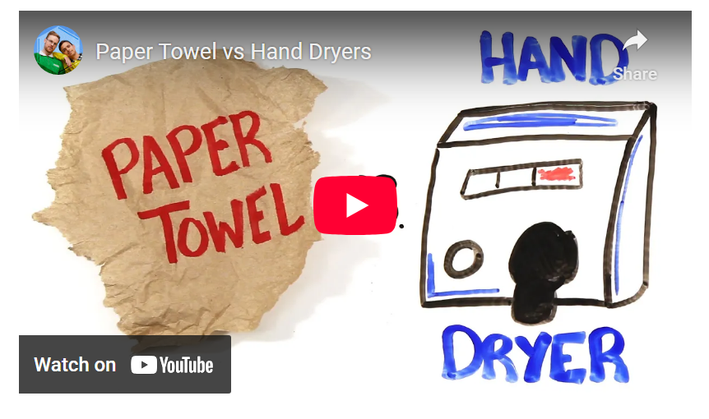
<iframe width="560" height="315" src="https://www.youtube.com/embed/2g4fWaegoDk" frameborder="0" allowfullscreen></iframe>
Pros and cons. Competing and contradictory scientific studies. So what is a consumer to do?
This situation is representative of the classic conundrum that occurs in the market place. The correct economic choice may be apparent if perfect knowledge were present, but consumers almost always have to make choices based on information that is far from perfect.
This lack of knowledge drives many of the hedges and securities mechanisms that decorate our day-to-day market interactions. Uncertainty and doubt set premiums on life, car, and homeowners insurance. Hedge funds sell guards against market downturns, sudden jumps in stock prices, and other forms of volatility. Interest on loans are a way of protecting against future inflation and rewarding delayed gratification.
Much in our economic lives is shaped by uncertainty as to what the future holds and how to make the best choice with limited information. We see it every day but it is rare to see it as cleanly laid out as it is in the paper towel wars.

