Too Much of a Good Thing
Economics is often called the dismal science. The conventional reasoning for this nickname is that economics often tells us that we can't do something. It is about finding the optimal way to use scarce resources, about how to make the hard choices that a society must contend with in order to decide what should should be produced and how much of it, who should produce and who should consume. And, I suppose, there is a great deal of truth to this.
But I can't help wondering if there isn't another, equally compelling reason.
It seems to me that economists spend a lot of time proving common sense notions through methods that are sometimes scientific, sometimes mathematical, and sometimes far less rigorous than reading tea leaves. Certainly there is value in providing a rigorous underpinning to old saws, honored adages, and accepted truisms, but much of that value is blunted by some of the most dense nomenclature that can be found in any science.
Take the familiar saying 'Too much of a good thing'. The written attribution of this phrase falls to Shakespeare's As You Like It from around 1600. It elegantly captures the basic idea that had long been known from antiquity and which formed a central concept in Aristotle's definition of virtue - moderation. To almost all of Western civilization, it was manifestly obvious that too little or too much of anything, even a 'good thing', was unbalanced and harmful.
With the advent of modern economic theory, many old notions were placed in a structured framework and equipped with mathematical rigor that made their study more of a science and less of a ethical philosophy. But it is important to note that in these cases no new content was added. So why then did economists go out of their way to name things obscurely? Perhaps it was because they wished to add a gravitas that reflected the rigor or perhaps it was that they just simply wanted to sound smart. Whatever might be the reason, their 'arcane' terms have done a lot to make their discipline seem even more dismal that it really is.
In the case of 'too much of a good thing', economists use the terms total utility and marginal utility. These clunky terms are meant to convey just what Aristotle argued - that there is a virtue in every activity where there is neither too little or too much. In the case of utility, the thing of interest is usually a good or a service. I'll use good to mean both.
The total utility is an absolute measure of the usefulness of a good. A consumer will not trade for or even consider a good if that consumer doesn't think that he will gain something out of such an acquisition. This something is what is meant by utility. The total utility of a good is difficult to define let alone measure since the worth of a good is really only understood in comparison with other goods. Nonetheless, it is a convenient fiction for introducing a related but much more useful concept: marginal utility.
Marginal utility is the relative gain in utility as the quantity of the acquired good increases. It is the derivative of the total utility curve with respect to the quantity demanded/consumed. This observation explains why it isn't terribly important to be able to assign an absolute number to the total utility. Each total utility curve with the same marginal utility differs from the other members by a constant of integration which shifts its relative importance. Its relative importance and rate of its change are what matters; absolute ranking being totally irrelevant.
The total utility must be positive for at least the first quantity of the good acquired since the consumer has a desire to consume it. What happens to the total utility after that depends on the good but generally the initial rise in total utility is followed by slower growth. Eventually, a stagnation point is reached where the total utility reaches a maximum value. Consuming/acquiring more of the good beyond this point causes the total utility to fall as the cost of dealing with unwanted goods overwhelms the intrinsic value of the good itself. This drop in utility reflects the added costs associated with storage of the good or with the fact that acquisition of a surplus of one good squeezes out other goods due to lack of time, money, or space. In this regime, the consumer can be said to be having too much of a good thing. And in this fashion, economist have re-expressed in a far less artful way what the great Bard put to paper over 150 years before Adam Smith penned The Wealth of Nations.
Often, it is believed that the marginal utility falls steadily as new goods are acquired but this need not be the case. The following table shows the values for total and marginal utility as a function of the quantity of goods consumed for a case study in chapter 4 of Microeconomic Theory, 3rd edition by Salvatore.

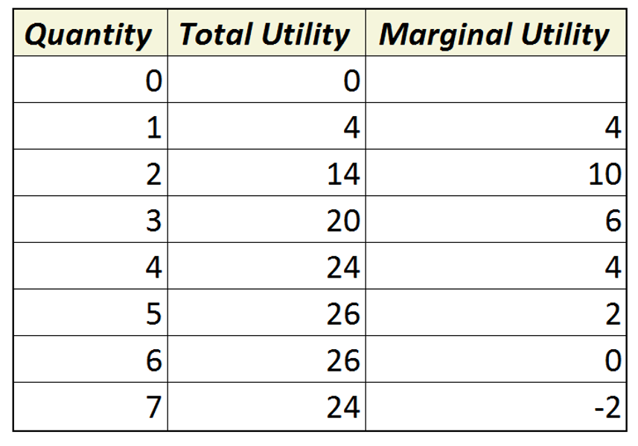
Note that in practice, the marginal utility is computed from the forward first difference in the total utility - the difference between the total utility in a given row (for a given quantity) and the prior row. This is due to the fact that quantity is often only expressed as a discrete number (would you buy a seventh of a toaster?).. As a result, the value for the marginal utility is blank in the first row.
What is happening is easier to see graphically than in tabular form. The initial rise in total utility is a modest value of 4 as the first good is consumed. The total utility increases more rapidly as the second and third goods are consumed and the marginal utility rises as a result. Eventually, the total utility reaches a maximum where the marginal utility reaches zero, Beyond that, the consumer is getting too much of a good thing.
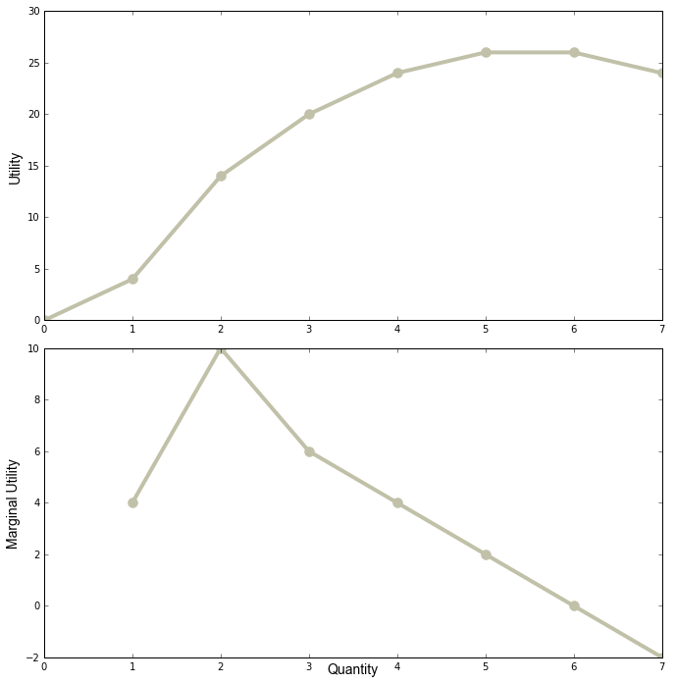
A natural question may be springing to the reader's mind. What kind of a good is it where getting two is much better than getting one? There are many possible answers, but the best one is a shareable good where the value for two is far increased over the value for one because two people get to enjoy the good at the same time - say a pair of tickets to the theater to see As You Like It.

