Tale of Two Koreas
Conrad SchiffMay 27, 2016Uncategorized
I had an occasion to visit the Republic of Korea, aka South Korea, this past month and I thought I would provide an on-the-ground style reporting of my observations and impressions and contrast these with what little is known about the Democratic People's Republic of Korea that inhabits the northern portion of this peninsula.
Before I get into details, a side-by-side comparison between South Korea, North Korea, and the United States seems appropriate for those, like me, who know very little of one or both of these north-east Asian countries. The following table contrasts geographic and economic statistics between the two countries (all information taken from the corresponding entries in Wikipedia accessible by the links provided).
 | South Korea | North Korea | United States
Area (km²) | 100,210 | 120,540 | 9,857,306
Population | 51,529,338 | 24,895,000 | 322,369,319
GDP (trillion $USD) | 1.392 | 0.0154 | 18.124
Per Capita Income ($USD) | $27,513 | $621 | $56,421
Adjusted Per Capita Income ($USD –PPP) | $36,528 | $1,800 | $56,421
Gini Index/Coefficient | 30.2 | N/A | 40.8
Human Development Index (HDI) | 0.898 | 0.595 | 0.915
Statistics being statistics, some words about them are required to set the proper context.
First of all, the two different values for per capita income reflect two different perspectives on income. The first is simply the ratio of dollars to population (i.e. $18.124 trillion/332,369,319 = $56,221 per capita – allowing for rounding and finite precision). The second is adjusted to reflect differences in cost of living to bring all countries to purchasing power equal to a US citizen (purchasing power parity); this explains why the values for the two entries are identical in the US column.
Second, the Gini Coefficient (which has been discussed in detail in an earlier column) is one measure of income distribution and, although it often hides important details about structural or temporal differences, is frequently used to gauge how equitably the income is distributed in a country. The values range from 0 to 100 for the index (0 to 1 for the coefficient), reflecting completely even distributions or totally inequitable ones, respectively. A correctly functioning, free market economy should have a nonzero index value somewhere below 50. Note that the index doesn’t reflect wealth simply the income distribution, so that a poor country may have a lower index than a richer one, or a smaller more homogenous population may have a smaller index than a larger, more diverse one.
Third, the Human Development Index is a composite measure of the life expectancy, educational achievement, and income distribution (Gini again) components of a society. While there seems to be some high powered thinkers behind the genesis of this index, I personally find it uninformative since the range for the top 50 countries was between 0.802 (Montenegro) to 0.944 (Norway) and high human development is considered to be 0.7 and above. Nonetheless, it is a measure that policy wonks use so it is useful to pay attention to it, even if only to refute it.
Note that it seems impossible to find a dependable Gini Index for North Korea but I’ll argue later that it can’t be very low, despite the communal economic system. Also, the HDI for North Korea is hard to swallow and seems to have been put into the Wikipedia entry based on the 1995 estimate, making it over 20 years out-of-date. It is also hard to imagine that it was ever so high, also for reasons discussed below.
I didn’t know what to expect from South Korea beyond the sorts of ‘rumors’ that any attentive citizen of the US hears – namely that they make some fine automobile lines (e.g. Hyundai and Kia) and that online video gaming is a passion and that many of the world’s best live on Red Bull and Cheetos and hang out in internet cafés looking to ‘pwn nwbs’.
After over a day of travel by car, plane, train, and taxi, I finally arrived at the city of Daejeon, which is, more or less, situated at the middle of the country. What I found was a vibrant, bustling economy with a modern infrastructure.
Several waterways slide through the city flowing north-south. One the bank of one of them is the Daejeon Convention Center surrounded by a host of tourist attractions, including a golf emporium and a performance hall.
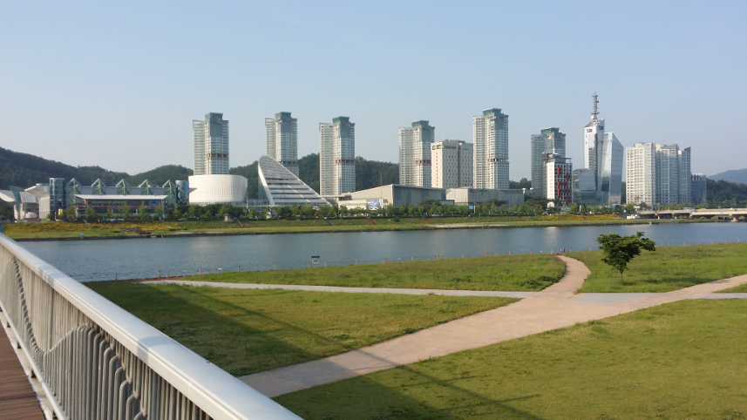

On the other side was downtown Daejeon proper with tall buildings, wide, bustling streets.
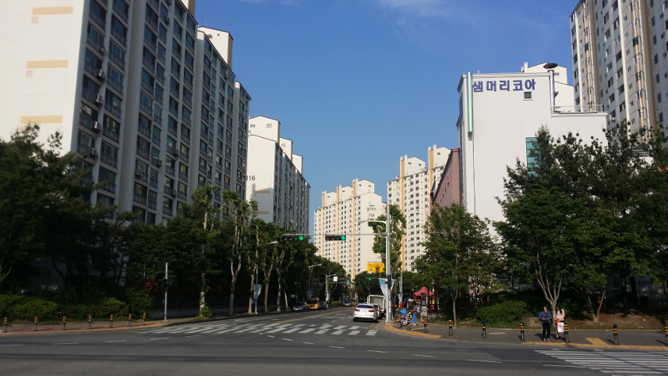
A wonderfully architected foot bridge spanned the two banks, providing a really attractive landmark for the walker, runner, or cyclist (many, many, many of these).
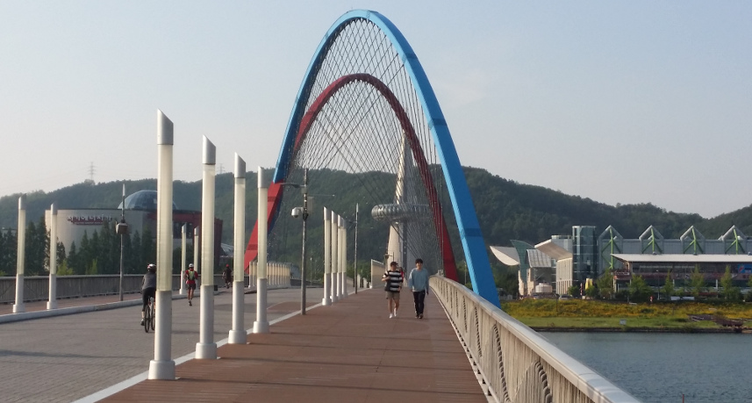
Almost everywhere I went there was modernity and construction.
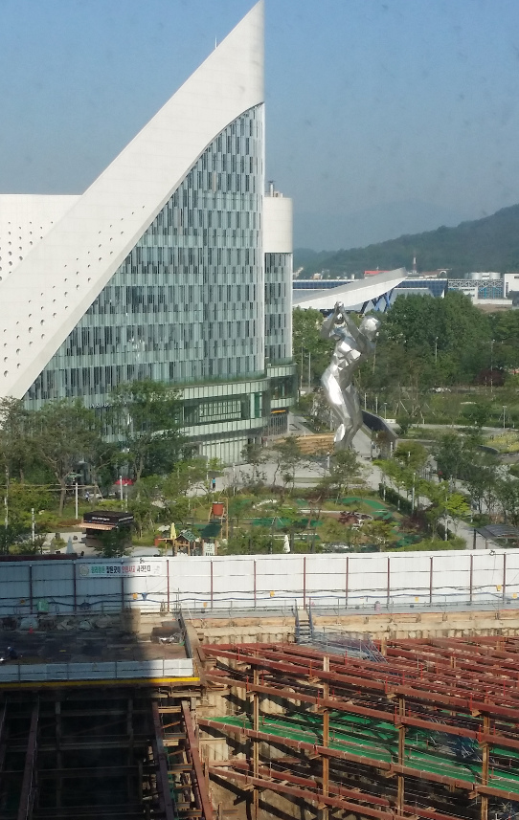
Sometimes the urban arrangement was brand new and well order. Sometimes it was grafted onto older slices of Korea – narrow streets, old shops, packing crates just outside. In all cases, people seemed to have enthusiasm and purpose and, most importantly, choice.
The influence of globalization was to be seen, most notably in the form of 7-11
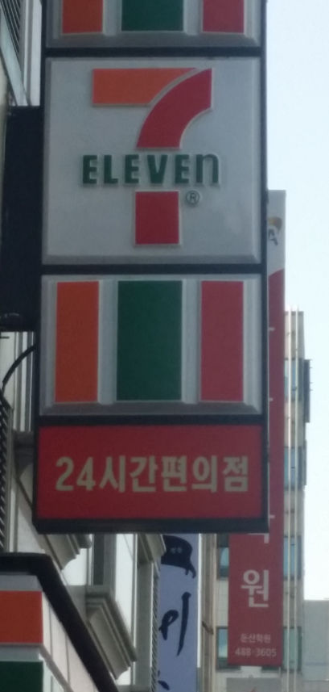
and Dunkin Donuts
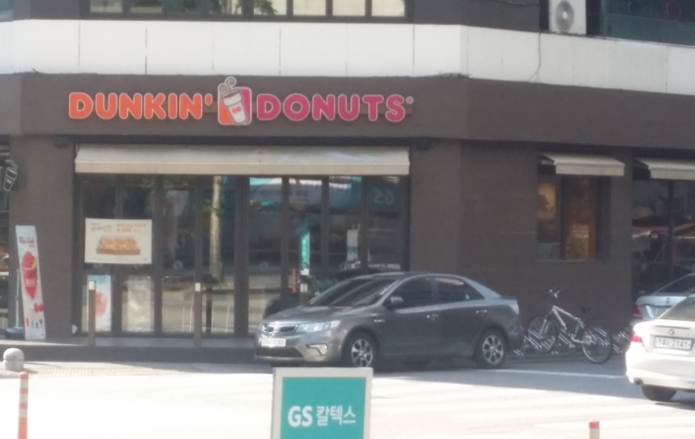
But the need for nature of green space was not ignored. Indeed, within the heart of a city was a large, well-groomed park that boasted an arboretum. A small but steady flux of people entered and left the park during the day, lingering and relaxing.
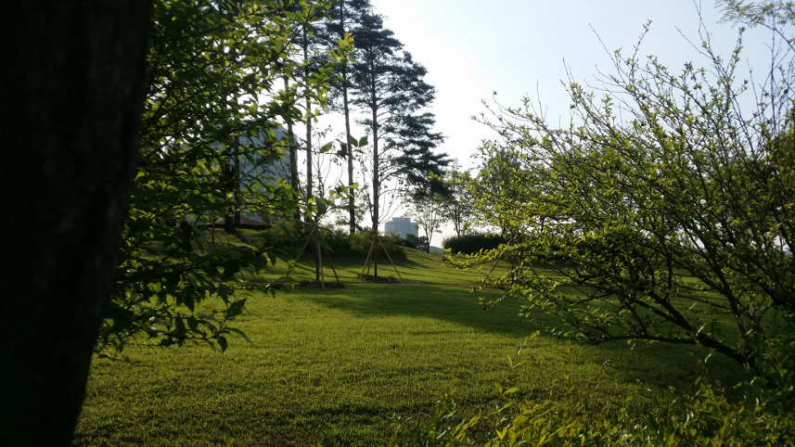
Daejeon plays host to many of the governmental entities, including the Korean Aerospace Research Institute (KARI), the country’s analog to NASA, and Statistics Korea (KOSTAT), an arm of the Ministry of Strategy and Finance, the Korean amalgam of the Bureau of Labor Statistics, Bureau of Economic Analysis and, no doubt, a bunch of other Bureaus and Agencies here in the US.
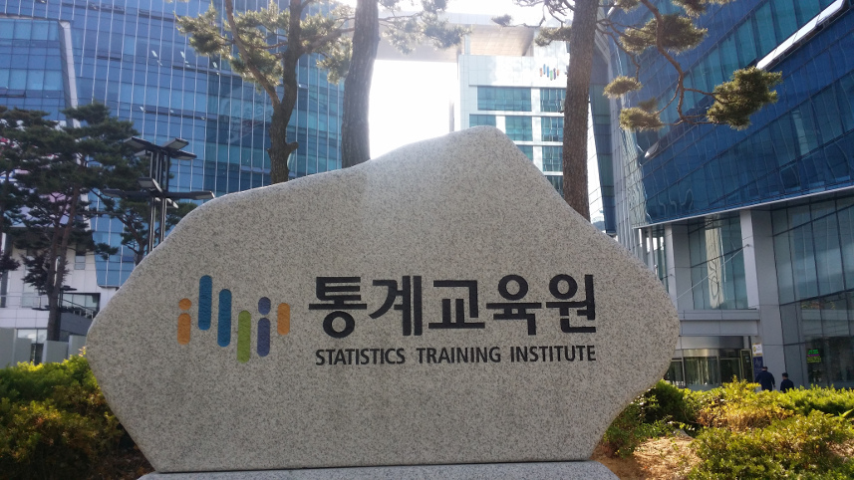
The South Korean government seems to take the promotion of economic growth, the development of high-tech infrastructure, and the health and well-being of their citizens seriously.
In contrast, the most charitable thing I can say about North Korea is that its government doesn’t. The only picture I can offer is the famous image of the Korean peninsula at night, taken from the ISS.
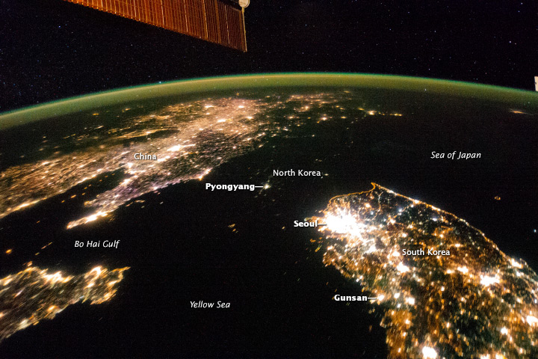
Note the dynamic nature of South Korea; the intense lights dotting the country with a veritable explosion of brightness surrounding Seoul. Note the substantial development even in China. It’s hard to believe that there is actually a land mass connecting the two, upon which North Korea stands. Alas, the Hermit Kingdom doesn’t provide infrastructure, or choice, or often even ample food for its population.
As I mentioned at the beginning, no reliable values for either the Gini Index nor the HDI are available. Based on an article from the Peterson Institute for International Economics entitled The Distribution of Income in North Korea there are good reasons for thinking that the income distribution is perhaps the worst in the world. To quote:
[I]f these trimmed sample estimates [of income distribution] are to be believed, one might consider North Korea as the country with the most unequal distribution in the world.
- Marcus Noland (PIIE)
Since the HDI is a geometric mean involving the Gini Index, overall citizen health, and overall education, it isn't credible to believe that human development in the country is high. Quite the contrary, the unequal distribution of everything argues that North Korea is a land of deprivation and misery for the majority of its people.
The view from space speaks more eloquently to this fact than a mountain of statistics. It is interesting to see how, in this one picture, the spectrum from full free-market to full centrally-controlled economies plays out for the entire world to see. Hopefully this photograph will find its way into all textbooks as a concrete lesson on the positive things that can happen when people are free to choose.

