Gravity Falls on Switzerland
Switzerland just flirted with their own version of the social experiment that has already worked oh so swimmingly for the company Gravity Falls: guaranteed outcome regardless of the performance. Flirted but not consummated. Swiss voters overwhelmingly rejected a proposal to grant each citizen the security of certain level of income regardless of personal station or level of responsibility or work ethic or any of those things that society wishes incentivize with profit.
So does this mean that Switzerland is not the social-democracy that much of the rest of Europe is? Well, that is not a safe conclusion to make. While there seems to be a germ of common, economic sense in the average Swiss, the fact that the proposal made it up for a national referendum is worrisome. So too are some of the explanations for why the measure was defeated by a 3-to-1 margin.
Before digging into the analysis, some words are in order to describe what that proposal actually proposed.
According to the BBC, the central notion was that each Swiss citizen would receive a stipend each month from the government in an amount of $2,500 USD for basically, well…, breathing. In addition, for each minor child that is also sucking in air, the caregiving would receive an additional $600 USD. (Please note that the figures cited here are rounded down from their actual values.)
Let’s take a moment to look at this. A single person would make a gross income of $30,000 for just hanging out. A married couple would make $60,000 for just hanging out with each other. If they start having children then the value goes up. A family of four would then ‘earn’ $88,000. Not too bad. Certainly it palls in comparison with the approximately $55,200 average net salary for a working individual (or $110,400 for a family of four) under the current rules, but then again, the recipient of the proposed windfall would not have to deal with that pesky work thing.
For those wondering if a fairer comparison would use the average gross salary, realize that the about 1/3 of gross income goes to the government whereas this ‘free money’ would also be free of taxes since it is provided by the government, who, no doubt, already took its cut – or so its supporters likely think. The picture further tilts towards disengagement from honest work when one realizes that average incomes are always skewed towards the high end by the few very larger earners (bankers, CEOs, and entertainers).
Thankfully the Swiss recognize that such a method is a fast way to disengage people from working. However, it is fun to think about what would have happened if the measure had passed.
The first day after passage would find not much had changed. The same number of Swiss would go to work as had gone the day before. This would last until the first checks were cut, shipped, and cashed. Then suddenly there would be more money chasing the same number of goods. So step one is inflation.
Now everyone is more miserable, and the hard workers would start looking around for someone to blame. It won’t take long for some of them to act on their resentment and quit – equity theory at work. They would lose their salary but would have the guaranteed money to fall back on. Now things may briefly get a bit better, as the inventory will not immediately fall but a lesser amount of money is now chasing the same number of goods. Thus inflation drops. So step two is a modest recovery.
But the recovery can’t last for very long. For when the inventory shrinks the number of goods will as well since there are now fewer people working. So here come inflation again. Here come more resentment by those who kept working. And, no doubt, some more workers will drop out.
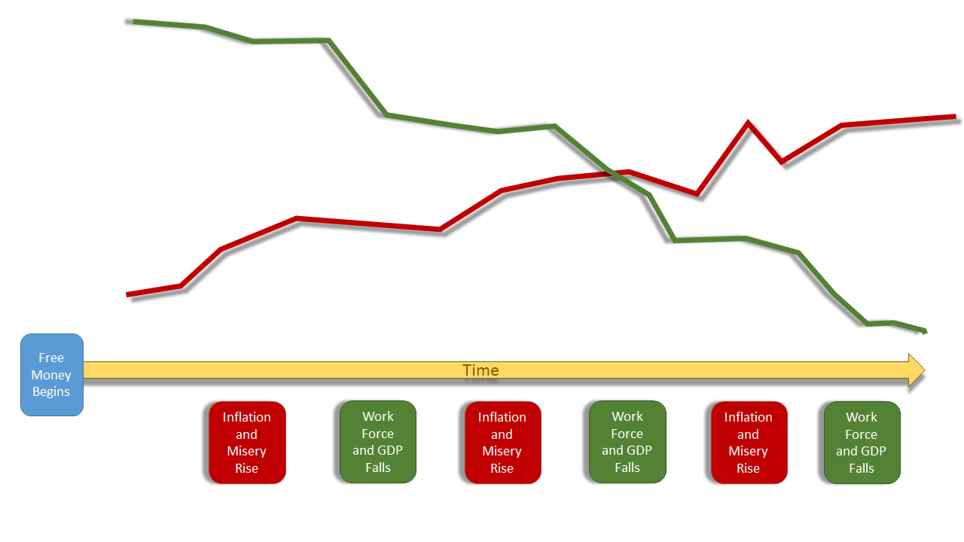And the cycle repeats itself, with the only result being an ever-shrinking GDP and an ever-growing misery.
This pattern has been seen time-and-time again, starting with the classic story of the near failure of the Plymouth Plantation, to the case of Gravity Falls, where a minimum salary prompted some of the best and most valuable employees to up and leave. Other cases include the Soviet Union, Zimbabwe, and like economic situations. When the profit incentive to work is lost so is the society as a whole.
What is really interesting where the arguments both for and against the Swiss measure as cited by the BBC. On the pro loafing side, the proponents claimed that
<since work was increasingly automated, fewer jobs were available for workers. – Supporters of the Unconditional Swiss Salary>
Okay, let’s think about this for a bit. Who maintains the machines? Perhaps other machines, which are, in turn maintained by still other machines. Switzerland must have machines all the way down. Oh wait! There must be human workers who maintain the machines. And what about improvements? Surely, even the fine country of Switzerland must have problems. Perhaps the supporters of this idea might put their energies into curing cancer, or helping the poor, or… well you get the picture.
Now the fact that there are slackers who want a free lunch presents no surprise. Every society has them. The fact that they were able to mount enough effort to get this measure up to a referendum is mildly unexpected but given Swiss law still not shocking. The real shock came in the governmental response.
The BBC quotes one Luzi Stamm, a supposed right-wing member of parliament as stating

<Theoretically, if Switzerland were an island, the answer is yes. But with open borders, it's a total impossibility, especially for Switzerland, with a high living standard,
If you would offer every individual a Swiss amount of money, you would have billions of people who would try to move into Switzerland. – Luzi Stamm>
Right-wing huh? More like right out to lunch. This quotation is perhaps one of the stupidest things I have ever heard. What does being on an island have to do with it. The Pilgrims were effectively on an island and their communal economics nearly killed them. And the Earth is the most ideal definition of an island as you can get. Isolated by space, with nobody getting on or off (except by birth and death) the planet has the most perfectly implemented closed borders. So following Stamm’s logic, we should all print ourselves money and, theoretically, it will all work out.
Thank goodness there are still hard working people in Switzerland with some sense in their head. No sooner had this measure’s defeat become news then we started hearing rumors that Washington D.C. was starting to explore the possibility of the same kind of handout. Whether the people of the nation’s capital have sense remains to be seen.

