The Pinto and the Tesla
It is hard to imagine two cars further apart from each other than the Ford Pinto and Tesla Motors’ Model S (or take Model X or 3 – the discussion works with any of these). The former is synonymous with the bad designs and sub-standard manufacturing that became the hallmark of Detroit’s ‘affordable cars’ in the seventies and eighties. The latter is a testament to how high-tech designs and advanced production can be married into a space-age, ultra-luxury vehicle for this digital world. Running on gasoline, the Pinto possessed not a single integrated circuit outside of its sound system, and the very idea of onboard computer control was laughable at the time of its launch. Powered by state-of-the-art electric batteries, Tesla vehicles have sophisticated computer controls that enable adaptive lighting, self-parking, and a host of other perks as every-day features.
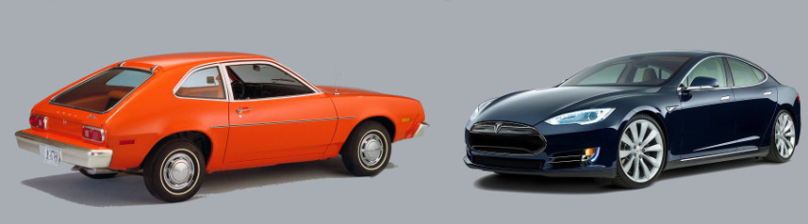
And yet, there is one very disturbing commonality between them that transcends the mere similarity that both are four-wheeled motor vehicles. Both cars will go down in history as object lessons on the danger of withholding safety information from the marketplace. Before exploring this topic, I want to make it clear that I am not implying that the Tesla is unsafe, nor am I asserting that the Pinto was, either. As I hope to make clear below, it isn’t even clear how to define what unsafe means. Rather, the central point is whether each manufacturer, Ford and Tesla, worrying about how the safety of their vehicles would be perceived, actually hid relevant information from the marketplace.
Each of us can relate to the concept of concealing embarrassing or unflattering information from the world around us. When it comes to our personal lives, each of us is entitled to a degree of privacy. But even this cherished concept has limits. Is it reasonable to be able to hide every fact of our private lives from an employer? Doesn’t the employer, who is buying our labor, have a right to know if there are any outside issues that will compromise our ability to deliver? Likewise, don’t we have a right to know certain facts about the people for whom we will work? Wouldn’t you like to know if your boss has had a history of embezzlement or sexual harassment?
The situation is even more pronounced when talking about a product or good. When contemplating buying a product, the consumer should be able to make an informed decision about what the product can do for the price required to procure it versus the risk; what it can’t do, what its limitations are, how reliable it is, how soon it will break, and so on. In economic terms, what we are talking about is the need to have relevant information in order to be able to adequately judge cost versus benefit risk. The need to mitigate risk with limited information is a major driver in economics decision making, even if the abstract theory is not well understood.
It is the idea of being well-informed, of having all the relevant information, that goes to the heart of both the Pinto and Tesla in their presentation to the public.

The Pinto
The Ford Pinto was a subcompact car that was sold for model years 1971-1980. While comparable in design and safety to its contemporaries in its class (in fact having a better safety record than most), the Pinto achieved a distinction in automotive history that the others failed to capture – it became known, ever after, as an ‘evil car’ that was a ‘fire trap’, and Ford, at the time, was perceived as a callous car company that put profit over human life. These verdicts resulted from the confluence of three factors (taken from the Wikipedia article and the factual summary provided in The Myth of the Ford Pinto Case, by Gary T. Schwartz).
First, during their design of the Pinto, Ford Engineers decided to put the fuel tank behind the rear axel rather than on top of it. This was a conscious decision made to afford the consumer more trunk space. The trade-off was that the fuel tank was prone to rupture in the event of a rear-end collision, causing a fire hazard to the occupants. The risk of tank rupture was increased by other design decisions that limited the size of the ‘crush space’ and significantly reduced mechanical structure that would have provided reinforcement to the space surrounding the gas tank.
Second, a tragic case occurred in May 1972 when Lily Gray gave a ride in her Pinto to her teenage neighbor Richard Grimshaw. The car stalled in a highway lane and was rear-ended. Gray died due to the crash and subsequent fire, and Grimshaw suffered horrible injuries. The Grimshaw family subsequently sued Ford, and the resulting discovery revealed documents that put Ford into a bad light.
Third, public opinion was significantly molded and shaped by an article that appeared in the September/October 1977 issue of Mother Jones entitled Pinto Madness by Mark Dowie. The article starts with the inflammatory accusation
<For seven years the Ford Motor Company sold cars in which it knew hundreds of people would needlessly burn to death – Mark Dowie>
This article turned public opinion very strongly against the Pinto and led to the National Highway Traffic Safety Administration (NHTSA) demanding Ford recall the Pinto despite the fact that years earlier NHTSA had concluded that there was not enough information to warrant even opening an investigation.
What swayed public opinion and cemented the legacy of the Pinto were internal memos from Ford that seemed to paint the picture that Ford thought it would be cheaper to pay settlements to those killed and injured than it would be to retool the factories to make the car safer. This led Dowie to say
<Ford waited eight years because its internal “cost-benefit analysis,” which places a dollar value on human life, said it wasn’t profitable to make the changes sooner. – Mark Dowie>
In contrast to Dowie’s outrage over cost-benefit analysis, Gary T. Schwartz, in his article, entitled The Myth of the Ford Pinto Case, remarks that
<…the standard public policy analysis of products liability calls on manufacturers, first of all, to design products in risk-beneficial ways, and secondly to advise consumers of non-obvious hazards that remain in a product’s designs once those risk-benefit decisions are rendered.>
Schwartz also goes on to note that
<[T]he case shows how disturbed the public can be by corporate decisions that balance life and safety against monetary cost. This disturbance suggests an apparent mismatch between public opinion and the assumptions underlying the risk-benefit test for design liability. … In any event, the public’s dissatisfaction with the practice of confidential corporate risk-benefit balancing highlights the appropriateness of thinking about the Pinto case in terms of the manufacturer’s duty to warn.>
In short, the Ford Pinto was done-in more by the perception that Ford withheld vital information than by the actual risk the car posed to its occupants.

The Tesla
Fast forward nearly forty years. While the technology may have changed, the human equation has not. This time the issue of withholding vital information from the marketplace falls squarely on the Tesla Motor Company. At issue is again a perception of safety and what responsibilities the manufacturer has to warn its customers.
To set the stage, we need to step back a bit to the fall of 2014. In an article dated October 9, CNET’s Wayne Cunningham gushes over the new features of the Model S, in particular, the set of advanced driver assistance features that enable adaptive cruise control and lane keeping assist. Cunningham notes that each Model S bears a forward-looking radar and camera and panoramic ultra-sonic sensors that enable the vehicle to ‘see’ speed limit signs and follow ‘curvy’ lane lines. Tesla Motors branded this new feature Autopilot, which, according to their website,
<… allows Model S to steer within a lane, change lanes with the simple tap of a turn signal, and manage speed by using active, traffic-aware cruise control. Digital control of motors, brakes, and steering helps avoid collisions from the front and sides, and prevents the car from wandering off the road. Autopilot also enables your car to scan for a parking space and parallel park on command. And our new Summon feature lets you "call" your car from your phone so it can come greet you at the front door in the morning. – Tesla Motors>
All this advertising sounds great but the fly in the ointment came about 18 months later, when on June 30, 2016, Tesla revealed that someone had lost their life in a traffic accident on May 7th with Autopilot enabled.
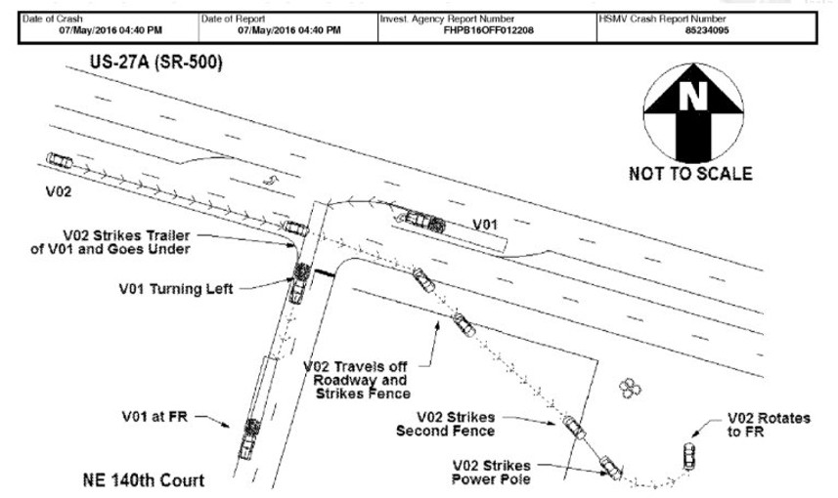
The news reaction, while so far more measured than the Mother Jones piece on the Pinto, still sought for the sensational angle. For example, consider the opening paragraphs in the article What Tesla Autopilot crash means for self-driving cars by Greg Gardener
< This summer, autonomous cars collided with reality.
All those sensors and cameras and spinning cylinders of laser beams don't know as much as we thought they did. At least not yet. >
And like the Pinto case, there are competing explanations for the accident. According to a report by the Associated Press, the fault in the crash lies with the car’s cameras being unable to distinguish the white tractor trailer with which it collided from the brightly lit sky behind. Another report suggests that the radar system on the Autopilot is tuned to disregard overhead signs and that, as a result, its input to the autonomous decision-making was disregarded even if it had sensed the truck. When questions of liability are involved, there is likely to be no end of speculation and controversy.
As a result of the accident, Tesla Motors is being investigated by three government agencies: The National Highway Traffic Safety Administration (NHTSA), The National Transportation Safety Board (NTSB), and the Security and Exchanges Commission. NHTSA’s involvement is natural. NTSB’s involvement, while a bit out of the ordinary, is reasonable since NTSB seems to be keeping its eye on autonomous driving features being developed. The reason for the SEC being involved smacks of the ‘profit before people’ angle that reared its head in the Pinto case. Tesla and Musk are being investigated for insider trading because they failed to report the fatality on May 7th before they sold $2 billion in stock on May 18th.
As these various threads weave together to form a tapestry, it will be interesting to see just where the line is drawn on what Tesla should have told its investors and its customers and when. Their advertising copy certainly makes Autopilot sound bulletproof. They don’t warn the consumer of its limitations; and not just the ones being attributed as the core causes to the May 7th accident. As far as I can tell, Tesla does not point out that Autopilot can’t keep the vehicle in a lane on a road with no lane markings. Many of the back roads and small highways in the nation don’t have clear markings and how Autopilot will respond in these cases is unknown. Of course, the more Tesla points out these limitations the less appealing Autopilot will seem. So where is the balance between too much and too little information to be struck? Only time will tell.

