Vicious Cycle
Often in macroeconomics analysis we hear about favorable and unfavorable business cycles, of the ebbing and flowing of macroeconomic forces of aggregate supply and demand that can sale a fleet of businesses into new waters teeming with fish or pitch them onto a reef. But there is another and more interesting business cycle which some recent experiences have put firmly in my thought.
The stage for my experiences can be set with one simply phrase – back to school shopping. Like millions of parents across the United States, I found myself in the position of hauling one of my kids and a not-insignificant subset of his position some 350 miles north to college. I have made this particular trip many times, laden with pounds and pounds of teenage positions. But what made this trip particularly interesting was it was the first time one of mine had housing in an unfurnished apartment, which was being shared between him and 3 other young men. This routine return-to-college trip suddenly transformed into something akin to a permanent moving to a new city.
Since my vehicle was the family car and not a rented U-Haul, the necessities of furnishing a new apartment had to be done once we had arrived and that meant purchasing lots of furniture in a short time from stores that I don’t normally or never had patronized before. And that is where the lesson really begins.
Looking for bargains (who doesn’t) and being in unfamiliar territory led us to visit a chain that had once been mighty in days gone by and was now transformed into something more akin to a bottom-feeder. I won’t mention the name for the very reason that doing so contributes the very ‘business cycle’ that this column is about.
This store, a mere shadow of what it once was during its former glory days, offered nice products, a bit on the cheap side, but nice. That said, neither the quality of the goods nor the quality of the shopping experience could really compare to its higher end competitors. Nonetheless, we found some suitable choices at prices we could live with and so the deals were struck, trunks were loaded and so on.
After having delivered and installed these items in our son’s room, we got into talking with the parents of the other boys, who, like us, were trying to furnish the apartment with as little cash outlay as possible – paying tuition tends to do that to a parent. We recommend the chain we had just visited and off the others went to give it a look.
Hours passed before they returned bearing goods from one of the competitors. When we asked what they thought about the store we recommended we got an interesting answer. It seems that the other parents had gone and had actually seen a set of table and chairs that would work for the shared kitchen at an agreeable price. What had stopped the deal from happening is that they wished to talk to someone about the goods and, after waiting 20 minutes, they had decided that the customer service was terrible and they took their dollars somewhere else.
As they were narrating their experience, I realized that when we were shopping in that store I hadn’t really seen any employees around. The store, for the most part, was devoid of employees. A few were at the registers, a few more at the snack bar, and I saw a manager moving to and fro keeping an eye on things. But I didn’t see employees circling different areas (e.g. electronics, apparel, etc.). There just wasn’t that many people supporting the day-to-day operations.
As I reflected on this realization, I found myself led to two different conclusions.
First, it makes perfect sense that the number of employees for a store such as I described earlier should be minimal. An institution trying to hang on to the low end of the market share can’t cut goods or store space. The only thing they can cut is people cost. They need to offer less in the way of services in order to keep costs and prices down and, in doing so, stay competitive.
Second, the necessity of cutting personnel costs drives customers and, more importantly, dollars away. As the shopping experience falls so does the traffic into the store and the probability of moving goods.
And so it is easy to see how a viscous circle can form that drives businesses out of business. It starts when a business stops growing, either due to management missteps or changing tastes or new technology, and begins to lose customers. As the cash flow beings to dwindle, the business need to cut back on goods and services, which usually results in an accelerated loss of customers, which in turn accelerates the descoping.
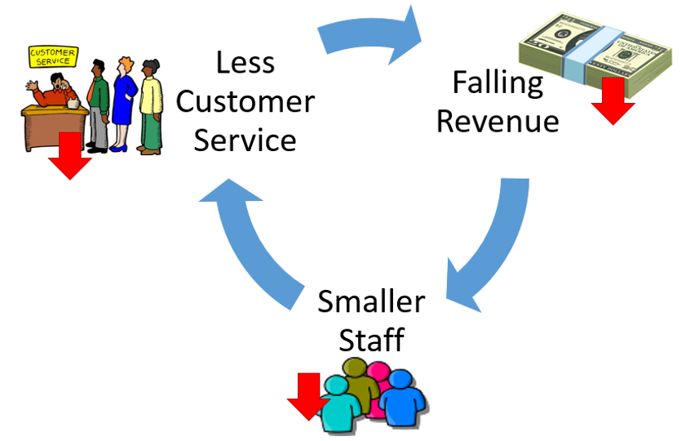
This negative feedback loop has only two ends. Either the company finds just the right combination of new goods and services to offer or it goes under. And it seems that the later outcome is more usual compared with the former. It takes a lot of hard work and luck for a business to reinvent itself once public perception has gone the other way and both of those require that the business stay afloat while the reinvention takes place – and that means capitol.
Capitol to continue the supply chain so that goods stay on the shelf. Capitol to keep employees working the business and keeping the customer service high. Capitol to create and air advertisements that hopefully change the consumer attitude towards the business. And if that capitol isn’t available, the viscous cycle will just pull a business down.
Indeed, there is a lot of truth in that old saying that it takes money to make money.

