On Gold, Water, and Shoes
Picture, if you will: the date is April 21, 1961, the network is CBS, the show: The Twilight Zone. For last 59 episodes, Rod Serling, the creative mastermind of one of the most influential and important of American TV shows had been serving up anthology stories with one part wonder blended one part terror blended with a strong helping of morality that served as its ethical compass.
On the particular evening in question, Serling presented an episode entitled The Rip Van Winkle Caper about a quartet of thieves who conceive a daring and unusual plan to steal a truck carrying gold, hide it in a Death Valley case, and outwait the authorities, thus allowing them to evade the consequences of their larceny and live large on the proceeds.
But, perhaps, the term outwait is inadequate to convey what they have in mind. The head of this little band of bandits, Mr. Farwell, is a scientific genius with a flair for the absurd. He invents a suspended animation device that sends the foursome a hundred years into the future under the assumption that by then the furor will have totally died down.
As most of the Twilight Zone tales go, there is a moral and a moral cost to this group’s bad decisions. One of them never lives to awaken a century later due to a malfunction in his unit and another one kills a third over mistrust and suspicion but, in the process, deprives the now-halved set of survivors of the ability to transport all that gold (too say nothing of themselves) through the desert and back to civilization.
Greed being what it is, the remaining two, the scientist and the weapons man, start off on foot with far too much gold and far too little of the water. Eventually, they dwindle down to just Farwell dragging an ever-dwindling supply of gold bars as he struggles more and more against the blazing sun and the deadly threat of dehydration.
In the final moments a traveler finds Farwell, who, being on the brink of death, offers his last bar of gold for just enough water to survive. Sadly, before the traveler can do anything to save him Farwell dies. Then the surprise of the tale comes:
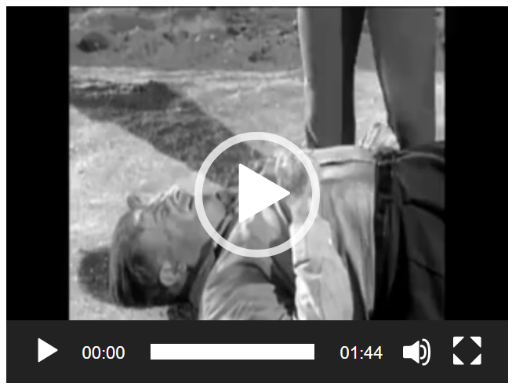
This tale vividly illustrates the seemingly irreconcilable contrast between the practical value of water and the perceived value of gold. This well-known effect is called the Paradox of Value, the solution of which eluded many of the most profound thinkers of human history. Afterall, how can a substance so useless to the health and preservation of life (e.g., diamonds or gold) be so highly sought after while the essential ingredients of human existence (air and water) are so cheap that everyone can afford them?
Economists argue that the resolution of the paradox comes by first recognizing the role that marginal utility plays in determining value. Marginal utility is defined as the additional joy, fulfillment, enjoyment, or satisfaction (i.e., utility) that comes from using one additional unit of a good or service.
One of the earliest illustrations of marginal utility comes from the economics work entitled The Positive Theory of Capital by Eugen V. Bohm-Bawerk. In this work, Bohm-Bawerk asks us to imagine a farmer who has just harvested 5 sacks of corn and must decide what to do with them. The first sack he deems essential for keeping himself just as subsistence while the second he uses for food to keep himself healthy enough to plow, plant, and harvest the following year. The next two sacks he designates for the more comfortable purposes of growing livestock so that he can have meat, cheese, butter and so on (third sack) and corn mash liquor (fourth sack). Finding no additional needs or burning wants, he uses the fifth sack to feed the parrots that flock near his farm “whose antics amuse him”. Bohm-Bawerk then asks us to further imagine the farmer now having lost a sack of corn. Will he take a fifth of the remaining four sacks so that he might again feed the parrots? Bohm-Bawerk’s answer is that the farmer will not as parrot-feeding is the least of his worries.
Returning to the water/gold question, the resolution is simply that in most cases a person can always find water and so the marginal utility of getting more water is low whereas gold, being quite rarer, has a higher marginal utility. Serling’s morality play being set in the Death Valley makes water rarer still and thus raising its marginal utility above gold’s. The final surprise, which is still enjoyable, merely underscores the notion that most things don’t have an intrinsic value but rather derive their value in context relative to everything else.
And this theory is all well and good as far as it goes, but it does raise an interesting follow on as to whether this theory helps us understand the modern-day phenomenon of the collector. To sharpen this idea, consider the commonly-asked question concerning a fascination that certain women have for fashion: just how many pairs of shoes does she need?
We can try to follow the example of Bohm-Bawerk by imagining a woman who collects shoes – an ordinary shoe collector and not the extreme as exemplified by Imelda Marcos.

Supposing that her collection is made up of, as is usually the case, distinct pairs of shoes. Does marginal utility really help us understand her economic decision making? Does it help us understand why a new pair of shoes is a priority when so many others are taking up space in a closet? On one hand, the styles differ one might well ask if a new pair of shoes doesn’t have the same marginal utility. After all, pumps and sandals hardly send the same fashion statement. On the other hand, just how many slightly different black shoes with kitten heels can one wear?
Judging by lack of scholarly articles and general website links this seems to be wide-open territory for the economic researcher. Perhaps the next Nobel prize in economics will go to the person who figures out the theory of value of the slingback.

