A Roche Limit Review
I don’t normally like to write about a new comic until the creators have published at least 6 issues. My logic being that it takes a while for the writer and illustrator to find their voice and hit their stride. But, letting my ‘geekier instincts’ get the better of me, I’ve decided to try something different and put down some thoughts about the new Image dystopic, science fiction comic Roche Limit.
My reason for ‘jumping the gun’ is that I am really fond of the dystopian, science fiction genre for a variety of reasons and I was excited since Roche Limit touches each one. First off, I have a long and abiding interest in the look-and-feel of science fiction in the visual media (films, video games, and comics). The lines and forms that can be expressed in these contexts are usually so much nicer than what can actually be engineered or manufactured that it is a treat for the senses simply to immerse oneself in the fictional world. Second, I enjoy the grittier presentations of the future where improved technology serves to enhance what is best and worst about us. The greater the technology a character has at his disposal the greater a magnifying glass we have to examine his soul. Third, I enjoy that form of detective fiction where the tracing of a small crime leads to a large and profound discovery. There is a certain pleasure in pulling on a seemingly insignificant thread and finding that it unravels a deep secret.
A prime cinematic example employing all these elements is found in the movie Outland. In Outland, a small-time and washed-up sheriff comes to a mining colony on the Jovian moon Io and, in the course of his normal duties, discovers a lethal conspiracy by the mining company’s management to improve productivity through the use of some creative chemicals (i.e. drugs). Similarly, the video game Bioshock offers these three elements in an engaging storyline in which the player ‘finds’ himself introduced into the futuristic underwater city of Rapture, where this closed community is suffering under the influence of a turf war between opposing political factions and a bad case of DNA-splicing technology run amok. Small choices quickly lead to interesting discoveries and troubling ethical questions.
Roche Limit is constructed to deliver a similar experience in comic form, mostly, it seems, by heavily borrowing inspiration from Bioshock with liberal with dashes of flavor from Outland to round out the recipe. The basic premise of the story is that sometime in the not-too-distant future, a gravitational anomaly has been found in a nearby galaxy. An eccentric billionaire, by the name of Langford Skaargred,
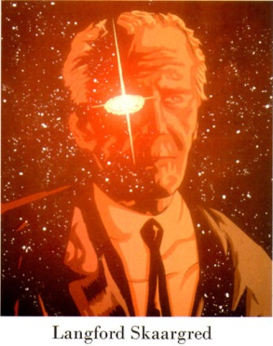
has funded the colonization of the dwarf planet that is in orbit about (or otherwise gravitationally bound) to the anomaly. Thus is born the Roche Limit colony. However, Skaargred’s dream of a shiny, happy future has been quickly corrupted by the realities of human nature and Roche Limit has turned into something a lot darker.
At the start of the story, Sonya
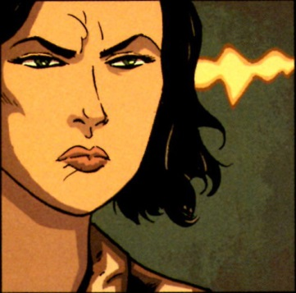
a cop from Earth, has arrived on Roche Limit to look for her missing sister Bekkah.
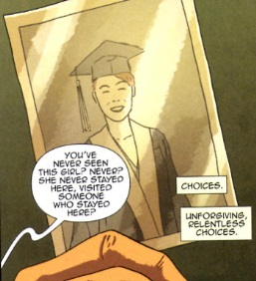
As her search for progress, Sonya becomes acquainted with the seedier elements of Roche Limit. Primary amongst these is Alex Ford
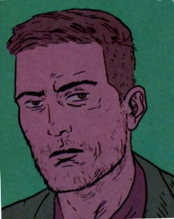
the only person in existence who knows how to make the drug Recall,
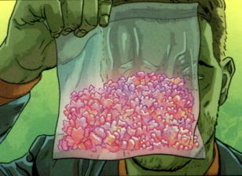
using a secret refining process of a mineral peculiar to the dwarf planet’s composition.
He quickly joins Sonya in her search as Bekkah and Ford were in a relationship up to her disappearance. Using Ford’s connections as the preeminent pusher in perhaps the whole galaxy, Sonya soon comes to be acquainted with a whole host of the colony’s most lovable playmates. These include: Gracie,
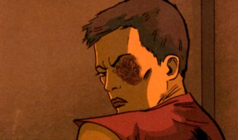
the one-eyed madam with a heart of gold for women and vicious streak for men who abuse them; Moscow, Gracie’s rival in crime,
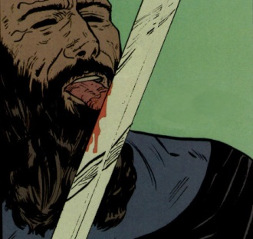
who seems to be as addicted to Recall as he as he is blood thirsty; and Doctor Watkins
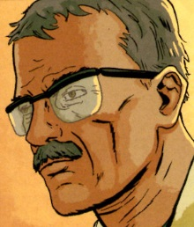
a shadowy scientist who is experiment on human subjects by sending them into the anomaly and then retrieving what is left over.
The whys and wherefores of this story are still developing and I don’t want to spoil too much, but it seems that there is connection between the Recall drug, Bekkah’s disappearance, the collapse of Langford Skaargred’s utopia, and some mysterious creatures that seem to be in touch with an intelligence that is in or beyond the anomaly.
On the surface, Roche Limit has all the makings of an excellent story. Futuristic technology – check; Gritty underworld drama – check; Dogged cop on the trail of something big – check. But somehow, the whole that I’ve seen so far is less than the sum of its parts.
The characters lack originality. It’s not that they are one-dimensional but more like they are clones of characters that have been done scores of times. Sonya is monolithic in her zeal to find her sister, but I suspect that somewhere along the line she and Ford will become involved. And the tension between Gracie as the good criminal and Moscow as the bad one seems also familiar and a bit tired. Most likely, Moscow will go completely off the rails and Gracie will come out on top as the tough and reluctantly benevolent leader of Roche Limit.
The verisimilitude is also limited. The creative team seems to want to be true to real world physics and even include a formula and some diagrams on the cover that are associated with the astronomical concept of the same name. Nonetheless, in trying to be realistic they actually undermine their story. They would have been better off invoking a new and unknown physics rather than trying to adapt to what is known.
Despite these limitations, I remain hopeful that Roche Limit will come through with a compelling story in the end. In particular the segment associated with the beings associated with (coming from?) the anomaly, the nature of the anomaly and the back story of what Watkins is doing with the missing girls seems quite novel.
Only the months that follow will tell whether or not but I intend to stick around for some time.

