Skye’s the Limit
This next set of posts grew out of the eager questioning by family and friends to help them get up to speed with what it means for Agent Skye
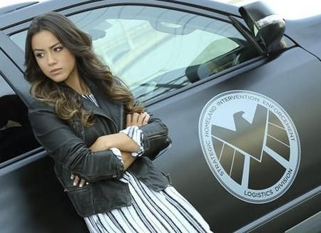
to be an Inhuman and for Calvin Zabo
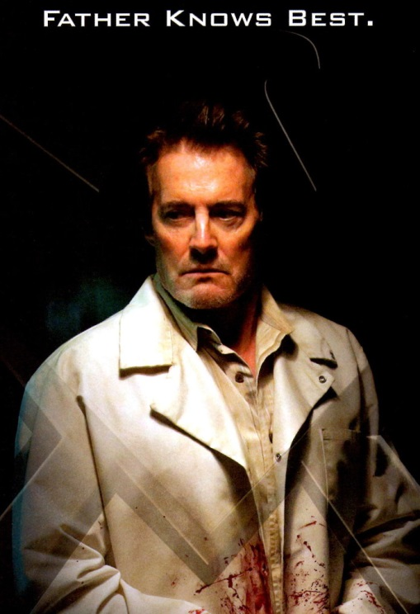
to be her father. As the primary television offering for the Marvel cinematic universe, Agents of Shield gathers many people who are not primarily comics readers. In addition, the show’s core demographic regard the years in which both the Inhumans and Dr. Zabo first appeared on the scene as ancient history. So much like Herodotus, “The Father of History”, preserved the events of antiquity for generations to come, so too do I offer this brief history of the origins and doings of Inhumans and Calvin Zabo from the misty corridors of the 1960s.
The first appearance of any of the Inhumans occurred in Fantastic Four #36 from 1965. The issue’s drama starts to unfold with a meeting between the Sandman, the Wizard, and Paste-Pot Pete. These somewhat inept super-villains contemplate becoming a foursome so that they can take down the Fantastic Four and, in typical comic book logic of the era, they discuss their need to add a lone woman to their ranks so that they can be the evil analog of the FF. The Wizard regales the others with a story about a woman he glimpsed on a Mediterranean island. Here is a snippet of his flashback
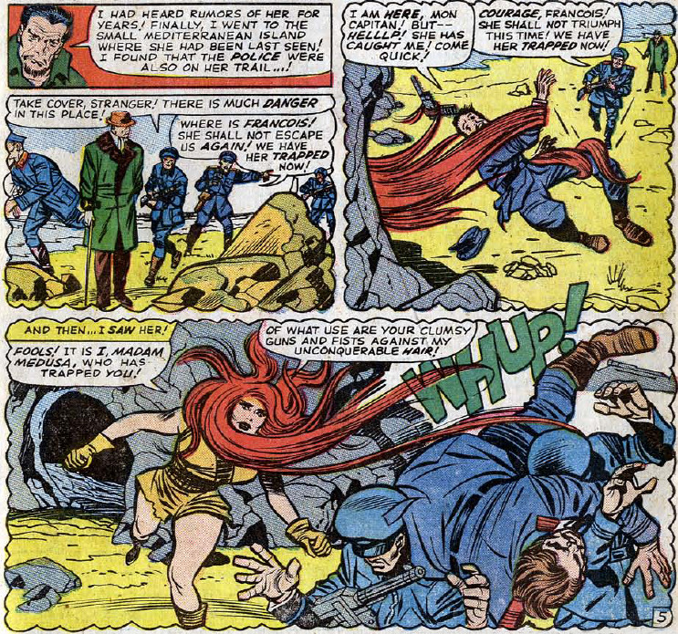
This mysterious woman, identified as Madam Medusa, is the first Inhuman that readers ever glimpsed. I’ve pondered from time to time whether Stan Lee and Jack Kirby planned on her being an Inhuman or whether that idea occurred later to them. I suspect the later interpretation is the correct one as there are clear signs of evolution in all the comics of this time and in the Fantastic Four as well.
In any event, it’s only a short matter of time (or a few pages) before Madam Medusa is decked out in a colorful outfit and ready to lock horns with Marvel’s first family.
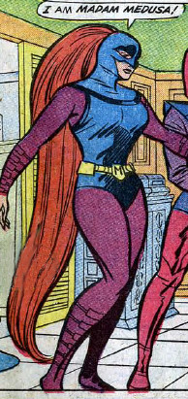
Initially, the Frightful Four, as our super-villains now call themselves, get the advantage over Reed and company, but soon the tide turns, and Fantastic Four emerge victorious.
In her next appearance, Medusa (for the most part Lee & Kirby have dropped the Madam) is given a back story and the Inhumans proper have been introduced. This storyline ran in FF #44 through FF #47.
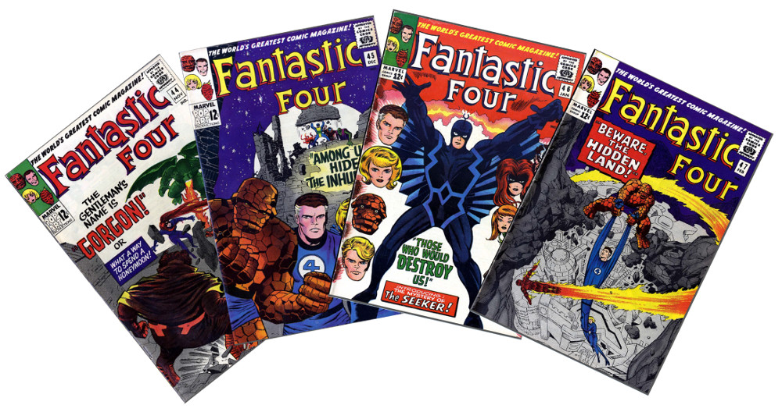
In the space of those four slim issues, almost the whole structure of the Inhuman’s mythos is introduced; a structure that remains mostly unchanged to this day.
Events begin to unfold when Medusa crosses paths with the FF for a second time. Instead of being the hunter, she is now the hunted. Desperate and on the run, she kidnaps the Human Torch in a vain hope that he can help her elude Gorgon. As it turns out, Gorgon is a fellow Inhuman who was sent to bring Medusa back into the fold.
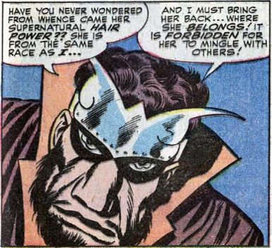
As is usual, a melee ensues, property is damaged, and melodrama jumps off the page. When the dust has cleared, Gorgon has spirited Medusa away to parts unknown.
Shortly thereafter, the Human Torch is roaming around a run-down section of New York City when he comes upon a beautiful blond girl perched wistfully on a crate in the middle of the slum. As he approaches her, this mystery woman summons a wind storm to knock him down as she flees. Johnny has no choice but to return back to the Baster Building. Unable to get her out of his mind, the Torch returns to the slum to next day where the girls now uses fire to block his approach. Finding himself in at home with this tactic, the Torch bursts into flame and quickly catches her.
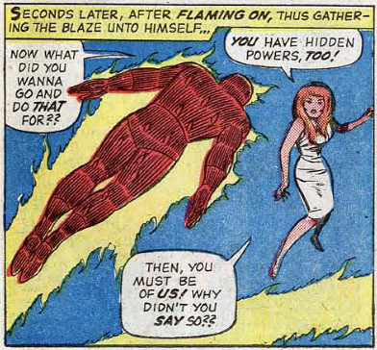
Impressed by his ‘hidden powers’, the girl, now identified as Crystal, assumes that Johnny is also an Inhuman and she immediately reverses course and befriends him. She takes him by the arm and leads him a secret gathering place where he meets other Inhumans, including the martial arts expert Karnak and the amphibious Triton. Naturally, he also comes face-to-face with Gorgon and Medusa, who instantly blow his cover.
Narrowly escaping a trap, the Torch manages to summon the rest of the FF to the scene. After an initial skirmish with Karnak and Gorgon, Black Bolt arrives on the scene. Black Bolt, who graces the cover of issue #46, is incredible powerful and fights the team to a standstill. During the course of this battle, Triton panics and blurts out that the Inhumans are hiding from the Seeker.
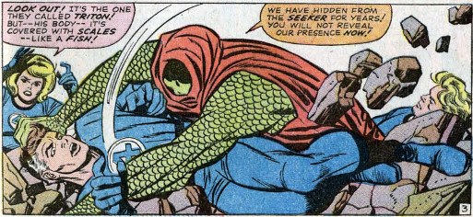
The fight end inconclusively, with the Inhumans teleporting from the scene thanks to their dog Lockjaw.
Unwilling to let the matter drop, the FF continue to investigate. This investigation brings them into contact with the Seeker who captures them and then, as expected, fills them in. It seems that the Seeker is an Inhuman as well and his job is to capture all Inhumans who have fled from the Great Refuge
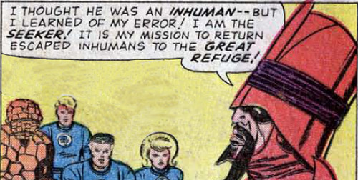
He goes on to explain that the Inhumans are a master race living side-by-side in an exotic local far from in both sophistication and in distance from mere mortals.
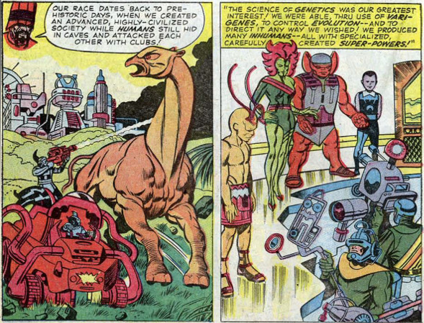
This idea of a hidden race with fantastic powers and sophisticated science is a common theme in many of the creations that Jack Kirby touched. This theme is seen in the creation of the Asgardians in Thor, the Eternals, the New Gods, and so on.
In any event, the Seeker soon leaves for the Great Refuge, taking Triton, who has been captured by the Seeker’s men. Seeking to rescue Triton, both the FF and the Black Bolt’s party of Inhumans follow the Seeker, although each group is unaware that the other is on the way.
As the Black Bolt and company arrive, we are privy to a discussion that fills in one more story point. It seems that the Great Refuge is ruled by Black Bolt’s brother Maximus, who, through some trickery, usurped the crown. Maximus is quite mad and his first gesture is to unleash the Alpha Primitives, a slave race of savages that the Inhumans rule, onto his ‘guests’.
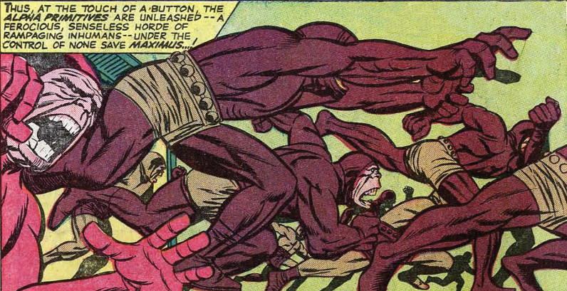
However, the Alpha Primitives prove no match and, shortly afterwards, Black Bolt claims the crown and is recognized as the rightful king. Moments after the crown changes hands, the Fantastic Four penetrate the Great Refuge and Johnny and Crystal, who seem to have fallen in love with each other, are finally reunited.
But the bliss is short-lived as the Inhumans stand in the way of Crystal being with an outsider. It seems that the Inhumans generally dislike and mistrust humans. Maximus, who is quite mad and power hungry, activates his ‘Atmo-Gun’ intended to kill all human life.
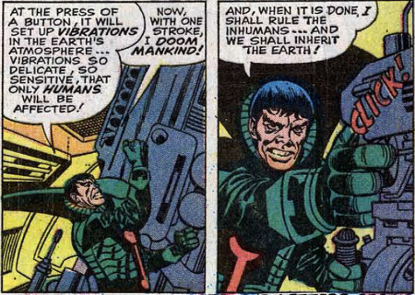
The weapon detonates, bathing the entire Earth, but it only causes a minor annoyance to the world’s population. It is in that moment when the Inhumans realize that they are humans too.
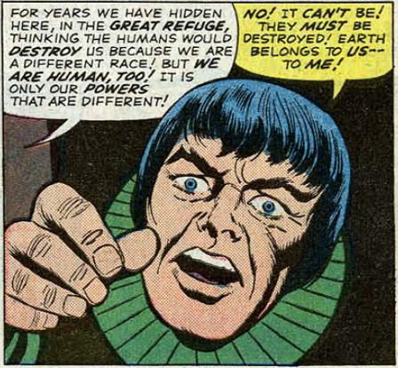
Now pushed into despair, Maximus modifies the output of the Atmo-Gun creating an unbreakable barrier between the Great Refuge and the outside world, sundering the new found kinship between the Inhumans and there more numerous if somewhat blander cousins and, heartbreakingly, separating the new-found love between the Human Torch and Crystal.
And thus concludes the main foundational arc of the Inhumans. Next week, I’ll provide a brief summary of their further exploits in the Marvel history. The following week, I’ll talk give the Calvin Zabo back story and I’ll speculate on what the future holds for Skye.

