Skye’s the Limit – Hyding in Plain Sight
In this final installment, I’ll be covering two different topics related to Agents of S.H.I.E.L.D. as they pertain to Skye and her father. The first topic is a historic look at just who Calvin Zabo is and where he was introduced into the Marvel universe. In the second topic, I’ll speculate on what is in store for our beloved 0-8-4 and how the writers may be deviating from the published works.
Who is Calvin Zabo
First let’s talk about Calvin Zabo.
I must admit that, when Skye’s father was introduced and the connection between Skye and the Inhumans (via the Kree) became increasingly obvious, I assumed that her father would end up being Maximus. This was a natural fit, since dear-ole-dad was clearly super-human and mad as the proverbial hatter.
So, it was a bit jarring when it was revealed that he was, in fact, Dr. Calvin Zabo. Since his introduction in Journey Into Mystery #99 in 1963 until now, Zabo has been a secondary villain, derivative and disgusting, and a bit of a pathetic loser.
For those who aren’t familiar, Journey Into Mystery (JIM) was an anthology title that featured short tales of weird fiction. The character of Thor was introduced in JIM #83, and the title was renamed to Thor by issue #125.
When we first meet Calvin Zabo in JIM #99, he is in his twisted ugly alter-ego Mister Hyde.
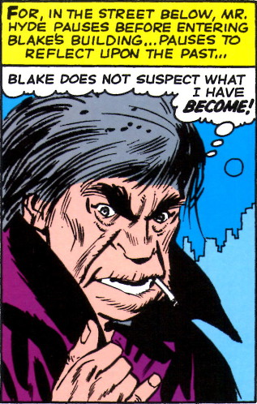
As he stands on a street corner, heedless of the fear and loathing of the people around him, he contemplates his upcoming confrontation with Dr. Donald Blake.
For those more familiar with the modern incarnation of Thor, Donald Blake was the name given to the human guise that Thor would assume in between outings. For a long time, readers were led to believe (and most likely the writers as well since they hadn’t retconned the story yet) that Blake just happened to be bestowed with a Thor alter-ego during a trip to Norway. Later it became convenient to say that frail and crippled Donald Blake was a disguise Odin forced upon Thor to teach him humility. It is this narrative that survives to this day in both the publication and cinematic universes.
In any event, Hyde’s hatred for the good Doctor began months earlier. Before his transformation to Mister Hyde, our villain was simply Calvin Zabo, a knowledgeable doctor and chemist but a complete crook whose modus operandi was to work for other doctors, gain their trust, and then rob them blind. Unfortunately for Zabo, Blake heard of him first and turns him out:
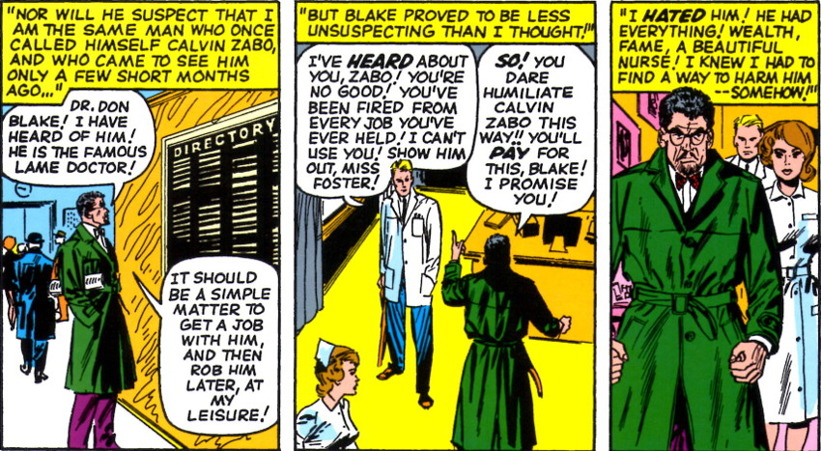
Bitter at this rejection (and apparently dejected that he doesn’t have a beautiful nurse), Zabo devotes himself to revenge. Inspired by the Robert Louis Stevenson story The Strange Case of Dr. Jeckyll and Mister Hyde, Calvin set out to recreate Jeckyll’s elixir.
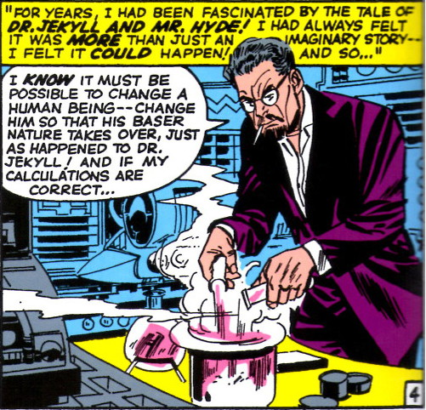
After weeks of experimentation, Zabo achieves success,
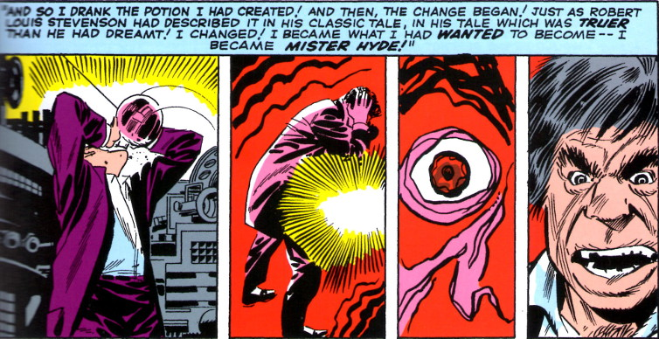
if you can call success being transformed into an ugly lout with a violent attitude and the strength of twelve men.
The remainder of the story is as uncreative and derivative as its beginning. Hyde confronts Blake and throws him out a window, but Zabo doesn’t stick around to see Blake produce a red splat at the end. As a result, Blake is free to transform into Thor on the way down. A typical melee occurs, evil seems to have the upper hand, but good triumphs in the end.
Mister Hyde remains in orbit about Thor for a while, eventually teaming up with another Thor foe by the name of the Cobra. Due to their different personalities and the fact that Hyde is a completely vulgar creature with no scruples, their alliance is an uneasy one, and they fail to bring down Thor. Even with a significant power boost from Loki
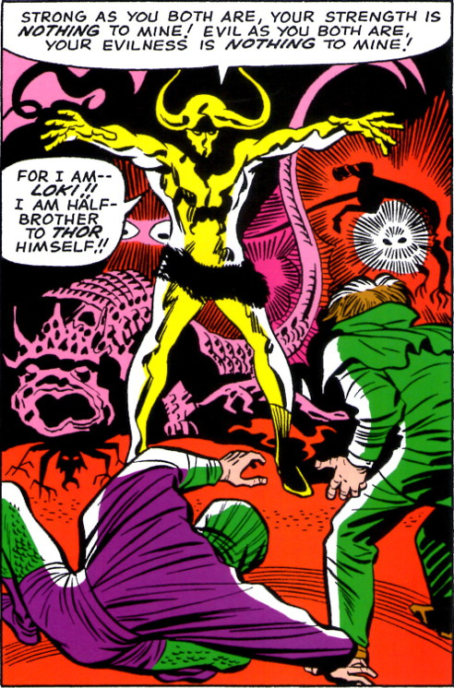
Hyde and Cobra are unable to prevail, and they soon separate and go their different ways.
Mister Hyde then kicks around other Marvel comics. He spends some time battling Daredevil, but is always defeated despite the fact that he is so much stronger and powerful. He also makes appearances in both Spider-Man and the Avengers, but despite the company he keeps, he never seems to shake off the B-list status.
His most ‘notable deed’ is that he manages to impregnate a prostitute during one of his business calls. The daughter grows up to be Daisy Johnson, aka Quake, who becomes a member of S.H.I.E.L.D. and one of its few level 10 operatives.
AOS and the Cinematic Universe
Clearly the writers of the Marvel cinematic universe are taking liberties with the published material, and I say that’s all for the good. The original Mister Hyde was completely unsympathetic, which would have been OK if he also weren’t boring and pathetic. In addition, it was hard to see how Calvin Zabo, a man who uses a chemical elixir to change into his alter ego, and a prostitute with no known special abilities, would produce a baby with super powers. It is even more farcical to see how that child, born into a very disadvantaged position, would then make it into S.H.I.E.L.D. and achieve a level 10 security rating, putting her on par with Nick Fury. I’m willing to concede that she might have inherited super powers from her father, but why does that make her so special compared to all the other paranormals in the Marvel world that she belongs in the inner circle of the most secretive spy organization in the world?
The current direction the show is taking is both more enjoyable and more logical. It seems that Zabo, while mad, is not the vile creature that we saw jumping from the pages of Thor. He is sympathetic, and perhaps driven to his madness by the horrible crimes committed by Daniel Whitehall against his wife, who, I assume, will be revealed in later episodes to be an Inhuman.
This approach nicely ties together a bunch of dangling plot points from the publication universe. And, so, I am going to kick back and wait eagerly for what I believe will be a wonderful half of Season 2 of Agents of S.H.I.E.L.D.

