Faustian Tale
Well it seems that my circle of friends and family are as devoted to the Marvel television show Agent Carter as they are to Agents of S.H.I.E.L.D.. And since I filled in the backstory the Inhumans and Calvin Zabo/Mister Hyde from the Marvel publication, the expectation arose that I would do something similar for Dr. Ivchenko.
To be fair, I brought this task on myself during the course of this past Tuesday’s episode, SNAFU. The episode starts with a flashback vignette from the Russian front during World War II. A Russian doctor approaches Ivchenko, asking for the later to use his ‘techniques’ to help in a surgery to save a young man’s life. It seems the man’s leg must be amputated in order to keep the infection that has invaded his wound from causing his death and that the field hospital has run out of anesthetic. Reluctantly, Ivchenko agrees to help, and as he rises to follow the surgeon back to the operating theater, he closes the book he was reading. We get a glimpse of the title for only a few seconds, but that was enough to see that he had been pondering the old renaissance tale The Tragic Life of Doctor Faustus.
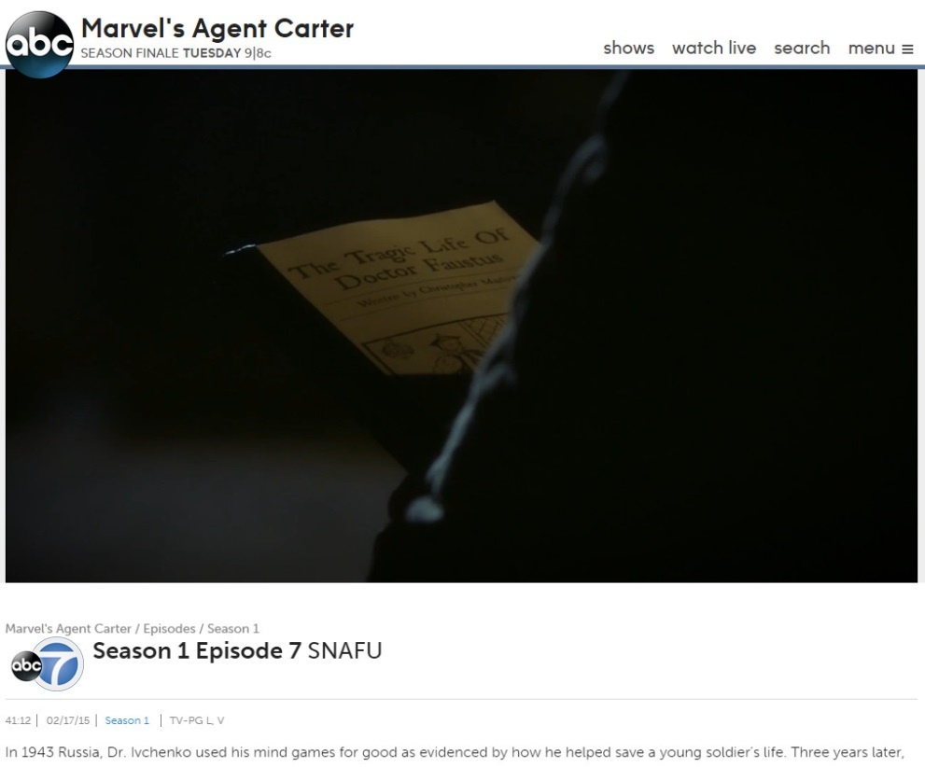
At this point, I believe I muttered something to the effect “Ah, so that’s who he is.” at which point the questions became to fly.
To begin, we need to take a step back about 500 years and briefly look at the German historical figure of Johann Georg Faust (why are these guys always called Johann?). History seems to know very little about the life of the original Dr. Faust except that he was an alchemist, astrologer, and purported magician. Above all else, he seems to have been a fraud or charlatan and he was denounced as by the Church as being in league with the devil, although I suspect that, in this regard, he was like Aleister Crowley or Ozzy Osborne or Marilyn Manson, having a reputation for dealing with demonic forces that was based more on the hysteria of those around him than on actual fact.
Johann Faust’s most lasting work was to give birth to the legend that currently bears his name. Tales about his demonic side remained largely oral until the publication of The Tragical History of the Life and Death of Doctor Faustus by Christopher Marlowe in 1604. In Marlowe’s telling, Faustus (the Latinized version of Faust) is a scholar of prodigious talent. Having mastered all of the fields of academia of his time, he remains unfulfilled and dissatisfied. He resolves to turn his skill to magic and, summoning the forces of Hell, he makes a pact with Lucifer. In exchange for his soul’s damnation, Faustus will receive tutelage in the mysteries of the universe from his own personal demonic servant Mephistopheles.
Later, in the 1800s, Wolfgang von Goethe published his two plays about the legend of Faust. The basic premise of the plays is identical to Marlowe’s tale, although the religious and philosophical implications that are explored are quite different, reflecting differences in both time and space between Calvinist England of the 17th century and Lutheran and Catholic Germany of the 19th.
And so by the middle of the twentieth century, Stan Lee and Jack Kirby had a rich literary tradition to draw upon when they were looking to introduce a sinister character into the pages of Captain America. First appearing in issue 107, Doctor Faustus was not intended to be the kind of traditional super villain who battered the hero with his fists or blasts of energy. Rather, Faustus battered minds with a wide barrage of techniques ranging from pharmaceutical & chemical manipulations, to carefully contrived scenes and social cues. All meant to inflict harm to the victim’s sanity.
Steve Rogers, aka Captain America, explains how he met Dr. Faustus
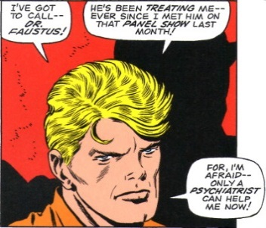
and has come to depend on the ‘good’ doctor’s his help in dealing with his guilt at Bucky Barnes’s death. Unbeknownst to Steve, Faustus has been hired to rid the world of Captain America and Faust boosts at his confidence that he can deliver.
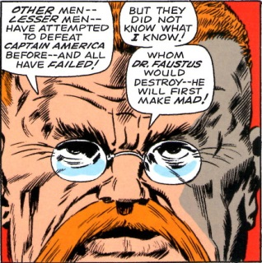
Faustus almost succeeds in breaking Rogers, but at the last minute he slips up and stands revealed as the fiend that he is. Sadly, Lee and Kirby fell back to the old standby of physical violence. Rather than depend on his wits and biding his time, Faustus decided to rely on his immense size. He challenged Captain America to a fight,
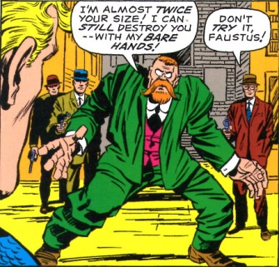
which he lost in short order.
Faustus was a bit player in the comic from then on. He made minor appearances throughout the run but never quite reached a height of evil that made him particularly memorable.
I don’t know if Ivchenko is intended to be Dr. Faustus. Perhaps, he is the first to develop these techniques and will eventually pass them on to a contemporary Dr. Faustus. Perhaps the appearance of the book is just a nod to the longtime fans of the comics. All I do know is that the character of Dr. Ivchenko is loathsome, a horrible, and scary – all the things that make you love to hate him.

