Roots of Quicksilver and the Scarlet Witch
I got a request from a friend after we both went to see Avengers 2: The Age of Ultron. My intention was that last week’s post on this installment of the Marvel Cinematic Universe (MCU), and what is likely to be a huge pot of money for the power structure of Disney, would be my only post related to the movie. Alas, that intention is now derailed as my dear friend asked for some back story on the Maximoff Twins, Pietro and Wanda.
Just in case you’ve been living under a rock, Pietro and Wanda Maximoff, also known as Quicksilver and the Scarlet Witch, are some of the new Avengers featured in the film. They received a cameo appearance in the mid-credit teaser from Captain America 2: The Winter Soldier. Quicksilver is super-fast, running so quickly as to be only a blur. His representation in the movie closely parallels the original conception of this character in the comic books. The Scarlet Witch is a bit more complicated. In the film, she possesses both telekinesis and the ability to manipulate the minds of her enemies. While stylistically similar to her comic book version (scarlet clothing and exotic gestures to invoke her power), the Scarlet Witch of the movie differs in some key ways, making it much easier to integrate her character into reasonable storylines.
The back story from the comic book begins with their premiere in X-Men #4 in 1964. When we first meet Quicksilver and the Scarlet Witch, they are seated at a dining table, eating an evening meal with the Toad and Mastermind. Brother and sister are not only mutants but also official members of Magneto’s Brotherhood of Evil Mutants.
<insert Pietro and Wanda dining>
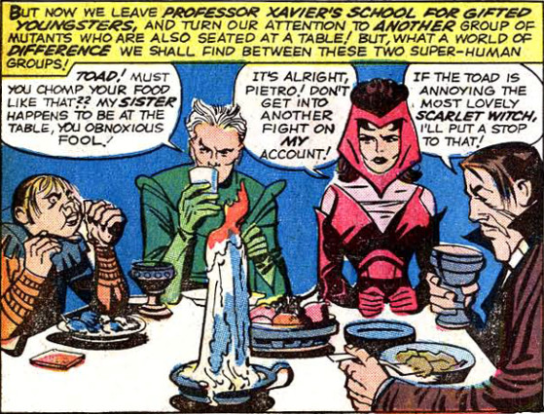
It seems that Magneto had saved them some time earlier from villagers intent on harming them for being different. In their first battle with the X-Men, Quicksilver’s incredible speed doesn’t prevent him from being literally out-maneuvered by the Angel. The Scarlet Witch quickly retaliates with a small movement of her hand and the ceiling caves-in on the Angel, incapacitating him.
<insert Wanda’s first hex>
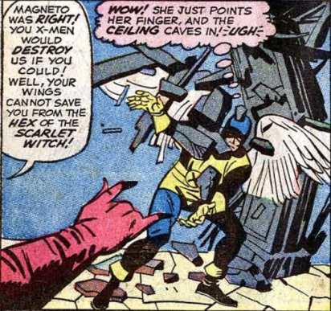
This is the first occurrence of her mysterious hex power. This choice of mutant ability will cause problems for Marvel from here on and will become a sort of ‘deus ex machina’ that some writers avoid and others embrace but which will continue to generate controversy even after it is ‘fully explained’.
The twins appear repeatedly in X-Men #5-7, but with the action always carefully scripted so that Wanda either doesn’t need to or is prevented from using her hex power in any significant way. There is even an occurrence when, while meeting the Sub-Mariner, Wanda is overcome by girlish emotion an accidently unleashes a hex his way.
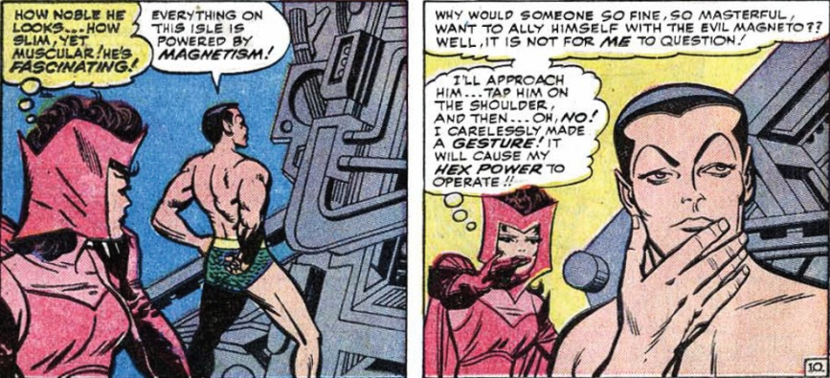
They stay under the thumb of Magneto until the end of X-Men #11, when the dread master of magnetism is snatched away by the Stranger. Feeling their debt to Magneto fully paid and longing for a more wholesome way to employ their mutant powers, brother and sister bid their time by laying low in Europe and looking for an opportunity to become heroes.
Such an opportunity presents itself in Avengers #19, when they read a newspaper account of how the Avengers had just added Hawkeye to their ranks and that other new members might be accepted as well.
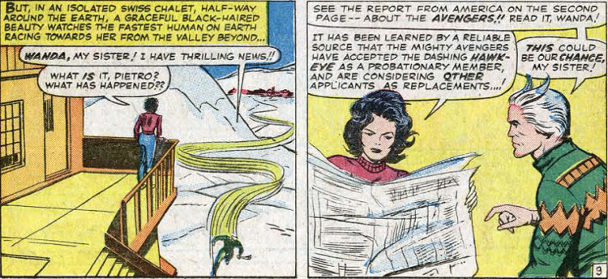
A quick letter is penned and sent to the Avengers (ah, the good ole’ days of snail mail and low security).
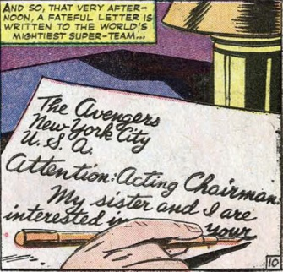
And the next thing you know, Wanda and Pietro arrive in New York, where they are greeted by none other than Tony Stark (looking vaguely like Robert Downey Jr).
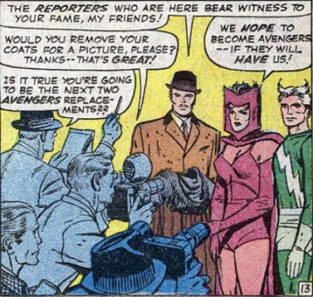
The Avengers do name them as replacements, as the heavy hitters on the team, Iron Man, Thor, and Giant-Man, had decided to step down from team adventuring for a while. At the end of Avengers #16, the first really new lineup is introduced
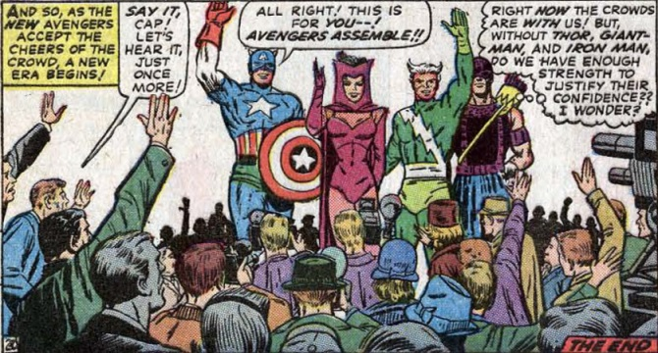
with Captain America leading the Scarlet Witch, Quicksilver, and Hawkeye.
In many ways, this is one of the best Avengers lineups, since the team now lacks in raw strength and has to compensate with teamwork, strategy, brains, and resourcefulness. It also provides a showcase for the talents of both Hawkeye and the Scarlet Witch. In particular, the nature of her hex power gets better defined and a limit on her ability is set down – most probably in order to cap the open-ended nature of her appearances in the X-Men. Wanda is only able to produce 3 hex bolts before becoming too exhausted and needing some time to recharge.
Unfortunately, this approach was probably too much of a strain on the writing crew and the roster gets switched again by issue #28 with the return of Giant-Man and the Wasp. Shortly thereafter, the twins return to Europe in Avengers #31 to regain their power. A brief stay seems to rejuvenate them both but with a greater impact on the Scarlet Witch. They rejoin the team in Avengers #36 and remain there until issue #53. During this time the Scarlet Witch is an on-again/off-again character – sometimes deadly strong with her hex power, sometimes weak. I think the writers simply didn’t know what to make of her powers and, by issue #48, she’s lost her hex powers completely. This happens during the opening round of a cross-over battle between the Avengers and the X-Men, on one side, and Magneto and his Brotherhood of Evil Mutants on the other.
After Magneto’s defeat in issue #53, Wanda and Pietro again return to Europe looking to revitalize Wanda’s mutant powers. The readership is denied even a glimpse of the pair until nearly two year later, when Wanda and Pietro resurface in issue #75. This time Wanda is lured into reciting a spell and releasing a menace from another world. This is the first inkling of her possessing magic as well as mutant powers.
Brother and sister again rejoin the Avengers shortly thereafter and a romance almost immediately blossoms between Wanda and the Vision. Indeed they almost kiss in issue #91 but, at the last minute, the Vision demurs.
By now, nearly 8 years have passed since Wanda and Pietro made their first appearance and during that time they were never really parted. That said, their paths diverge in Avengers #104. After a battle between the Avengers and the Sentinels, Quicksilver is mortally wounded and, being stranded in an unknown location, is left behind.
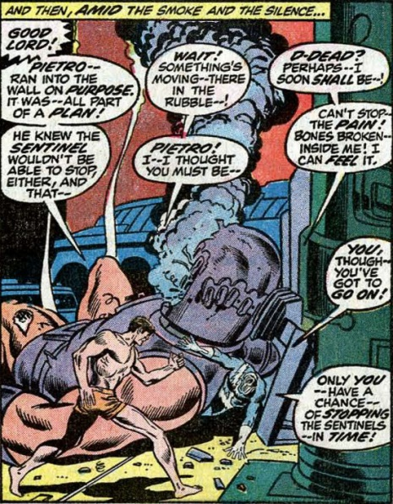
As I recounted elsewhere, he is eventually rescued by Crystal of the Inhumans; an act of kindness that entwines his fate with theirs.
Wanda remains with the Avengers, where her romance with the Vision deepens. Eventually the twins are reunited at the marriage of Quicksilver and Crystal. Shortly after the ceremony, the witch known as Agatha Harkness, who had been the Fantastic Four’s governess, chooses Wanda as her new magical apprentice.
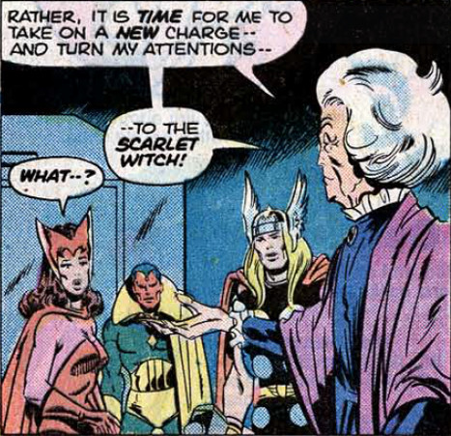
Under Harkness’s tutelage (and Steve Engelhart’s scripting), the Scarlet Witch begins to evolve from a love-smitten damsel into a strong, mature character. Part of that maturation results in her marriage to the Vision in a joint ceremony marking the end of the Celestial Madonna storyline that ran through the Avengers from 1972-1975.
By now, the attentive reader might have noticed that I have not used the name of Maximoff in describing the Wanda and Pietro of the comic book universe. This is because their parentage and surname went unrevealed for a long period of time, and when revealed it was given as Frank (Giant-Sized Avengers #1, 1974). The Golden Age hero Robert Frank, aka the Whizzer, maintains that Wanda and Pietro are his children, and this identification seemed natural as both the Whizzer and Quicksilver possessed super speed. Robert, distraught with grief over his wife’s death in childbirth, abandoned the children to be raised by Roma in Eastern Europe. Frank’s assertion of paternity remains unchallenged for five years until John Byrne ties all of the various pieces together into one of the best storylines in Marvel’s publication history.
It starts in issue #181, when a Roma by the name of Django Maximoff ‘kidnaps’ Pietro and Wanda and tells them an alternative origin.
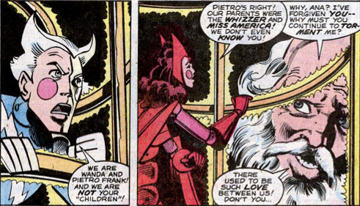
He insists that Pietro and Wanda are his very own children and urges them to remember him. They soon free themselves from his clutches but decide to journey with him to Eastern Europe to find the truth. After all, they had returned there on two other occasions when they needed to. Their journey leads them to the awful truth that neither the Franks nor the Maximoffs are their parents.
By eyewitness testimony of the cow-woman Bova, they come to learn that their mother, a woman named Magda, had fled from her husband and sought refuge on Wundagore mountain. Wundagore is the home of the High Evolutionary, a scientist obsessed with creating a race of sentient animals.
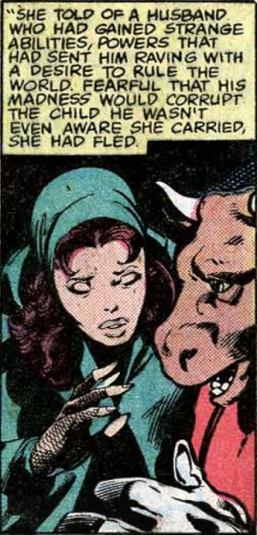
Magda soon gives birth to Wanda and Pietro, but her happiness is short lived. Fearing that her husband would soon hunt her down, Magda leaves Wanda and Pietro with Bova, who then brings the babies to her master. The High Evolutionary first attempts to give them to the Franks,
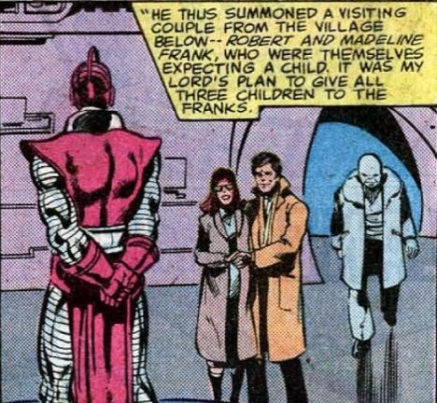
who were expecting their own child. However, Madeline Frank dies after giving birth to a stillborn baby and Robert flees under the weight of his own grief. The High Evolutionary then gives the babies to the Maximoffs to raise as their own.
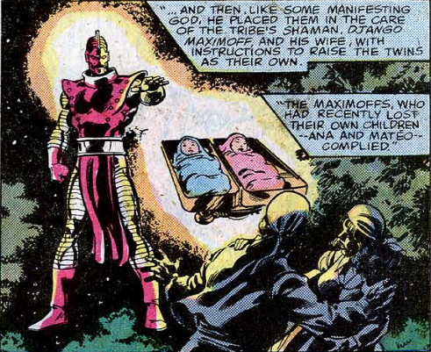
While not explicitly stated, long time readers knew that Magda’s mysterious husband was none other than Magneto. Thus the twins had been saved early on and subsequently bullied by their own father, even though they were unaware of it.
Later writers build upon this structure. Wanda’s mutant powers are explained as manipulating the probabilities of the universe. These powers, her magical training, and her kinship to Magneto lead to weirder and weirder storylines.
Thankfully, the creators involved in the Marvel Cinematic Universe have the sense to limit her powers and, since Fox owns the Marvel mutant property, this twisted history will never see the silver screen.

