Big Trouble Equals Big Fun – Act 2: Lo Pan Returns

Okay Lo Pan is back and he is particularly annoyed with Jack for not only having killed him in their last encounter but for consigning him to torment in the Hell of Those Killed by Idiots. And his renewed presence on our plane means yet another demise of a relationship between our mullet-sporting hero and a love one. This time it is Pete, who once more under Lo Pan’s control, turns on Jack. Even all the good times traveling in the Pork Chop Express aren’t enough to save marriage number five
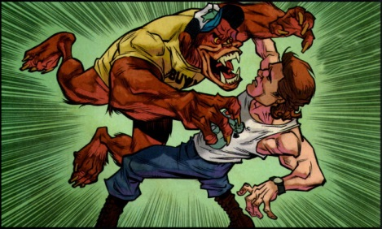
Fortunately for our adventurous band, the Chang Sing show up just as things get hairy, allowing Egg Shen and company to use the old ‘vanish in a cloud of smoke routine’ to get out from under Lo Pan and his twisted boy band.
Despite their narrow escape, things aren’t rosy. Egg reminds them that Lo Pan has vast resources and all of those will be bent towards revenge. As a spirit, Egg is unable to harm Lo Pan and the only way to make him flesh again is rather unpleasant.
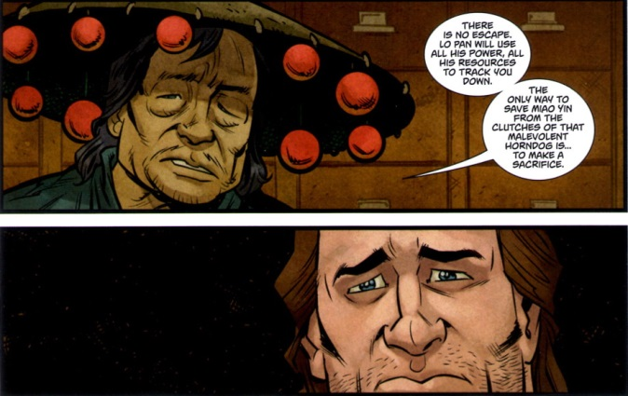
And so a quick plan is put together off panel. Not one to be daunted by tales of death and destruction, Jack leaves in a conspicuous fashion with Wang disguised as Miao Yin to get lure everyone away – including the Lords of Death.
Once on the road together, Burton takes a few opportunities to tease Wang about how good a a women Wang makes. These comedic observations must be pretty accurate, though, because when Wang and Jack stop at a biker’s bar for some food, Wang comes under some unwanted attention
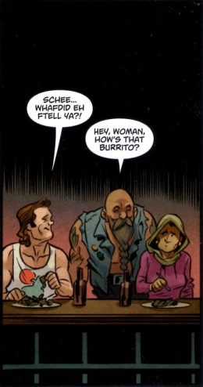
Feeling sexually harassed, Wang reacts in the only way he knows how – with his feet of fury. He is in the process of taking the how bar down when the burrito he just ate drives home a bad case of Montezuma’s revenge.
Green to the gills, Wang sinks to his feet, about to get stomped, when he and Jack are saved by an old acquaintance by the name Moonie Joe, who also happens to be the big man at the biker bar.
Meanwhile, the real Miao Yin walks the Midnight Road with Egg Shen under the assumption that this would be the last place where Lo Pan and company would look for them. Like her husband, it seems that Miao is having a hard time keeping her temper, perhaps due to the ‘coitus interuptus’ events surrounding her wedding. Whatever the reason, she goes off in hilarious fashion over the smallest of slights leaving Egg to wonder what exactly has happened
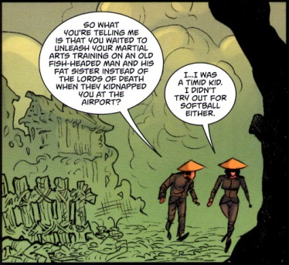
Back at the biker bar, Moonie Joe, Jack, and Wang confer about the next steps unaware that two men in black, the Zhang Brothers, are on their trail
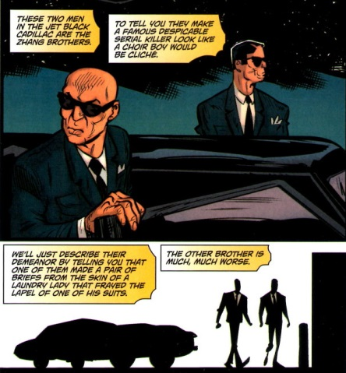
Jack unveils his master plan to take Boot Nail Highway, a mostly abandoned and scenic stretch of highway. Much to his surprise, Moonie Joe freaks out and begins to tell a story of a dead alien whose ghost haunts Boot Nail Highway looking for people to eat.
Jack dismisses the warnings and soon he and Wang are camped out on the side of the cursed road, drinking beer and slurring their speech. They look like sitting ducks and indeed the Zhang brothers are quite sure that they will be able to bring Jack back to Lo Pan, although perhaps not in one piece,
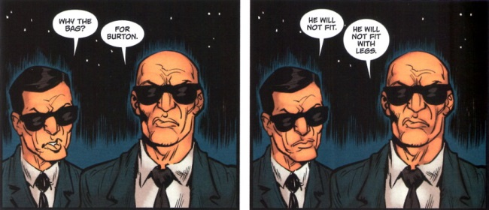
Before the campers are caught unawares by the Zhang Brothers, the ghost alien that Moonie Joe warned them about shows up and eats the assassins, putting an end to a brilliant mayhem career.
While these events are happening on the earthly plain, Egg and Miao continue their journey in the spirit realm. As they climb through the bizarre, other-worldly scenery, they discuss what it means to be a hero
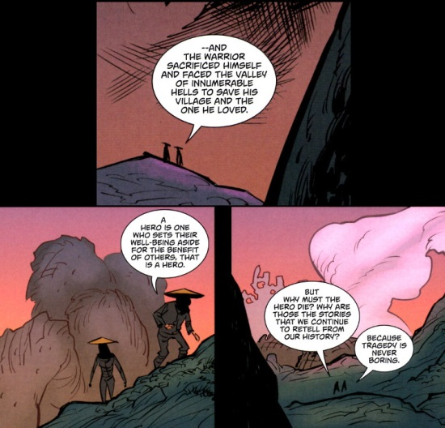
What they don’t realize is that agents of the Seven-Faced Widow are tracking them and they are soon subdued and brought to face they lady with seven faces and five hundred pounds of flesh for each one.
Jack and Wang continue eastward, stopping for lunch at a truck stop in Nashville. It seems everywhere he goes, Jack is known by the locals and this truck stop is no different and the pair are waited on by a giant, slow-witted country cook by the name of Bert. And what a good thing that turns out to be, for when Wang and Jack head back to the Pork Chop Express, who do you think is waiting for them? None other than the Lords of Death.
The Lords starting taking a bite out of Jack and things look bad when Bert gets involved and levels a beat-down on the Chinese street gang.
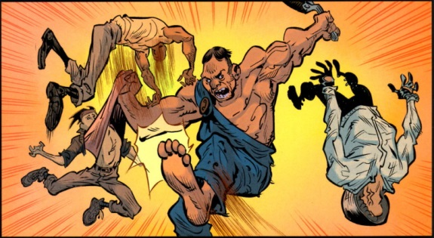
Sadly, before he can finish the job, his ma shows up and scolds him and drags him away. But by this time the locals have joined Jack and Wang in the free-for-all. The cops show up shortly thereafter and propose a southern-styled solution to the ‘disagreement’ between the two sides
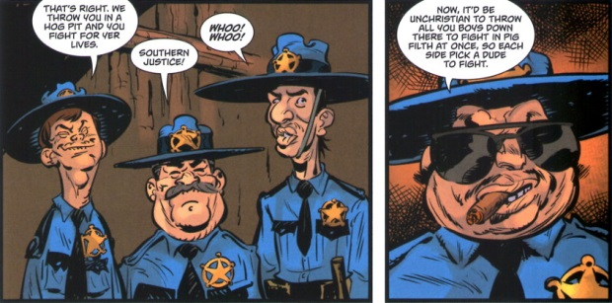
The Lords of Death pick their leader, Black Knife, to represent them and the rednecks pick Jack (mostly because of his hair). Facing off in the pig pit, Jack looks grossly overmatched and it seems certain that he’ll be the one the pigs dine on that night. However, fate seems to be on the side of our hero as she so often is, and when Black Knife rush forward he slips in the muck and accidently impales himself on a broken shovel handle. In typical style, Jack greats the sudden victory with a “It’s all in the reflexes” response.
Having defeated their leader, the Lords of Death now swear their allegiance to Jack. With a small army now under his command, Jack resolves to head back to San Francisco and confront Lo Pan.
Back in San Francisco, we find Egg and Miao prisoners, after the Seven-Faced Widow had turned them over to Lo Pan. Her asking price is that Lo Pan whacks Jack – something he’s already itching to do. Egg is tied up while Lo Pan prepares Miao Yin for his pleasure. Qiang Wu pays a visit to Egg but is doesn’t end to well for Qiang’s ego
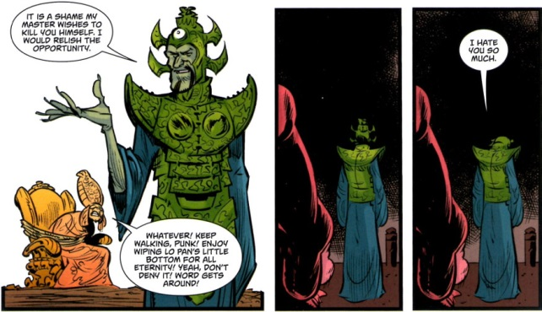
Jack soon launches his offensive and lots of action takes place with Wing Kong, Chang Sing, Lords of Death, and demon combatants all going at it in the subterranean lair of Lo Pan. Egg takes down Qiang but is exhausted. As Jack joins his side, Egg asks if Jack is ready
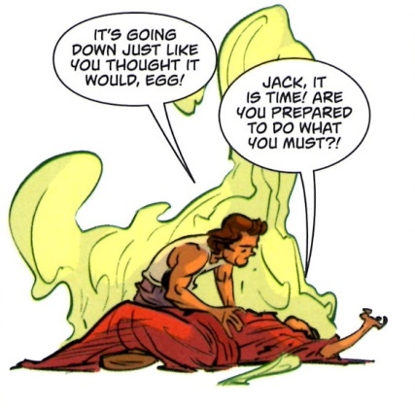
Jack allows himself to get captured and Lo Pan stabs him through with a sword. Gleeful that he is finally going to have some ‘earthly pleasure’ Lo Pan is heedless of the fact that now that he is flesh he can he killed
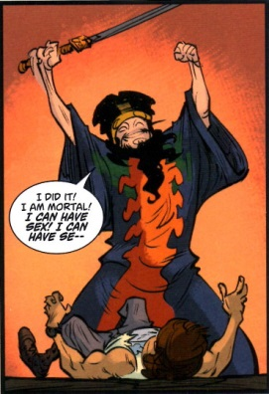
and Egg runs him through, thus ending the threat, at least for now.
Egg consoles a grieving Wang Chi suggesting that there may be a way to bring Jack back – after all Lo Pan didn’t seem to stay dead long. And Jack, as he journeys to the afterlife, decides that it isn’t too bad. Not what he imagined but not too bad – that is until he finds that he and Lo Pan are sharing a common hell.
So ends Act 2; a little darker and less humorous than Act 1 but certainly a lot of fun.
Next time act 3.

