Big Trouble Equals Big Fun – Act 3: Jack’s Back?
Well this week was supposed to be the finale of the review of the first story arc of Big Trouble in Little China, the comic. But due to a production delay, as of this writing, I don’t have Issue #12, which seems to tie it all up. I make that last comment based on the descriptions of Issue #13 in Previews that states that a new creative team is taking over and Jack Burton is being brought into the 21st century.
Perhaps it’s all for the best as this review will end with a bit of a cliff hanger that may whet the reader’s appetite even more.
Anyway, of all the three acts, the last one is the poorest. While still fun, it lacks some of the originality found in the first two. At times, it seems that one is reading the same set of panels as in the previous issue. In addition, the narrative is confusing in places and there is still a strange interaction that I haven’t yet figured out.
At the end of Act 2, Lo Pan was once again defeated and killed but at the expense of Jack’s death being thrown into the bargain. Where Act 2 was darker and more grim, Act 3 captures more of the light heartedness of the first set of issues. Perhaps this explains the lapses in storytelling.
In any event, the action starts in the Hell of No Escape, where we find the spirit of Mr. Burton consigned with his arch-enemy, David Lo Pan. Since Jack can’t suffer any bodily harm at the hands of Lo Pan, he is even cheekier with the ancient Chinese sorcerer and much of the humor in this act comes from the back and forth between the two.
As an example, shortly after their arrival in the underworld, Lo Pan turns his frustration on Jack and laments the fact that he will not be able to have his earthly pleasures with Miao Yin. When Jack points out that Miao Yin was never into Dave, Lo Pan begins a pouty ‘yes she was’ back-and-forth with Jack responding in turn with a ‘no she wasn’t’. Finally Jack asks
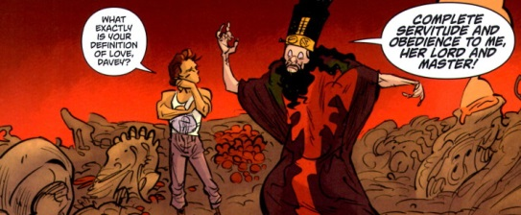
further confirming Lo Pan as a total nut job.
Their argument is soon interrupted when a demon cohort comes to torture them. Captured and soon to be ravaged, Lo Pan convinces the demons to free him and, in return, he will show them where a martyr can be found to make their ‘games’ all the more fun. The demons agree and Lo Pan explains Jack’s situation. As he leaves the Hell of No Escape (come on there is a way in there must be a way out), Lo Pan is quite happy at the thought of Jack’s imminent suffering.
Meanwhile, back on Earth, Egg has Wang Chi dump Jack’s body into a pickle barrel and off they go to find someone who can help restore Jack to the land of the living. The pair soon arrives at the home of Tai Sui Laohu
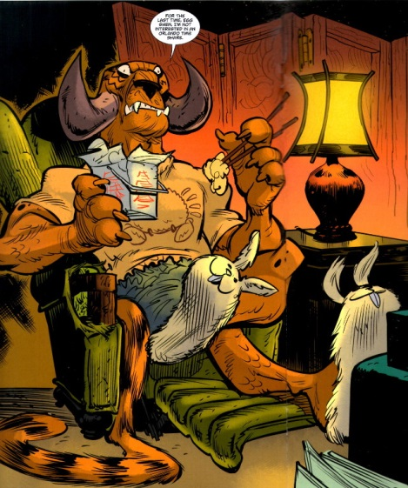
who is chowing down on some rice as he’s kicked back in an easy chair with his bunny slippers. Tai Sui Laohu thinks there is a way to get Jack back but says that all of them are going to have to consult a guy who rides a turtle. More on this later.
Back in hell, things don’t work out quite the way Lo Pan hopes and soon Jack has the demons ponying up their stuff in an all-out game of Texas Hold ‘Em.
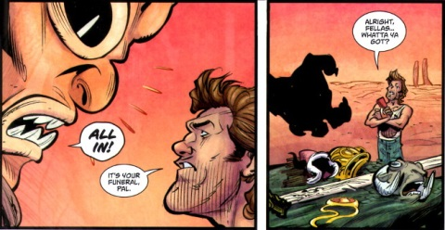
Whether demons are stupid or whether these ones had an sinister plan is never quite clear, but Jack wins a way of the Hell of No Escapes with all their stuff by cheating them in a manner reminiscent to the classic episode of Star Trek called ‘Piece of the Action’. As Jack leaves hell, he makes an interesting observation about marriage which is best consumed straight from the horses mouth.
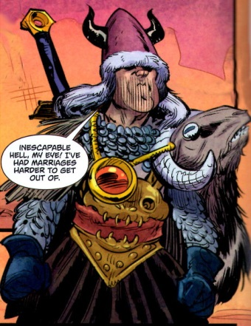
Note the amulet around Jack’s neck, for reasons I can’t explain, it plays a critical role in some later events. As Jack leaves the Hell of No Escape behind, he finds himself in the spaces between and then soon in a new hell where he meets a reptilian demon whom Jack dubs Slinky. Jack tells Slinky he could really go for a trip to a bar and is amazed when Slinky points out that there is one handy. Jack offers to buy Slinky a round
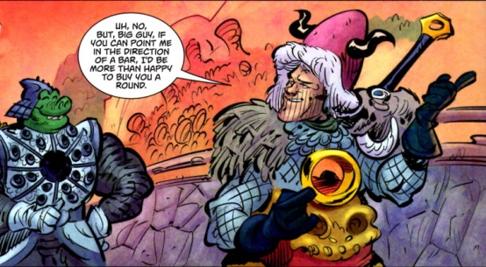
and almost immediately Jack has a new demon BFF. Another inexplicable item is worth mentioned here (as seen from the advantage of hind sight). Note the curious hole in Slinky’s breast plate. It looks like something round and amulet-sized might fit in there. Hmmm….
Well off they go to get some brew and no sooner do they enter the gin joint then what do theirs eye behold? None other than David Lo Pan, belly up to the bar with a face that could curdle fresh milk.
Jack and Lo Pan get into a fracas. In the commotion, Jack loses the amulet and Slinky (who is much smaller than his armor implies, finds himself able to seize it as a prize.
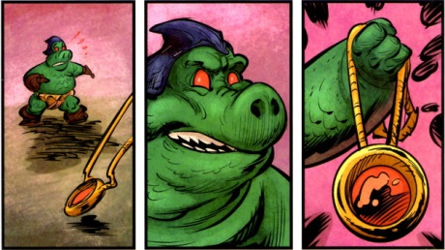
He flees with the amulet while Jack and Lo Pan are cuffed by the owner and forced to pay of the damages by washing dishes.
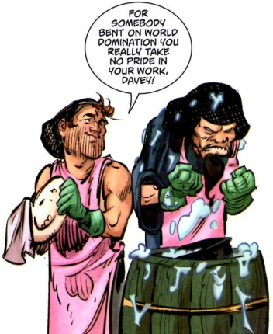
Some while later, Slinky returns to liberate Jack, sporting the amulet in his breast plate, sort of like Iron Man’s main repulsor ray on his chest. Why Slinky took the amulet and why he comes back are quite a mystery to me – and one I don’t believe will be explained in the final issue of this arc.
Slinky and Jack face overwhelming odds in their attempt to escape but, at the last minute, a giant flying demon, like something out of the demented mind of H. P. Lovecraft, swoops in to kill all their pursuers. And you thought deus ex machina was dead and gone.
Unfortunately, Lo Pan also escapes and threatens them with a horrible revenge as soon as he retrieves something called the Black Serpents Tongue. Playing the role of Captain Obvious (or a Cistercian Monk for those who get that reference), Slinky steps in with a handy explanation of why they should be worried. He tells of the god Yama defeating the Black God of Chaos by ripping the beast’s tongue from its mouth. Somehow, Yama forged it into a sword of great power but he soon lost it
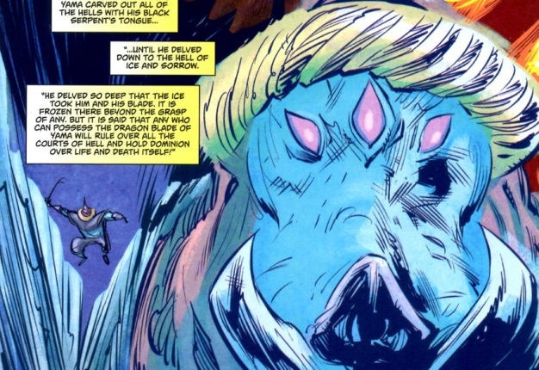
In order to get the power to retrieve the blade from the Hell of Ice and Sorrow, Lo Pan makes a particular evil deal with the Dark Gods of the East
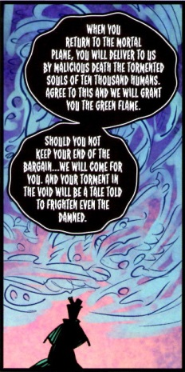
who consent to give Lo Pan the power of the Breathe of Green Flame.
While Slinky and Jack pursue Lo Pan in the hopes of preventing him from retrieving the sword, Egg, Wang, and Tai Sui find the man on the turtle
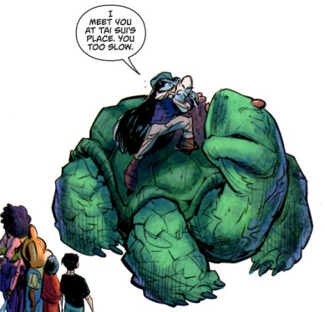
whose name is P’an Ku (although it should be Master Roshi).
And this were it ends. As explained above, Issue #12 looks like it should draw this story arc to a close. If I had to guess, I imagine that Lo Pan is lost forever in the Hell of Ice and Sorrow. Jack returns to the land of the living but somehow 28 years into the future, probably due to some spell cast by P’an Ku. And what about Slinky? I think he’ll open his own bar in the Hell of a Thousand Hangovers.

