Story Construction 7 – The New Marvel Way?
After the rather heavy analysis of Alan Moore over the last three weeks, I thought I would take a look at a lighter presentation to the approach to comic book creation found in the back of the 2005 Free Comic Book Day offering from Marvel Comics.
Tucked in the back of the issue, after a story involving Spider-Man, the Fantastic Four, and the Chameleon, is a short 8-page crash-course in the mechanics of creating comic books by John Barber.
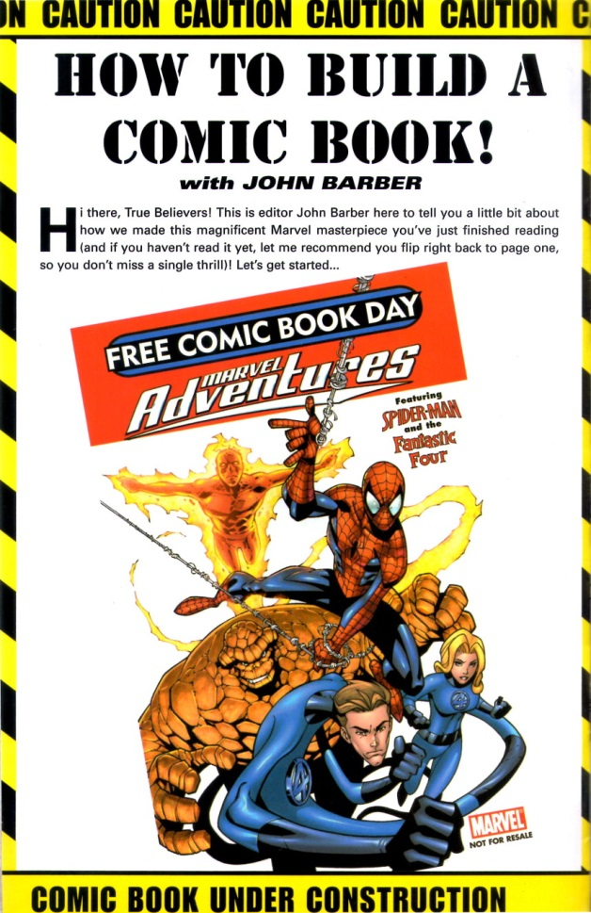
Using the short story that preceded it as a guide, Barber’s treatment focuses essentially on one page, discussing how the page is transformed from script to finished product through a number of steps. In a nutshell, these are:
- Creation of a plot/script
- Generation of rough thumbnail sketches showing panel configuration and action layout
- Detailed penciling based on the thumbnails
- Inking of the penciled page
- Coloring of the inked page
- Lettering and captioning
For the most part, the creation of the plot/script is not covered. No details are given about how the creator gets started, what points should be covered in the writing, how to pace the panels, or any other details.
Barber simply provides the bare-bones description of what a plot/script is and, despite its brevity, this description is actually quite revealing of his point-of-view on the creative process and the writer’s role. Specifically, he says that the script is the writer’s way of describing each and every panel via the panel description, which provides a verbal summary of the image the reader will see, and the dialog, which contains what each character will say (and I suppose what captions, if any, will be used to provide exposition).
As way of an example, the following page of script is offered to describe a particularly action-packed page in the story.
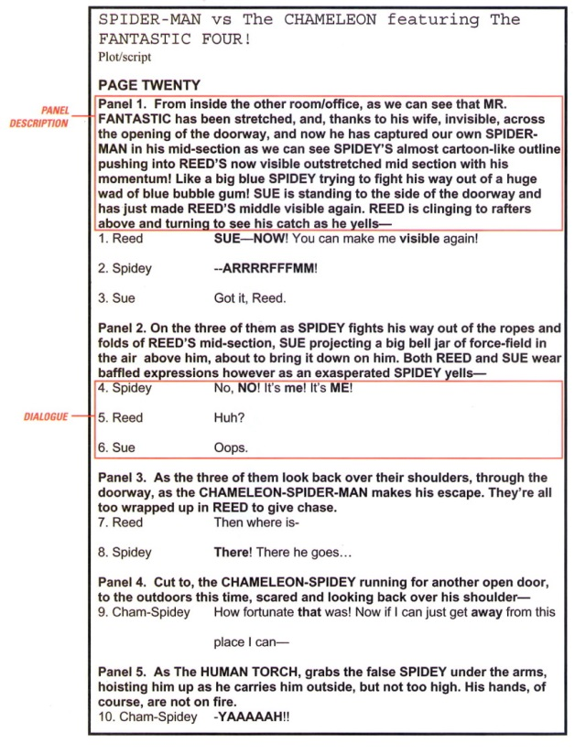
Barber characterizes the panel description as the writer’s method for telling the artist “who’s doing what (and sometimes why!).” This terse and seemingly innocent sentence suggests that Barber is endorsing a method that is very much like what Gaiman presented in his ‘behind the scenes’ look at the creation of Sandman. The emphasis is on the writer calling the shots in the story-telling and it is from his mind that the visuals come. The artist’s job is to render the scene for the writer, according to the writer’s conception, with small visual changes either due to aesthetic or to technical details, but with little input on the overall storytelling structure.
Admittedly, this is a lot to read into a few sentences, but given that this ‘how-to’ was part of the Marvel Free Comic Book Day offering in 2005, a showcase for Marvel creativity, and that the refined tastes of the modern young reader are more visual now than ever before, I think that it speaks volumes.
Further evidence of a writer-centric approach can be found in narrative that accompanies the four figures presented in the later pages showing how the writer’s description transitioned from thumbnail sketches (a), to pencils (b), to an inked page (c), and finally to colors and letters (d).
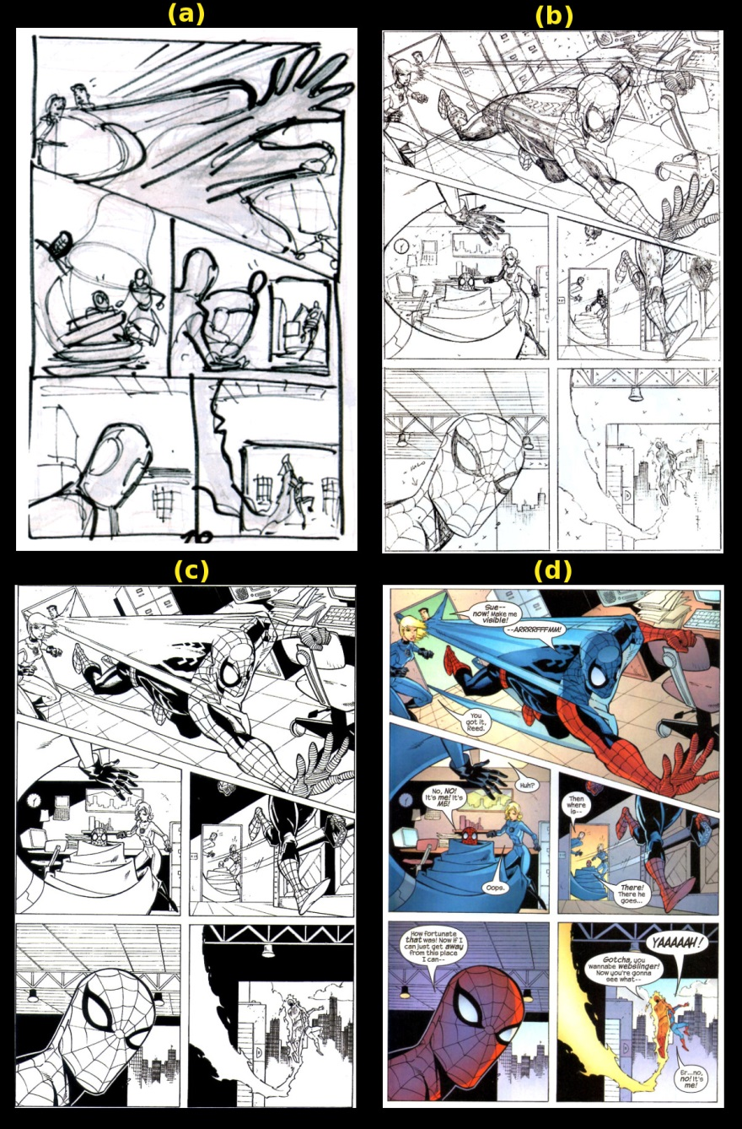
According to the text, the thumbnails are produced by the artist and then sent to the editor (in this particular case, Barber) for confirmation that the rendering is following the writer’s plan and leaves ample space for dialog and captions. After the editor gives his approval, the artist produces pencils that mostly match the thumbnails, although a side-by-side comparison of panels 1 and 3, show that the artist has changed the composition from the original conception. However, the artist doesn’t deviate, even in this case, from the panel description originally proposed by the writer.
Consider panel 1 that has changed most from the original thumbnail. In both compositions, the basic idea is preserved as can be seen by comparing the final panel version directly with the panel description provided by the writer.
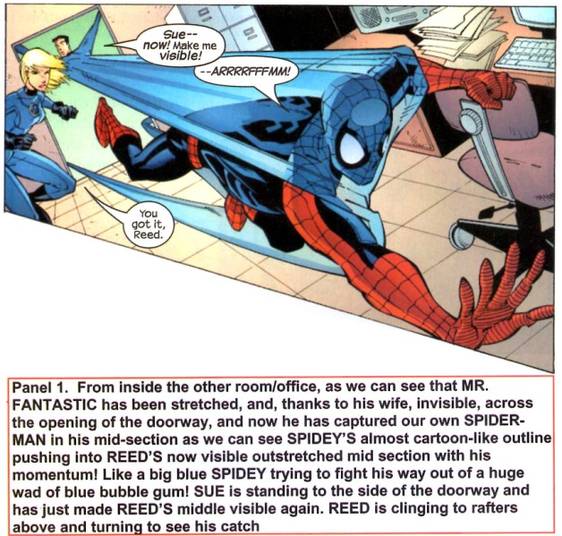
Barber does touch upon a more collaborative component to this work when he discusses panel 1 during the inking step. He says that the action is pretty complex and that to make it clear “we put our heads together to figure out how to make the panel work.” The result of this collaborative group-think was to omit certain details of Spider-Man’s costume as being obscured by the mid-section of Mr. Fantastic as he begins to turn visible. Again, this input on the story-telling is confined to technical details of the visuals but doesn’t touch the story or plot itself.
What’s most remarkable about this presentation is the implication that the artist’s job is to render the writer’s concept – not to embellish or change it. I am sure that embellishment does happen but when and under what circumstances it occurs is not touched upon. I must admit that I found this ‘21st-century’ Marvel way surprising after many of the traveler’s tales I have heard at various conventions and Marvel’s own press about the central role of the artist in the storytelling. Perhaps the most well-known example that Marvel has presented about the impact of the artist on the story is famous page 12 from X-Men #57 where Neal Adams as the Beast falling from the roof of a skyscraper.
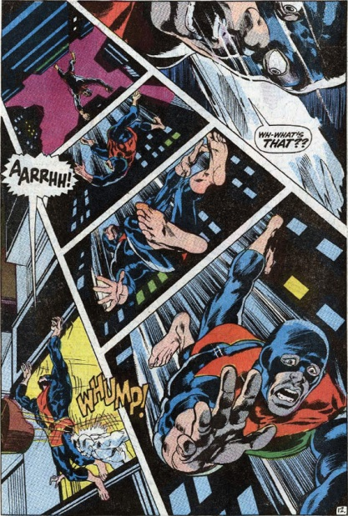
They had sold this as a basic component of the Marvel Way in the 1970s through the 1990s and the pinnacle of this approach was reached by the style-over-substance, artist-centric nonsense of the mid to late 90s that resulted in the mass exodus of ‘talent’ from Marvel to Image.
I suppose that if Barber’s brief exposition is to be held up as the Marvel standard then the pendulum has swung the other way and maybe that’s all for the best. After all, as the early Image comics proved, there’s only some much eye candy a reader wants before they crave a more filling helping of solid stories.

