A View From a Con
This week’s column is a departure from the ordinary thread on comics creation that had been the focus for the last few months and, instead, deals with that once-a-year happening of attending the Baltimore Comic Con.
Last weekend, I headed north to the Baltimore Comic-Con with three friends to check out the lay of the land. Despite the fact that the usual state of the average Maryland driver sits somewhere between distracted and negligent, the trip on the highways and byways of the Free State was accomplished without incident or even a close call. Parking was also fairly easily settled at the lot just behind the Days Inn. A short walk later found our party just outside the Convention Center.
Surprisingly, there really wasn’t anything in the way of lines and it was only a matter of few minutes before we received our wrist bands and were heading in. The majority of the action at Comic Con happens in the lower level of the convention center where the vendors, comic creators, and independent artists, creators, and associated personnel have their tables set up. The upper levels are setup for panels.
In the course of wandering through the crowd that showed up I came away with a variety of impressions; most good, a few bad.
First off, the overall state of the con had a real family feel. The number of small children present was amazing to me after the usual state of affairs at Anime conventions, where the target demographic is more focused on the slice of our population from older high-school students, to college-age attendees, and the proverbial young adults. It was a common sight to see parents and children cosplaying together and that was also stood in sharp contrast with the usual Anime program. There were several Raven cosplayers who were in their earlier teens at about the time many kids get shy these girls felt that they could express themselves. In addition, there was a kid’s area in the lower level where the attendees could do some arts and crafts led by a comics creator. I didn’t really see much of this but I sat in on Andy Runton’s drawing lesson and it was nice to see his interaction with the kids and his encouragement and coaching about drawing.
Another really nice observation was that the quality of the cosplay was quite splendid. I didn’t take many photos but there was a nice couple who came dressed as Hawkeye and Black Widow
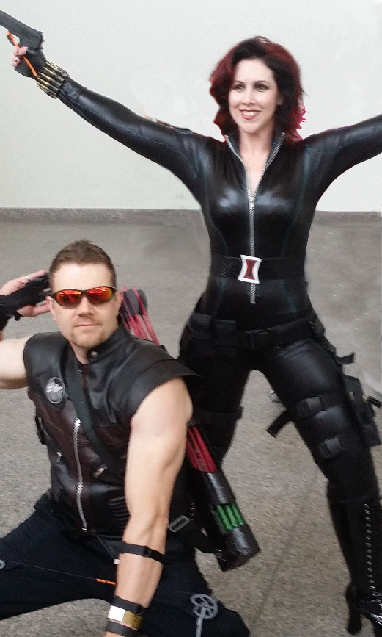

They were really friendly and chatted with my wife and me for a while about how they assembled their costumes, where they found their props, and how long it took for them to get it all together. The repurposing of common household items that ‘Hawkeye’ did to make his quiver was impressive.
Equally impressive was the fellow who came dressed as the Man of Steel version of Superman.
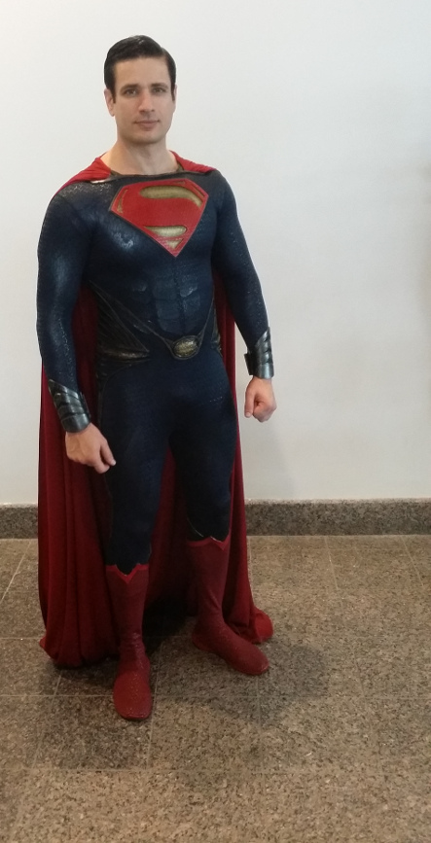

It was uncanny how well he ‘nailed it’ in costume, look, and overall how he carried himself. He was also very friendly.
In the vendor’s area, there were the typical wheely-toting fanboys carrying their latest prized-find in large suitcases from setup to setup. Despite the lack of social graces, generally they were well-behaved and tried to avoid running you over with their rolling treasure chests. The vendors were engaging and quite a few went out of the way to find or search for things. So overall, a real plus there.
The most unusual table was manned by a guy who works full time at the NASA Langley Research Center in Virginia. His table, which boasted screen snaps from 3-dimensional renderings of some of NASA’s most experimental aircraft, was actually devoted to his doctoral research. I’m not sure what degree he was pursuing but it clearly was in one of the psychology-related fields based on the questionnaire that he asked con-goers to fill out. The subject of the questions was the responder’s attitude to the mental state of Bruce Wayne versus Batman. Is Batman the dominant role and Bruce Wayne a mask? Is it the other way around? Is Bruce crazy? Things like that.
This guy wasn’t the only NASA presence at the convention. Numerous people had NASA paraphernalia on – NASA tee-shirts, NASA pins, etc. I wonder if the agency knows its reach?
Only one thing rubbed me the wrong way the whole day. Unfortunately, it came at the end of the con and there really wasn’t enough time to wash the bad taste out of my mouth. My wife and I intended to go to the last panel of the day and, being a bit tired, decided to stop in at the end of the panel prior to it and grab a seat. This was a mistake. A cast of creators, mostly from DC comics I believe, were indulging a raunch-fest. The program clearly said the panel was 16+ so that fact that there was adult material wasn’t so disturbing. Rather it was the mean way that the panelists interacted with each other and with the audience. It was akin to watching Don Rickles in his old Las Vegas act without any of the cleverness and charm – just the vulgarities. I wasn’t so much offended and embarrassed. Not for myself but for the creative guys who formed the panel. These guys hold dream jobs, getting paid to create art in a fashion that makes them admired by others and only bitterness seemed to come forth. True each line had a laugh surrounding it but still there seemed to be no graciousness from most of them (the one panelist who tried to be gracious was roundly mocked…sigh).
Overall, it was a good experience but I should have stayed in the kid’s area surrounded by people who still see the charm and wonder of the medium and not the edginess of teenage rebellion and shock value that just never quits.

