Sixth Gun Review
The Sixth Gun is an ongoing series from the creative team of Cullen Bunn and Brian Hurtt which is published mostly monthly by Oni Press.
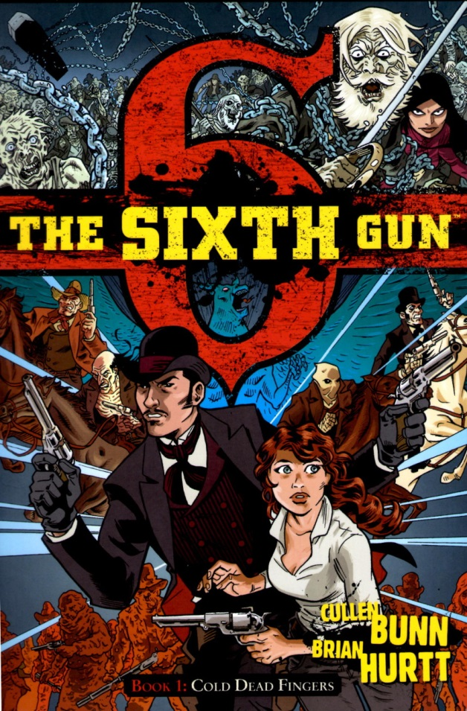
The Sixth Gun falls firmly into the Wild, Weird West genre that I’ve spoken about it the past with my reviews of The Deadlands, East of West, and the ‘weird’ offerings in the Jonah Hex limited series from Vertigo.
Somehow, this series escaped my notice for quite a while until I stumbled across an entry in Previews and the light bulb finally went off. I’ve spent some time getting caught up on the initial set of issues which are conveniently collected in nicely produced and affordable trade paperbacks.
Having sampled about 20 issues, I can say that I am definitely puzzled by my reaction to the series – in short I am conflicted. There are many things that the series does right; the art is fine, the narrative is reasonably well-paced and intelligent, and the characters are interesting albeit they are presented a bit more like caricatures rather than real persons. If I had to put a finger on it, I would say that the series is neither cozy & creepy enough nor is it epic enough.
In a nutshell, The Sixth Gun is formed around the premise of 6 weapons from perdition whose influence on man has existed since time immemorial.
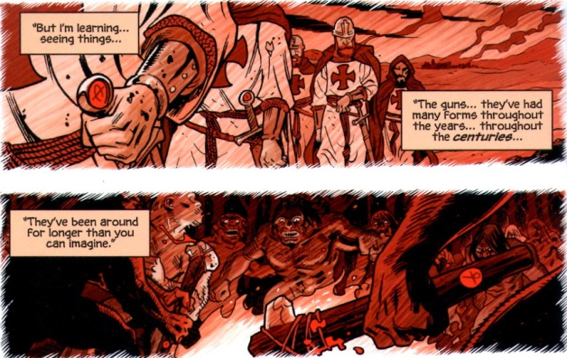
Their introduction into the old West is affected through the workings of a Confederacy general by the name of
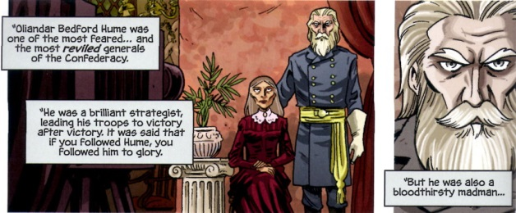
General Hume apparently has made a deal with the incarnation of the evil behind these weapons -
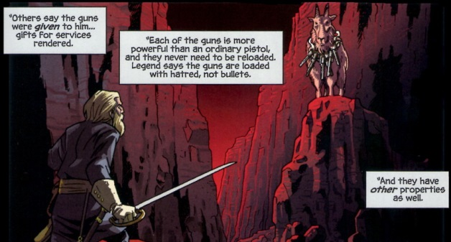
which appeared to him in the form of the demonic ‘Goat’ bearing the 6 guns about its neck. What the general got was incredible power but why the Goat was willing to grant this power to him remains unclear to me.
In any event, once the 6 guns were in his possession, General Hume forms a merry little band of psychopaths as his core team, each member wielding one of the guns. Each gun grants its possessor physical toughness and a unique special ability at the cost of their bodies, minds and souls.
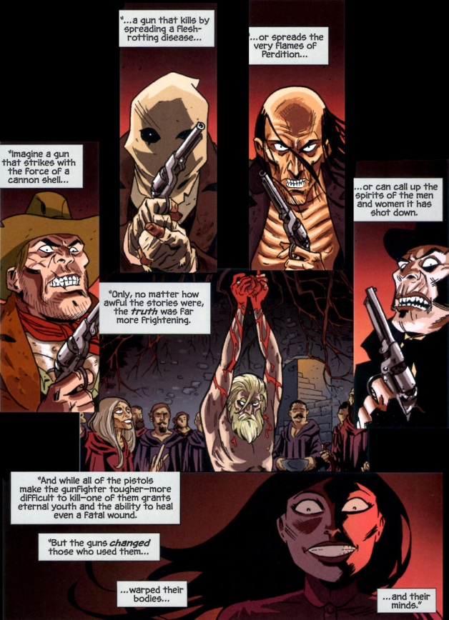
Of course, the general reserved the sixth gun, perhaps the Devil’s own, as his.
The story starts well after the defeat and subsequent death of the general at the hands of a group of men who ambushed him and managed to separate him from the infernal firearm. One of those men, Drake Sinclair, becomes a leading protagonist in the series, although it is perhaps better to view him as an anti-hero who begrudgingly does what is right – while he is far more handsome that Jonah Hex in looks (who isn’t) his morals and personal conduct are similar. Opposite to Drake is Beck Moncrief. A daughter of one of Drake’s fellow conspirators, Becky accidentally takes possession of the sixth gun when her father is killed by agents sent by the general’s widow to find and restore the revolver from hell to her husband who, despite the fact that he was ‘murdered’, looks pretty spry for a corpse
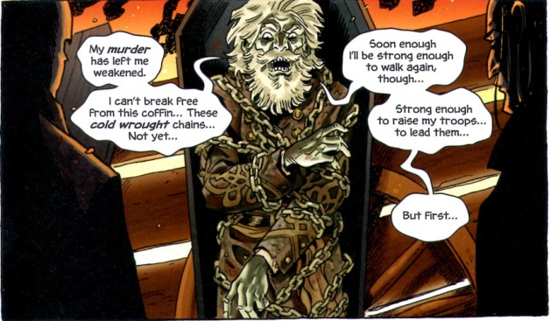
And so the mayhem begins. Along the way, the reader is treated a variety of spooky images, including: a gallows tree, where the ghosts of hanging victims can be consulted as an oracle; Louisiana voodoo monsters and shape changers; a vault holding riches or perhaps a portal to hell; and so on.
The mechanics are good, the production value high and yet the series lacks something. One on hand, it seems to want to be character-driven with stories of revenge, love, lust, and hate being the central lynch pin. On the other, it seems to want to be a grand epic about the coming apocalypse brought about by these six guns.
A very skilled writer can make the immense questions about life and death quite cozy and creepy. The best example of this is The Waiting Room, a short film from the old Night Gallery television show in which a gun-fighter finds out the ultimate cost of his violent ways (and his ultimate fate) during a brief visit to a saloon. Shot entirely within this ‘cozy’ waiting room, the dialog and mood do more to deal with the grand questions of heaven, hell, redemption, and damnation than many stories set in a grander landscape. Likewise, a very skilled writer can marry character to immenseness within the context of an epic. The small personal scene’s found scattered throughout The Lord of the Rings (book only) are masterpieces that bridge the gap between the large and universal and the small and personal.
The Sixth Gun, at least the portions I’ve read so far, seems to be unsure where it belongs and so suffers in its presentation. Nonetheless, I’m going to continue to read the series hopefully expectant that Bunn and Hurtt will manage to produce memorable stories in one of the best genres out there.

