The Many Faces of Hydra
Well the season start of Agent Carter is underway with new adventures, new romances, and a new locale – the City of Angels. The back-to-back one hour episodes that formed the Tuesday night’s opening showed that Marvel takes Agent Carter seriously as a tie-in to the MCU.
The action opens with a bank robbery in progress by a gang of thieves led by none other than Dottie Underwood, the demented trainee from the Black Widow program who locked horns with Peggy in Season 1. The heist soon turns sour when Dottie discovers more than her sought-after loot when she opens the vault to find safe deposit box she was commissioned to pilfer. Peggy was keeping the loot company and, after big knock-down, hair-pulling fight, she manages to take Dottie into custody. And what was so important to Dottie in that box? Why a simple label pin with a symbol similar to the re-imagined Hydra logo that has dominated the Agents of S.H.I.E.L.D. storyline of late (Comic Book Resources has a nice article on the link between Hydra, Agents of S.H.I.E.L.D., Agent Carter, and the Inhumans).
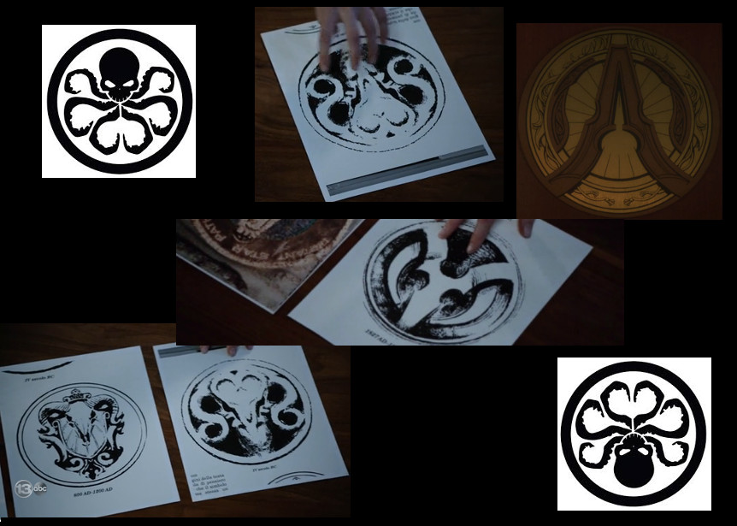
The lapel pin, which resembles the image in the upper right, decorates a variety of secret-society types later in the episode, including a senatorial wannbe with a wife worthy of Lady Macbeth, and a lab that possesses a material called ‘zero matter’ that looks like the portal material that Fitz and Simmons have been learning about.
Certainly Hydra has come a long way from the shadow of James Bond inspired, S.P.E.C.T.R.E. clone that existed in the early days of Lee, Kirby, and Steranko – and thankfully so. That Hydra was boring and unmotivated. The new Hydra resembles a deliciously creepy cult with really epic ambitions (and petty evils) and this change amounts to more fun. The big question now is whether the minds behind the MCU can smoothly mesh these new faces of Hydra with the face originally presented by the Red Skull in the first Captain America movie. Only time will tell.

