Unfollowing Unfollow
It begins mysterious enough. A well-dressed man, wielding a semi-automatic weapon, and wearing an Oni mask has just tracked down and murdered one of his fellow beings. The dead body having fallen over a cliff, our assassin confirms the kill by glancing down onto the rocks below. Satisfied that his job is done, he utters:

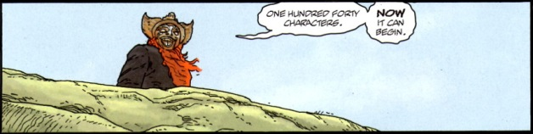
And so begins Unfollow, the new, ongoing Vertigo series by Williams, Dowling, and Winter.
Of course, the phrase ‘one hundred forty characters’, immediately conjures images of Twitter but one suspects that there is more. After all, there is no evidence that the launch of Twitter was any more harmful than to cause mild damage to the diets, eyes, and familial relationships of the many programmers that made it possible.
Playing on two different meanings of ‘character’, Unfollow is really a Lord-of-the-Flies look at what happens when a rich entrepreneur, by the name of Farrell, leaves his 18-billion-dollar fortune to 140 random persons.
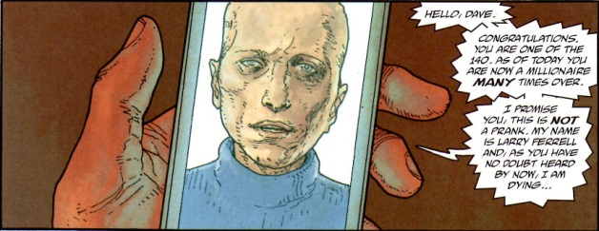
Rubinstein, our Japanese-faced enforcer, works for Farrell but seems to be a loose cannon. His function is the clean up around the edges so that Farrell’s morality play can develop as planned.
The rest of the action so far (issues #1-3 are out as of this writing), is devoted to the identification of the key winners, the gathering of them to Farrell’s island (what else) and the setting of the stage.
The story focuses on five key characters:
- Dave, a stereotypical inner city kid;
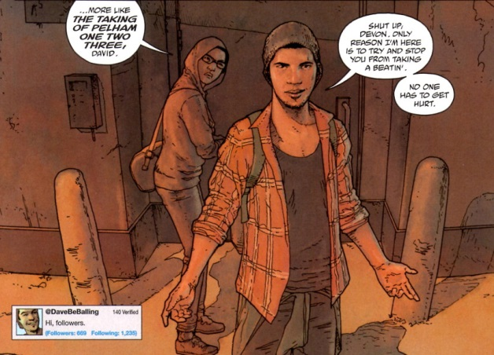
- Courtney, a rich, disaffected young woman who is a perpetual thrill-seeker;
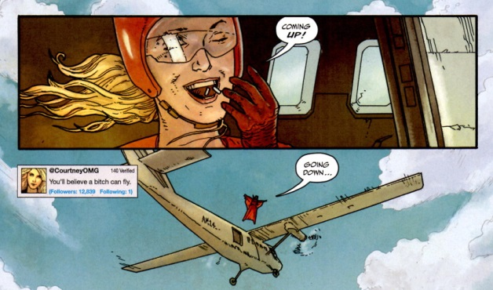
- Deacon, tough, evangelical-survivalist hybrid;
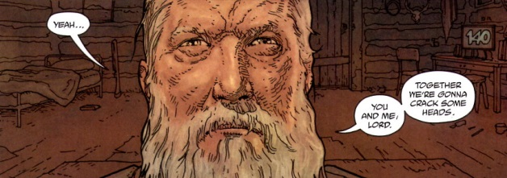
- Akira, a sexually ambiguous Japanese artist, with gentle delusions of godhood;
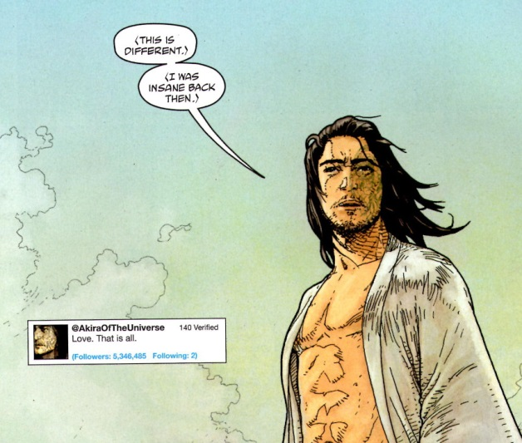
- and Ravan, an Iranian woman who, as BBC reporter, has just covered the public execution of a 10-year old girl and is now trying to go underground to avoid the authorities.
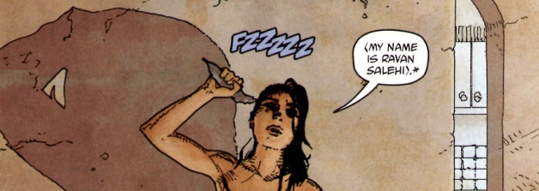
Some additional characters are also introduced, including an enormous Nigerian oil worker, with a propensity to violence.
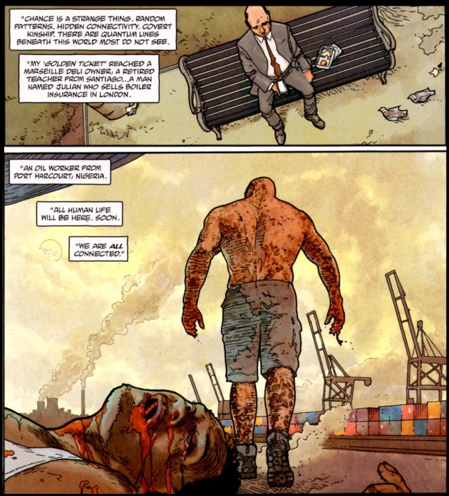
Early indications point to this latter winner as the villain of the piece, at least the catalyst for violence.
After summoning the winners to his Caribbean island, Farrell addresses each of them with provocative message. Pointing out that only 139 of the original 140 winners remain alive, Farrell goes on to say that each of them has now increased his fortune to the tune of about a million dollars.
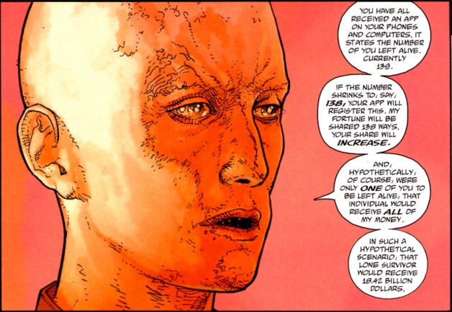
He ends his speech by observing that should only one of them be left alive, that ‘last man standing’ would get the whole pile of cash – all he or she would have to do would be to kill the others.
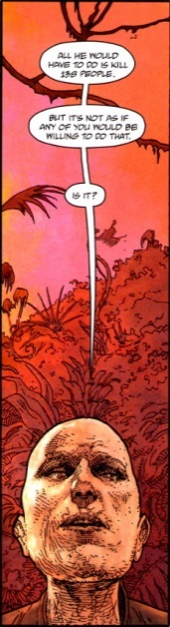
On the surface, Unfollow has elements familiar to the western mind. The creators make multiple allusions to the Golden Ticket of Willy Wonka fame. And, no doubt, the theme of power pitting people against people reminds us of stories like The Hunger Games or Lord of the Flies. All these elements are now blended into something new. So what’s not to love?
Well, Unfollow isn’t new. It’s really patterned after is a fairly recent and unheralded amine called Eden of the East. The plot is almost line-for-line the same, with Eden of the East having a good 4 or 5 years on the scene before Unfollow came out. Now derivative isn’t a criterion for rejecting but content is. While Unfollow has acceptable art, its characters are cookie cutter, archetypes. One can predict what each character will do, how each will behave, simply by knowing what each looks like of where each hails from. In addition, these characters are unsympathetic (with the exception of Ravan) and the only entertainment is in seeing how the spectacle will unfold. On this point, I doubt that Unfollow can match Eden of the East. So with the aim of keeping my experience with Eden of the East alive and unsullied, I’ll be unfollowing Unfollow.

