A Marvel Epic: Part 3 – The Opponents Gather
The last column covered the basic tension in the Everything Dies storyline – namely that incursions between two universes in the Marvel multiverse pose a imminent threat to the existence of each and, ultimately, of the multiverse itself. This threat forms the key element and the various ways in which it is dealt pose the central moral conundrum.
But every good epic needs more than a framing problem, it needs human conflict large and small. There needs to be many sides, strong loyalties and shifting allegiances, personalities working together and struggling against each other. In Homer’s Iliad, there is often as much conflict within the Greek camp as there is between the Greeks and the Trojans.
By setting the stage with the biggest ‘save something’ scenario, Hickman provides himself with the vehicle to generate the conflict he wants. Since the stakes are bigger than saving a group of people, a city, a planet, a galaxy, or even a universe, he can reach into any dusty corner of the Marvel publication history he likes. In addition, since he is going to reboot the entire franchise, he can safely add new elements to the mythos without fear of being retconned. In some sense, he is retconning the whole thing, so why worry about the last details of a string of soon-to-be-obsolete publications.
The single biggest new element is the idea of the Builders. As discussed in Part 2, the Builders are the oldest race in the universe.
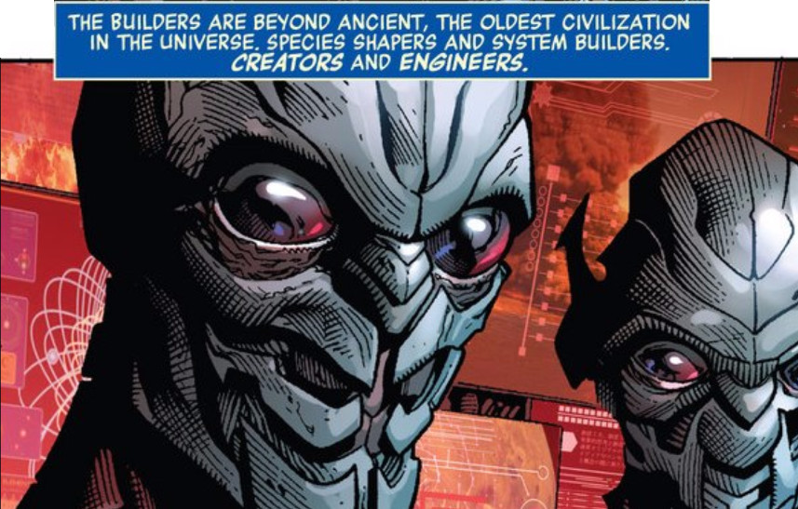
Originally content to worship the mother-maker, i.e. the universe, the Builders soon became the creators of a universe-wide system to ensure the protection and stability of the universe. How exactly their systems mesh with the avatar-based systems involving the abstract entities – such as Eternity, Infinity, Master Order & Lord Chaos, Galactus and the Celestial, and so on – is not detailed to my knowledge. But the universe is big and it doesn’t really matter now anyway.
What does matter is that the Alephs, Ex Nihili, and Abysii are one aspect of that system. Another aspect is a type of planetary defense built into the fabric of the universe and set to trigger when a world becomes advanced enough. The Ex Nihili encountered on Mars triggers that system through his origin bombs and his creation of what he described as the perfect human. This perfect human is born speaking Builder code so it takes a while until his name can be translated. When it is, the reader is treated to the revelation that his name is Nightmask and that he is a herald of the White Event.
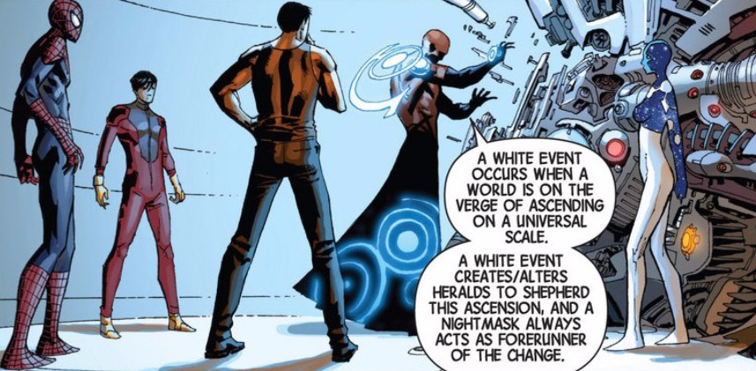
In this way, Hickman is able to pull the New Universe titles into the main Marvel publication universe in a smoother way than Mark Gruenwald attempted in Quasar. Of course, the New Universe is not complete without a Starbrand and, fortunately, soon after the introduction of Nightmask, one appears.
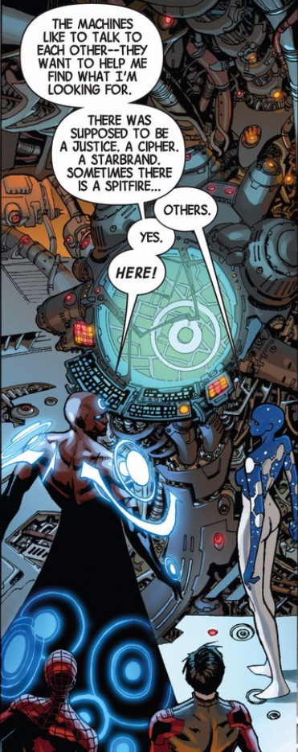
Unfortunately, his appearance is accompanied by a catastrophic disaster that claims the lives of thousands of people. When the Avengers arrive, the new Star Brand is out of control and they can’t control him. Finally, Captain Universe steps in and shocks some sense back into him.
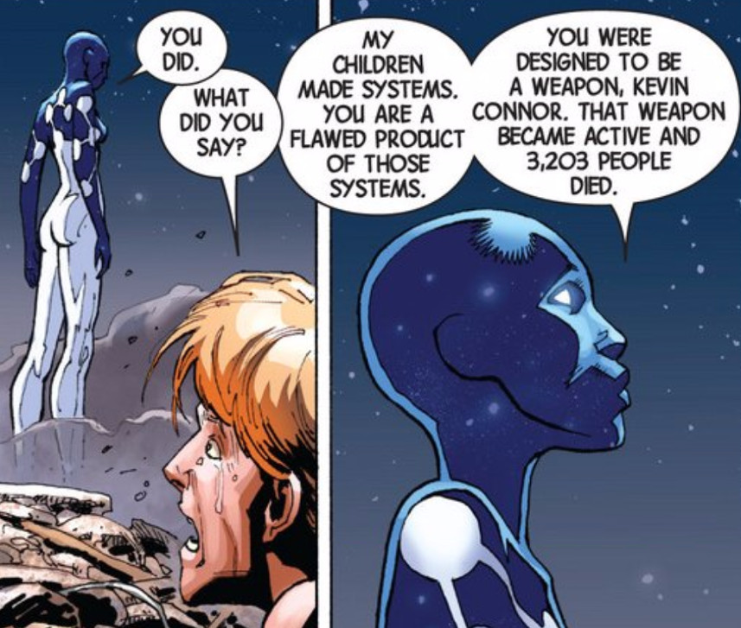
Here is one of the themes that Hickman returns to again and again. That the system is broken, which itself is a pale reflection of the fact that the universe is dying, that everything dies. Against this backdrop, he then casts all the actions and motivations.
One such set of actions are a whole set of new happenings around the sites of the origin bombs. People located with the impact radius of the bombs are transformed into new, evolved entities as the system fights to find a remedy for what ails it. One such, poignant story is when the Canadian super-team Alpha Flight penetrate a region where an origin bomb had detonated. Some of the team are repurposed for the new system response and the painful goodbye between Vindicator and her father is punctuated with
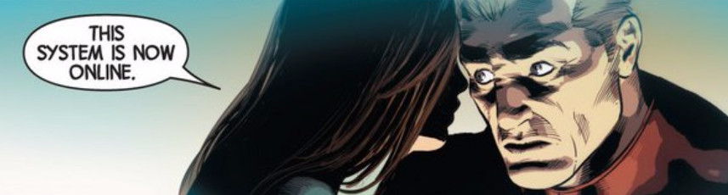
These smaller stories provide the human interest but for shear action, Hickman returns to the motions of the Builders, who, sensing the demise of all that is, seek to destroy the Earth hoping that since
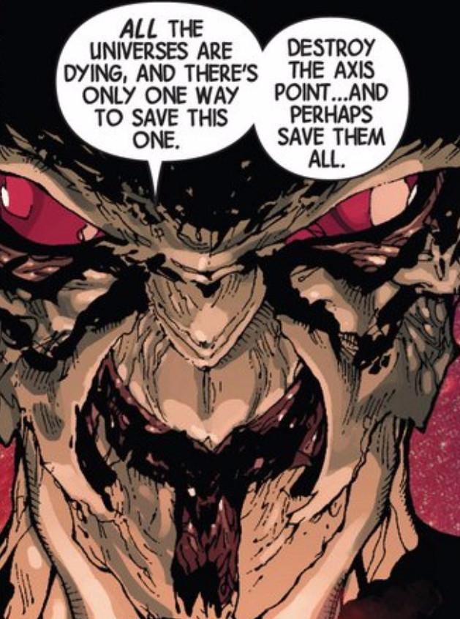
This reaction is not unexpected. In addition to the incursion dynamic, the reader of the Avengers has been reminded numerous times by Captain Universe that the Earth is special. Two such tellings are
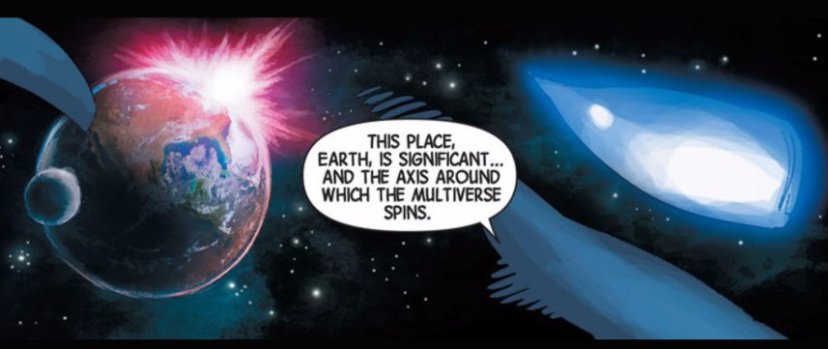
and
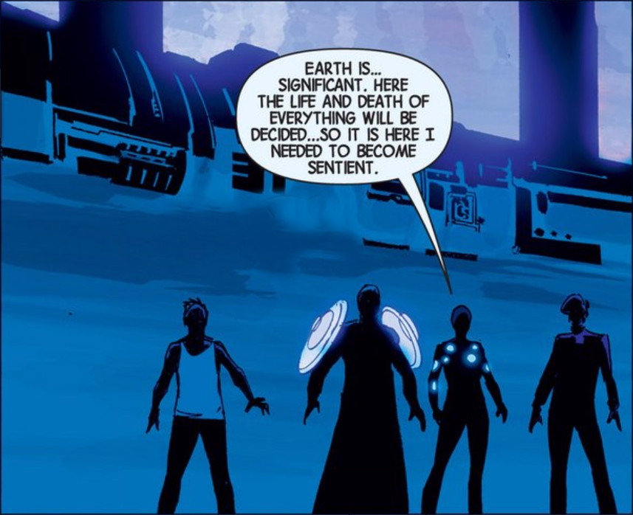
And so begins the Builder war. Despite the alliance of the Avengers with the most advance star-faring races – the Shi’ar, the Kree, the Skrulls, Spartax, the Brood, and Annihilus , the Builders are still essentially unstoppable. The primary reason for the unprecedented coalition is that the Builders are moving from one end of the universe to the Earth and are destroying everything in their way.
Hickman makes a point to explain why such an advanced race can’t just appear near the Earth and lay waste. The superflow, the fluid that resides between the universes, and which, I suppose, embeds the individual universes, is breaking down
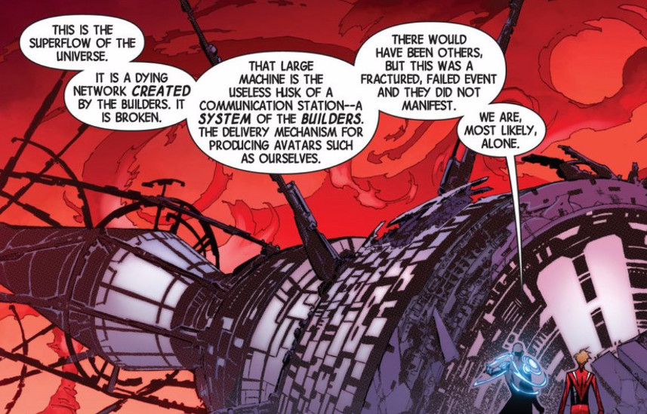
The Builders are no longer capable of using it to strike wherever they wish. A fact they lament.
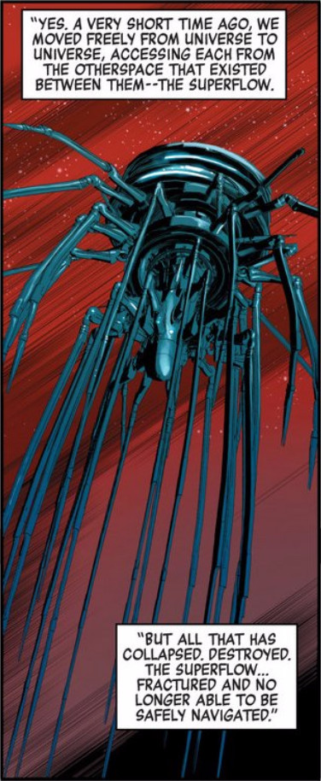
And so the Builders start from where they entered the Earth-616 universe just where they were shunted out of the superflow. There first target is Galador, of Rom the Spaceknight fame.
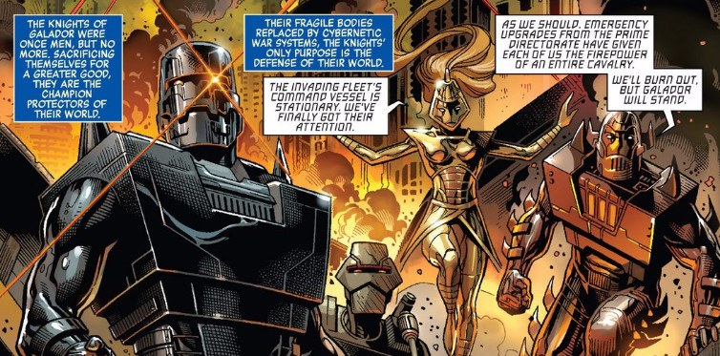
Captain Universe shows up to see the destruction saying that 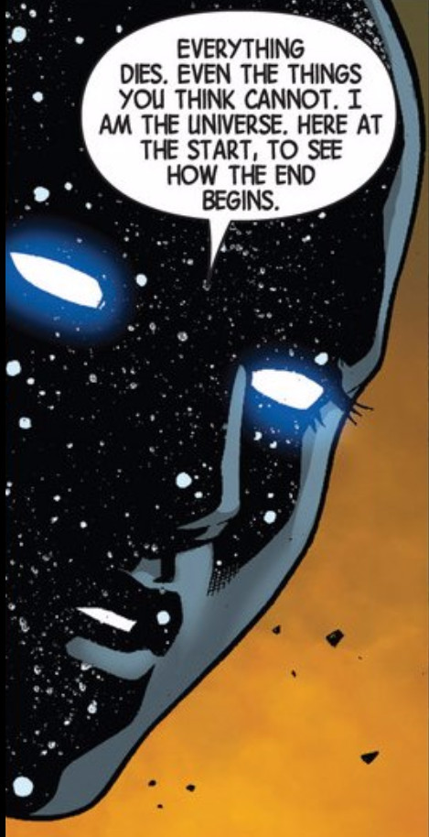
The shock of seeing Galador fall sends Captain Universe’s human host into a type of catatonia and disables her for a while and, as a result, she is not there to stop the Builders from waging war against everything in their way. The threat the Builders pose is enough to pull the Avengers from Earth and into space, leaving Earth effectively unguarded. It is at this time that Thanos and his inner circle the Cull Obsidian compel their ragtag crew to assault the Earth, despite the protestations,
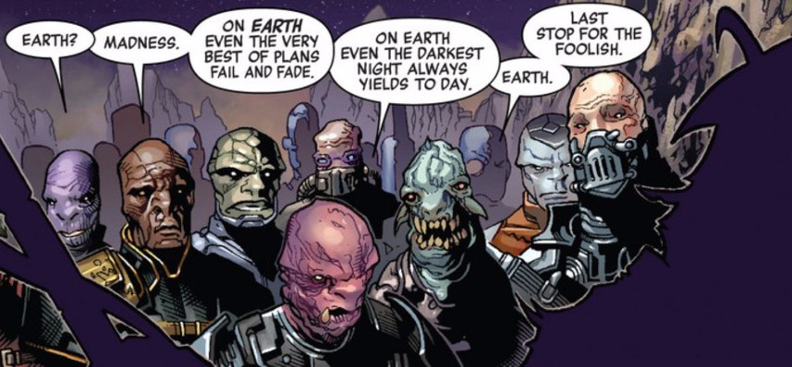
so that Thanos may kill the last of his children. A fuller account can be found in the post on Thanos and Thane.
So as the Avengers fight off-world, the Illuminati are all that is left to fend off the mad titan’s onslaught. Black Swan, her usual snarky self, derides the threat of the Builders
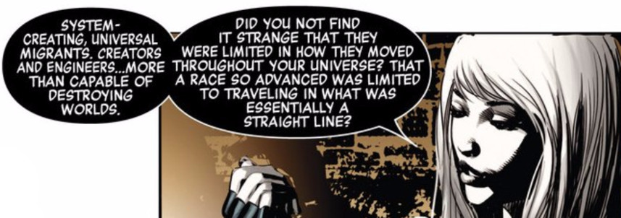
Instead she speaks with awe and fear of the multiversal threats that actually accompany the incursions. Of these, Black Swan talks cryptically about the Black Priests who destroyed her world
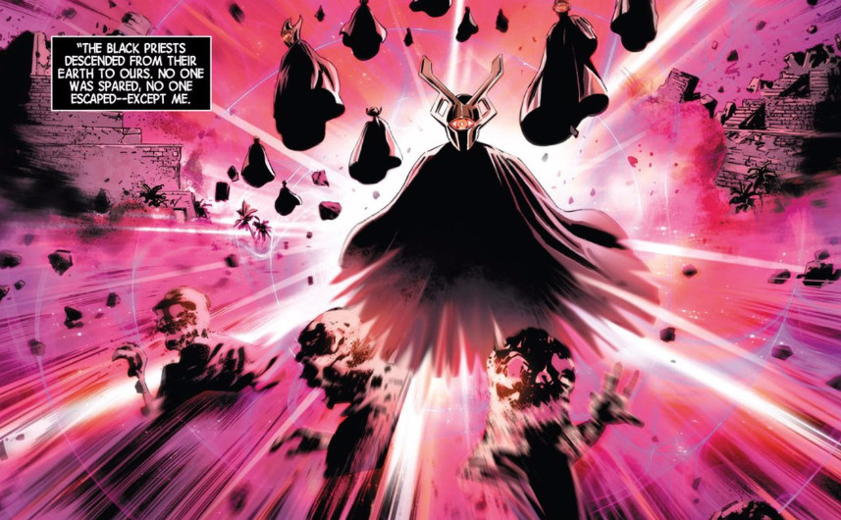
And the Map Makers and Sidera Maris, servants of the Ivory Kings, who she has witnessed destroy other Earths.
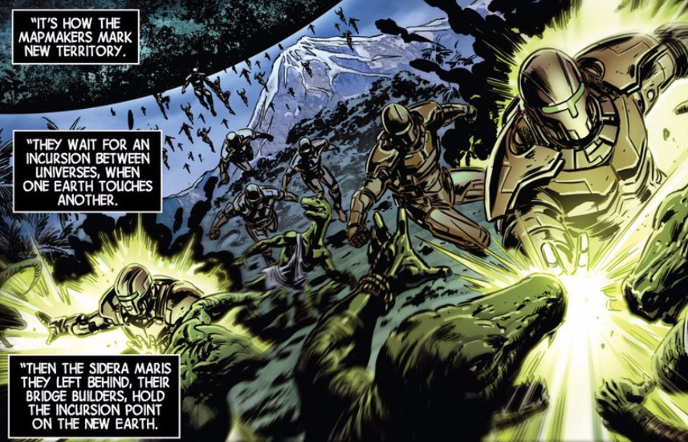
The Builder war comes to an end when they capture Captain Universe, Nightmask, Starbrand, Abyss, and the Ex Nihilo from Mars. The Builders are amazed that the humans possess the sentient systems they designed, especially an Abyss, of whom all were thought lost.
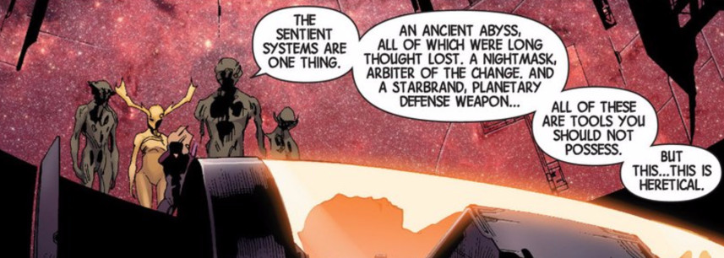
But they are absolutely flabbergasted to realize that a human plays host to the mother-maker in the form of Captain Universe.
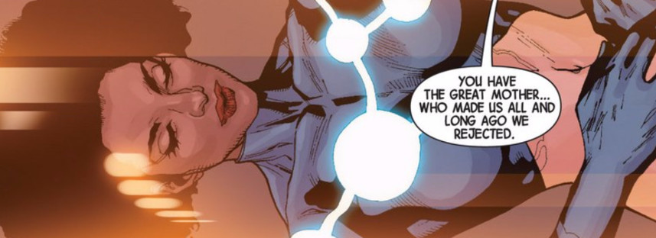
As the drama unfolds, there are two particularly pivotal events. First, the Ex Nihili, who are in the train of the Builders, are perplexed by the presence of the last Abyss. They ask the Martian Ex Nihilo how such a thing could be. Abyss answers by point out that the Builders had lost their way and had given up on life
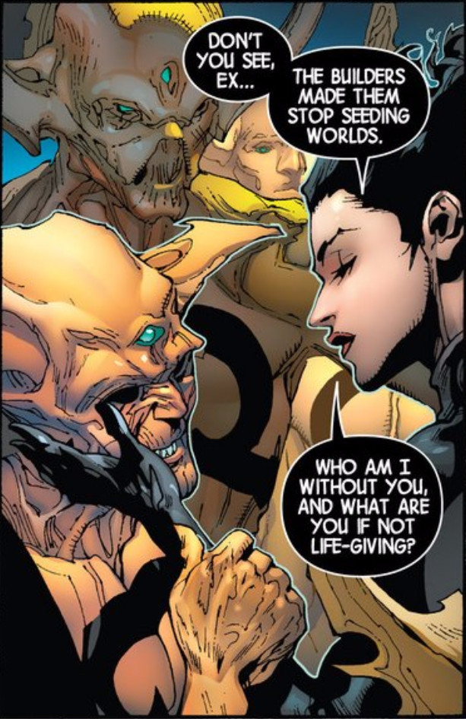
Seeing the truth of her words, the Ex Nihili unite to stop the Builders. But even their might when married to the intergalactic alliance of the Avengers and the star-faring races proves too little. At the end, Captain Universe wakes and confronts the Builders.
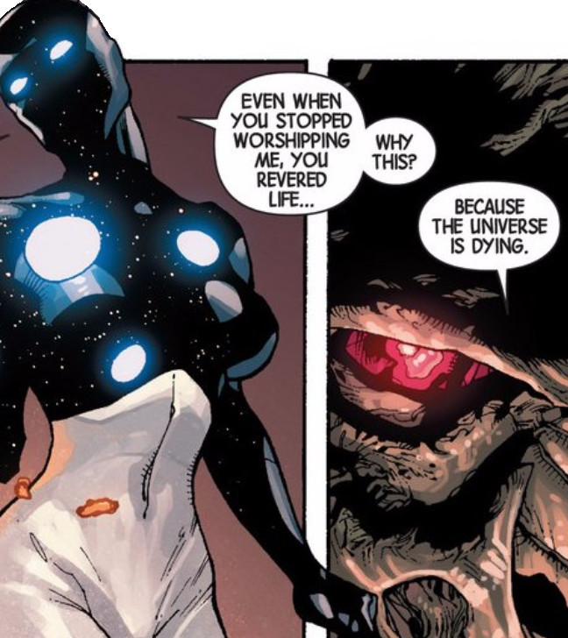
Her might brings the conflict to an end.
Back on Earth, the Illuminati are able to hold off Thanos and the Cull Obsidian until the Avengers can return. However, the costs are high including the loss of the Inhuman city of Attilan and the virtual destruction of Wakanda. Like the Builders war, the fight between Earth’s mightiest and Thanos’ death-seeking cult comes to an end through the intervention of an outsider. Thane consigns his father and two members of the Cull Obsidian to a living death (see the Is Anybody Up There Listening post from Dec. 2014).
The rest of the events in both the Avengers and the New Avengers titles are designed to strip away the hidden stratagems of the Illuminati and let the entire world know that the end is nigh. Along the way, the reader finds a variety of smaller arcs. One such arc involves a time-travel story (the explanation for why the Time Gem didn’t shatter when the rest of the Infinity Gems did) wherein Captain America discovers what the Illuminati did to him after he used the Infinity Gauntlet. Another involves Doctor Strange selling his soul to dark forces to gain the power he hopes will stop multiversal armageddon. Still others involve the creation of a new type of Super Adaptoid that can move between universes, eventually joining forces with the Sidera Maris and the mining of alternate worlds for various evil Dopplegangers.
Next week I’ll review the end of both series and the whole run of Secret Wars.

