Pretty Deadly Storytelling
I can’t say for sure whether I like the Image series Pretty Deadly by author/scripter Kelly Sue Deconnick and artist Emma Rios. One some level I like it a lot but in other areas I find its low points so distracting that it is hard to remember the good parts.
Set in the Old West of the late 1800s, the series is as much fairy tale as it is a Wild, Weird West tale (a la East of West, The Sixth Gun, or the Deadlands). It’s also constructed as a frame tale, in which the main story is about the telling of the real story by one character for the benefit of the other.
Our western version of Homer is, in fact, a dead rabbit who goes by the name of Bunny Bones. The audience is filled with only one listener – Butterfly – who often asks questions and urges Bunny Bones to include something or skip some other thing. There is very much a quality of a parent reading to a child in their dialog.
The outer tale opens with Butterfly asking about the day they both met; the day in which Bunny Bones escaped his earthly life and become something simultaneously more and less. Butterfly is curious about his death and whether Bunny was afraid.

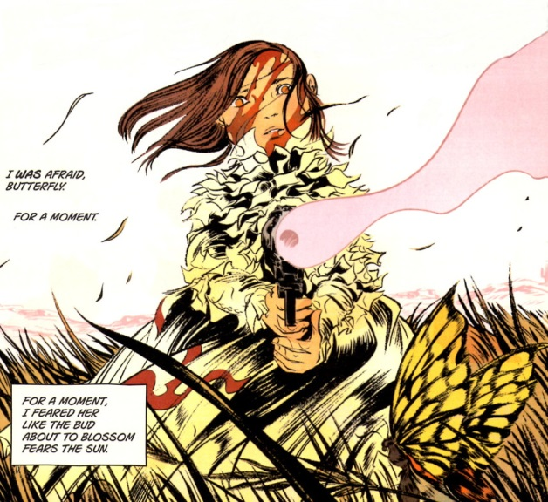
The gun-wielding little girl, as we come to know later, is Ginny, a daughter of death, and much of Bunny’s story centers around her, although she plays only a secondary role.
The bulk of Bunny’s story deals with the events that led to Ginny’s birth and the ongoing aftermath as their consequences play out. However, the thread of the tale is tugged in the middle as Butterfly, after asking Bunny to tell him her story, urges the skeletal rabbit to skip to the other girl.
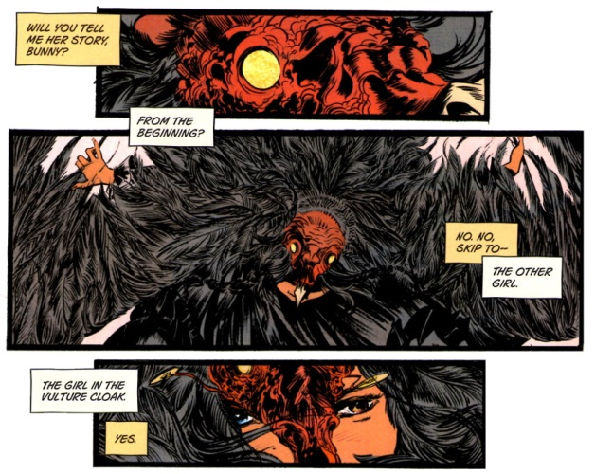
The other girl is small and dark and wears a vulture costume and has mismatched eyes. Her name is Sissy and she’s just arrived in a western town with her hulking, ‘blind’ guardian by the name of Fox. The pair has a strange side show that they perform for whatever change the townsfolk are willing to throw their way. In it Fox, who seems to be able to see despite his hidden eyes, stands at the rear of the stage, holding a large banner bearing the likeness of many people and events; a storyboard of sorts; with all the characters born out in Tarot Card fashion. At the front Sissy weaves a tale, in doggerel, of the gain and loss of the wonderful woman Beauty by her jealous husband Mason.
In her yarn, Sissy tells how Mason, fearful and envious, locks Beauty up in a tower to keep her from other men. Despite her numerous prayers and entreaties, Mason refuses to free her. Her desperation grows until she decides death is better. Using her own blood, Beauty begs for death; but instead being claimed by one of Death’s minions, the head man comes himself. He is immediately taken with her and falls in love and weds her. Together they have a child, whom Death calls Ginny. After her birth, Death allows Beauty to depart from life, but the child, as Sissy’s ragged rhyme says,
<He raised her a reaper of vengeance,
A hunter of men who have sinned—
If you done been wronged,
Say her name,
Sing this song,
Sound the bell’s knell
That calls her from hell…
Ginny rides for you on the wind my child..
Death rides on the wind!>
After she’s done with the show, Sissy mingles amongst the crowd for and is soon accosted by a crafty redhead by the name of Johnny Coyote. While outwardly he is pressing some coins into her palm, secretly he is manipulating her into stealing the Binder, a parchment or document of some importance to Death.
Fox and Sissy take a break from their journey to the next town and settle in for a night on prairie. Sitting by the fire, Sissy idly burns the Binder and waves the flaming sheet under Foxes blind eyes. He immediately realizes what the thing is and flees with her to the closest safe house run by a woman named Sarah.
In the meantime, Johnny, who is spending some time indulging his carnal side in the town, receives a visit from one of Death’s little helpers, a reaper who goes by the name of Big Alice. She’s tracking down the Binder and, after forcing the information out of Johnny with a bullet placed ever so lovingly in his left thigh, she begins her pursuit.
Fox and Sissy, having rested at Sarah’s, decide to press on into the night. But before they go, Sissy teaches the summoning song for Ginny to one of Sarah’s kids. A good thing too, since Big Alice soon arrives with her crew and begin to take Sarah and her farm and family apart. This ruckus stops when the rhyme is said and Ginny arrives. Ginny soon kills the crew and destroys Big Alice, who returns to Death disembodied but otherwise, apparently no worse for wear.
Back in the town, a talking raven, by the name of Molly rouses Johnny to take action. He soon starts his own pursuit. Meanwhile, the pair Fox and Missy continue their flight. Missy tells Fox of a woman she barely remembers, who gave her something – a key. It isn’t clear at this point what significance this interlude has and, unfortunately, it doesn’t become much clear later.
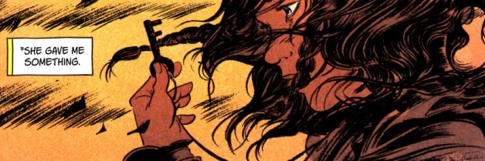
Eventually Missy refuses to go any further until Fox explains what it’s all about, why they are fleeing and who is pursuing and why. Fox reveals that he is the Mason of her story and then he tells the rest of his tale with Beauty and Death, the part she’s never heard. He tells how, when he learned she had died that he wanted to follow her to death. He tells of how he dug and dug and dug until he found his way into Death’s realm. Death refused to grant Fox/Mason release and is ready to send him away when Mason becomes aware of Ginny. He invokes his right to the child since Beauty was his wife. Death rebuffs the claim but offers a deal: Mason must go to a river of blood where
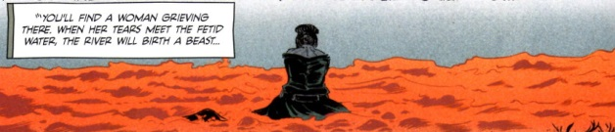
Once there, if he kills the beast, Death will bind Ginny to the spirit realm and Mason will live out his normal lifespan and once he has dies, Death will allow Mason to meet his wife and ask for her forgiveness. Should Mason refuse the deal, Death will unlease Ginny on him to exact revenge for Mason’s ill treatment of her mother.
When Mason arrives at the river, he sees that the beast that is birthed is a small girl with mismatched eyes
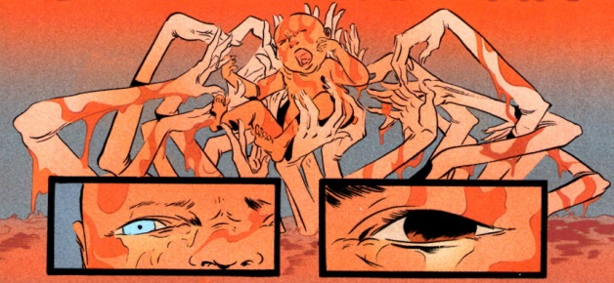
and he refuse to slay her. Instead he cares for her as his own.
During this revelation, rain waters swell the river next to where they are standing and a flood soon separates Fox (Mason) and Sissy. Johnny finds her and somewhat explains the Binder. He admits that her tricked her into stealing it but he thought she would read it and not burn it. That is the unspoken reason why the song sung by Sarah’s boy brings Ginny out when all the times the song was sung by Sissy nothing happened.
Johnny vows to give Sissy straight answers but as he starts to explain things about her the scene changes to Death’s domain. Like Mason before him, Death too can’t let Beauty go but her words and company are no comfort. She tells him that she knows that each Death must live and must die and that his time as death draws to a close as his cycle is ending. She offers him the comfort that when he dies he can join her. But Death has other plans
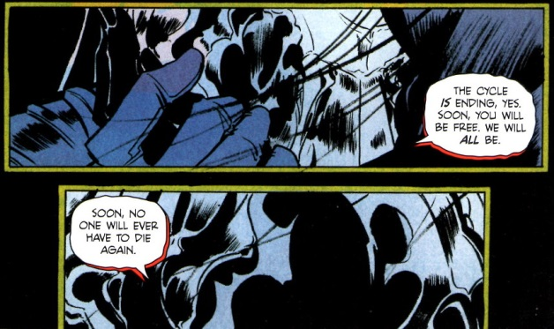

At this point, it seems likely but remains categorically stated, that Sissy is the replacement and that Death’s hope in sending Mason to kill her was to prevent anyone ever becoming Death, thereby stopping the natural order of things.
The one flaw in his plans is his wayward child Ginny. Now released, she soon tracks down Fox. Together, they enjoy a gentle father-daughter moment wherein they try to bash each other’s brains out. During the course of their ‘debate’, Fox is able to gain her sympathy by having her understand Sissy’s fate.
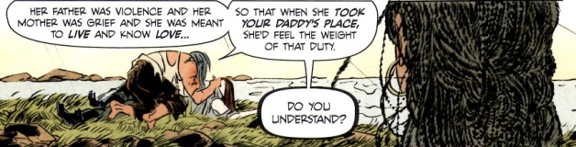
Eventually, everyone reunites and heads to Death’s realm. His guardians, the Day Maid and Night Maid, allow entrance to his realm since they recognize Sissy as the new Death ascendant
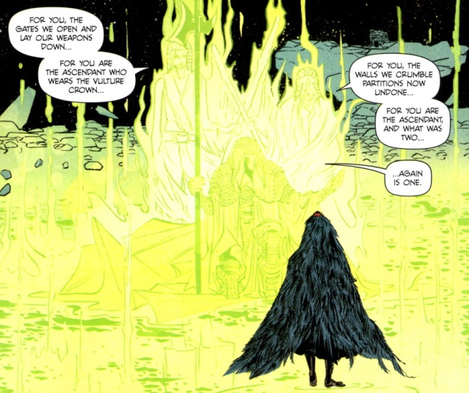
the being who reunites them again as a single entity. Apparently the world has been torn by the machinations that Death is employing so that he may be with Beauty forever.
The rest of the tale is actually easier to summarize. Ginny stops Death by running him through with a sword; Death dies; Sissy takes over as the new Death in a Vulture guise and the Soul of the World (whatever that really means) is healed.
If you understand that last bit you are quite a bit better than I am. This whole arc has a mythic, fable-like quality that has a great deal of charm. But much of this charm is marred by poor storytelling. The reader must interpolate between scenes or read additional information provided on the back cover just to understand character information. Most grievous is the fact that new information is place into the previous-issue summary. Why should a reader, who has already read the previous issue, be required to read the previous-issue summaries in order to get critical exposition? This lack of craftsmanship severely detracts from what could have been a good slice of myth.
Nonetheless there are some good bones here and perhaps Pretty Deadly will mature into a fine vehicle for storytelling. I haven’t given up on it yet but if Volume 2 is like this one, then the cycle will end for it as well.

Important piece on the back cover.

Johnny offers Sissy some money
Johnny lets Sissy steal the Binder
Fox realizes what Sissy got after she’s burned most of it

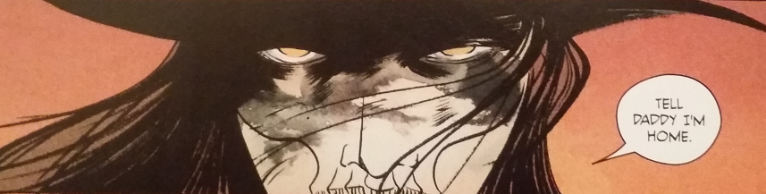

Dramatis Personae
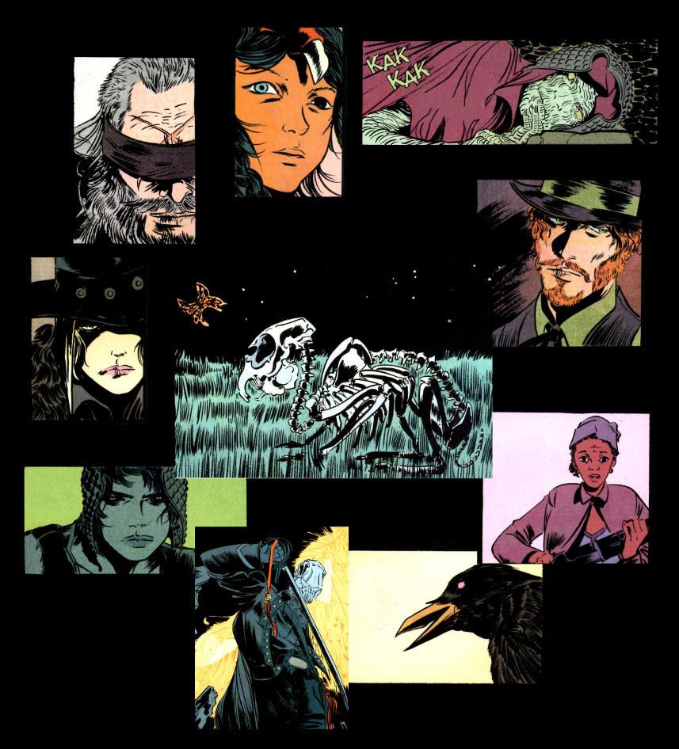
Clockwise from upper left: Fox, Sissy, Night Maid, Johnny Coyote, Sarah, Molly, Death, Day Maid, Big Alice. In the middle are the storyteller and audience: Bunny Bones and Butterfly.

