Consistency Matters
This past Sunday I had the pleasure to sit in on a round-table discussion about comics in general and the recent Secret Wars storyline in particular. This book discussion was put on by a local shop by the name of Third Eye Comics, which has locations in Annapolis and Lexington Park, Maryland.

For those who have never visited Third Eye, it is series of three stores; two of them (Annapolis and Lexington Park) are focused on comics, manga, collectibles, and the like. The third store (also in Annapolis), which is devoted to gaming, sports an eclectic mix of games, including the usual European board games (Catan, Ticket to Ride, Princes of Florence, etc.), collectable card games (Magic: The Gathering, Pokémon, etc.), and more specialized franchises like Warhammer and Dice Masters.
The book club was held after hours in the common area of the gaming store. This type of discussion was the first of its kind that I ever attended and, I believe, the first such event that Third Eye held. And before I share my impressions, I would be remiss if I didn’t mention that the Third Eye staff were quite hospitable. They brought in food and refreshments, provided swag, and were welcoming and engaging.
I wasn’t quite sure what to expect from this experience. As I’ve written elsewhere, my exposures to panel discussion at comic cons have left me with a bad taste. But the conversation was here was different. The mood was relaxed but respectful and everyone acted as and were treated as human beings.
While the majority of the discussion was on the Secret Wars, it was inevitable that other topics were introduced. Comparison and contrast with other mega-series brought in conversation points from DC’s numerous Crisis events. In the same vein, Hickman’s work on East of West was also touched upon if for no other reason than to note the differences in his style when he is creating his own work rather than interpreting the properties of others.
But the most interesting component was when the group started looking at the various Battleworld spin-offs and companion series that went on during the whole reboot of the Marvel Universe. I only followed two of the numerous satellite series: Infinity Gauntlet and the Ghost Racers, and it didn’t really enjoy them. Apparently my experience was not reflective of the rest of the group and their experiences, especially with Weird World, were quite positive.
And it was out of this discussion that I actually learned the most interesting point of the evening – consistency really matters to most readers. I’ve always cared about consistency but I didn’t really have a sense of how much anyone else does. If book club discussion is a guide, the answer is quite a bit. Admittedly, this conclusion is not based on a statistically valid sample size with a carefully crafted questionnaire delivered in a well-designed double-blind fashion. It is based on common sense and on listening to what was said and how it was said and how often.
Perhaps the most intriguing part was when the mechanics of ‘healing factors’ were explored. The trigger for this discussion is very amusing side moments in Secret Wars when Mister Sinister loses his head, which then gets knocked around for a while like some demented sort of soccer ball.
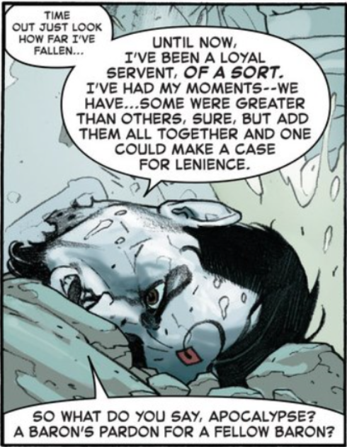
The group started to wrestle with just how does the how thing work. Take, in particular, Deadpool. If he has his hand cutoff, does it grow back? If it does, does the severed hand grow back an entire Deadpool. Clearly this isn’t the case since there aren’t numerous Deadpools running around, but why not? How does Deadpool compare to Wolverine? Where does the energy come from to do all this?
This line of questioning shouldn’t be dismissed as the idle musings of a fanboy. Rather these are the normal trains of thought for intelligent minds trying to understand the world around them. These are the sort of questions that lie at the heart of scientific inquiry. True they deal with a fictional world constructed, only partially, by men but the point is this. Reading comics (and reading in general) may be an escape but the escapee take his reason and his sense of cause-and-effect with him. The writer would do well to pay more attention to consistency. It matters – just ask Mark Gruenwald.

