Badger Redux
The last column was devoted to The Badger comic book run of the 1980s. This column is devoted to the 5-issue mini-series (at least at the time of this writing) that revamps the Badger character to be in line with the current day.
Mike Baron is again the writer and creative force behind the book and much of bones of the original story are present in this incarnation. The central three characters of Ham, Norbert (aka the Badger), and Daisy Fields again grace the pages of the book. And their origins and backstories closely parallel the original material but with variations designed to coincide with today’s zeitgeist. Let’s start with Norbert.
Unlike the original Viet Nam motif, where, no doubt, Sykes was drafted, this time around he volunteers for military service. From the get-go, Norbert is a bit strange, as evidenced by his behavior when he enlists with the army.
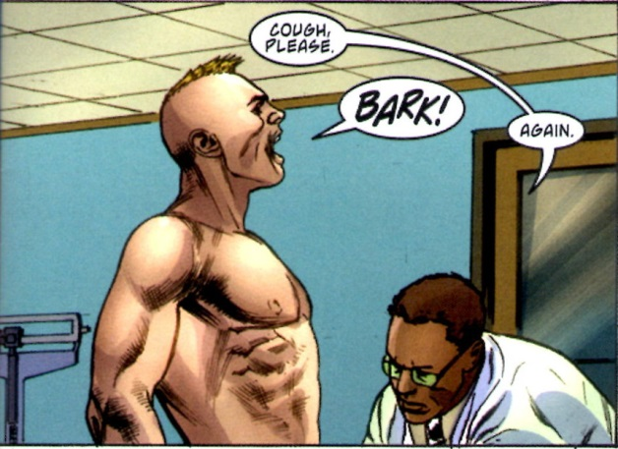
He is soon teamed with a bomb-sniffing dog and both of them pull a tour in Iraq. Sykes shows an aptitude working with Otis (as he so named the dog) and a positive aptitude for combat. However, he is a bit standoffish with his fellow non-comms.
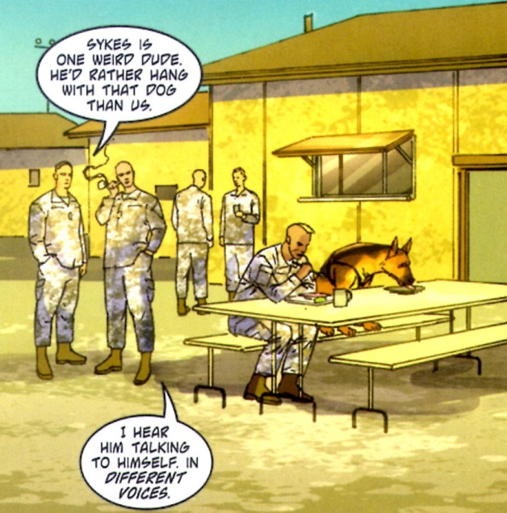
Their time together is short-lived and, as most of the stories from Iraq go, jihadis have soon killed Otis and captured Norbert. They torture him with a combination of physical and psychological techniques, but the one that sends him over the edge is when they place a puppy in a bucket to drown on top of the cage in which they keep him. Driven mad by his impotence in helping an animal, Sykes soon has a vision in which he is visited by a badger (get it – a badger)
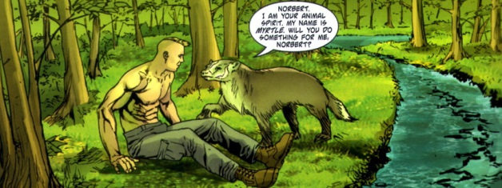
In return for his assent to be a human champion for animal, Myrtle grants him an even greater ferocity in combat – a skill he soon employs to great effect when he breaks free and slaughters his captors. Thus the Badger is born and, perhaps, his personality is splintered.
After he has made his way back to the US held side, he is honorably discharged and sent home. But being a restless sort, Norbert doesn’t stay in Walter Reed to receive the attention he needs. Slipping out, he heads for the open road, hitchhiking back to Wisconsin. Along the way, when asked how many jihidis he killed, Norbert remarks that he didn’t kill any, Pierre did.
Shortly after his arrival in Wisconsin (Racine perhaps, maybe Madison), Norbert comes on a bunch of punks hassling a wheelchair-bound man who had just left the bank. When Sykes comes to his aid and roundly beats the spit out of the thugs he is rewarded with arrest, trial, and subsequent commitment to the sanitarium.
There he meets Dr. Daisy Fields – yes she’s become her own woman and has moved from assistant to full-fledged doctor. She soon recognizes that Norbert suffers with multiple personalities but her reaction is one filled far more with concern than with fascination.
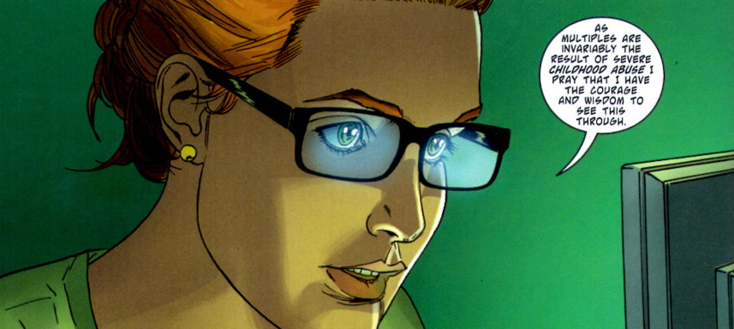
For a while, the santarium permits him to roam the grounds freely, but when he intervenes to stop some orderlies from abusing some geese he again is rewarded; this time with a nice straight jacket and a stay in the padded room. It is while Norbert is looked up in that dark, confined space that the final ingredient in our little drama shows up – Hammaglystwyth (Ham for short).
To prove his power, Ham first unleases Max, the gay-architect splinter of Norbert’s psyche, and, second, arranges for him to have a fine suit, tailored to his needs. Max is getting along splendidly with Doctor Bor, the head of the Sanitarium,
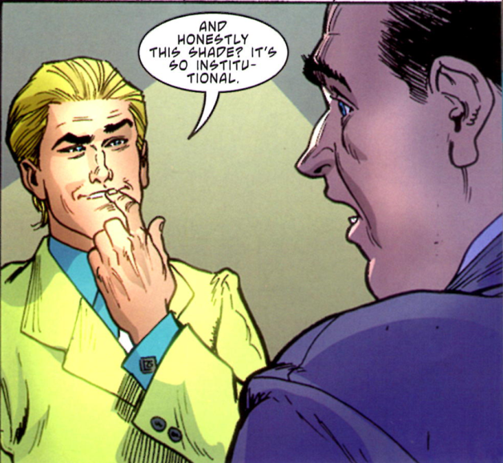
handing out decorating advice, when one of the orderlies bursts in to inform the Doctor that they can’t find Sykes. Back goes the Badger into the general population but not before he is so impresessed with Ham’s magic that he agrees to be Ham’s familiar.
Ham soon affect’s his release from the Sanitarium using magic far more powerful than that of the Druids – today’s legalistic, wired, politically correct sensibilities.
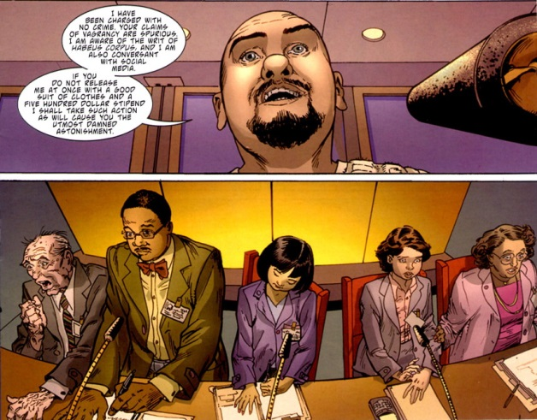
Using the stipend provided on his release, Ham soon turns $500 in mega millions.

Meanwhile, Daisy has arranged for Norbert to be an outpatient, and hoping to get him a new set of clothes as the first step to trying to help him reintegrate into society, she pulls up to a store with Sykes in tow. But her rehabilitation plans soon go awry, when the Badger comes out to physically punish a rich, arrogant, punk who parks in the handicapped spot since he’ll “only be a sec”. Before the cops can come by, Ham shows up (as if he knew) and whisks them both away in his limo.
Ham soon fills in his Druidic origin; how he was placed under spells in the 4th century that caused him to sleep until modern times; how his inert body was carried to the new world and left buried by Vikings; and how he subsequently woke up and educated himself using that handy modern magic of the internet. Ham further reveals that his plight was the result of the machinations of Rathkrogen, his eternal enemy, and that Rathkrogen is none other that Vladimir Putin. Ham claims that it is only a matter of time before Putin sends an assassin to kill him. No sooner are those words uttered, than a behemoth of a man bursts in (how does he know where and how to penetrate the castle) and the farce is underway. Despite the size differential, the Badger makes short work of the villian.
Ham interogates the now-defeated ‘bully boy’ and finds some startling changes have occurred while he slept
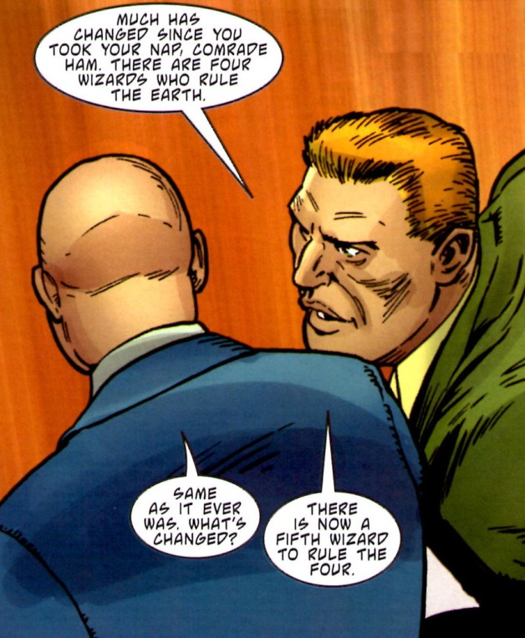
Putin, it seems is vying to be the Fifth Wizard. So end Issues #1-2.
Well there’s more – a lot more. But very little else is important. The key groundwork has been laid and I, frankly, am a bit dissappointed. Not by the story itself, which is reasonably well constructed and paced. Nor by the art, which, while not as vibrant as the original, is pretty good. No, what is disappointing is the tone of the story, which is a queer mix of too much and too little.
Too much time is spent on Norbert’s origin. His enlistment in the army and tour of duty in Iraq is very serious and dramatic and depressing. It pulls back the curtain too much on what made Norbert the man (or men/women/little girl/dog) that he is. The mystery of the Badger was one of the most enjoyable components of the original run. You never knew just what was going to be revealed. Too much pathos is generated around Norbert’s plight – being punished for being a good guy, being misunderstood, and so on.
Too little time and space is spent on the crazy hijinks that made the first series so much fun. Gone are the random acts of pummelling jay walkers and snacking people who don’t fill in their checks before getting in the cashier’s line. Gone are the wacky social observations and zany one-liners. Gone is the banter between the main three characters.
In short, this mini-series has too much drama, too many explanations, too few jokes, and too little of the original style that made the Badger of the 1980s a hit. It is true, that the tone does lighten as the series progresses but in all cases it is more accurate to say that broods along rather than capers. As I mentioned above, the Badger has been recast to fit in with modern times. Perhaps reflecting the zeitgeist is not the way to go – a sad commentary on our current day.

