Mantis Retrospective
Well Guardians of the Galaxy, Vol. 2, has proven itself to be the first big blockbuster of the summer season. The entire gang are there, Starlord, Rocket, Drax, Gamora, and Groot (assuming that you count Baby Groot as the same as Groot in the first movie). In addition, we are introduced to some new characters, including Ego the Living Planet and Mantis, his empathic companion. But a relatively small percentage of the movie-going public likely know the publication history of Mantis in the comics. This post attempts to fill in this gap for those who are being introduced to Mantis for the time.
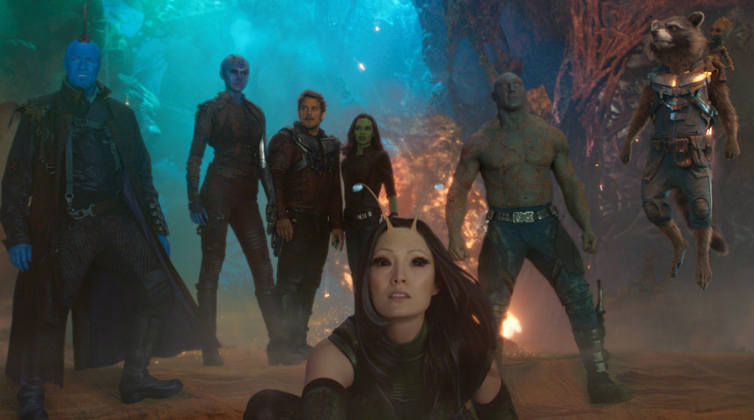
Pound-for-pound, Mantis may have had the greatest impact on Marvel comics of any character. Her initial tales cover only about 2 years, starting in Avengers #112 and ending with Giant-Sized Avengers #4, at total of 27 comic books.
The brain child of Steve Engelhart, the Mantis, when she first appears in Avengers #112, is relegated to a mere 3 panels where she is in the company of a mystery man, whose identity is later revealed to the be former super-villain Swordsman – now reformed and seeking entrance into the Avengers.
Her initial appearance is rather modest and she is missing her characteristic antennae.

Her subsequent storyline through the Avengers over the next 2 years can only be described as ‘Flat out weird’, using Engelhart’s own introduction to the book.
Her next appearance in Avengers #113 is also limited to 3 panels in her modest garb but by the time she appears on the cover of Avengers #114, she has now been transformed into a sensuous femme fatale whose is one part martial artist, one part empath, and one part sex-symbol.
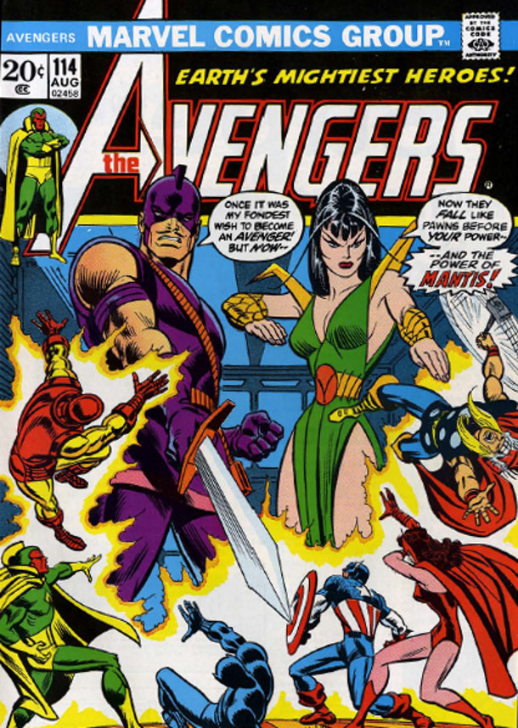
Demonstrating an unparalleled ability to control her own body, Mantis is able to even lay Thor low with her martial arts techniques (as she often says ‘strength is nothing compared with skill’).
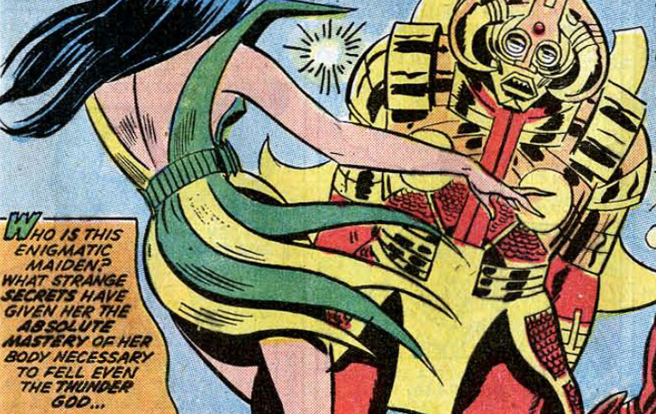
Her empathic abilities provide here with some rudimentary command of the mystic arts
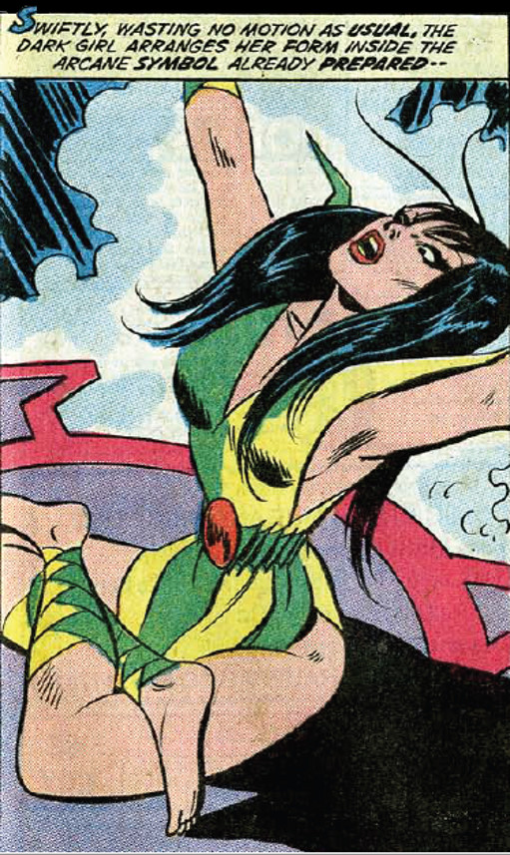
And clearly Englehart and his various artists delight in depicting her in sensuous and slinky positions
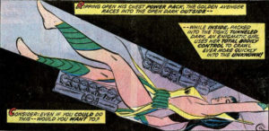
Her situation quickly complicates. Her background story as a gutter snipe raised on the streets of Saigon is soon challenged when the Libra, one of the 12 super-villains in the Zodiac, confesses to being her father.
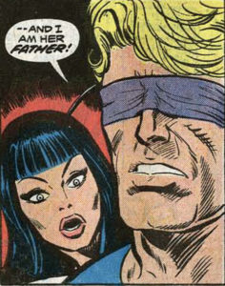
Libra relates quite a different story. He was a German mercenary working for the French in Viet Nam. He meets a girl called Lua (took her back to his place, feeling guilt, feeling scared), fell in love, and eventually married her. Unfortunately, her brother, Monsieur Khruul, is an infamous Vietnamese crime lord and he doesn’t take kindly to his sister marrying outside her race. Finally catching up with the married couple, now raising a baby daughter, the maniac orders his men to burn all them alive. Lua is killed, but Libra, now horribly disfigured, escapes with Mantis into the jungle.
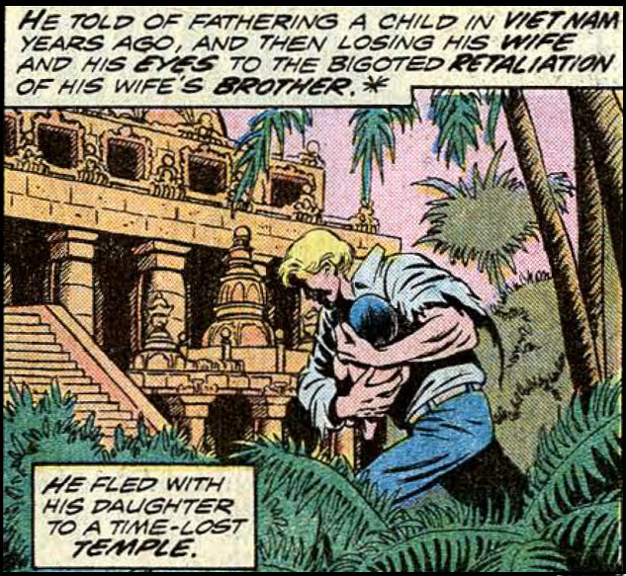
Libra discovers the temple manned by the Priests of Pama, who train both him and his daughter in the martial arts. The priests take a special interest in the girl, helping her to unlock vast untapped aspects of human existence
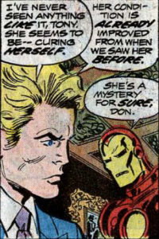
Unfortunately, the Priests keep Libra apart from his child
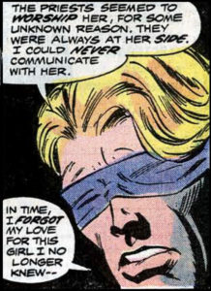
and he returns to the outside world, to take up a mantel of crime lord.
Mantis is quick to dismiss Libra’s story as a complicated pack of lies and that may have settled it, except for a set of actions her fickle nature sets in motion. Her innate attraction to powerful men causes her to start flirting with the Vision. Mad with jealously, the Swordsman, deciding to prove himself worthy of her love, rushes to Saigon to exact revenge on Monsieur Khruul.
Instead, the Swordsman is bested by Khruul’s men. Tortured, he relates Libra’s story to Khruul, who then orders all the Priests of Pama killed. The Avengers and Libra, following hot on the Swordsman’s heels, arrive at the temple where they bring Khruul’s men to justice. However, Khruul escapes.
They later find him dead, ripped to shreds by an extraterrestrial entity called the Star Stalker that absorbs most forms of energy. The Star Stalker reveals that the Priests of Pama were in fact Kree Pacifists and that they alone knew how to defeat him. With them gone, he threatens to consume the Earth in revenge. With the priests dead, all hope seems gone. Insisting his story is true, Libra turns to Mantis, insisting that the priests would have taught her the secret as well and that all she needs to do is recover her memories.
Much to her surprise, Mantis realizes that she does know the Star Stalkers weakness and she soon directs the Vision in destroying him. Her conflict over her past further alienates her from the Swordsman
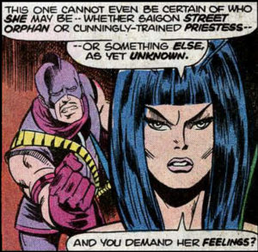
and when pressed she spurns him and turns all her affection to the Vision.
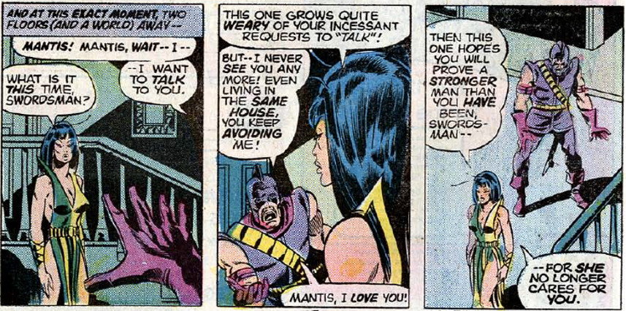
This burgeoning love triangle is soon interrupted with the arrival of Kang the Conqueror from the future announcing that his goal is to find and wed the Celestial Madonna.
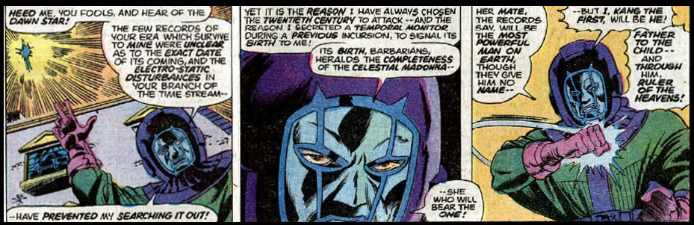
Kang makes short work of most of the Avengers, capturing them so that he may determine who is the Celestial Madonna. Considering him beneath contempt, Kang leaves the Swordsman behind. This proves to be a serious mistake, as the Swordsman is able to recruit other versions of Kang from other times to stop him. Unfortunately, the Swordsman is killed in the process.
Mantis insists that the Swordsman be buried in Saigon. After the ceremony, she begins to examine her life and finds herself in no way worthy of being a possible Celestial Madonna.
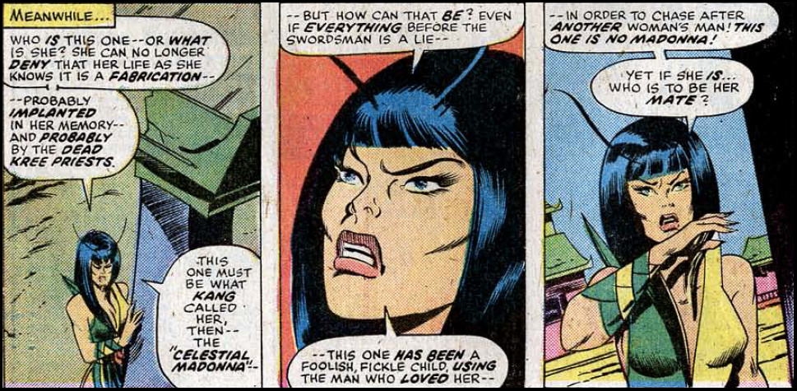
In the meantime, Kang beaten but not driven back, remounts his attack to claim the Celestial Madonna. Again his alternative selfs assist in his defeat and one of them, Immortus, provides the Avengers with the means to untangle Mantis’s past once-and-for-all.
As the story comes, together, the Avengers discover that Mantis’s origin is inextricably tied to the Kree, Skrulls, and a new race the Cotati
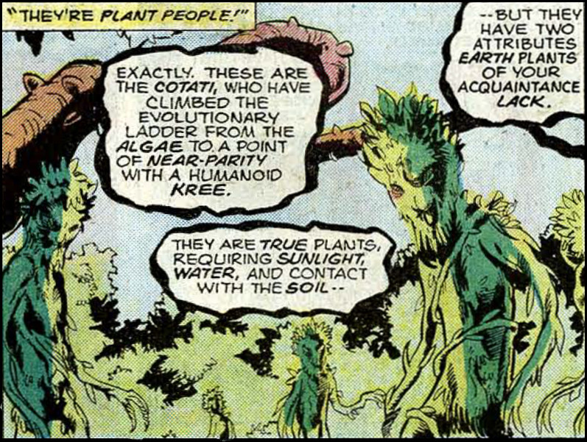
who also began their existence on the Kree Home world. Eons ago, the Skrulls were more technologically advanced than either the Kree or the Cotati. They gave the Kree and Cotati a chance to share in their technology – it was to be the prize for winning a competition as to which race could best use the Skrull technology.
The competition was held on the Earth’s moon and, at the end of the year allotted, the Kree had built the Blue City, the future home to the Watcher. In contrast, the Cotati had built a park. The Skrulls, impressed by the work of the Cotati, are poised to pick them winners when the Kree slaughter all the plant people. They then kill the Skrulls, coopt their technology, and start the eternal Kree-Skrull war.
But not all Kree turn out to be militant. The pacifists among them choose a different path. Shunned by their society, they train in defense and spirituality. One day they discover that the Cotati were not all wiped out by the initial genocidal rage of their ancestors. It is hard to kill a race that produces seeds. But these Cotati are no longer mobile, having chosen to give up action, instead focusing on their refinement of their mental abilities. They form an alliance with the pacifist Kree. Their partnership is cut short when the Kree imprison the pacifists on a prison planer. The Cotati are able to engineer their freedom in exile by attracting the Star Stalker and them helping them realize how to defeat his menace. By doing so, the pacifists are able to appeal to the Kree Supreme Intelligence, who agrees to allow them to journey in exile to many worlds. Unbeknownst to the Supreme Intelligence, the exiles take the Cotati with them. The pair that heads to Earth found the Priests of Pama and plant their Cotati companions in the garden in Saigon where Swordsman is buried.
Swordsman’s body is now animated by the Cotati
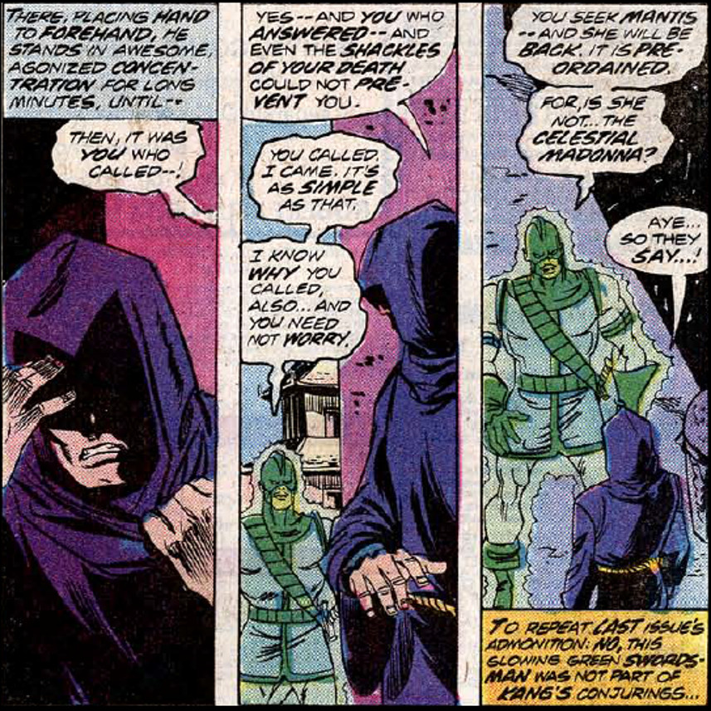
and after some adventures too long to relate, Mantis agrees to marry him, thus facilitating the first animal-plant mating from which will come the most powerful being on Earth.
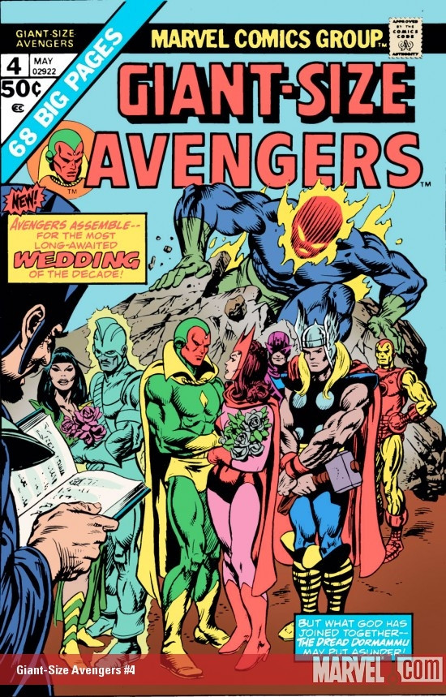
The rest on Mantis’s story is not very interesting. After he left Marvel, Engelhart was able to introduce a Mantis-like character in both DC and Eclipse comics. Mantis eventually resurfaces in Marvel comics as both a mother to Sequoia (her celestial offspring), a lover to the Silver Surfer, and a murderous freak seeking revenge for the ‘lies’ visited upon her by Libra, the Cotati, and the Avengers. Unfortunately, she never again inspired the interest she had under Steve Englehart in the initial 2-year run of flat out weird stuff indeed. Hopefully her MCU trajectory will be a lot more interesting.

