A Brief History of the Infinity Stones/Gems – Part 3 Quest for the Stones
Last month’s post covered the linkage that Steve Engelhart created between the Elders of the Universe and the Soul Gems, the universal ontology into which the gems fit, and how these connections set the stage for what Jim Starlin would do with his resurrected of Thanos. This month’s column will take a look at the two-issue mini-series entitled The Thanos Quest that connects the dots between Thanos’ faked death in Silver Surfer #38 and his bursting back onto the scene with the Infinity Gauntlet in Silver Surfer #44 and the Infinity Gauntlet mini-series.
Not as well-known as the The Infinity Gauntlet, The Thanos Quest is, nonetheless, worthy of special attention for many reasons. First, Thanos is the protagonist of the plot much as he is in the Avengers: Infinity War and the general outline of his quest sheds light on how the movie was constructed. Second, this series affords a enormous insight into dead-and-resurrected Thanos. Having outgrown the Mad Titan mold he filled when questing for the cosmic cube, this Thanos is a more mature version of the schemer who vexed Adam Warlock. He would rather outsmart his opponents or bargain with them rather than just brawl; he plays the long game. Finally, Starlin expands on the cosmic themes he and Engelhart explored in Silver Surfer and some of these philosophical points are interesting food-for-thought in their own right.
The quest proper begins with Thanos haunting the halls of the dead in his beloved’s court, staring almost incessantly into the Infinity Well. Soon one of her minions approaches, challenging him over his negligence to the chore she assigned.
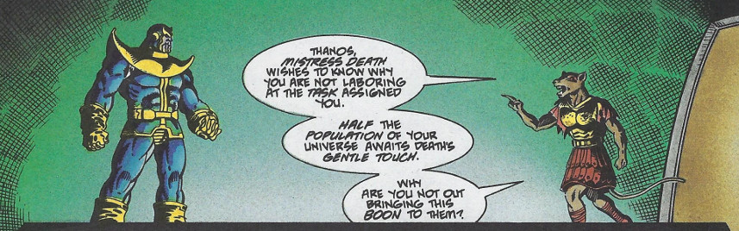
Thanos begs leave of Mistress Death to pursue the Soul Gems so that he may comply with her wishes in a timelier fashion.
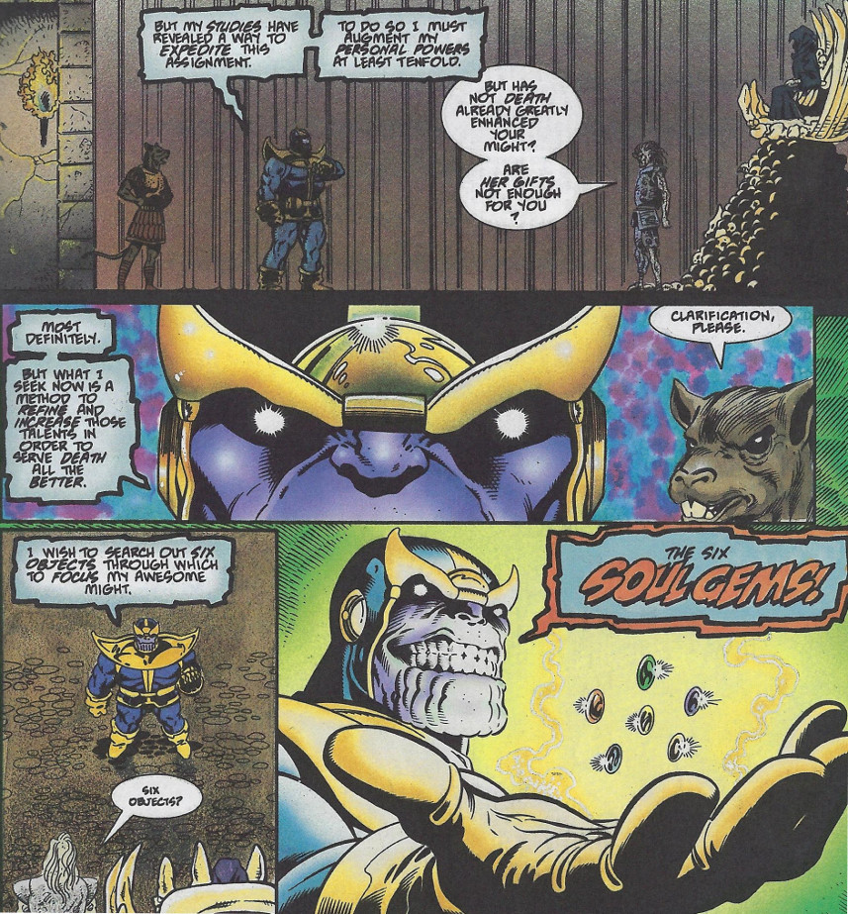
Or so he says. His secret plan is that in acquiring the gems he would stand equal to her and be allowed to take his place at her side as consort and king.
Death capitulates to his request and his first stop is the Nexus of Reality where Lord Chaos and Master Order had imprisoned the In-Betweener after his loss to Galactus (see last month’s post for details).
Offering to help free the In-Betweener and in return for making him a disciple, Thanos unites their power in a single blast that just barely breaches the prison. Once free, the In-Betweener sarcastically thanks Thanos for betraying Death in order to save him and offers his rescuer a less desirable reward.
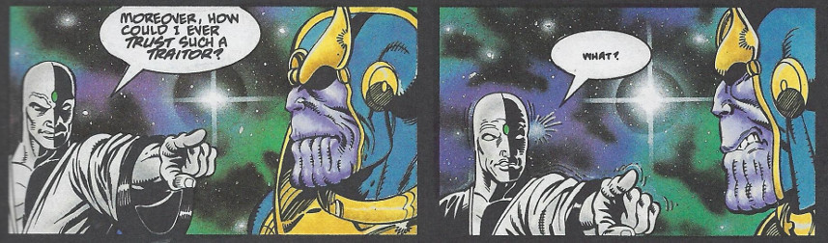
But Thanos had correctly reasoned that the In-Betweener would be powerless at the Nexus of Reality, where order and chaos cancel each other out, and humiliates the pompous parody of black-and-white in one of the best panels in the history of comics
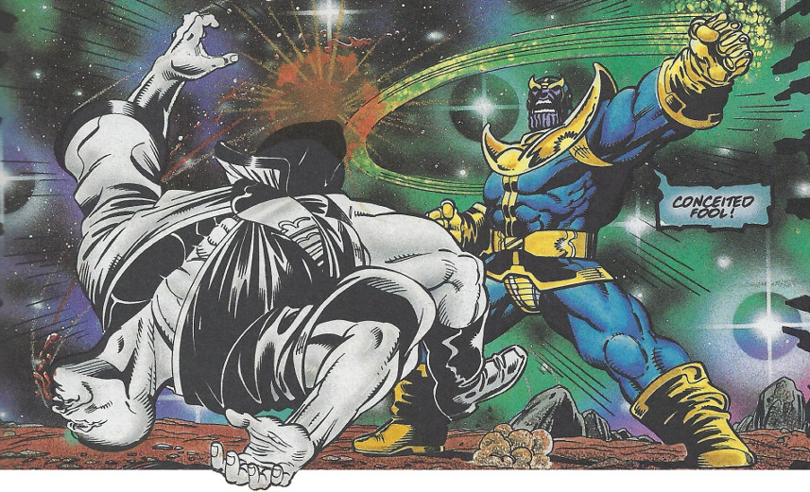
Stripping the In-Betweener of his gem (the Soul Gem previously held by Adam Warlock),
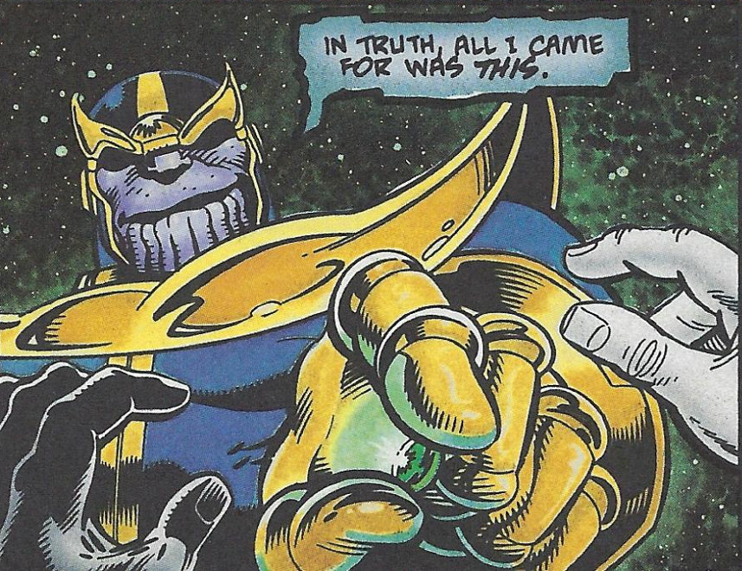
Thanos moved onto his next victim, the he Elder of the Universe known as the Champion.
The Champion has taken up residence on the planet of Tamarata and it is clear by his continuing engagements with that planet’s warlike races, that the Elder’s physical might is unparalleled. Unperturbed, Thanos tricks the Champion into destroying the whole planet, effectively stranding the latter in space.
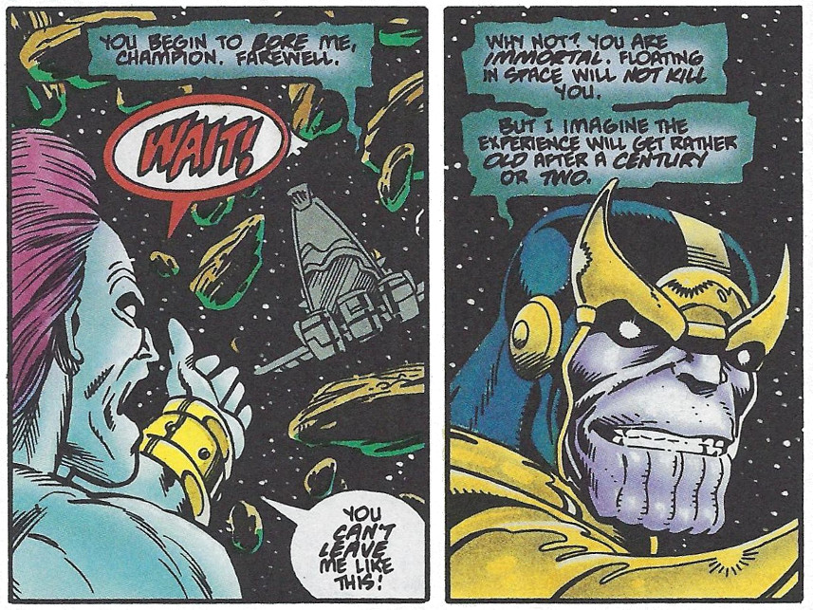
Faced with spending an near eternity in space, the Champion begs for help, a request Thanos is willing to grant in return for something else.
Reluctantly, the Champion surrenders his gem in exchange for delivery to the nearest planet. It is at this point that Starlin begins to differentiate the gems from each other, explaining that the Champion held the Power gem and that is was his subconscious tapping into that artifact that made him an irresistible physical force.
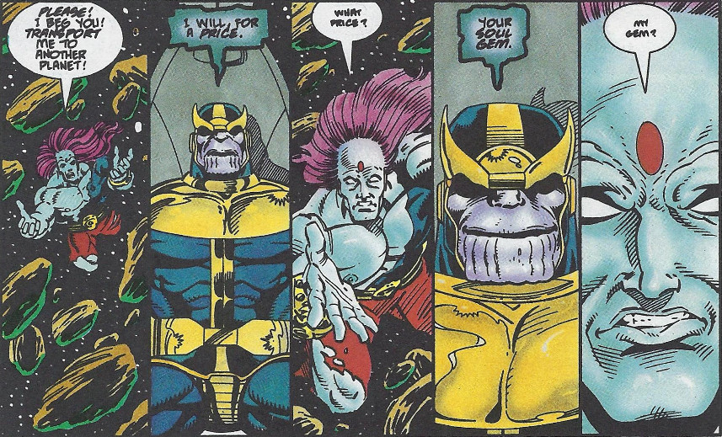
The next encounter between our Avatar of Death and an Elder of the Universe plays out when Thanos visits the Gardener. Already established as someone who knows how to yield a gems power, the Gardener tries to overcome the titan with the abundant botanical growth at his command. But Thanos’ possession of the Power gem gives him the edge and soon he takes from the Gardener’s dead body the Time gem, a fact he reveals in a heartfelt soliloquy he delivers in homage to the maker of such beauty.
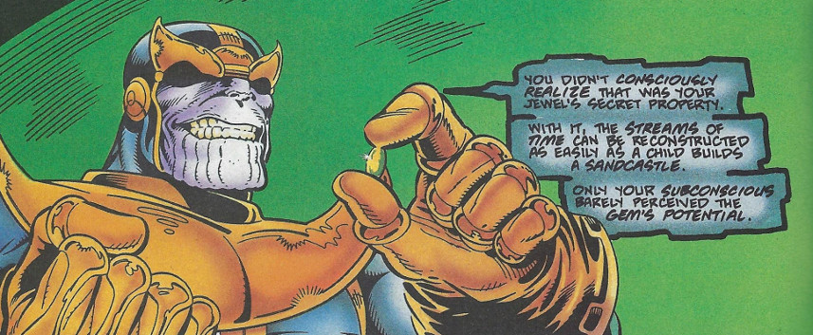
Here we see a facet in Thanos’ personality that we had not seen before, an ability to lament the loss of something worthwhile in the pursuit of a higher goal.
His next action is to call the Collector, another of the Elders of the Universe, with an offer for a trade: the Collector’s gem in exchange for an even rarer item.
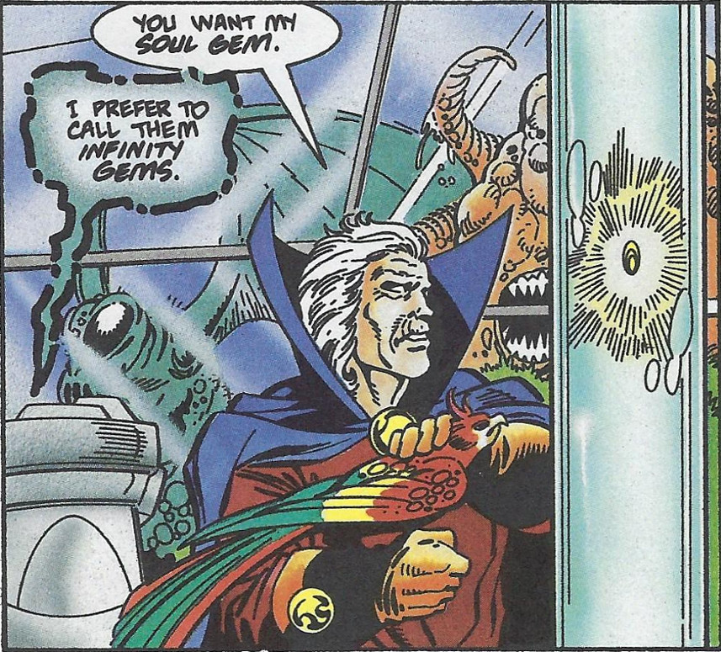
Intrigued, the Collector agrees to at least consider the trade, especially since most of those who oppose Thanos tend to end up dead. It is at this point, that the term Infinity Gem is used to describe these objects.
Before the reader can contemplate just what is worth trading an Infinity Gem for, Thanos is off to see the Runner. This Elder possesses the Space gem and using its power, he can out maneuver anyone.
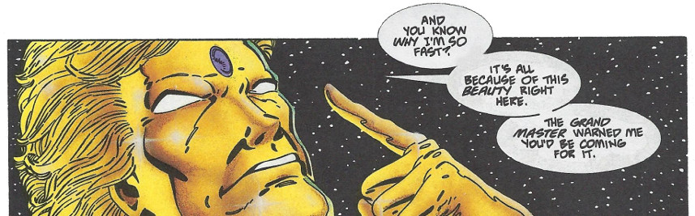
Thanos is quickly unseated from his transport and left adrift amidst floating rubble. However, he quickly regains the upper hand by using his craftiness. Thanos relays to the Runner the origin of the Infinity Gems.
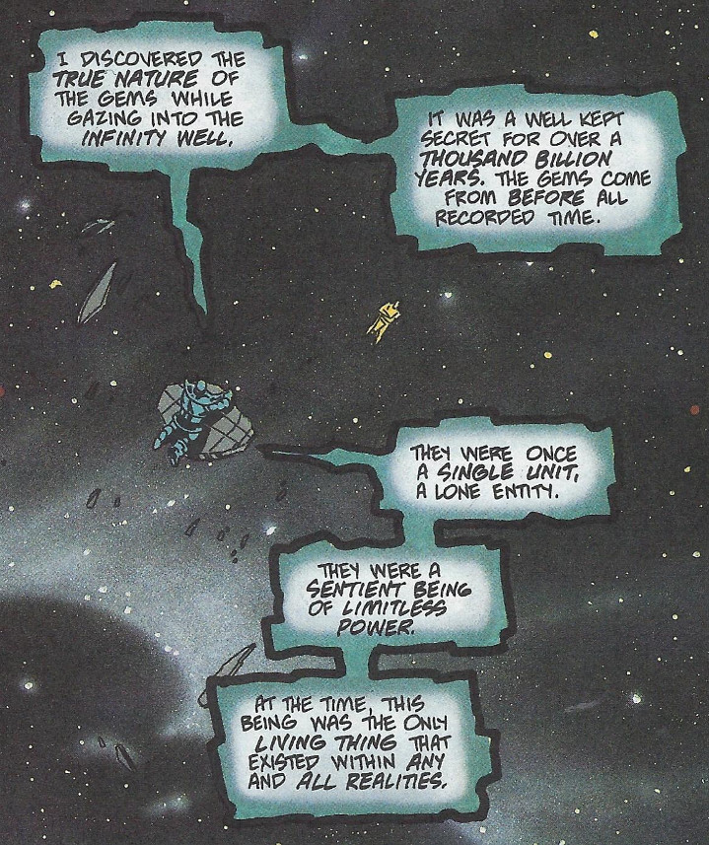
As he continues to weave his tale, Thanos tells how this Sentient Being hated the desolation of its singular existence, devoid of all contact with other beings, and commits a form of cosmic suicide.
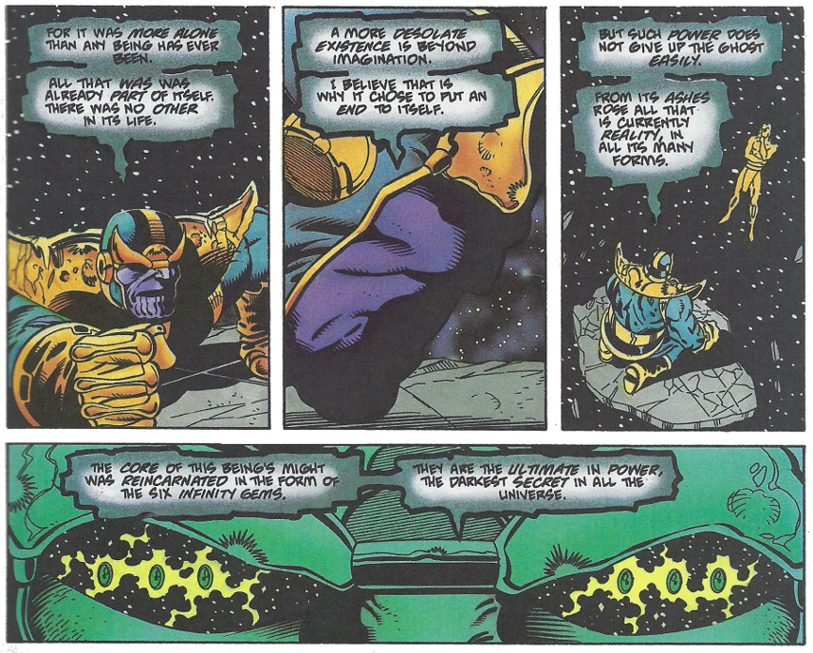
The Runner, captivated by these revelations, gets to close and soon pays the price. Now within his striking distance, Thanos ages the Runner to decrepitude and relieves him of the Space gem. Thanos then regresses the Runner to infancy before delivering this cosmic babe to the Collector in exchange for his gem. The Collector, who had been unable to unlock his gem’s ‘soul’ power, willingly makes the trade before disconcerted to learn that this gem controls reality.
With five gems in his grasp, Thanos confronts the Grand Master (the same character as from Thor: Ragnarok), easily the most crafty and devious of all the Elders. It was the Grand Master who had, in years past, manipulated Death into barring the Elders from her realm, making them effectively immortal. Mindful of the titan’s might, now augmented with 5 Infinity Gems, the Grand Master insists on a battle in a virtual world as a way of leveling the playing field. Thanos accepts and the two face-off in some abstract cyber space.
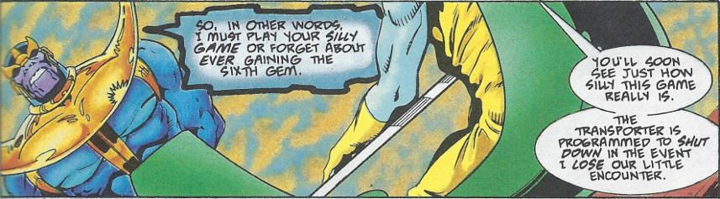
Despite the Grand Master having the home field advantage, Thanos quickly gets the hang of the virtual battle. The Grand Master, however, being not one to take chances, cheats his way to victory and kills Thanos. Gloating over his win and secure in his safety, the Grand Master fails to leave the virtual world soon enough. Thanos, anticipating treachery, had sent a duplicate to compete in his place and, taking advantage of the Grand Master’s vulnerability, Thanos destroys the virtual machine and claims his last prize: the Mind gem.
With all of the Infinity Gems in his possession,
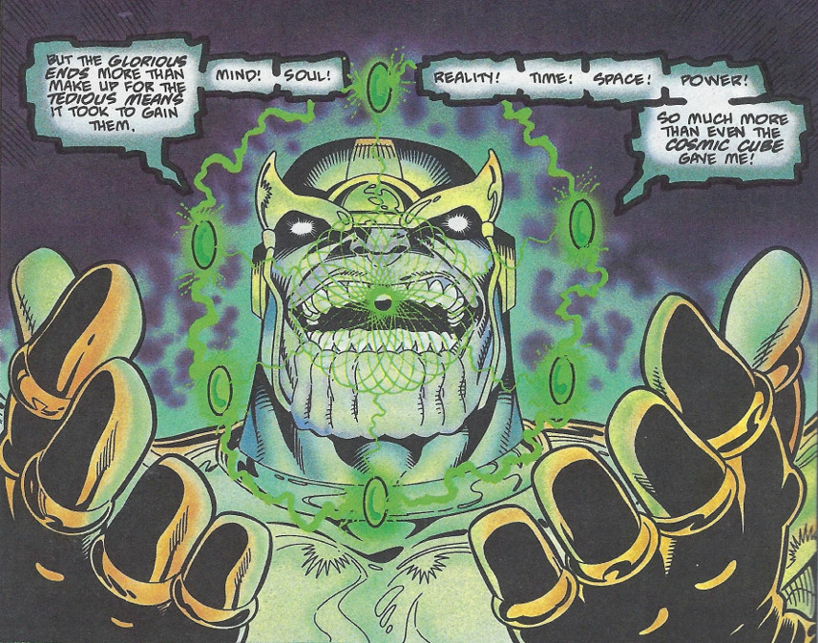
Thanos once again seems to have fallen into his old Mad Titan routine.
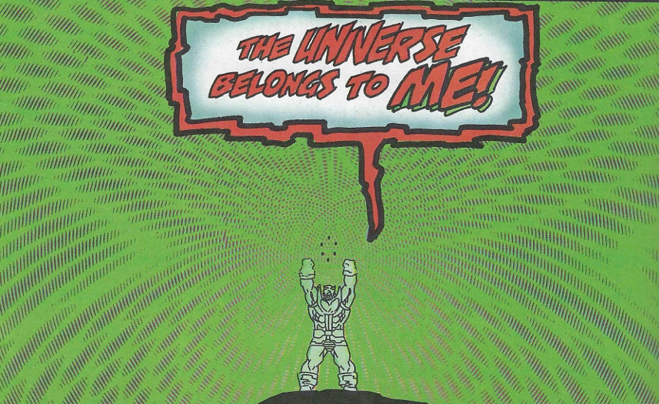
However, his ecstasy is soon short-lived. Returning to Death’s realm seemingly a triumphant hero, Thanos soon confronts the cold, hard, fickle nature of Death. Asserting himself her equal, Death consents to let Thanos sit next to her on the throne, a throne she soon vacates. Her final statement to him, again, as always, through some other minion, is that he is now above her in station and she can not be his.
The closing scenes show a forlorn god now sadly reflecting on his hollow victory.
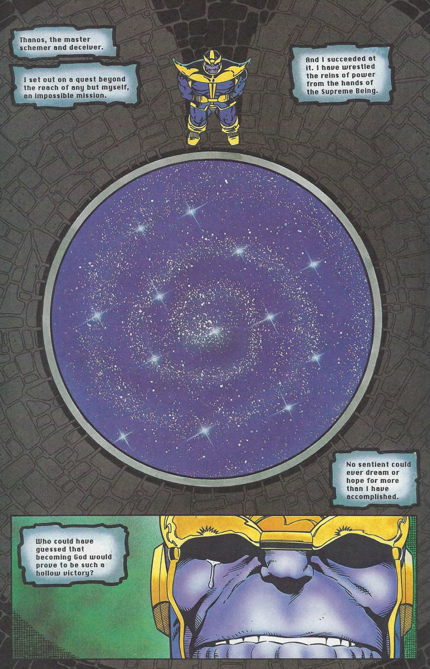
Next month’s column will explore just what the happens to our spurned protagonist when he fashions a gauntlet for his gems and shakes the pillars of heaven in his grief.

